rpm -Uh gtk-demo-2.24.28-r0.cortexa7hf_vfp_vfpv4_neon.rpm

“/usr/bin/gtk-demo” brings up a new window.

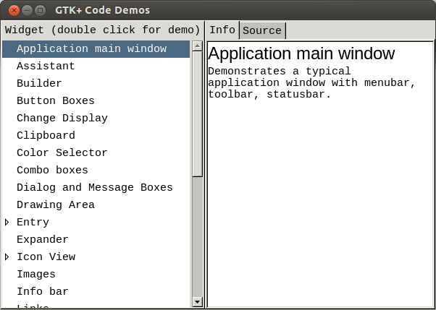

Highlighting the Button Boxes

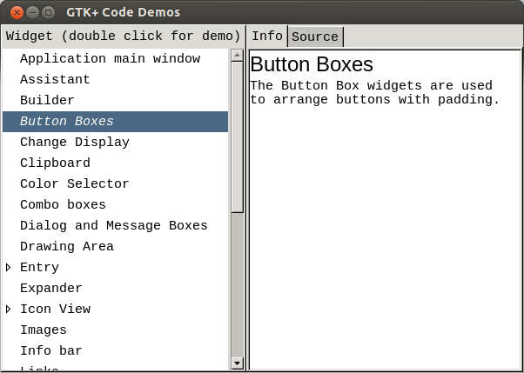

When you Double click

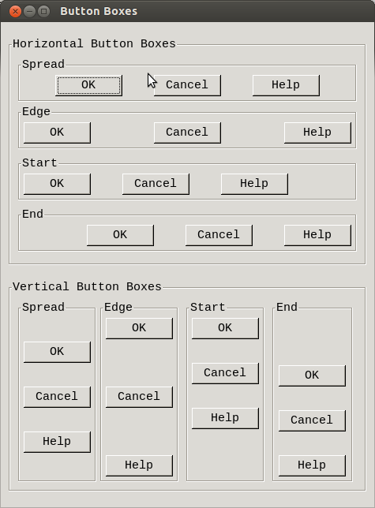

Depressing the Info button on the main window displays the code that was used to generate the above window.

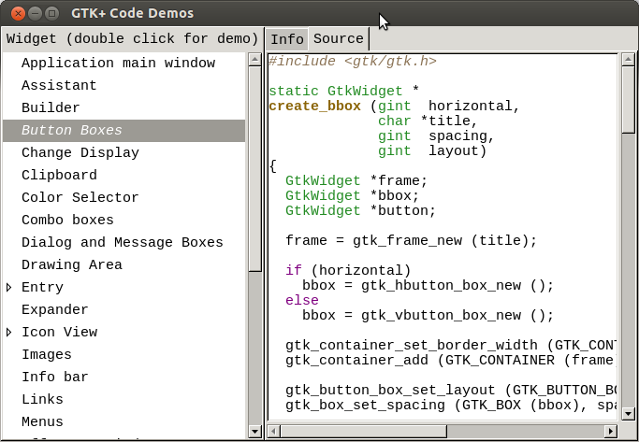

Below is the copy and paste of the source code.

#include <gtk/gtk.h>

static GtkWidget *

create_bbox (gint horizontal,

char *title,

gint spacing,

gint layout)

{

GtkWidget *frame;

GtkWidget *bbox;

GtkWidget *button;

frame = gtk_frame_new (title);

if (horizontal)

bbox = gtk_hbutton_box_new ();

else

bbox = gtk_vbutton_box_new ();

gtk_container_set_border_width (GTK_CONTAINER (bbox), 5);

gtk_container_add (GTK_CONTAINER (frame), bbox);

gtk_button_box_set_layout (GTK_BUTTON_BOX (bbox), layout);

gtk_box_set_spacing (GTK_BOX (bbox), spacing);

button = gtk_button_new_from_stock (GTK_STOCK_OK);

gtk_container_add (GTK_CONTAINER (bbox), button);

button = gtk_button_new_from_stock (GTK_STOCK_CANCEL);

gtk_container_add (GTK_CONTAINER (bbox), button);

button = gtk_button_new_from_stock (GTK_STOCK_HELP);

gtk_container_add (GTK_CONTAINER (bbox), button);

return frame;

}

GtkWidget *

do_button_box (GtkWidget *do_widget)

{

static GtkWidget *window = NULL;

GtkWidget *main_vbox;

GtkWidget *vbox;

GtkWidget *hbox;

GtkWidget *frame_horz;

GtkWidget *frame_vert;

if (!window)

{

window = gtk_window_new (GTK_WINDOW_TOPLEVEL);

gtk_window_set_screen (GTK_WINDOW (window),

gtk_widget_get_screen (do_widget));

gtk_window_set_title (GTK_WINDOW (window), "Button Boxes");

g_signal_connect (window, "destroy",

G_CALLBACK (gtk_widget_destroyed),

&window);

gtk_container_set_border_width (GTK_CONTAINER (window), 10);

main_vbox = gtk_vbox_new (FALSE, 0);

gtk_container_add (GTK_CONTAINER (window), main_vbox);

frame_horz = gtk_frame_new ("Horizontal Button Boxes");

gtk_box_pack_start (GTK_BOX (main_vbox), frame_horz, TRUE, TRUE, 10);

vbox = gtk_vbox_new (FALSE, 0);

gtk_container_set_border_width (GTK_CONTAINER (vbox), 10);

gtk_container_add (GTK_CONTAINER (frame_horz), vbox);

gtk_box_pack_start (GTK_BOX (vbox),

create_bbox (TRUE, "Spread", 40, GTK_BUTTONBOX_SPREAD),

TRUE, TRUE, 0);

gtk_box_pack_start (GTK_BOX (vbox),

create_bbox (TRUE, "Edge", 40, GTK_BUTTONBOX_EDGE),

TRUE, TRUE, 5);

gtk_box_pack_start (GTK_BOX (vbox),

create_bbox (TRUE, "Start", 40, GTK_BUTTONBOX_START),

TRUE, TRUE, 5);

gtk_box_pack_start (GTK_BOX (vbox),

create_bbox (TRUE, "End", 40, GTK_BUTTONBOX_END),

TRUE, TRUE, 5);

frame_vert = gtk_frame_new ("Vertical Button Boxes");

gtk_box_pack_start (GTK_BOX (main_vbox), frame_vert, TRUE, TRUE, 10);

hbox = gtk_hbox_new (FALSE, 0);

gtk_container_set_border_width (GTK_CONTAINER (hbox), 10);

gtk_container_add (GTK_CONTAINER (frame_vert), hbox);

gtk_box_pack_start (GTK_BOX (hbox),

create_bbox (FALSE, "Spread", 30, GTK_BUTTONBOX_SPREAD),

TRUE, TRUE, 0);

gtk_box_pack_start (GTK_BOX (hbox),

create_bbox (FALSE, "Edge", 30, GTK_BUTTONBOX_EDGE),

TRUE, TRUE, 5);

gtk_box_pack_start (GTK_BOX (hbox),

create_bbox (FALSE, "Start", 30, GTK_BUTTONBOX_START),

TRUE, TRUE, 5);

gtk_box_pack_start (GTK_BOX (hbox),

create_bbox (FALSE, "End", 30, GTK_BUTTONBOX_END),

TRUE, TRUE, 5);

}

if (!gtk_widget_get_visible (window))

{

gtk_widget_show_all (window);

}

else

{

gtk_widget_destroy (window);

window = NULL;

}

return window;

}

