Transfer core-image-sato-
and Resize the SD card
08/04/2015

Go to the location where the the image was created as root.

“cd /home/vidal/wkg/yocto/RaspberryPi2/poky/build”

“fdisk -l”

“fdiisk /dev/sdb”

delete the partitions.

Remove the SD card and re insert the SD card.

Transfer the image to the SD card.

“dd if=tmp/deploy/images/raspberrypi2/core-image-sato-raspberrypi2.rpi-sdimg | pv | sudo dd of=/dev/sdb bs=16”

The above command takes about 8 mins.

Remove the SD card and re insert the SD card.

“gparted /dev/sdb
”
======================

libparted : 2.3

======================

A new window will appear. This program lets resize the partitions.

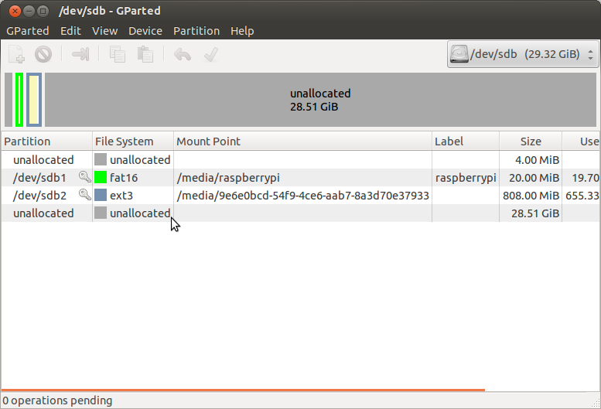
Highlight each of the 2 partitions and umount them

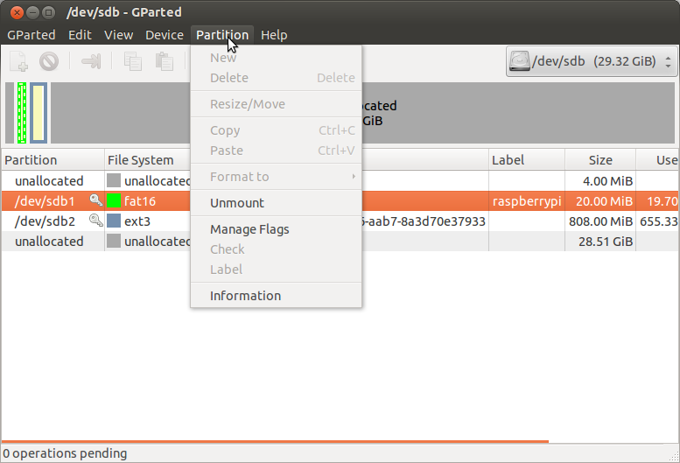
Select Umount. Repeat the process for the other partition.

After the partitions have been Umount highlight the 2nd partition.

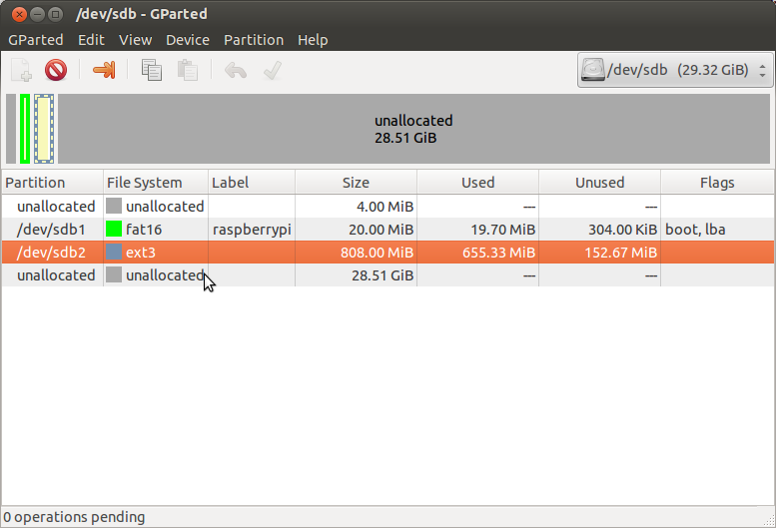
This partition will be resized.

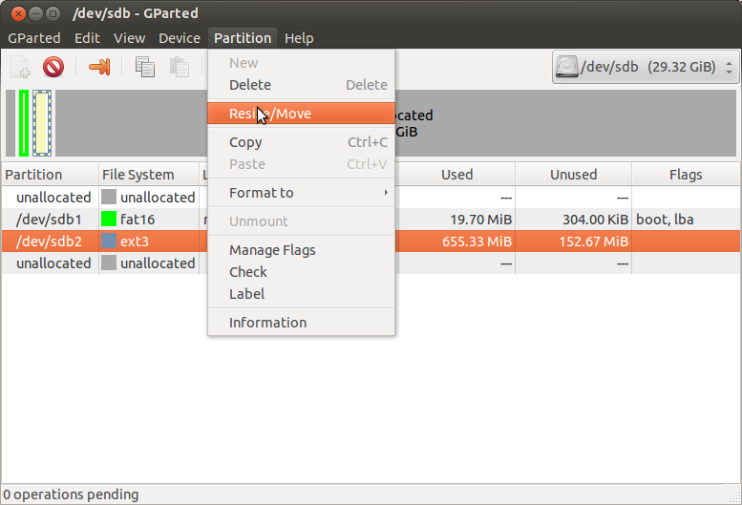
This will bring up a new window which has boxes where values can be adjusted. Looking Maximum size I normally use a value 4 less for the new size.

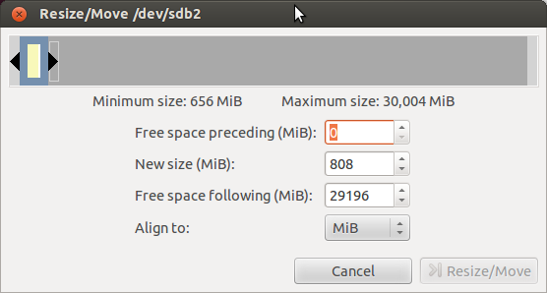
Entering the value and the window wil change.

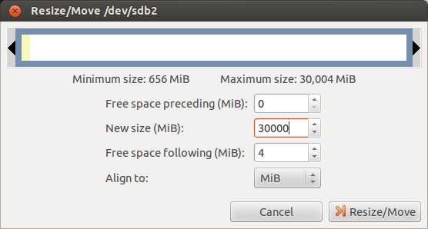
This shows the space used and the new size and the Resize/Move becomes active.

Depressing the Resize/Move button and the window disappears.

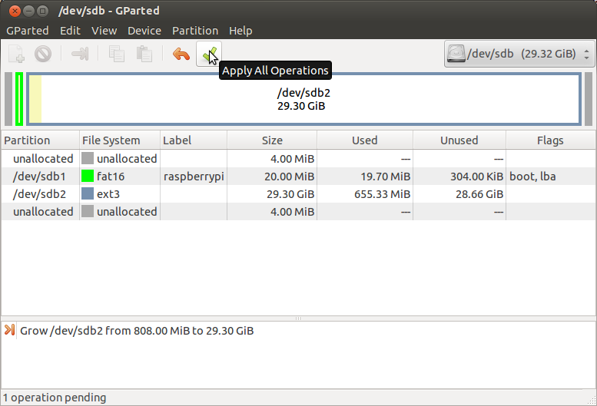

Depress the green check. A new window will appear.

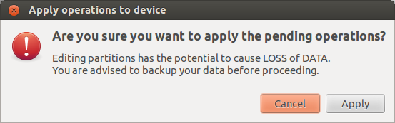
Depress the Apply button. A progress window will appear.

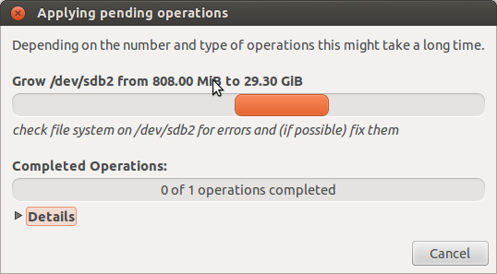
When the resize is complete a new window will appear.

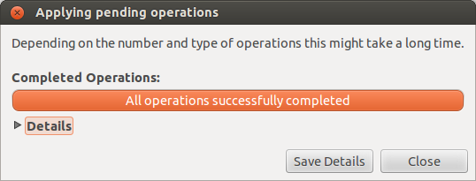

Depress Close button and Exit the program.
Remove the SD card and install on the Raspberry Pi 2 B.

