Verilog Testing SDRAMCNTL
Created by Udara & Dave Vandenbout
during GSoC 2015
ISE & MyHDL
10/09/15
Upgraded myhdl on Windows 8.1
commit bd0cfba9a74b0fc73c69edbc1c6d043cc631308d
Merge: ddcc815 ba99b90
Author: jandecaluwe <jan@jandecaluwe.com>
Date: Wed Oct 7 20:23:12 2015 +0200

Merge pull request #130 from jck/py35

Python 3 fixes, test improvements
C:\Users\vidal\Documents\GitHub\myhdl
python setup.py install

cd Users/vidal/Documents/GitHub/SDRAM_Controller/
python Conversion

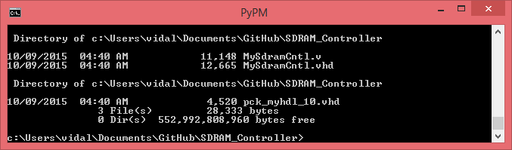

ISE:

Created a project SDRAM with the verilog MySdramCntl.v file

New Source

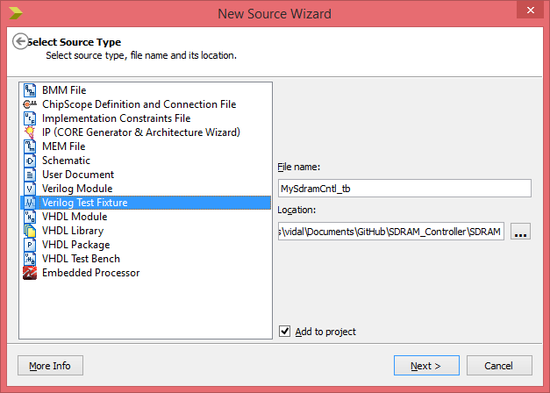

Associate

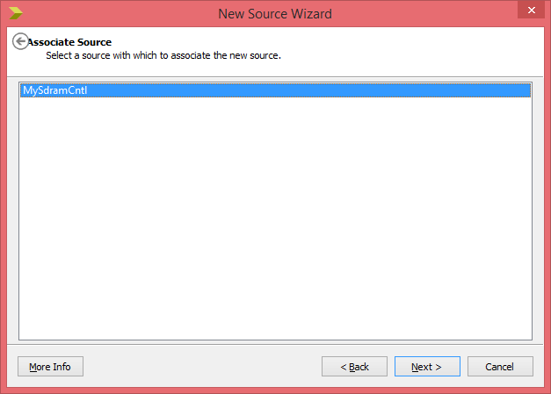
Depress Next

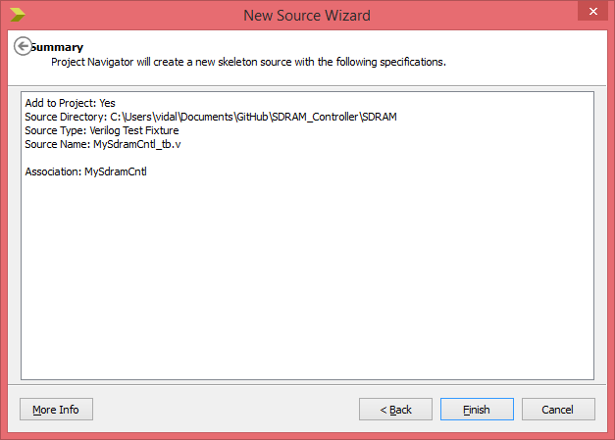
Depress Finish

Verilog Test Fixture
MySdramCntl_tb.v
module MySdramCntl_tb defines the signals
// Inputs
reg clk_i;
reg host_intf_wr_i;
reg host_intf_rst_i;
reg [15:0] host_intf_data_i;
reg host_intf_rd_i;
reg [23:0] host_intf_addr_i;

// Outputs
wire sd_intf_cke;
wire sd_intf_we;
wire [12:0] sd_intf_addr;
wire sd_intf_dqml;
wire sd_intf_cas;
wire sd_intf_dqmh;
wire sd_intf_ras;
wire [1:0] sd_intf_bs;
wire sd_intf_cs;
wire host_intf_done_o;
wire host_intf_rdPending_o;
wire [15:0] host_intf_data_o;

// Bidirs
wire [15:0] sd_intf_dq;

// Instantiate the Unit Under Test (UUT)

Manually added a clkgen process. https://embeddedmicro.com/tutorials/mojo/writing-test-benches/

initial begin
clk_i = 1'b0;

repeat(4) #10 clk_i = ~clk_i;

forever #10 clk_i = ~clk_i; // generate a clock
end

Adding stimulus

#210 host_intf_rst_i = 1;
#220 host_intf_rst_i = 0;
// Add stimulus here
#240 host_intf_data_i = 250;
#250 host_intf_wr_i = 1;

#260 host_intf_wr_i = 0;
#270 host_intf_rd_i = 1;

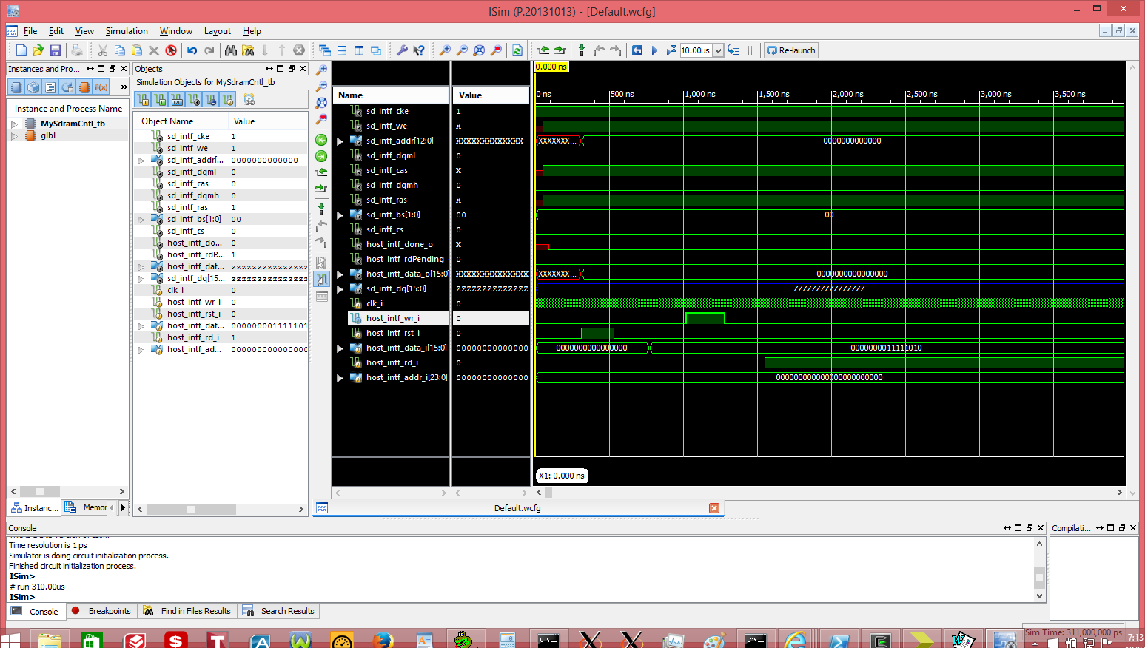

Later in time 42.07 usecs

