Configure & Test Universal asynchronous receiver/transmitter
(UART) on Raspberry Pi 2B (RPi2B)
To Transmit & Receive Data Between the RPi2B & Lattice ICE40-HX8K (FPGA)
02/17/16

The overall goal is to program the CAT-Board Field Programmable Gate Array ICE40-HX8K (FPGA) to receive & send data over the a serial port between the RPi2B & CAT-Board.

This is based on the information found at [1] Using the UART.
Instructions om Turning off the UART functioning as a serial console are found at [2].

After backing up the file cmdline.txt and making the change in [2].

diff cmdline.txt cmdline_backup.txt

1c1

< dwc_otg.lpm_enable=0 console=tty1 root=/dev/mmcblk0p2 rootfstype=ext4 elevator=deadline fsck.repair=yes rootwait

---

> dwc_otg.lpm_enable=0 console=ttyAMA0,115200 console=tty1 root=/dev/mmcblk0p2 rootfstype=ext4 elevator=deadline fsck.repair=yes rootwait

Installing Minicom software on RPi2B with the command “sudo apt-get install minicom”.

Changing the permissions “sudo chmod a+rw /dev/ttyAMA0”

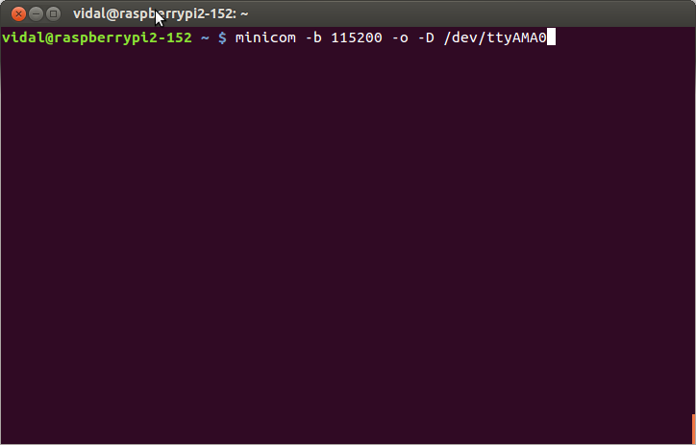

After pressing the return

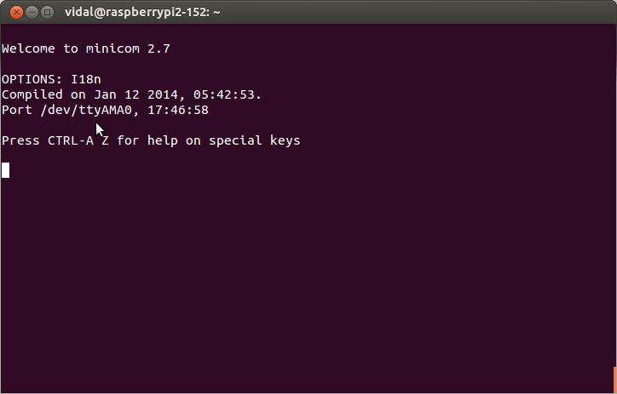
Minicom help screen.

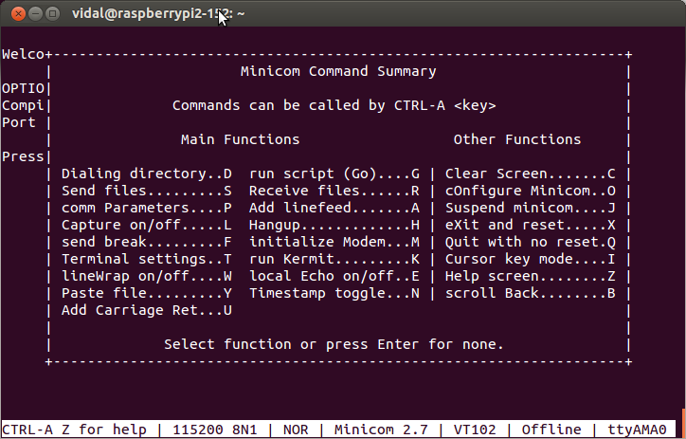
Raspberry Pi 2 B GPIO

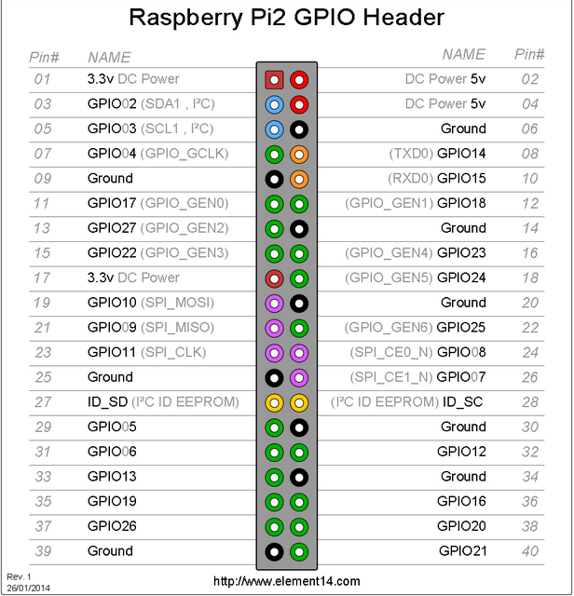
The CAT-Board GPIO

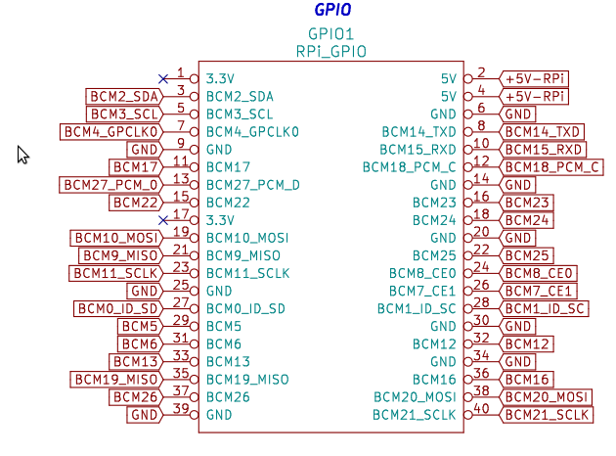

The ICE40 connections

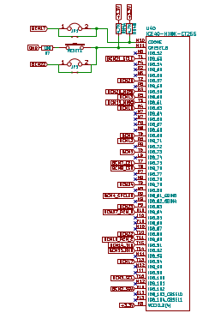

Pins BCM14_TX 8 & BCM15_RX 10 are connected to ICE40 FPGA.
The corresponding pins on the FPGA are BCM14_TX T15 & BCM15_RX T14.

Before programming the CAT-Board we need to take a look at the file iceriver/catboard.pcf to verify that the correct pins are selected.

# pin definitions

set_io tx T15

set_io rx T14

With a jumper on pins 8 & 10 of the RPi2B. The character typed will be sent back to the RPi2B.

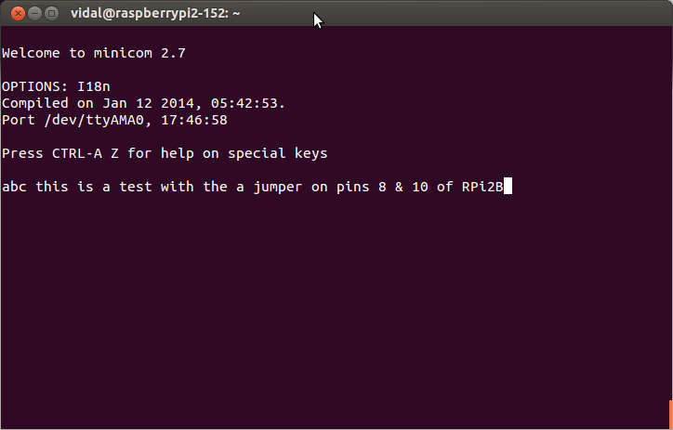

On the RPi2B with a CAT-Board you can not place a jumper on the pins BCM14_TX 8 & BCM15_RX 10. The CAT-Board will have to provide the jumper by echoing the tx signal back to rx signal. The program to make the CAT-Board echo the characters is found at Appendix A.

Next step will be to modify the “icestick_blinky_host.py” found at [3].

The file “catboard_blinky_host.py” found at [4]

On a RPi2B pi@raspberrypi2-152 ~/rhea/examples/boards/catboard $

The program “catboard_blinky_host.py” is found at Appendix B catboard_blinky_host.py.

With rhea created the file “catboard.v” & “catboard.pcf”
with the command “python catboard_blinky_host.py --build”.

Created the file “catboard_bitmap.bin” with iCEcube2 software on Windows 8.

Program the ICE40 FPGA “sudo config_cat catboard_bitmap.bin”

Created 2 files “led_on.bin” & “led_off.bin” with the python programs
These files will be uploaded to FPGA using minicom
The command to start minicom is “minicom -8 -H -b 115200 -o -D /dev/ttyAMA0”

Depress AS and select ascii

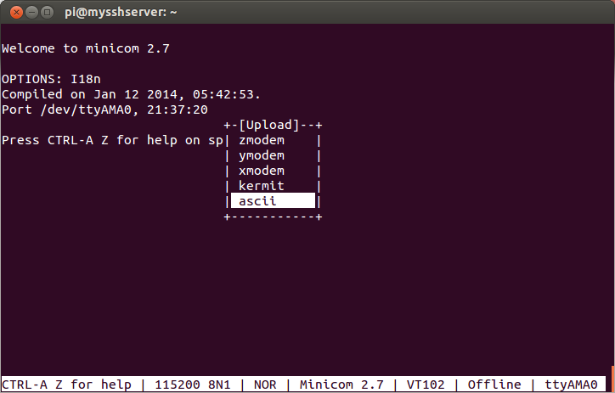
After enter

Scroll down to the file led_on.bin Space to highlight

od -x led_on.bin

0000000 02de 0000 2000 ca04 0000 ff00

0000014
pi@mysshserver ~/jpeg-2000-test/pc_fast_blinker_jpeg/input_examples $ od -x led_on.bin

0000000 02de 0000 4000 ca04 0000 ff00

0000014

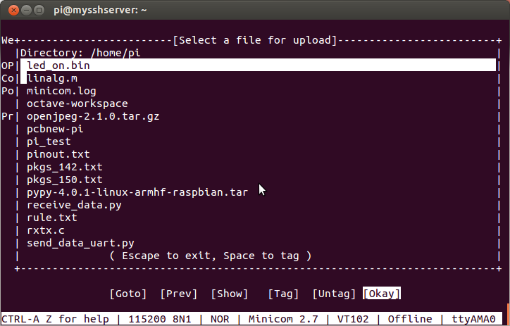
Depress the enter to send the file

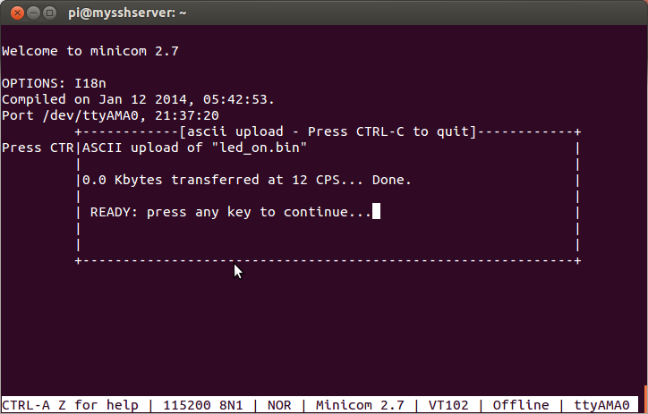
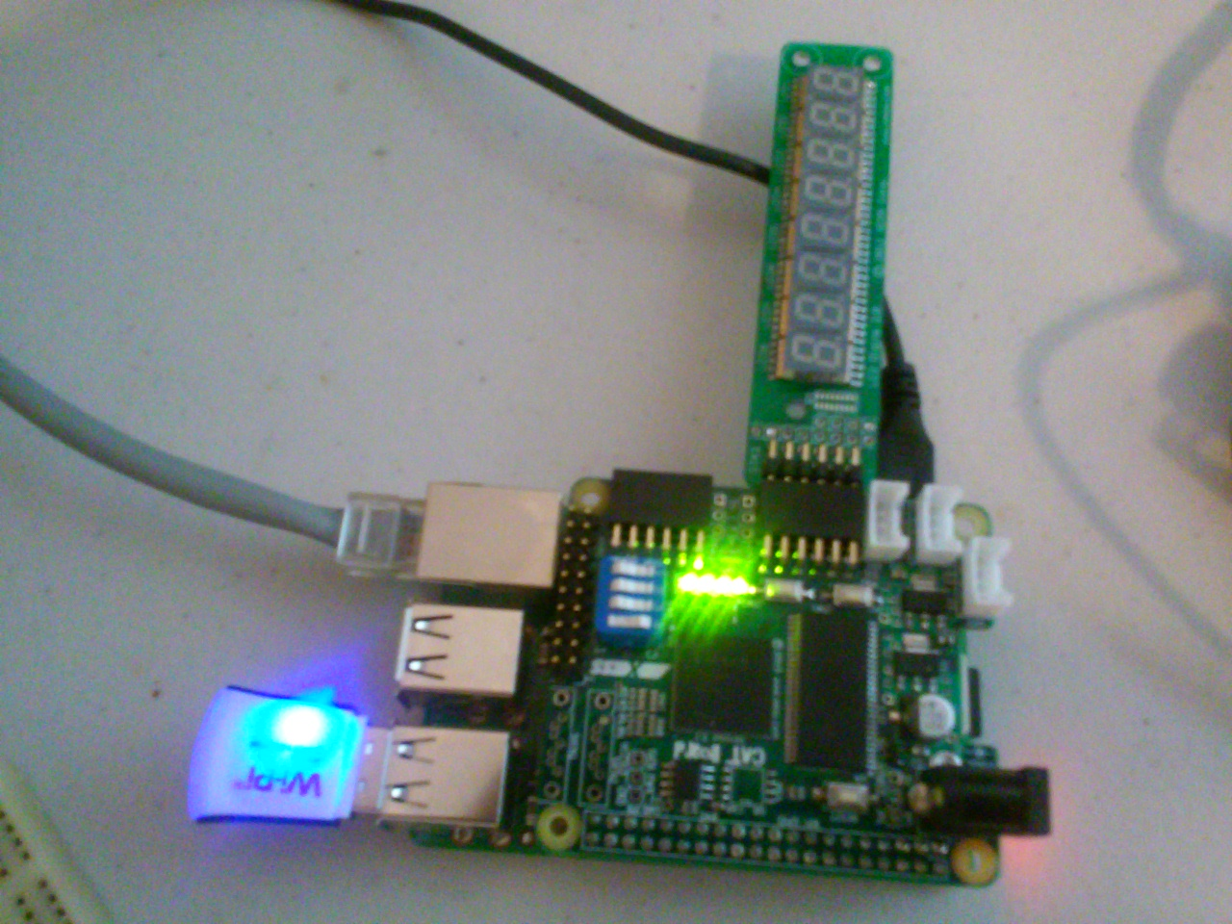
file = open("led_off.bin","wb")
file.write("\xde\x02\x00\x00\x00\x20\x04\xca\x00\x00\x00\x00")
file.write("\xde\x02\x00\x00\x00\x40\x04\xca\x00\x00\x00\x00")
file.close

file = open("led_on.bin","wb")
file.write("\xde\x02\x00\x00\x00\x20\x04\xca\x00\x00\x00\xff")
file.write("\xde\x02\x00\x00\x00\x40\x04\xca\x00\x00\x00\xff")
file.close

pi@mysshserver ~/jpeg-2000-test/pc_fast_blinker_jpeg/input_examples $ sudo config_cat ~/iCECube2021616/catboard_bitmap.bin

pi@mysshserver ~/jpeg-2000-test/pc_fast_blinker_jpeg/input_examples $ time python test_dwt_img.py

2 982599844 0x3a9148a4

4 982595740 0x3a91389c

6 980498596 0x3a7138a4

8 982595740 0x3a91389c

10 980498588 0x3a71389c

12 980498588 0x3a71389c

14 980498588 0x3a71389c

16 980498588 0x3a71389c

this is the reply �##�

this is the reply �###�

this is the reply �#�

this is the reply �#

#�

this is the reply �###�

this is the reply �###�

this is the reply �###�

this is the reply �###�

this is the reply �# #�

this is the reply �#$#�

this is the reply �#(#�#�

this is the reply �#,#�#�#

this is the reply �#0#�

this is the reply �#@#�

1 846284964 0x327148a4

3 848382108 0x3291489c

5 846280860 0x3271389c

7 846284956 0x3271489c

9 846280860 0x3271389c

11 846280860 0x3271389c

13 846280860 0x3271389c

15 846280860 0x3271389c

this is the reply �##�

this is the reply �###�

this is the reply �#�

this is the reply �#

#�

this is the reply �###�

this is the reply �###�

this is the reply �###�

this is the reply �###�

this is the reply �# #�

this is the reply �#$#�

this is the reply �#@#��

real 0m0.744s

user 0m0.510s

sys 0m0.160s

od -x data_from_fpga.bin

0000000 02de 0000 0000 ca04 0000 0000 02de 0000

0000020 0400 ca04 0000 0000 02de 0000 0800 ca04

0000040 0000 0000 02de 0000 0c00 ca04 0000 0000

0000060 02de 0000 1000 ca04 0000 0000 02de 0000

0000100 1400 ca04 0000 0000 02de 0000 1800 ca04

0000120 0000 0000 02de 0000 1c00 ca04 0000 0000

0000140 02de 0000 2000 ca04 0000 0000 02de 0000

0000160 2400 ca04 0000 0000 02de 0000 2800 ca04

0000200 fc01 0000 02de 0000 2c00 ca04 fc01 fc01

0000220 02de 0000 3000 ca04 0000 0000 02de 0000

0000240 4000 ca04 0000 0000 02de 0000 0000 ca04

0000260 0000 0000 02de 0000 0400 ca04 0000 0000

0000300 02de 0000 0800 ca04 0000 0000 02de 0000

0000320 0c00 ca04 0000 0000 02de 0000 1000 ca04

0000340 0000 0000 02de 0000 1400 ca04 0000 0000

0000360 02de 0000 1800 ca04 0000 0000 02de 0000

0000400 1c00 ca04 0000 0000 02de 0000 2000 ca04

0000420 0000 0000 02de 0000 2400 ca04 0000 0000

0000440 02de 0000 4000 ca04 f400 f400

0000454

Appendix A. A simple program to echo the character sent by RPi2B.
from myhdl import *
#from ice40_primitives import *
import argparse
tx = Signal(bool(0))
rx = Signal(bool(0))

def cliparse():
parser = argparse.ArgumentParser()
parser.add_argument("--build", default=False, action='store_true')
parser.add_argument("--test", default=False, action='store_true')
parser.add_argument("--convert", default=False, action='store_true')
args = parser.parse_args()
return args
def tx_rx(tx,rx):
@always_comb
def rtl():
rx.next = tx
return rtl

def tb(tx,rx):
@always(delay(10))
def clkgen():
clock.next = not clock
return instances()

def convert(args):
toVerilog(tx_rx,tx,rx)

def build(args):
import rhea.build as build
from rhea.build.boards import get_board
#from input_clk import cat_in:

def run_catboard():
brd = get_board('catboard')
#BCM15
brd.add_port('rx', 'T14')
#BCM14
brd.add_port('tx', 'T15')
flow = brd.get_flow(top=tx_rx)
flow.run()
run_catboard()

'''
rx T14 data sent from CAT-Board to RPi2B
tx T15 data sent from RPi2B to CAT-Board

python jumper.py --build
creates the files
iceriver/catboard.bin
iceriver/catboard.pcf
sudo config_cat iceriver/catboard.bin
'''

def main():
args = cliparse()
if args.test:
tb_fsm = traceSignals(tb,tx,rx)
sim = Simulation(tb_fsm)
sim.run()
if args.convert:
convert(args)
if args.build:
build(args)
if __name__ == '__main__':
main()

Appendix B catboard_blinky_host.py ver 2ac9d5a4625bf33dc2318af2aa6

import argparse
import subprocess

from myhdl import *

from rhea.cores.uart import uartlite
from rhea.cores.memmap import memmap_command_bridge
from rhea.cores.misc import glbl_timer_ticks
from rhea.system import Global, Clock, Reset
from rhea.system import Barebone
from rhea.system import FIFOBus
from rhea.build.boards import get_board
from jpeg import dwt
from signed2twoscomplement import signed2twoscomplement
from l2r import lift2res1
from sh_reg import toSig

WIDTH_OUT = 36
WIDTH = 31
W0 = 9
upd0 = Signal(bool(0))
upd1 = Signal(bool(0))
z0 = Signal(intbv(0)[W0:])
z1 = Signal(intbv(0)[W0:])
done0 = Signal(bool(0))
done1 = Signal(bool(0))
res0 = Signal(intbv(0, min=-(2**(W0)), max=(2**(W0))))
res1 = Signal(intbv(0, min=-(2**(W0)), max=(2**(W0))))
flgs0 = Signal(intbv(0)[3:])
flgs1 = Signal(intbv(0)[3:])
lft0 = Signal(intbv(0)[W0:])
lft1 = Signal(intbv(0)[W0:])
sam0 = Signal(intbv(0)[W0:])
sam1 = Signal(intbv(0)[W0:])
rht0 = Signal(intbv(0)[W0:])
rht1 = Signal(intbv(0)[W0:])
lift0 = Signal(intbv(0, min=-(2**(W0)), max=(2**(W0))))
lift1 = Signal(intbv(0, min=-(2**(W0)), max=(2**(W0))))

upd2 = Signal(bool(0))
upd3 = Signal(bool(0))
z2 = Signal(intbv(0)[W0:])
z3 = Signal(intbv(0)[W0:])
done2 = Signal(bool(0))
done3 = Signal(bool(0))
res2 = Signal(intbv(0, min=-(2**(W0)), max=(2**(W0))))
res3 = Signal(intbv(0, min=-(2**(W0)), max=(2**(W0))))
flgs2 = Signal(intbv(0)[3:])
flgs3 = Signal(intbv(0)[3:])
lft2 = Signal(intbv(0)[W0:])
lft3 = Signal(intbv(0)[W0:])
sam2 = Signal(intbv(0)[W0:])
sam3 = Signal(intbv(0)[W0:])
rht2 = Signal(intbv(0)[W0:])
rht3 = Signal(intbv(0)[W0:])
lift2 = Signal(intbv(0, min=-(2**(W0)), max=(2**(W0))))
lift3 = Signal(intbv(0, min=-(2**(W0)), max=(2**(W0))))

upd4 = Signal(bool(0))
upd5 = Signal(bool(0))
z4 = Signal(intbv(0)[W0:])
z5 = Signal(intbv(0)[W0:])
done4 = Signal(bool(0))
done5 = Signal(bool(0))
res4 = Signal(intbv(0, min=-(2**(W0)), max=(2**(W0))))
res5 = Signal(intbv(0, min=-(2**(W0)), max=(2**(W0))))
flgs4 = Signal(intbv(0)[3:])
flgs5 = Signal(intbv(0)[3:])
lft4 = Signal(intbv(0)[W0:])
lft5 = Signal(intbv(0)[W0:])
sam4 = Signal(intbv(0)[W0:])
sam5 = Signal(intbv(0)[W0:])
rht4 = Signal(intbv(0)[W0:])
rht5 = Signal(intbv(0)[W0:])
lift4 = Signal(intbv(0, min=-(2**(W0)), max=(2**(W0))))
lift5 = Signal(intbv(0, min=-(2**(W0)), max=(2**(W0))))

upd6 = Signal(bool(0))
upd7 = Signal(bool(0))
z6 = Signal(intbv(0)[W0:])
z7 = Signal(intbv(0)[W0:])
done6 = Signal(bool(0))
done7 = Signal(bool(0))
res6 = Signal(intbv(0, min=-(2**(W0)), max=(2**(W0))))
res7 = Signal(intbv(0, min=-(2**(W0)), max=(2**(W0))))
flgs6 = Signal(intbv(0)[3:])
flgs7 = Signal(intbv(0)[3:])
lft6 = Signal(intbv(0)[W0:])
lft7 = Signal(intbv(0)[W0:])
sam6 = Signal(intbv(0)[W0:])
sam7 = Signal(intbv(0)[W0:])
rht6 = Signal(intbv(0)[W0:])
rht7 = Signal(intbv(0)[W0:])
lift6 = Signal(intbv(0, min=-(2**(W0)), max=(2**(W0))))
lift7 = Signal(intbv(0, min=-(2**(W0)), max=(2**(W0))))

myregister0 = Signal(intbv(0)[32:])
myregister1 = Signal(intbv(0)[32:])
myregister2 = Signal(intbv(0)[32:])
myregister3 = Signal(intbv(0)[32:])
myregister4 = Signal(intbv(0)[32:])
myregister5 = Signal(intbv(0)[32:])
myregister6 = Signal(intbv(0)[32:])
myregister7 = Signal(intbv(0)[32:])

data_to_host0 = Signal(intbv(0)[32:])
data_to_host1 = Signal(intbv(0)[32:])
data_to_host2 = Signal(intbv(0)[32:])
data_to_host3 = Signal(intbv(0)[32:])
def catboard_blinky_host(clock, led, uart_tx, uart_rx):
"""
The LEDs are controlled from the RPi over the UART
to the FPGA.
"""

glbl = Global(clock, None)
ledreg = Signal(intbv(0)[8:])

# create the timer tick instance
tick_inst = glbl_timer_ticks(glbl, include_seconds=True)

# create the interfaces to the UART
fbustx = FIFOBus(width=8, size=4)
fbusrx = FIFOBus(width=8, size=4)

# create the memmap (CSR) interface
memmap = Barebone(glbl, data_width=32, address_width=32)

# create the UART instance.
uart_inst = uartlite(glbl, fbustx, fbusrx,
serial_in=uart_rx,
serial_out=uart_tx)

# create the packet command instance
cmd_inst = memmap_command_bridge(glbl, fbusrx, fbustx, memmap)

@always_seq(clock.posedge, reset=None)
def beh_led_control():
memmap.done.next = not (memmap.write or memmap.read)
if memmap.write and memmap.mem_addr == 0x40:
ledreg.next = memmap.write_data

@always_comb
def set_data():

data_to_host0.next = z1 << 16 | z0
data_to_host1.next = z3 << 16 | z2
data_to_host2.next = z5 << 16 | z4
data_to_host3.next = z7 << 16 | z6

# blink one of the LEDs
tone = Signal(intbv(0)[8:])

@always_seq(clock.posedge, reset=None)
def beh_assign():
if glbl.tick_sec:
tone.next = (~tone) & 0x1
led.next = ledreg | tone[5:]

jpeg0 = dwt(flgs0, upd0, lft0, sam0, rht0, lift0, done0, clock)
l2res0 = lift2res1(lift0,res0)
sign0 = signed2twoscomplement(res0, z0)

jpeg1 = dwt(flgs1, upd1, lft1, sam1, rht1, lift1, done1, clock)
l2res1 = lift2res1(lift1,res1)
sign1 = signed2twoscomplement(res1, z1)

jpeg2 = dwt(flgs2, upd2, lft2, sam2, rht2, lift2, done2, clock)
l2res2 = lift2res1(lift2,res2)
sign2 = signed2twoscomplement(res2, z2)

jpeg3 = dwt(flgs3, upd3, lft3, sam3, rht3, lift3, done3, clock)
l2res3 = lift2res1(lift3,res3)
sign3 = signed2twoscomplement(res3, z3)

jpeg4 = dwt(flgs4, upd4, lft4, sam4, rht4, lift4, done4, clock)
l2res4 = lift2res1(lift4,res4)
sign4 = signed2twoscomplement(res4, z4)

jpeg5 = dwt(flgs5, upd5, lft5, sam5, rht5, lift5, done5, clock)
l2res5 = lift2res1(lift5,res5)
sign5 = signed2twoscomplement(res5, z5)

jpeg6 = dwt(flgs6, upd6, lft6, sam6, rht6, lift6, done6, clock)
l2res6 = lift2res1(lift6,res6)
sign6 = signed2twoscomplement(res6, z6)

jpeg7 = dwt(flgs7, upd7, lft7, sam7, rht7, lift7, done7, clock)
l2res7 = lift2res1(lift7,res7)
sign7 = signed2twoscomplement(res7, z7)

inst_sig0 = toSig(clock, myregister0,flgs0,lft0,sam0,rht0)
inst_sig1 = toSig(clock, myregister1,flgs1,lft1,sam1,rht1)
inst_sig2 = toSig(clock, myregister2,flgs2,lft2,sam2,rht2)
inst_sig3 = toSig(clock, myregister3,flgs3,lft3,sam3,rht3)

inst_sig4 = toSig(clock, myregister4,flgs4,lft4,sam4,rht4)
inst_sig5 = toSig(clock, myregister5,flgs5,lft5,sam5,rht5)
inst_sig6 = toSig(clock, myregister6,flgs6,lft6,sam6,rht6)
inst_sig7 = toSig(clock, myregister7,flgs7,lft7,sam7,rht7)

@always_seq(clock.posedge, reset=None)
def beh_my_ret_reg():
if memmap.read:
if (memmap.mem_addr == 36):
memmap.read_data.next = data_to_host0
if (memmap.mem_addr == 40):
memmap.read_data.next = data_to_host1
if (memmap.mem_addr == 44):
memmap.read_data.next = data_to_host2
if (memmap.mem_addr == 48):
memmap.read_data.next = data_to_host3
@always_seq(clock.posedge, reset=None)
def beh_my_registers():
if memmap.write:
if memmap.mem_addr == 0:
myregister0.next = memmap.write_data
elif memmap.mem_addr == 4:
myregister1.next = memmap.write_data
elif memmap.mem_addr == 8:
myregister2.next = memmap.write_data
elif memmap.mem_addr == 12:
myregister3.next = memmap.write_data
if memmap.mem_addr == 16:
myregister4.next = memmap.write_data
elif memmap.mem_addr == 20:
myregister5.next = memmap.write_data
elif memmap.mem_addr == 24:
myregister6.next = memmap.write_data
elif memmap.mem_addr == 28:
myregister7.next = memmap.write_data
elif memmap.mem_addr == 32:
upd0.next = 1
upd1.next = 1
upd2.next = 1
upd3.next = 1
upd4.next = 1
upd5.next = 1
upd6.next = 1
upd7.next = 1
elif memmap.mem_addr == 36:
upd0.next = 0
upd1.next = 0
upd2.next = 0
upd3.next = 0
upd4.next = 0
upd5.next = 0
upd6.next = 0
upd7.next = 0

return instances()

def build(args):
brd = get_board('catboard')
brd.add_port_name('uart_rx', 'bcm14_txd')
brd.add_port_name('uart_tx', 'bcm15_rxd')
flow = brd.get_flow(top=catboard_blinky_host)
flow.run()

def program(args):
subprocess.check_call(["iceprog", "iceriver/icestick.bin"])

def cliparse():
parser = argparse.ArgumentParser()
parser.add_argument("--build", default=False, action='store_true')
parser.add_argument("--test", default=False, action='store_true')
parser.add_argument("--program", default=False, action='store_true')
parser.add_argument("--walk", default=False, action='store_true')
args = parser.parse_args()
return args

def test_instance():
# check for basic syntax errors, use test_ice* to test
# functionality
catboard_blinky_host(
clock=Clock(0, frequency=50e6),
led=Signal(intbv(0)[8:]),
uart_tx=Signal(bool(0)),
uart_rx=Signal(bool(0)), )

def main():
args = cliparse()
if args.test:
test_instance()

if args.build:
build(args)

if args.program:
program(args)

# @todo: add walk function

if __name__ == '__main__':
main()

Appendix C. Simulation

Testing sending from host 8 packets with 3 9bit values and a 3bit in a memmap_command_bridge.
The 8 packets are placed in myregister0 to myregister7. Data is received on the signal uart_rx in a 12 byte packet. The address are (0,4,8,12,16,20,24,28) with addresses 32 & (36, 40, 44, & 48) used to start the lifting step of the dwt and receive the results of the dwt. Each packet is separated into 3 9bit (lft0, sam0, rht0 & flgs0) to (lft7, sam7, rht7 & flgs7).

Flag 7 row 2 4 6 8 10 12 14 16

(1 2 3)(3 4 5)(4 6 7)(7 8 9)(9 10 11)(11 12 13)(13 14 15)(15 16 17)

2 4 6 8 10 12 14 16

data_to_host0 data_to_host1 data_to_host2 data_to_host3

These need to be sent back is the question, since most of the values needed for flgs 6 are all ready in signals that need to (lft0 → sam0), (rht0
--> sam1), (z0 → rht0 & z0 → lft1)

flag 6 row 1 3 5 7 9 11 13 15

(0 1 2)(2 3 4)(4 5 6)(6 7 8)(8 9 10)(10 11 12)(12 13 14)(14 15 16)

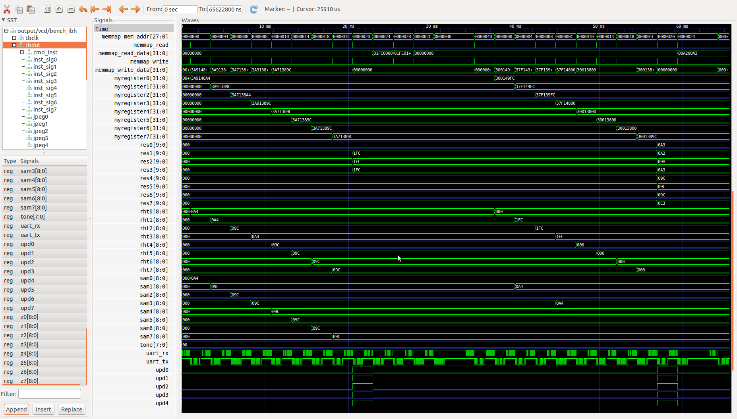
In the image above 9 bit (sam0 to sam7) & 9 bit (rht0 to rht7.

In image below the 3 bit (flgs0 to flgs7) and 9 bit (lft0 to lft7) which make up the inputs to lifting step of the dwt. The ouput is the 10 bit (lift0 to lift7) signed data.

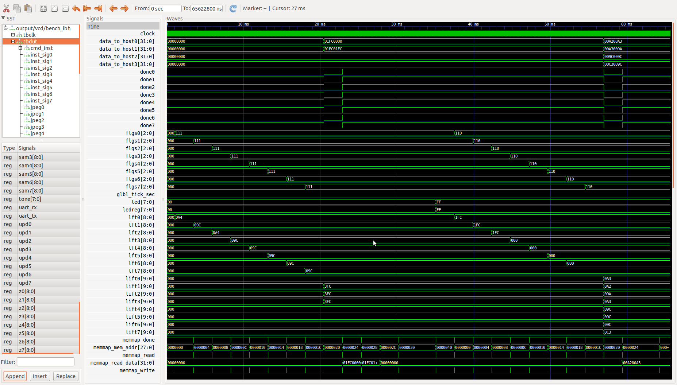

In the test_catboard_blinky_host setting the values which should be returned.
m[0][0] = 0
m[2][0] = 508
m[4][0] = 508
m[6][0] = 508
m[8][0] = 0
m[10][0] = 0
m[12][0] = 0
m[14][0] = 0
The sending the odd samples we get the first pass of 8 instances of dwt.

[1] http://www.raspberry-projects.com/pi/programming-in-c/uart-serial-port/using-the-uart

[2] http://www.raspberry-projects.com/pi/pi-operating-systems/raspbian/io-pins-raspbian/uart-pins

[3] https://github.com/cfelton/rhea/blob/master/examples/boards/icestick/icestick_blinky_host.py
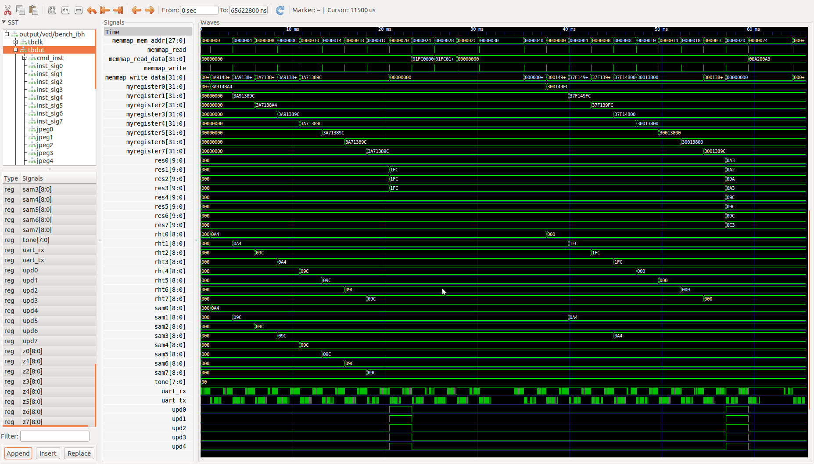
[4] https://github.com/cfelton/rhea/blob/master/examples/boards/catboard/catboard_blinky_host.py

