Configure Serial to Peripheral Interface (SPI)
on Raspberry Pi 2B (RPi2B)
To Transmit & Receive Data Between the RPi2B & Xula2-LX9 (FPGA) with StickIt-MB
02/23/16
This is based on the information found at [1]. spidev0.0 & spidev0.1
ls /sys/class/gpio/
export gpio17 gpio22 gpio25 gpiochip0 unexport
Data and control lines of the SPI and the basic connection:
An SPI protocol specifies 4 signal wires.
1. Master Out Slave In (MOSI) - MOSI signal is generated by Master, recipient is the Slave.
2. Master In Slave Out (MISO) - Slaves generate MISO signals and recipient is the Master.
3. Serial Clock (SCLK or SCK) - SCLK signal is generated by the Master to synchronize data transfers between the master and the slave.
4. Slave Select (SS) from master to Chip Select (CS) of slave - SS signal is generated by Master to select individual slave/peripheral devices. The SS/CS is an active low signal.

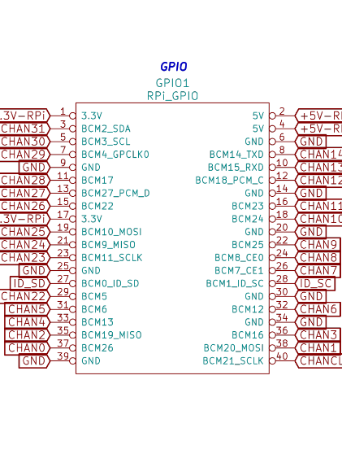
The pins on RPi2B

On the RPi2B with a XulA2-LX9 & StickIi-MB you can not place a jumper on the pins BCM10_MOSI & BCM9_MISO. The XulA2-LX9 & StickIi-MB will have to provide the jumper by echoing the MOSI back to MISO signal. The program to make the XulA2-LX9 & StickIi-MB echo the characters is found at Appendix A. Running the command “python jumper_xula2_spi.py –build” will create the “xula2.v & xula2.ucf” files which will be used by ISE WebPack to create the “xula2.bit”
On the RPi2B you need to compile the program to test the SPI port pi@raspberrypi2-141 ~/bcm2835-1.45/examples/spi $
“gcc -o spi spi.c -l bcm2835”.
Program the XulA2-LX9 & StickIi-MB with “xula2_jum_spi.bit”.
pi@raspberrypi2-141 ~/bcm2835-1.45/examples/spi $
“xsload --usb 0 --fpga ~/xula2_jum_spi.bit”.

pi@raspberrypi2-141 ~/bcm2835-1.45/examples/spi $ “sudo ./spi”
Sent to SPI: 0x23. Read back from SPI: 0x23.
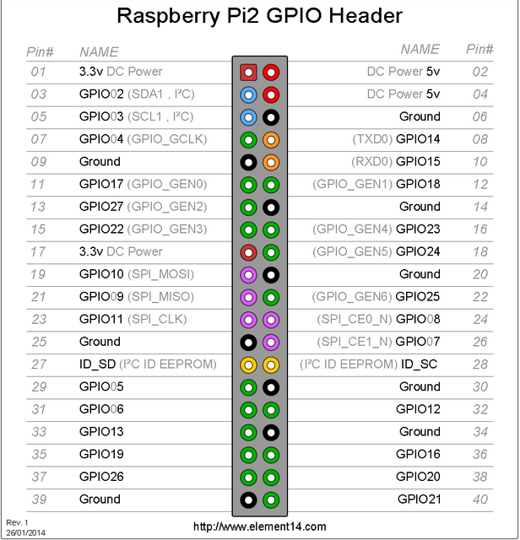
[1] http://www.eeherald.com/section/design-guide/esmod12.html

Appendix A. jumper_xula2_spi.py

from myhdl import *
#from ice40_primitives import *
import argparse
mosi = Signal(bool(0))
miso = Signal(bool(0))

def cliparse():
parser = argparse.ArgumentParser()
parser.add_argument("--build", default=False, action='store_true')
parser.add_argument("--test", default=False, action='store_true')
parser.add_argument("--convert", default=False, action='store_true')
args = parser.parse_args()
return args
def spi(mosi, miso):
@always_comb
def rtl():
miso.next = mosi
return rtl

def tb(mosi, miso):
@always(delay(10))
def clkgen():
clock.next = not clock
return instances()

def convert(args):
toVerilog(spi, mosi, miso)

def build(args):
import rhea.build as build
from rhea.build.boards import get_board
#from input_clk import cat_in:

def run_xula2():
brd = get_board('xula2')
brd.device = 'XC6SLX9'
#BCM25
brd.add_port('mosi', 'F2')
#BCM24
brd.add_port('miso', 'F1')
flow = brd.get_flow(top=spi)
flow.run()
run_xula2()

'''
rx B16 data sent from xula2 to RPi2B
tx B15 data sent from RPi2B to xula2

python jumper_xula2.py --build
creates the files
xilinx/xula2.bit
xilinx/xula2.pcf
xsload --usb 0 xula2_jum.bit
'''

def main():
args = cliparse()
if args.test:
tb_fsm = traceSignals(tb,tx,rx)
sim = Simulation(tb_fsm)
sim.run()
if args.convert:
convert(args)
if args.build:
build(args)
if __name__ == '__main__':
main()

