Testing 16 instances of jpeg
2000 lifting step
with a UART interface on XuLA2-LX9 CATBoard HX8K
05/25/16

Data is sent in 12 byte packets with 32 bit address & 32 bit data. Each packet is starts with 2 bytes “02 DE”, 32 bit address 2 bytes “04 CA” and 32 bit data. The 12 byte packet sent for address 00 00 00 00 DE 02 00 00 00 00 04 CA 3A 91 48 A4 and data 3A9148A4.

Sam0to3 in 32 bit words
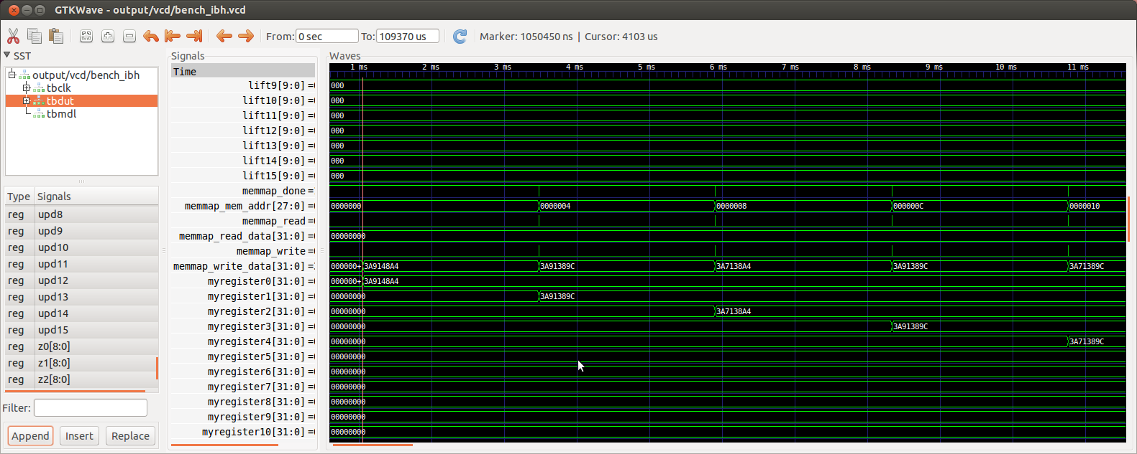
Sam4to8 in 32 bit words
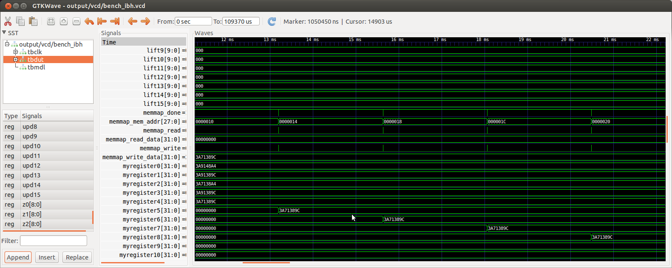
Sam9to13 in 32 bit words
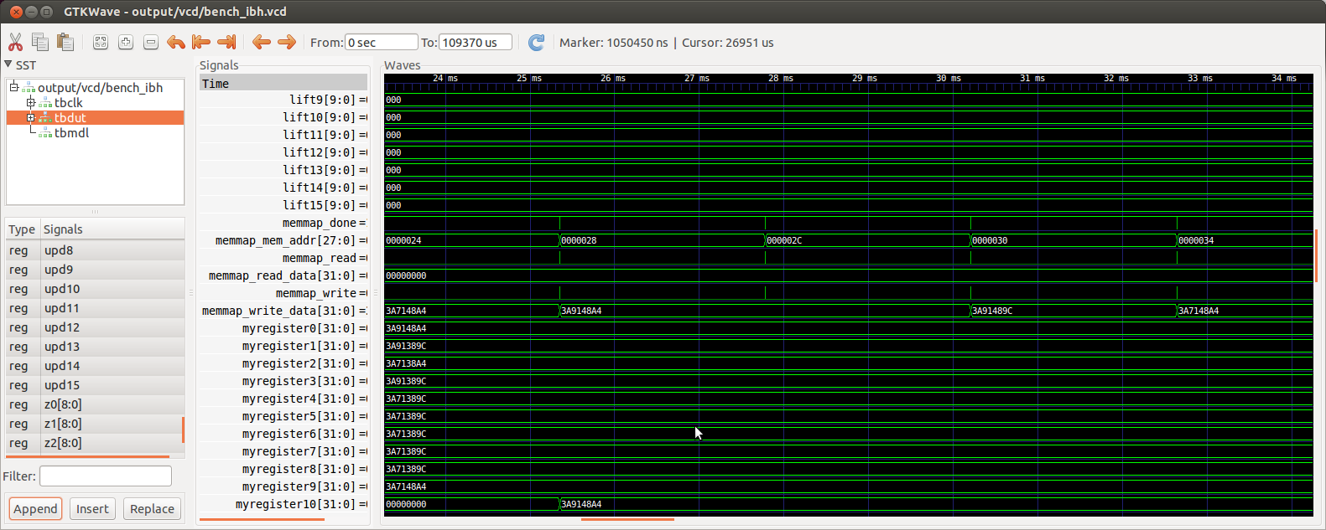
Sam14to15 in 32 bit words
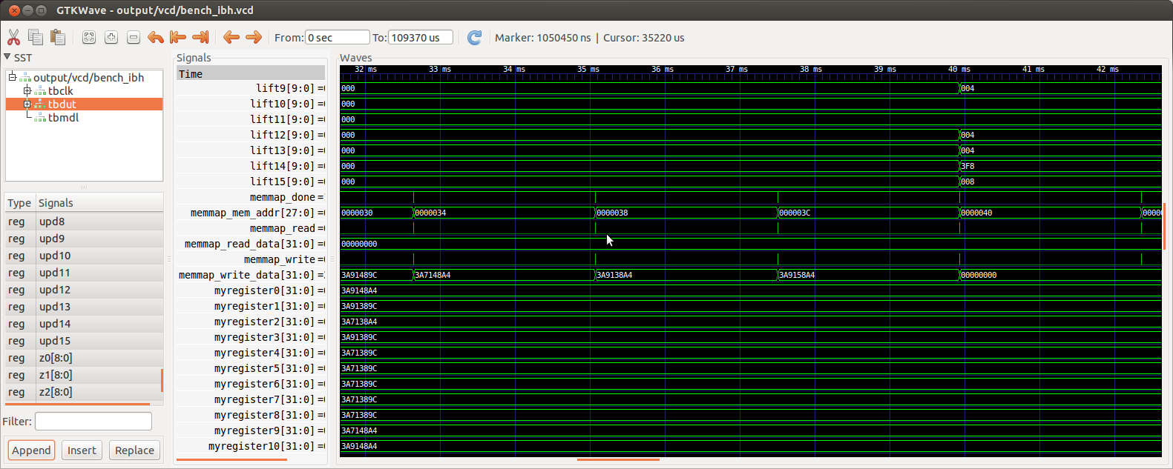
results0to15
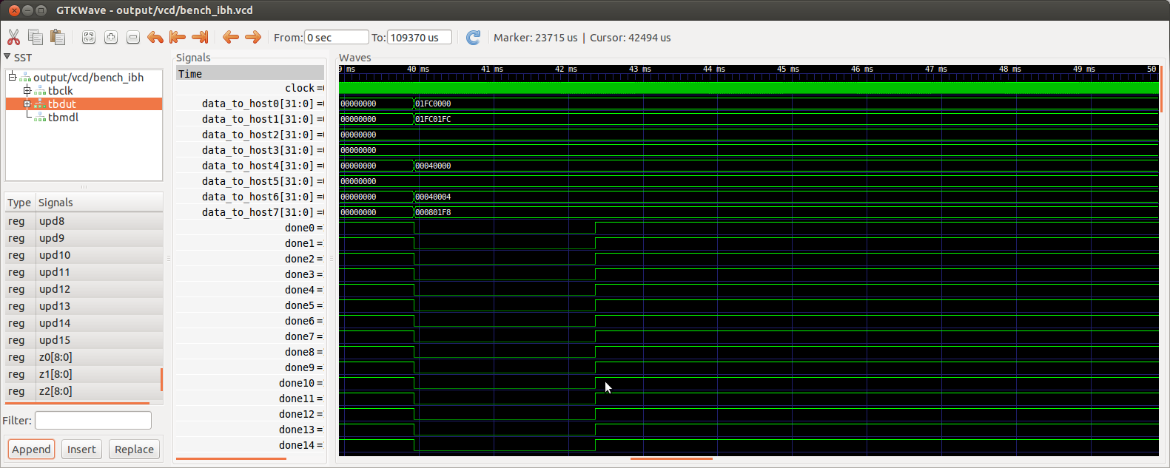
sam0to3 in 9 bit words
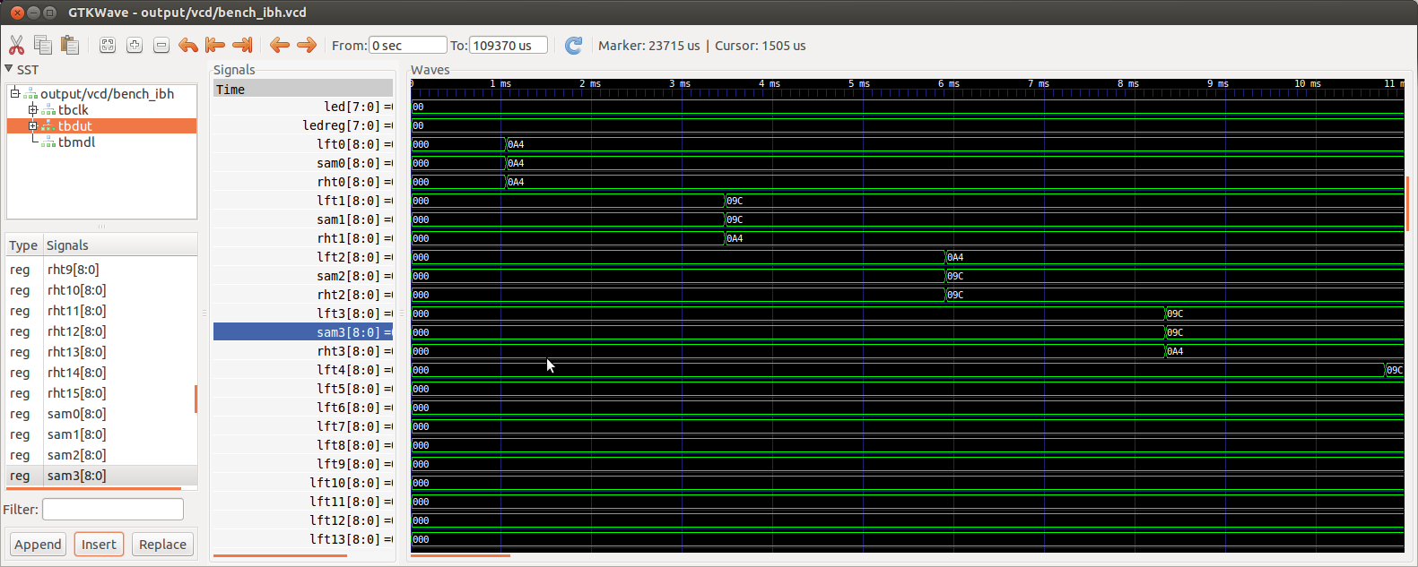
sam4to7 in 9 bit words
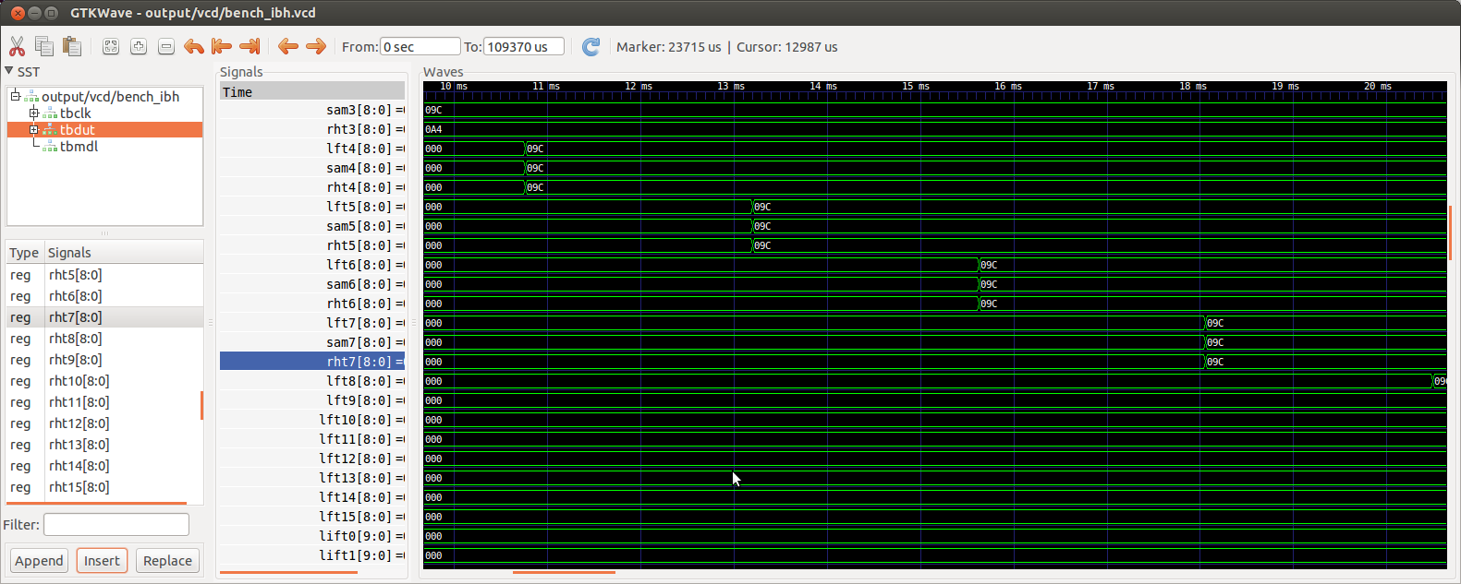
sam8to11 in 9 bit words
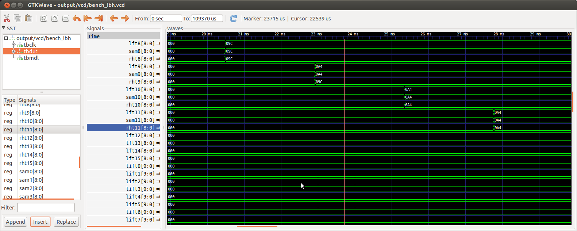
sam12to15 in 9 bit words
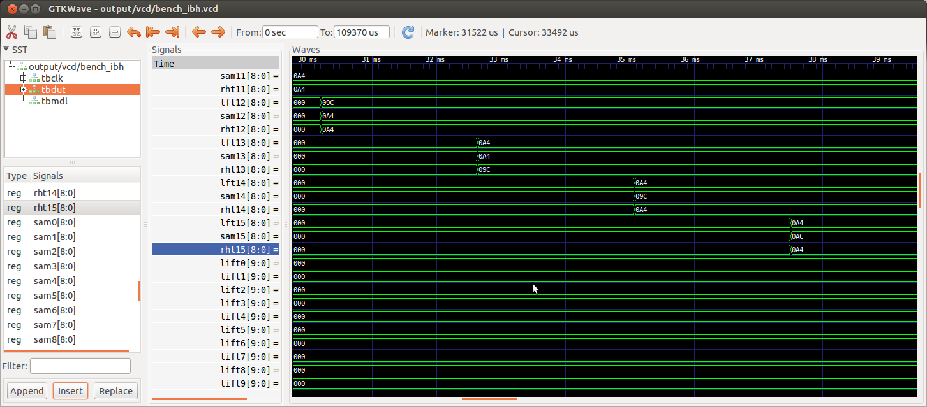

Requires two reads of results. The leds are turned on for 5 seconds. The 32 samples are sent starting at addresses 0000 – 0003C. The upd on/off commands are sent to addresses 0040 & 0044. The 16 results are read at addresses 0048-0064
python test_uart.py
de020000008004ca000000ff
de020000008004ca000801f8
de020000008004ca00000000
de020000008004ca000801f8
sample 0
de020000000004ca3a9148a4
de020000000004ca000801f8
sample 1
de020000000404ca3a91389c
de020000000404ca000801f8
sample 2
de020000000804ca3a7138a4
de020000000804ca000801f8
sample 3
de020000000c04ca3a91389c
de020000000c04ca000801f8
sample 4
de020000001004ca3a71389c
de020000001004ca000801f8
sample 5
de020000001404ca3a71389c
de020000001404ca000801f8
sample 6
de020000001804ca3a71389c
de020000001804ca000801f8
sample 7
de020000001c04ca3a71389c
de020000001c04ca000801f8
sample 8
de020000002004ca3a71389c
de020000002004ca000801f8
sample 9
de020000002404ca3a7148a4
de020000002404ca000801f8
sample 10
de020000002804ca3a9148a4
de020000002804ca000801f8
sample 11
de020000002c04ca3a9148a4
de020000002c04ca000801f8
sample 12
de020000003004ca3a91489c
de020000003004ca000801f8
sample 13
de020000003404ca3a7148a4
de020000003404ca000801f8
sample 14
de020000003804ca3a9138a4
de020000003804ca000801f8
sample 15
de020000003c04ca3a9158a4
de020000003c04ca000801f8
upd on/off
de020000004004ca00000000
de020000004004ca000801f8
de020000004404ca00000000
de020000004404ca000801f8
reading results 0 & 1 01fc 0000
de020000004804ca00000000
de020000004804ca
01fc -4
0000 0
reading results 2 & 3 01fc 01fc
de020000004c04ca00000000
de020000004c04ca
01fc -4
01fc -4
reading results 4 & 5 0000 0000
de020000005004ca00000000
de020000005004ca
0000 0
0000 0
reading results 6 & 7 0000 0000
de020000005404ca00000000
de020000005404ca
0000 0
0000 0
reading results 8 & 9 0004 0000
de020000005804ca00000000
de020000005804ca
0004 4
0000 0
reading results 10 & 11 0000 0000
de020000005c04ca00000000
de020000005c04ca
0000 0
0000 0
reading results 12 & 13 0004 0004
de020000006004ca00000000
de020000006004ca
0004 4
0004 4
reading results 14 & 15 0008 01F8
de020000006404ca00000000
de020000006404ca
0008 8
01f8 -8
Wed May 25 20:55:14 2016 Wed May 25 20:55:14 2016

