Introduction:
I am working on two versions of the Software. One is a custom version that I build entirely from source. Yocto [1] is a project that provides the capabilities to download the source from around the world, configure the software for the various processors, compiles, packages the various packages and creates an image that can be put on SD card. The 2nd is version that someone packages the binaries only and creates a distribution (Raspbain based on Debain). Both of these are Linux based compared to what others are using which are sold by Microsoft or Apple. The Linux kernel is very heart of the computer [2].
Processor:

- Broadcom BCM2836 ARMv7 Quad Core Processor powered Single Board Computer running at 900MHz
- 1GB RAM so you can now run bigger and more powerful applications
- 4 USB ports
- 40 GPIO pins
- Full HDMI port
- Ethernet port
- Combined 3.5mm audio jack and composite video
- Camera interface (CSI)
- Display interface (DSI)
- Micro SD card slot
- VideoCore IV 3D graphics core
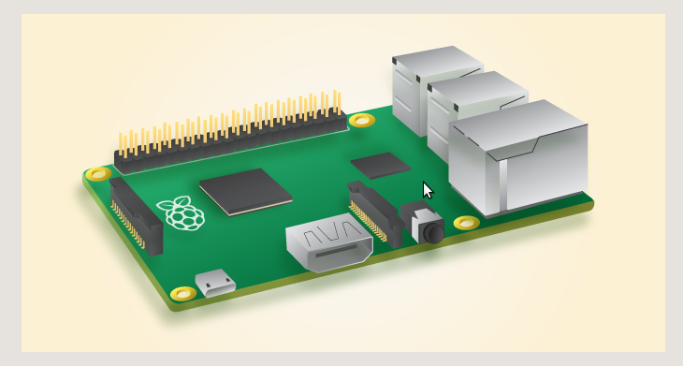

Software RaspBian:

What is LibreOffice[3]?
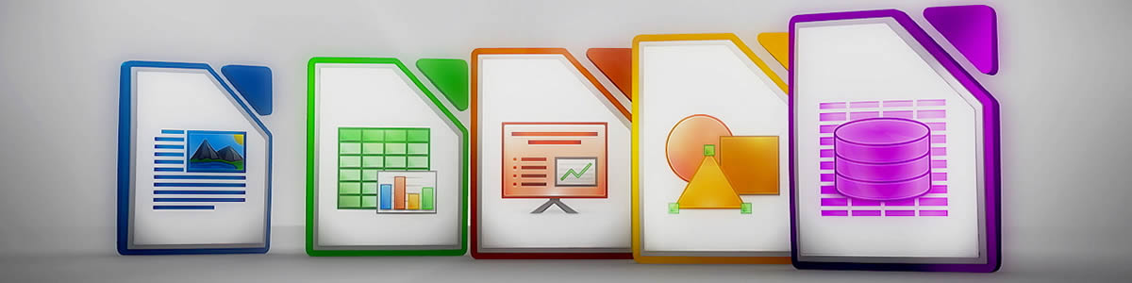
LibreOffice is compatible with many document formats such as Microsoft® Word, Excel, PowerPoint and Publisher. But LibreOffice goes further by enabling you to use a modern open standard, the OpenDocument Format (ODF).

Matplotlib [4]
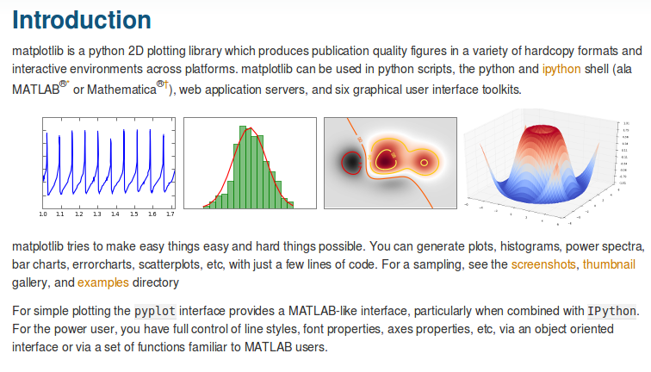
[1] https://www.yoctoproject.org/
[2] https://en.wikipedia.org/wiki/Linux_kernel
[3] https://www.libreoffice.org/discover/libreoffice/
[4] http://matplotlib.org/

