Samba on Raspberry Pi 2 B
10/07/15

Need to create a user account
In the file /etc/group add the line below.

vidal:x:1000:

create the user
useradd -d /home/vidal -g vidal vidal

passwd vidal this is the pi passwd

smbpasswd -a vidal This is the passwd on the windows system.

Below are the changes made to /etc/samba/smb.conf file

raspberrypi2:/etc/samba# diff -u smb.conf.orig smb.conf
--- smb.conf.orig 2015-10-05 05:48:19.159995528 +0000
+++ smb.conf 2015-10-05 06:29:07.049999335 +0000
@@ -39,7 +39,8 @@
# the "loopback" interface. For more examples of the syntax see
# the smb.conf man page
; hosts allow = 192.168.1. 192.168.2. 127.
-
+ hosts allow = 192.168.1. 127.
+
# If you want to automatically load your printer list rather
# than setting them up individually then you'll need this
load printers = yes
@@ -95,7 +96,7 @@
# If you have multiple network interfaces then you must list them
# here. See the man page for details.
; interfaces = 192.168.12.2/24 192.168.13.2/24
-
+ interfaces = 192.168.1.141/24
# Browser Control Options:
# set local master to no if you don't want Samba to become a master
# browser on your network. Otherwise the normal election rules apply
@@ -207,6 +208,12 @@
; writable = yes
; printable = no
; write list = @staff
+[samba_extra]
+ comment = Public Stuff
+ path = /home/samba
+ public = yes
+ writable = yes
+ printable = no

# Other examples.
#
raspberrypi2:~$ smbclient -L 192.168.1.34
Enter vidal's password:
Domain=[WS031] OS=[Windows 8.1 9600] Server=[Windows 8.1 6.3]

Sharename Type Comment
--------- ---- -------
ADMIN$ Disk Remote Admin
C$ Disk Default share
IPC$ IPC Remote IPC
print$ Disk Printer Drivers
session request to 192.168.1.34 failed (Called name not present)
session request to 192 failed (Called name not present)
session request to *SMBSERVER failed (Called name not present)
NetBIOS over TCP disabled -- no workgroup available
raspberrypi2:~$ smbclient -L 192.168.1.141
Enter vidal's password:
Domain=[MYGROUP] OS=[Unix] Server=[Samba 3.6.25]

Sharename Type Comment
--------- ---- -------
homes Disk Home Directories
samba_extra Disk Public Stuff
IPC$ IPC IPC Service (Samba Server)
vidal Disk Home Directories
Domain=[MYGROUP] OS=[Unix] Server=[Samba 3.6.25]

Server Comment
--------- -------

Workgroup Master
--------- -------

Testing of samba from Raspberry Pi 2B 192.168.1.141

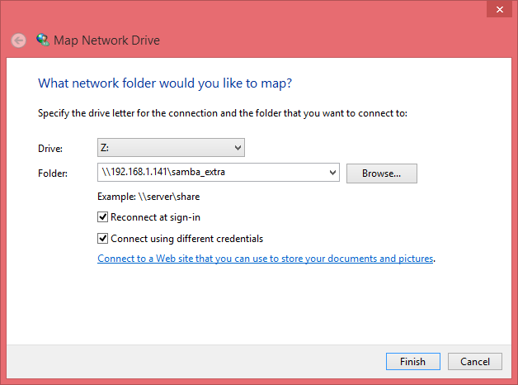

This is where you provide the samba passwd

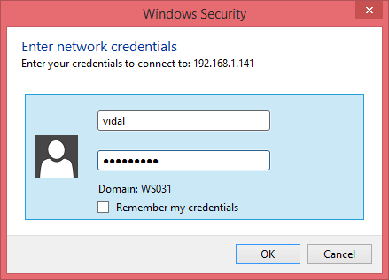
This is the drive on Raspberry Pi 2B being share with windows 8.1

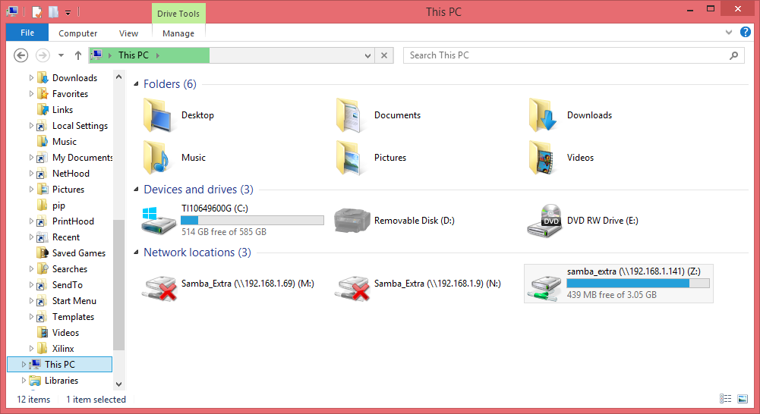
The files below were created on Raspberry Pi 2B
