***********Draft***********
Custom Raspbian Image
Created with pi-gen
Testing Lazarus/FPC
02/07/18
***********Draft***********

Introduction:
The overall goal is to create a bootable micro sd card ready to start developing Ultibo applications using Lazarus IDE (Ultibo Edition).with Free Pascal Compiler FPC. This was made possible with creation of the “ultiboinstaller.sh” found at https://github.com/ultibohub/Tools/blob/master/Installer/Core/Linux/ultiboinstaller.sh by Gary from Ultibo, “pi-gen” and the “Stretch Raspbain release” make this possible. Ultibo releassed an installer script “utiboinstaller.sh” that installs Lazarus and Free Pascal Compiler
FPC on the Raspberry Pi. This marks a milestone in the Ultibo Bare Metal development providing
an Intregrated Development Enviornment (IDE). The Strech Raspbian release still needs serveral dependencies to install Lazarus IDE (Ultibo Edition).with Free Pascal Compiler FPC. In addition, other tools such as arm-none-eabi tools, telnet, tftp, gitk, diffuse, hexedit are desired.
This is why pi-gen was used to get the system up quickly.

The target system is Linux based since the Linux firmware plus the
kernel7.img or kernel.img are what make ultibo run on the RPi hardware.
We currenty have a Lazarus/FPC executeable that runs on Windows System.
This still requires the binutils and arm-none-eabi compiler.

Creating the boot & rootfs in zip file that can be transferred to the micro sd card:
This requred several steps found in Appendix A: Notes during pi-gen testing

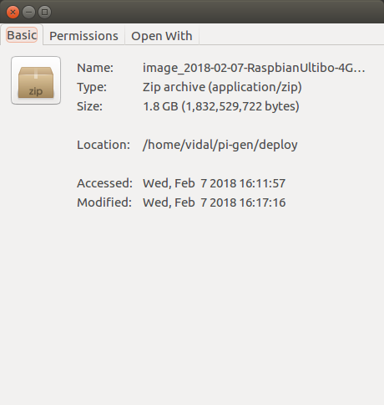

Testing:
pi@raspberrypi:~ $ mkdir test_examples
pi@raspberrypi:~ $ cd test_examples/
pi@raspberrypi:~/test_examples $ git clone https://github.com/develone/Ultibo_PWM_TFTP.git

note
pi@raspberrypi:~ $ ultibo/core/startlazarus was the command used to start the Lazarus IDE (Ultibo Edition).
This was required since a tar file -rw-r--r-- 1 vidal vidal 329724698 Feb 7 17:19 ultibo.tgz was used to install lazarus
pi@raspberrypi:~ $ time tar xfz ultibo.tgz

real 5m0.582s
user 1m24.990s
sys 0m44.640s
ultibo
2123 directories, 32499 files

From the Raspberry Pi/Programming/Lazarus IDE (Ultibo Edition)

If the PWM_TFTP_SERVO project was the current project Run/Compile

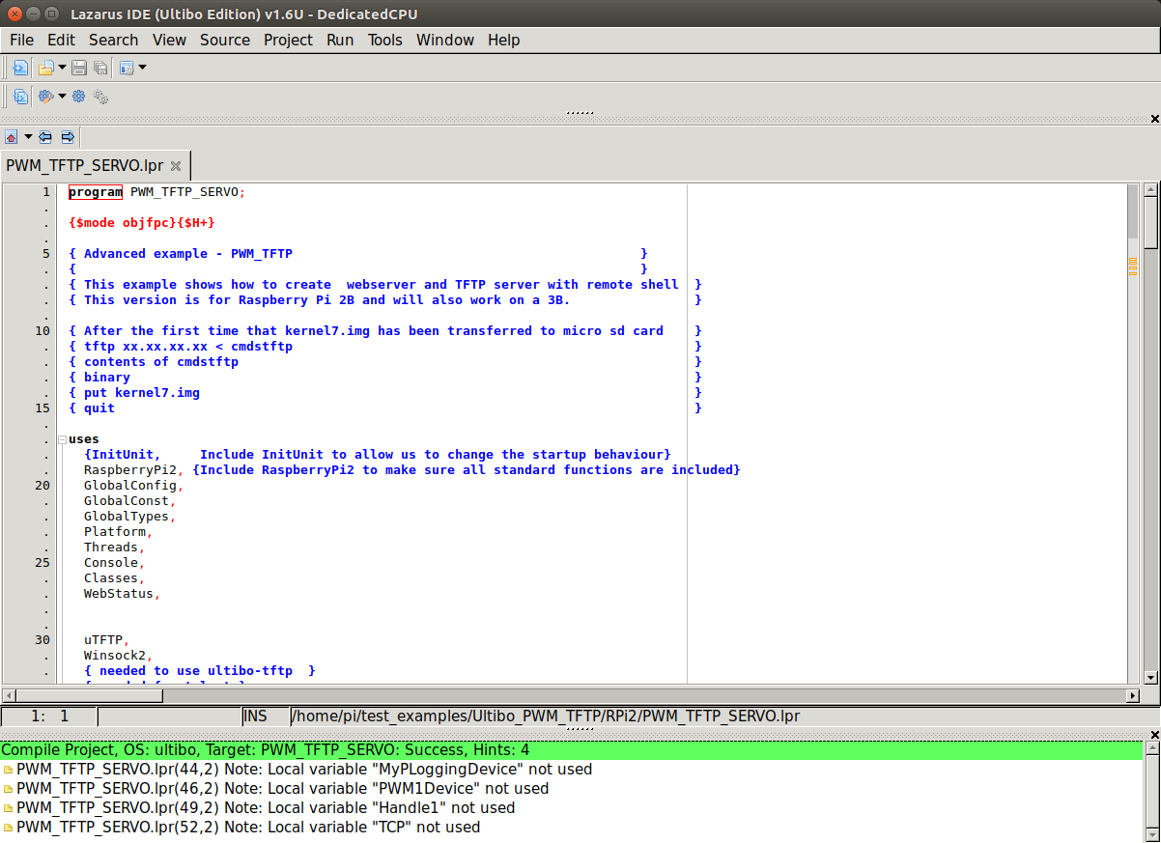

Success Compile
If the compile works without errors a green bar wil appear as seen above.

Transferring the kernel7.img and firmware files displays the following when booting.

The Core was updated
ULTIBO_RELEASE_DATE = '31 January 2018';
ULTIBO_RELEASE_NAME = 'Beetroot';
ULTIBO_RELEASE_VERSION = '2.0.173';
The recently built target matches the values found in ultibo/core/fpc/source/rtl/ultibo/core/globalconst.pas

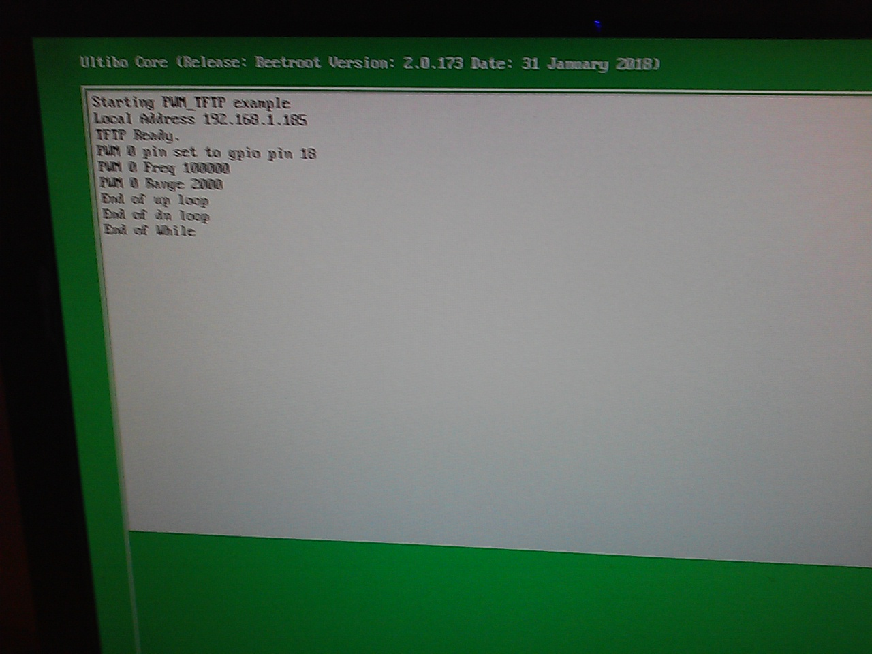
pi@raspberrypi:~/test_examples/Ultibo_PWM_TFTP/RPi2 $ cp kernel7.img /media/pi/6FCF-2BFD/

Appendix A: Notes during pi-gen testing

pi-gen Tool used to create the raspberrypi.org Raspbian images.

Forked pi-gen https://github.com/RPi-Distro/pi-gen
commit 066eb03d52868290661e813738a9a66eda263aa9
Author: Ben Pirt <ben@pirt.co.uk>
Date: Wed Jan 3 12:48:31 2018 +0000

Allow image building to be skipped for stages (#137)

pi-gen
GitHub - RPi-Distro/pi-gen: Tool used to create the raspberrypi.org ...
https://github.com/RPi-Distro/pi-gen

README.md. pi-gen. Tool used to create the raspberrypi.org Raspbian images.
Dependencies. pi-gen runs on Debian based operating systems. Currently it
is only supported on either Debian Stretch or Ubuntu Xenial and is known
to have issues building on earlier releases of these systems. To install
the required

On a Ubuntu 16.04 added pi-gen dependencies.
sudo apt-get install quilt parted realpath qemu-user-static debootstrap zerofree pxz zip dosfstools bsdtar libcap2-bin grep rsync xz-utils

Linux sim2 4.4.0-112-generic #135-Ubuntu SMP Fri Jan 19 11:48:36 UTC 2018 x86_64 x86_64 x86_64 GNU/Linux
AMD FX(tm)-4130 Quad-Core Processor
cpu MHz : 1800.000

Steps create the pi-gen/work/2018-02-07-RaspbianUltibo tree.

1.0)
git clone https://github.com/develone/pi-gen.git
2.0)
cd pi-gen/
3.0)
cp ~/raspbian-pi-gen/config .
4.0)
cp ~/raspbian-pi-gen/stage4/00-install-packages/02-packages stage4/00-install-packages/
5.0)
date > t1.txt; sudo ./build.sh ; date > t2.txt

cd deploy/
fdisk /dev/sdb
date > ../st.time ; sudo gzip -dc image_2018-02-07-RaspbianUltibo.zip | dd bs=16M of=/dev/sdb; date > ../end.time
0+137615 records in
0+137615 records out
6366953472 bytes (6.4 GB, 5.9 GiB) copied, 1124.77 s, 5.7 MB/s
Wed Feb 7 16:45:56 MST 2018
Wed Feb 7 17:04:41 MST 2018

This build has 1313 pkgs installed
ssh -Y pi@192.168.1.185
uname -a
Linux raspberrypi 4.9.59-v7+ #1047 SMP Sun Oct 29 12:19:23 GMT 2017 armv7l GNU/Linux

Testing new build with the dependencies need to install the Lazaraus/FPC

Added a file pi-gen/stage4/00-install-packages/02-packages
libgtk2.0-dev
libcairo2-dev
libpango1.0-dev
libgdk-pixbuf2.0-dev
libatk1.0-dev
libghc-x11-dev
binutils-arm-none-eabi
gcc-arm-none-eabi

Added a file pi-gen/config
#!/bin/bash
export IMG_NAME=RaspbianUltibo

./build.sh
Creates the pi-gen/work/2018-02-06-RaspbianUltibo tree.
vidal@sim2:~$ ls pi-gen/work/2018-02-06-RaspbianUltibo/stage0/rootfs/var/cache/apt/archives/*.deb | wc
220 220 23687
vidal@sim2:~$ ls pi-gen/work/2018-02-06-RaspbianUltibo/stage1/rootfs/var/cache/apt/archives/*.deb | wc
15 15 1613
vidal@sim2:~$ ls pi-gen/work/2018-02-06-RaspbianUltibo/stage2/rootfs/var/cache/apt/archives/*.deb | wc
214 214 23353
vidal@sim2:~$ ls pi-gen/work/2018-02-06-RaspbianUltibo/stage3/rootfs/var/cache/apt/archives/*.deb | wc
427 427 46856
vidal@sim2:~$ ls pi-gen/work/2018-02-06-RaspbianUltibo/stage4/rootfs/var/cache/apt/archives/*.deb | wc
525 525 57691
vidal@sim2:~$ ls pi-gen/work/2018-02-06-RaspbianUltibo/stage5/rootfs/var/cache/apt/archives/*.deb | wc
9 9 1006
1410 packages are required

date > ../st.time ;gzip -dc image_2018-02-06-RaspbianUltibo-4GB.zip | dd bs=16M of=/dev/sdb; date > ../end.time
gzip: image_2018-02-06-RaspbianUltibo-4GB.zip: invalid compressed data--length error
0+138615 records in
0+138615 records out
5628755968 bytes (5.6 GB, 5.2 GiB) copied, 825.41 s, 6.8 MB/s

pi@raspberrypi:~ $ dpkg -l | wc
1400 14224 200233
pi@raspberrypi:~ $ uname -a
Linux raspberrypi 4.9.59-v7+ #1047 SMP Sun Oct 29 12:19:23 GMT 2017 armv7l GNU/Linux

date > t1.txt;./ultiboinstaller.sh ; date > t2.txt
Tue 6 Feb 23:47:19 UTC 2018
Wed 7 Feb 00:52:52 UTC 2018

Free Pascal and Lazarus (Ultibo edition) prerequisites
------------------------------------------------------
Installing and building Free Pascal requires several tools
from the build essentials package including make, ld and as
as well as the unzip utility.

These can be installed on Debian based distributions using:

sudo apt-get install build-essential unzip

Lazarus requires the GTK2 and X11 dev packages which can
be installed on Debian based distributions by using:

sudo apt-get install libgtk2.0-dev libcairo2-dev \
libpango1.0-dev libgdk-pixbuf2.0-dev libatk1.0-dev \
libghc-x11-dev

Cross compiling Ultibo applications from Linux requires the
arm-none-eabi build of the binutils package, this can be
installed on Debian based distributions using:

sudo apt-get install binutils-arm-none-eabi

Press return to check for these prerequisites

make found
gdb found
unzip found
libgtk2.0-dev found
libcairo2-dev found
libpango1.0-dev found
libgdk-pixbuf2.0-dev found
libatk1.0-dev found
libghc-x11-dev found
arm-none-eabi-as found
arm-none-eabi-ld found
arm-none-eabi-objcopy found

Enter an installation folder or press return to
accept the default install location

[/home/pi/ultibo/core]:

The install folder will be:
/home/pi/ultibo/core

Continue? (y,n): y

After install do you want a shortcut created in:
/home/pi/.local/share/applications (y/n)? y

Downloading FPC minimal stable 3.0.2
Extracting FPC minimal stable 3.0.2
Downloading Ultibo core
Downloading Ultibo examples
Downloading Free Pascal (Ultibo edition)

Next step required

Need to create a ultibo-laz-fpc.deb file.
This will based on ultibo tree,

