***********Draft***********
Custom Raspbian Image
image_2018-02-14-RaspbianUltibo.zip
First Boot
02/16/18
***********Draft***********

date > t1.txt; gzip -dc image_2018-02-14-RaspbianUltibo.zip | dd bs=16M of=/dev/sdb; date >> t1.txt
0+165834 records in
0+165834 records out
7730102272 bytes (7.7 GB, 7.2 GiB) copied, 696.3 s, 11.1 MB/s
Wed Feb 14 15:43:22 MST 2018
Wed Feb 14 15:54:58 MST 2018

After inserting the micro sd card in a Raspberry Pi 2B RPi2B or Raspberry Pi 3B RPi3D and applying power the boot process starts. If this was a Raspberry Pi Zero only 1 Raspberry would be displayed indicating that a single core is booting

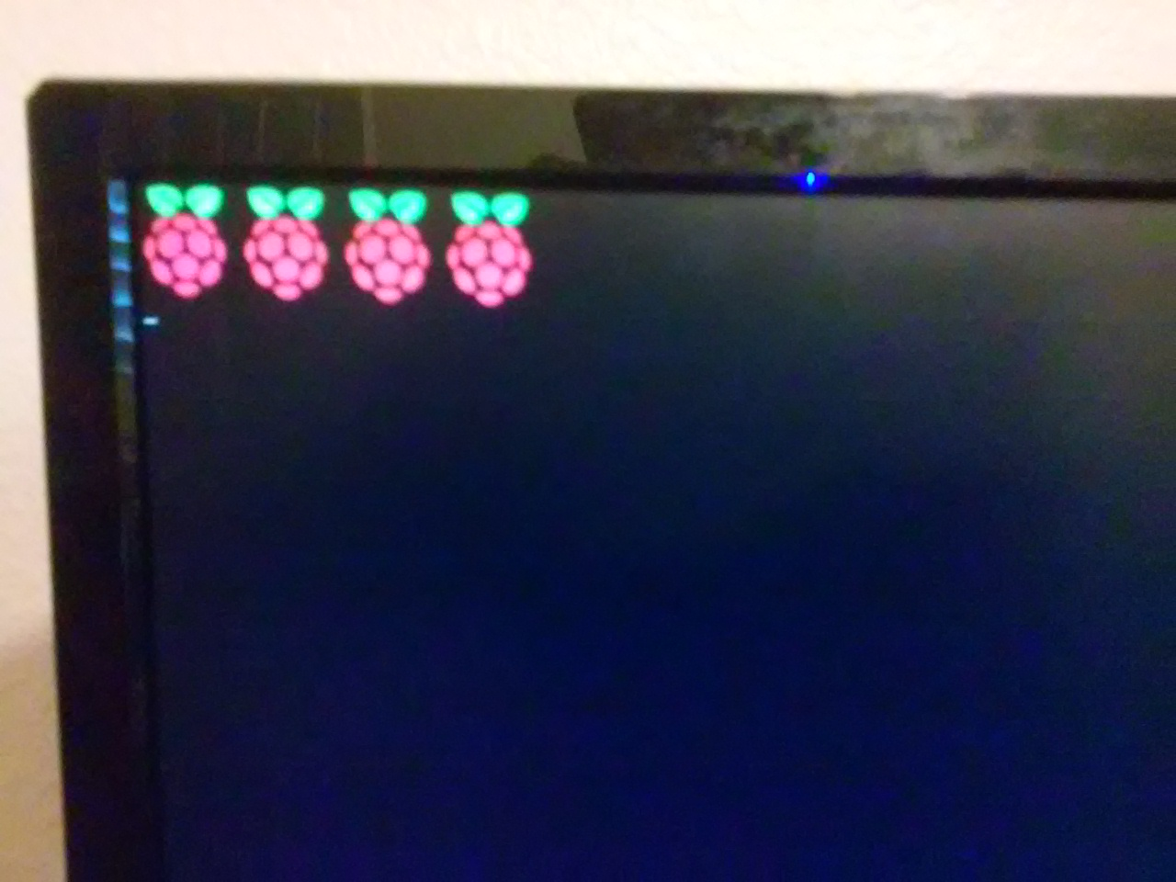
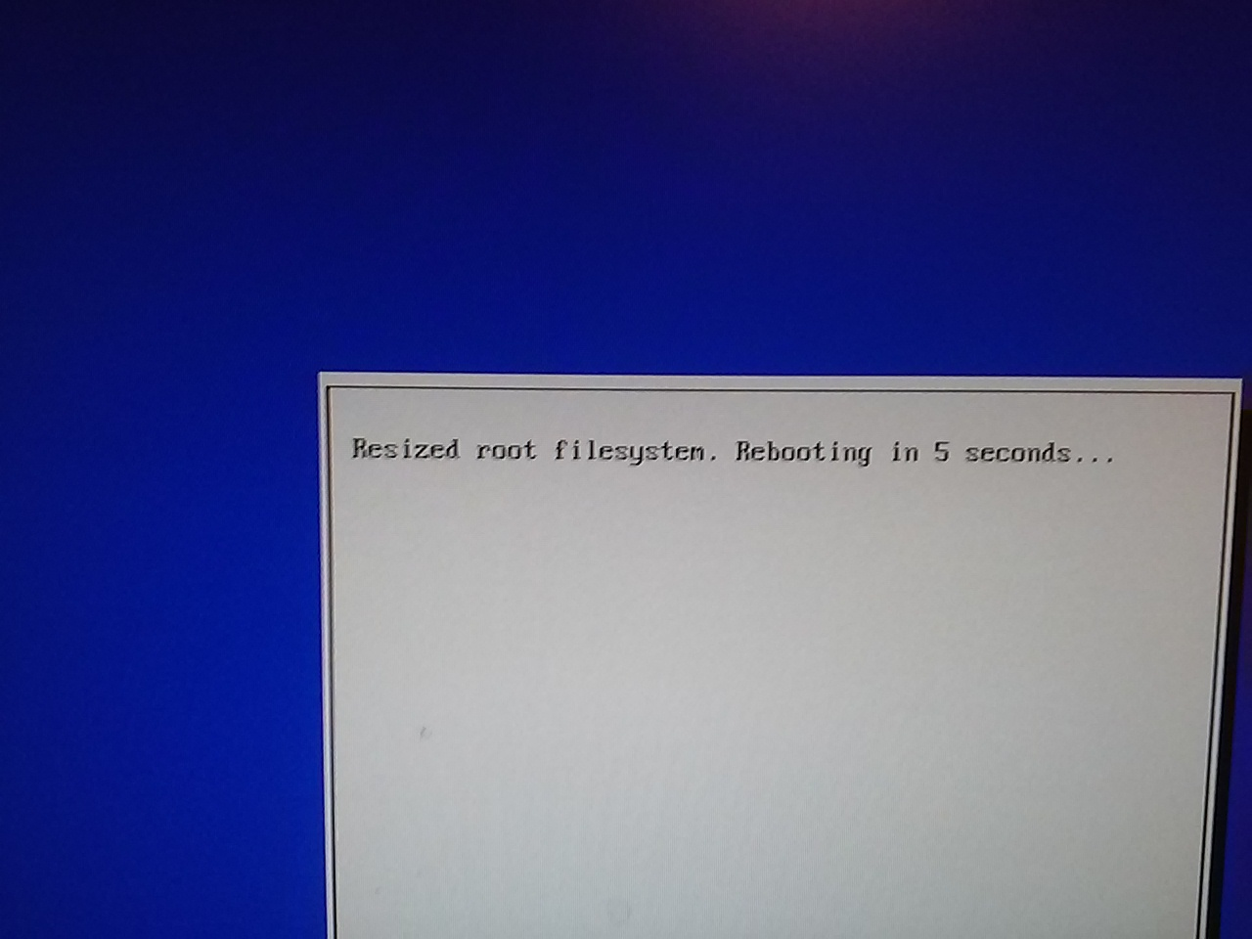
On thee first boot the process detects the that the micro sd card has additional space. The message below is displayed if micro sd card was a 16GB or 32GB it expands to the full size and reboots.

If this was a Raspberry Pi Zero only 1 Raspberry would be displayed indicating that a single core is booting

Followed by the Raspberry Pi logo

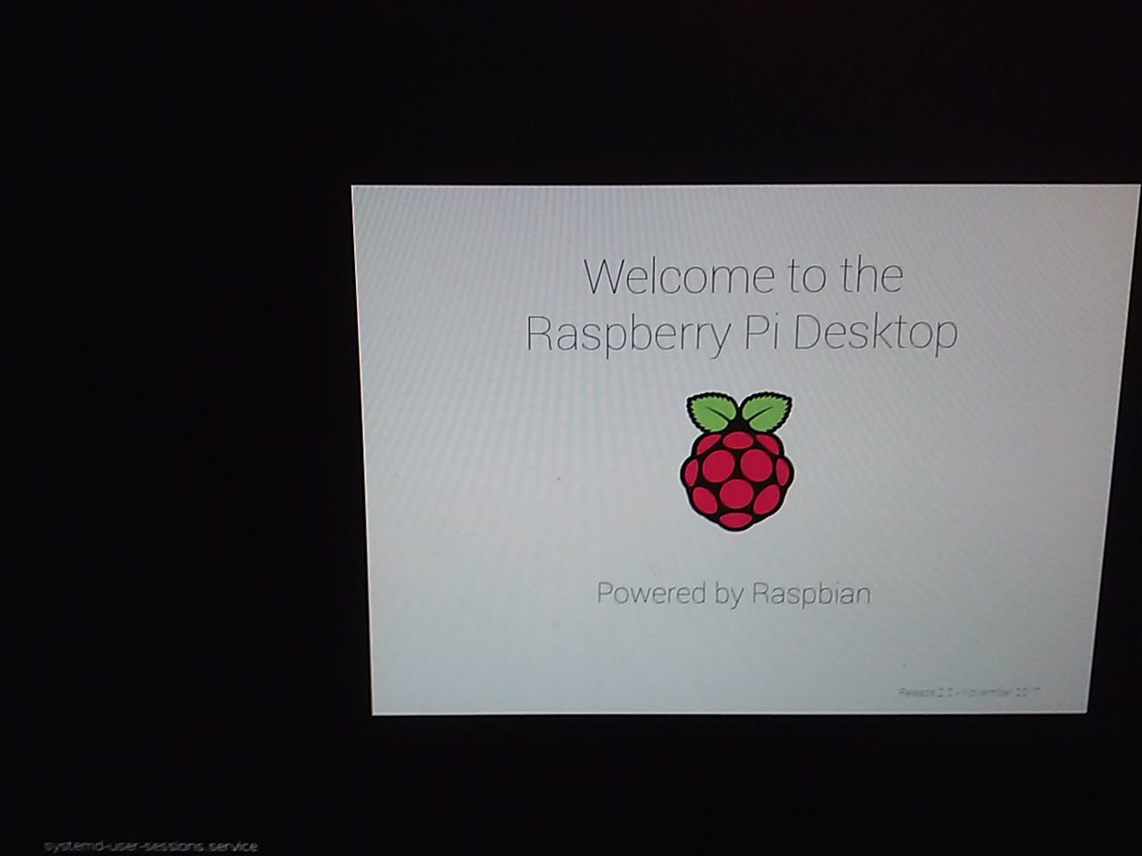
Then the main screen appears.
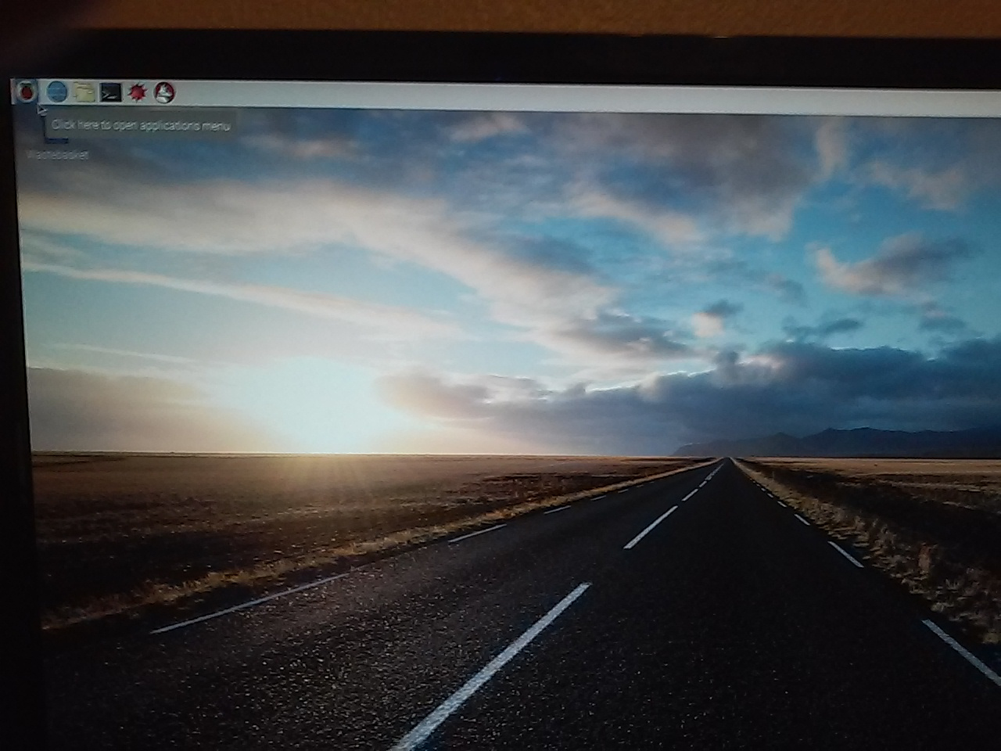
From the main menu open a terminal and execute “sudo passwd pi”The pass word should be reset.

The Keyboard should be changed to

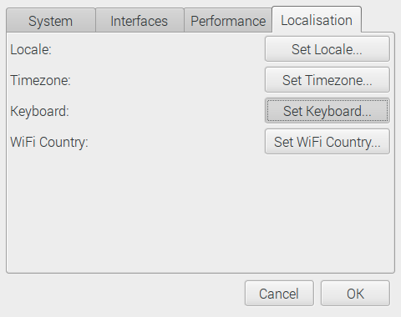

Depress OK
United States.English

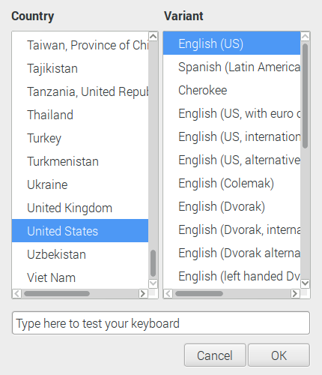

Depress OK
The GPU memory needs to increase from 64M

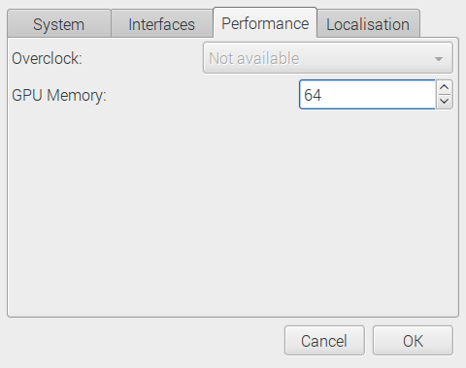

Depress OK
to 128M.

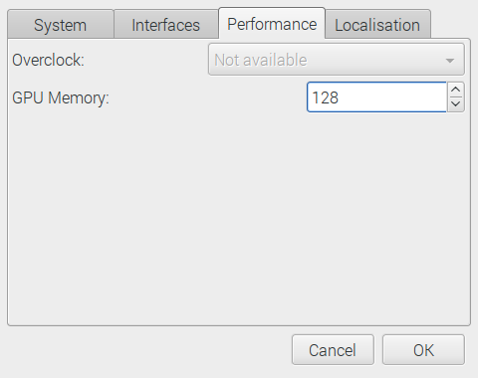

Depress OK
SSH should be enabled

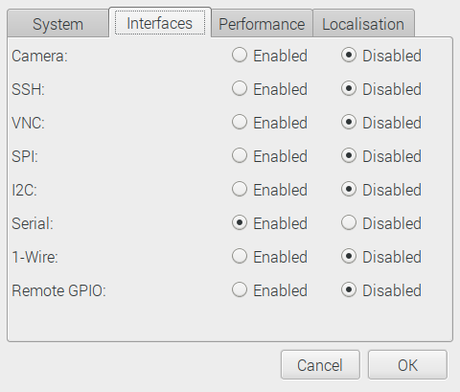

Depress OK

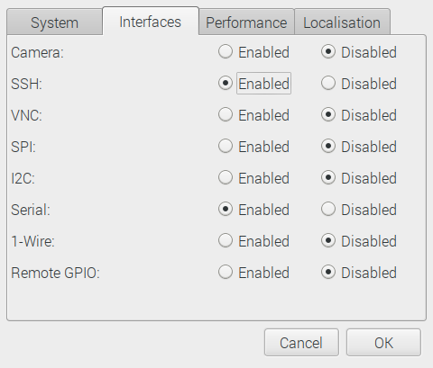

Depress OK

On Raspbian stretch requires
1313 packages
1400 packages with Ultibo dependencies
1420 packages with Ultibo & tools

