***********Draft***********
Custom Raspbian Image
with Lazarus FPC installed

image_2018-02-14-RaspbianUltibo.zip
Demo
02/16/18
***********Draft***********

First Lazarus run

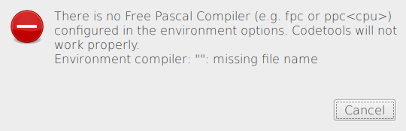
Depress Cancel

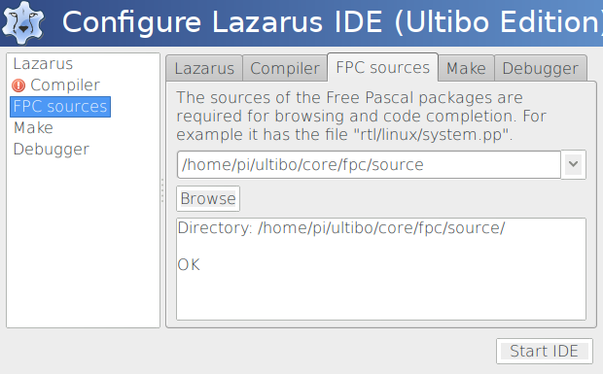
Highiight Compiler Browse to ultibo/core/fpc/bin/ppcarm

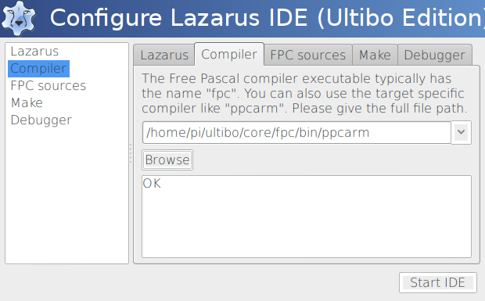
Depress Start IDE

git clone https://github.com/develone/Demo.git

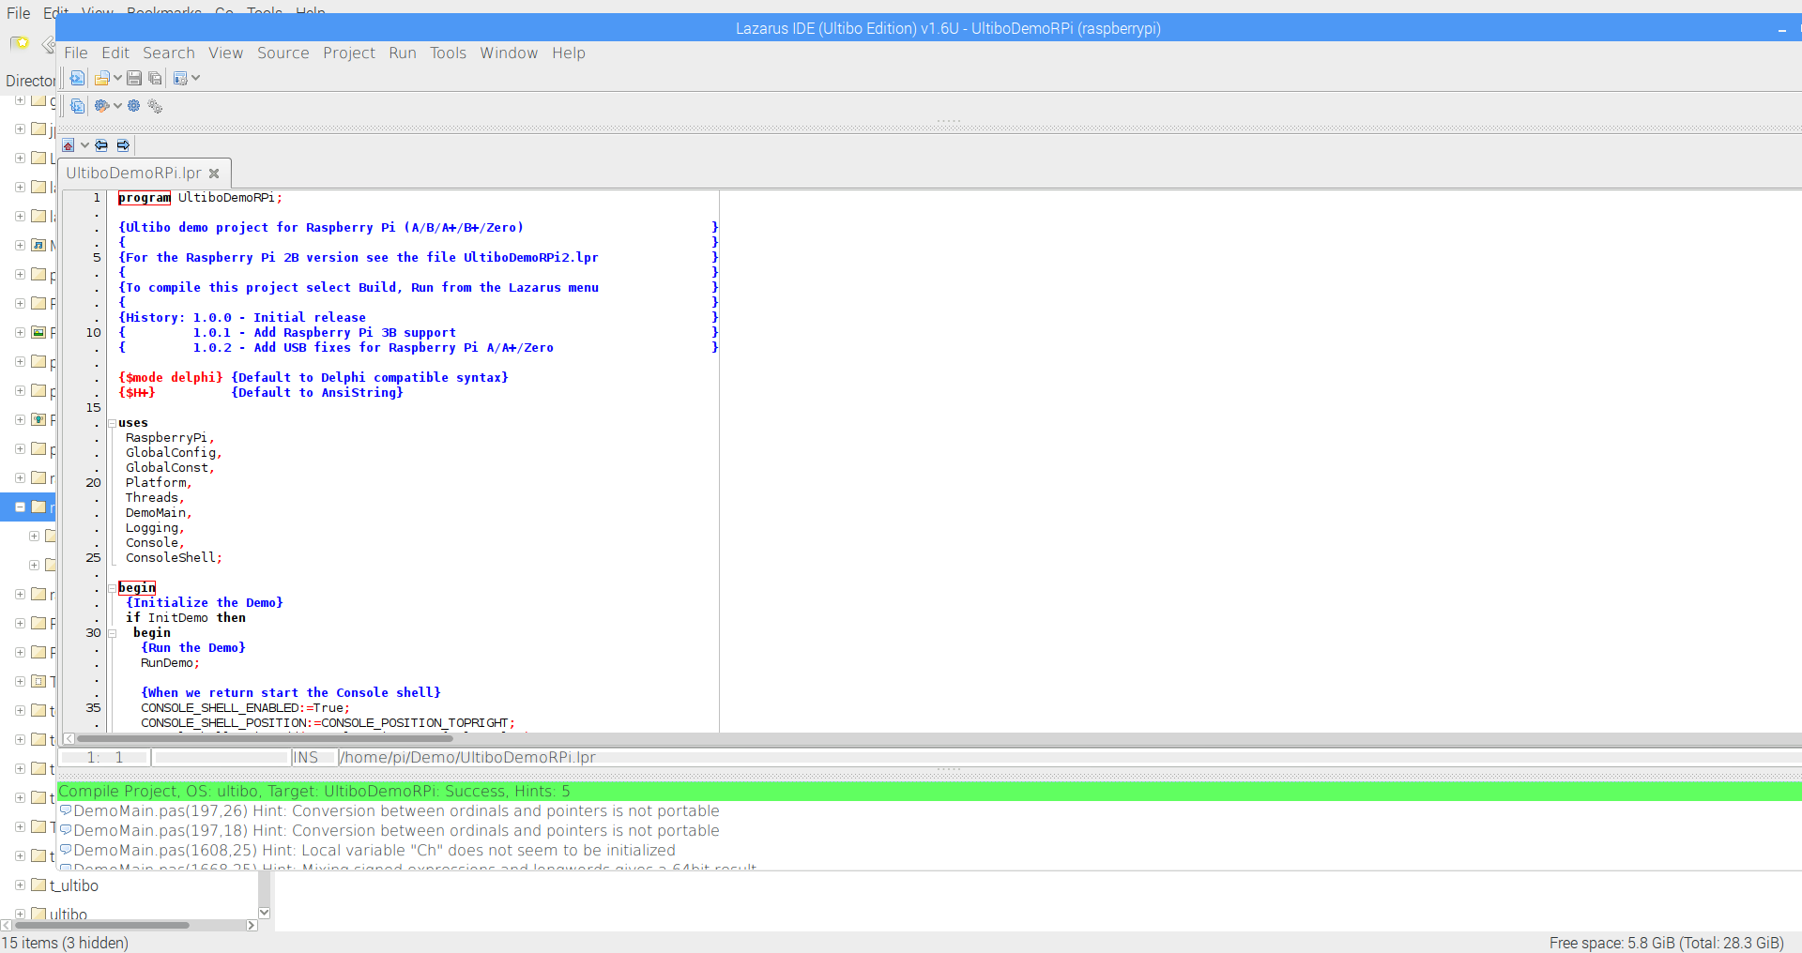

Compile for Raspberry Pi

Demo boot

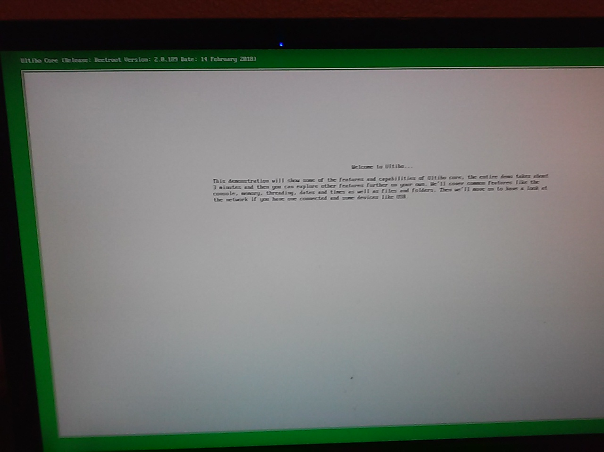
Rp Zero
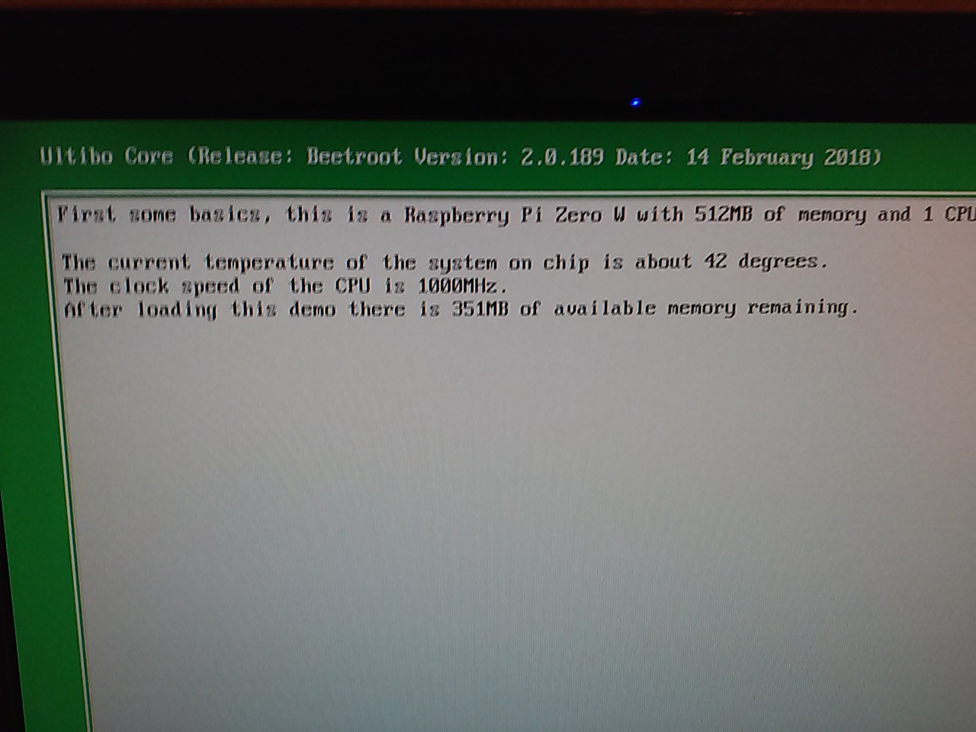
Compile for Raspberry Pi 2B

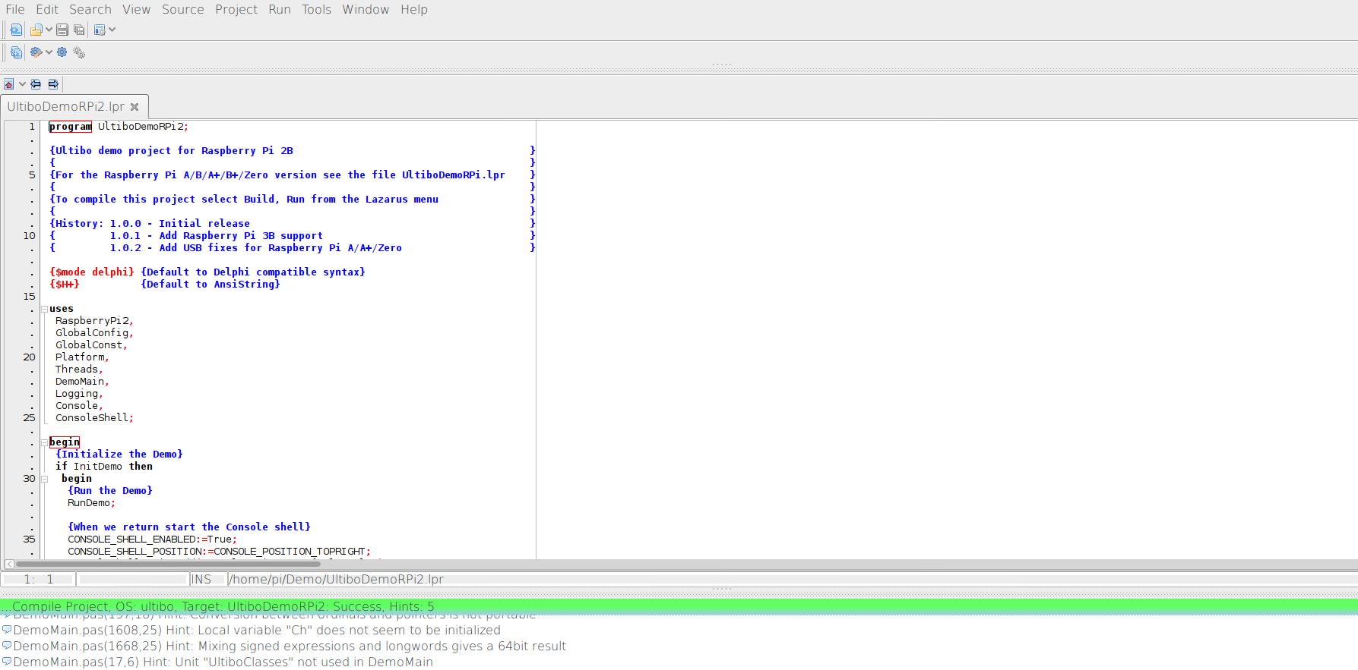
Raspberry Pi 3B

