*****DRAFT*****
KICAD for CATBOARD

03/28/18
*****DRAFT*****

The schmatic & pcb artwork for the CATBOARD were created with Kicad.

The following 3 repositories were forks from xesscorp.
git clone https://github.com/develone/CAT-Board.git
git clone https://github.com/develone/KiCad-Schematic-Symbol-Libraries.git
git clone https://github.com/develone/KiPart.git

Install the kicad with sudo apt-get install kicad
http://kicad-pcb.org/help/tutorials/
All of the files to build a CATBOARD are
https://github.com/develone/CAT-Board/tree/master/docs/Manual/pics

pi@pi3-2:~ $ cd CAT-Board/pcb/
pi@pi3-2:~/CAT-Board/pcb $ kicad CAT.pro

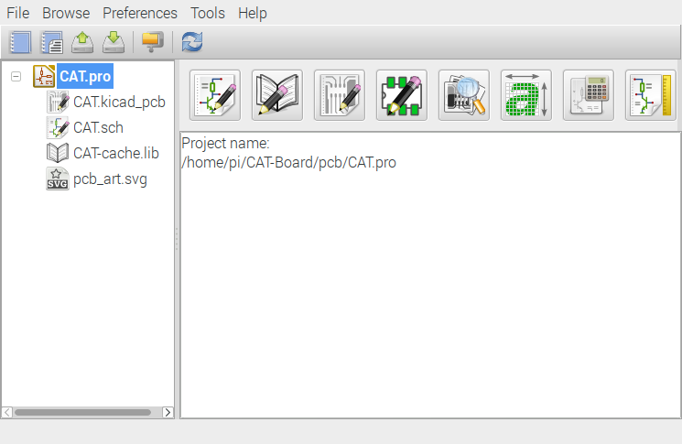

The first icon is Eeschema Electronic Schematic Editor.
The xesscorp libraries need to be added.
Depress the Eeschema icon a new window will appear.

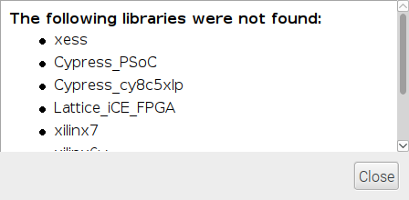

Depress Close

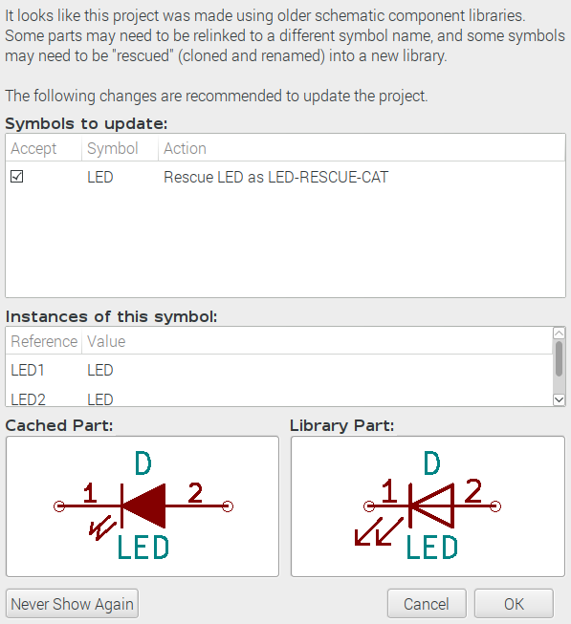

Depress OK

Depress Close

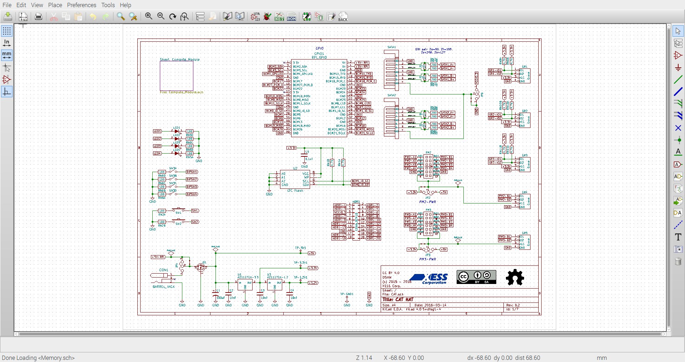
Depress Perference/Component Libraries

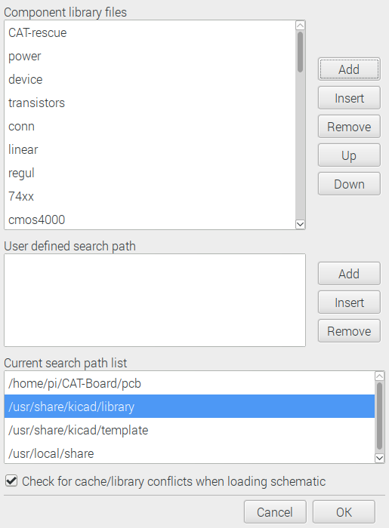

Depress Add for User defined search path.

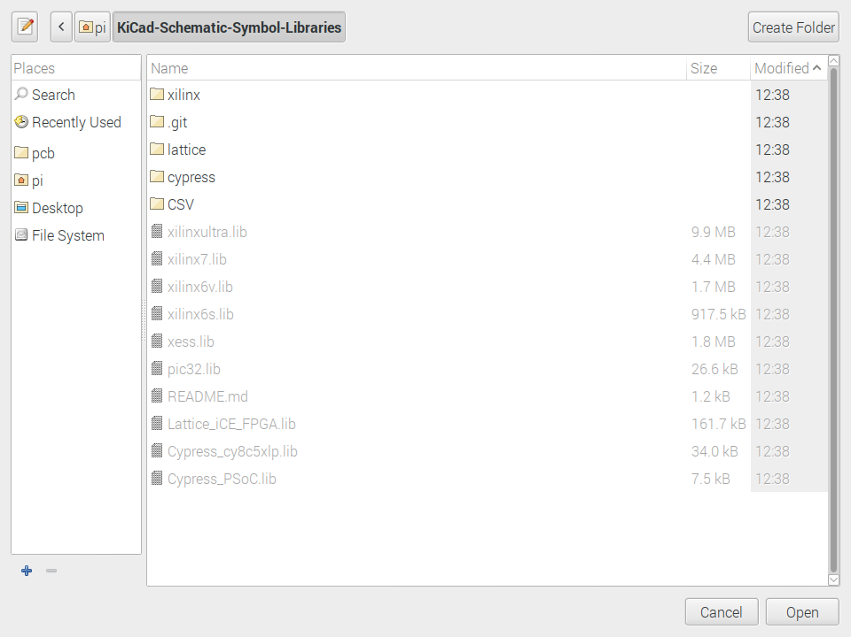

Depress Open



Depress Yes

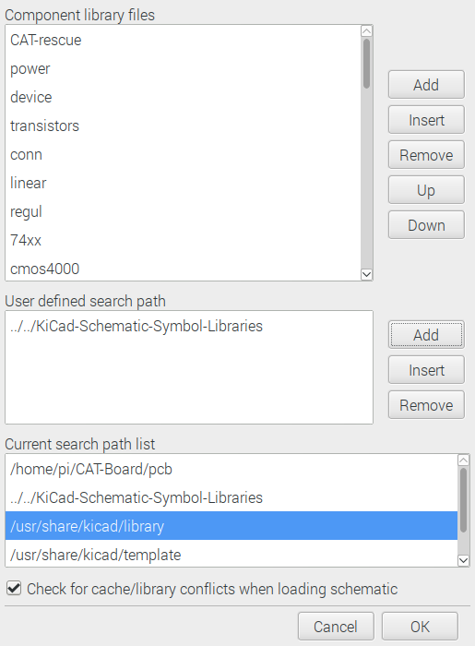

Still having an issue with Cypress Lib.

Note:
git clone https://github.com/develone/KiPart.git
cd KiPart/
sudo python setup.py install
cd ~/
mkdir testkipart
cd testkipart
cp -R ~/KiCad-Schematic-Symbol-Libraries/cypress/ .

pi@pi3-2:~/testkipart/cypress $ make
kipart CY8C5XLP.csv -r psoc5lp -b -s name -o Cypress_cy8c5xlp.lib -w
mv -f Cypress_cy8c5xlp.lib ..

cd ../
cp Cypress_cy8c5xlp.lib ~/KiCad-Schematic-Symbol-Libraries/

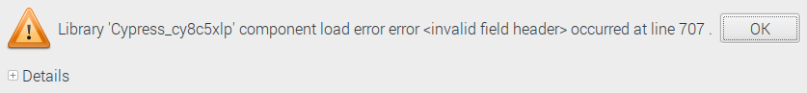

Depress OK

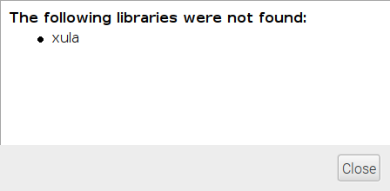

Depress Close

Section where the reset, spi, done.

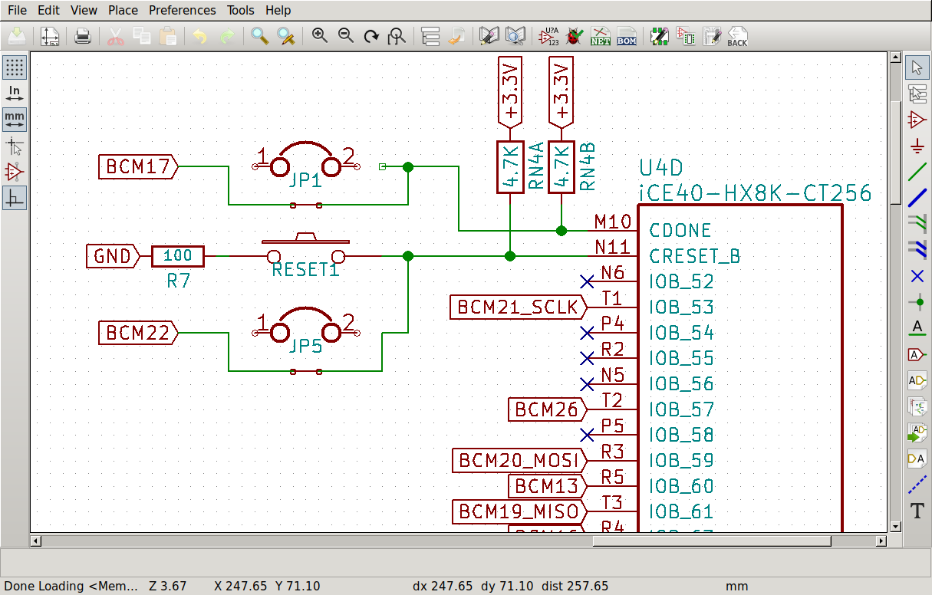
SPI Flash

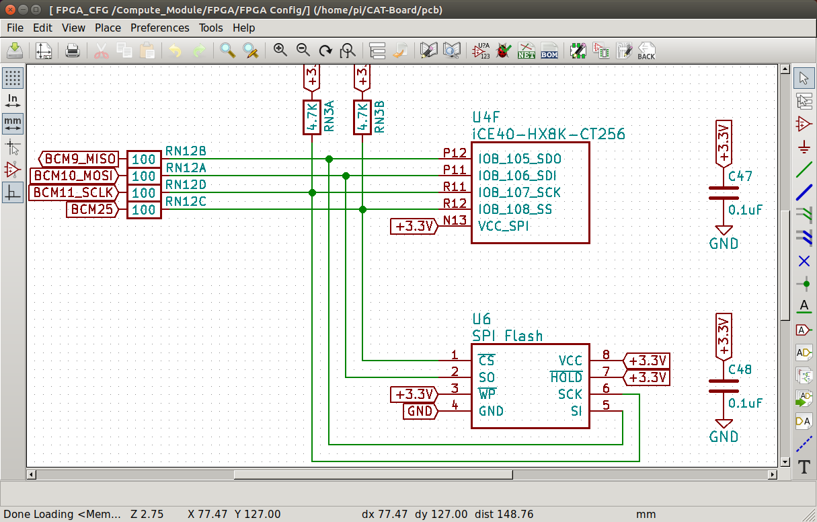

Depress Ok

