********************Draft********************
Amplitude Shift Keying (ASK) Raspberry Pi
07/22/26
********************Draft********************

could not fork this repo https://github.com/hallard/RadioHead.git
now included in https://github.com/develone/raspi-ask-433-tests

To use the RadioHead ASK (Amplitude Shift Keying) library for a 433/315 MHz receiver on a Raspberry Pi in C, you must rely on the wrapper for the underlying C++ library and the bcm2835 hardware driver. However, due to the Pi's multitasking OS, it cannot handle the strict, cycle-accurate bit-banging required for basic ASK, so you must use hardware-accelerated modules like the RFM69 or RFM95
Because the standard ASK classes in the RadioHead Packet Radio Library were originally designed for microcontrollers with dedicated timers, using cheap ASK receivers (like the FS1000A) natively on the Raspberry Pi often results in poor performance. Instead, connecting an Arduino to your Pi via USB/Serial to do the radio heavy-lifting is the community's preferred workaround

Setting Up the Environment (RFM Modules)
If you are using a supported module (e.g., RFM69) wired to the Pi's SPI pins, you will need to compile the C++ example using the bcm2835 library
cd bcm2835-1.75
./configure make
sudo make check
sudo make install

Repo https://github.com/develone/raspi-ask-433-tests

transmitter
sudo apt update
sudo apt-get install pigpio

gcc -Wall -pthread -o ask_transmitter ask_transmitter.c -lpigpio -lrt

devel@pi4-50:~/test-ask-C $ sudo ./ask_transmitter

receiver
Requires WiringPi https://github.com/WiringPi/WiringPi.git
git clone https://github.com/WiringPi/WiringPi.git
cd WiringPi
./build

gcc -o ask_receiver ask_receiver.c -lwiringPi
devel@pi4-50:~/test-ask-C $ sudo ./ask_receiver

transmitter
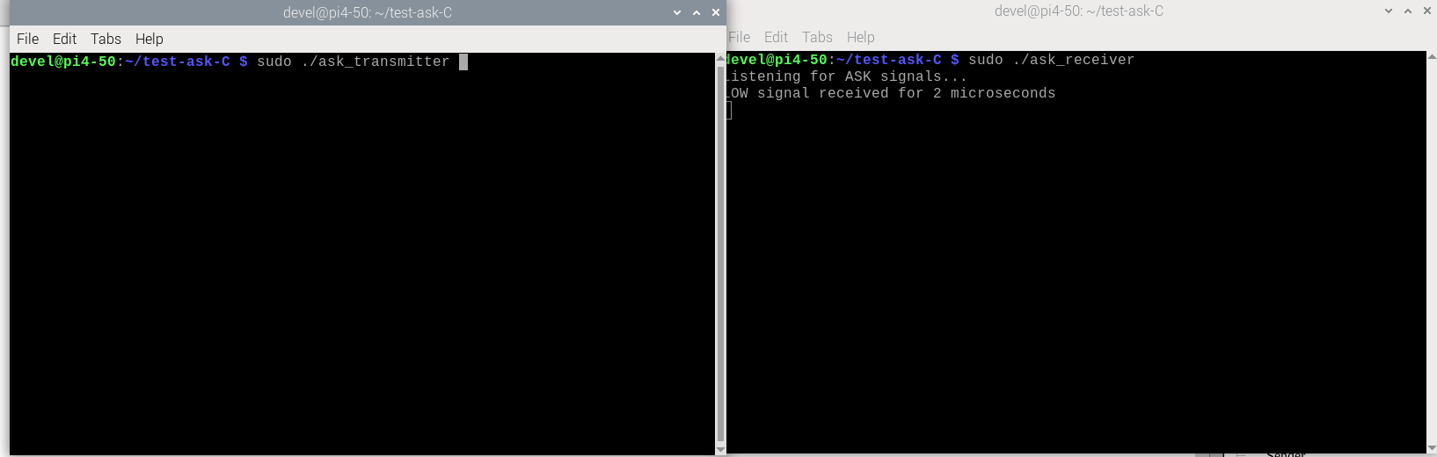
receiver
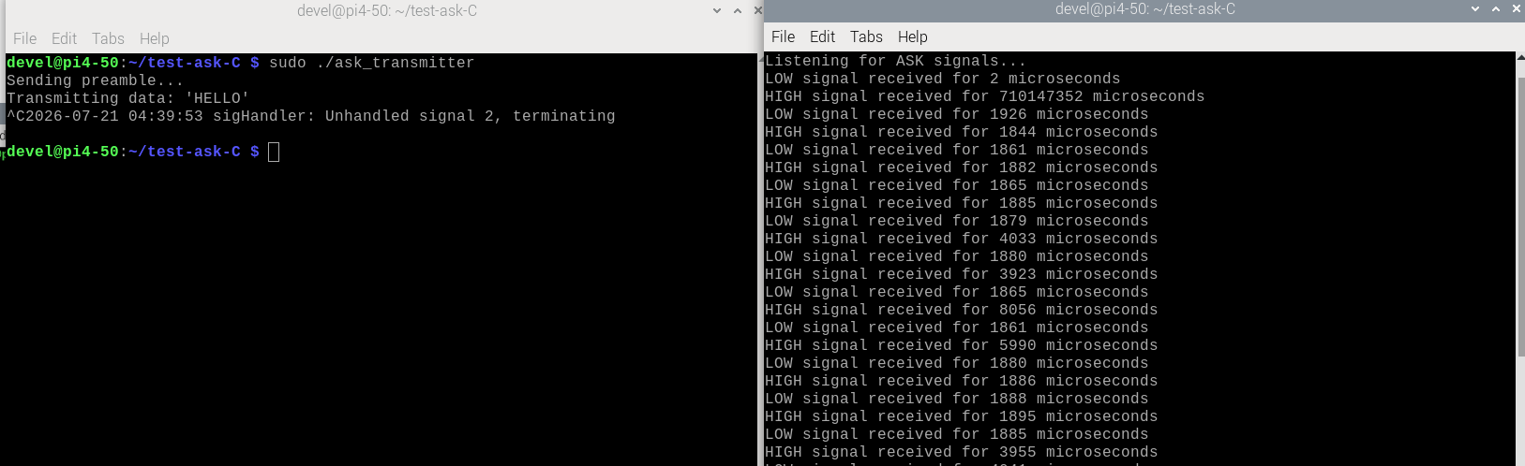
pi-connector

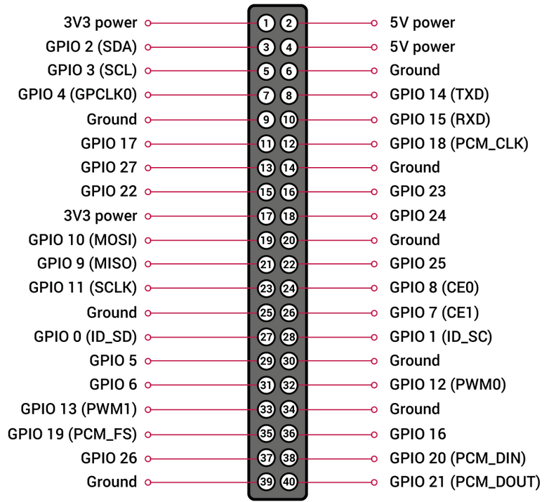

Needs number of char sent
Needs a CRC

