*******************Default*******************
Using module usbmon with with Wireshark to
Examine what is sent to pico using picotool
05/16/22
*******************Default*******************

I forked https://github.com/raspberrypi/picotool

git clone git@github.com:develone/picotool.git

cd picotool

mkdir build

cd build

cmake ..

make
sudo ./picotool help
Help pico is found at Appendix A.

Found at the site
https://technolinchpin.wordpress.com/2015/10/23/usb-bus-sniffers-for-linux-system/

sudo apt-get install wireshark
Should non-superusers be able to capture packets?

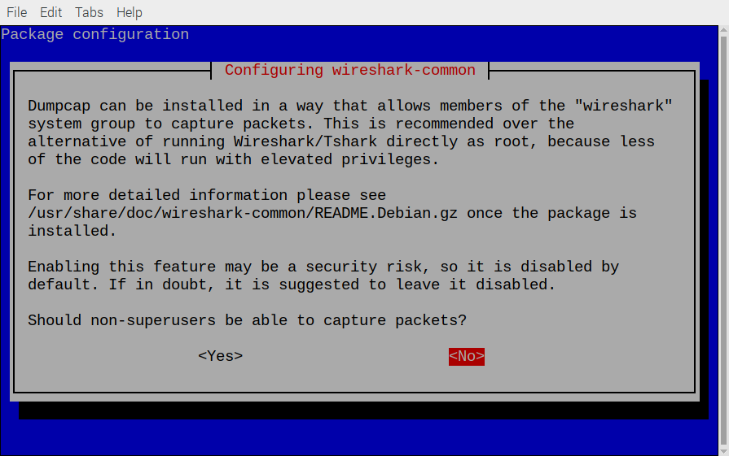
Be sure and use no.

sudo lsmod | grep -i usbmon
usbmon 32768 0

sudo or as root modprobe usbmon

sudo or as root wireshark

devel@pi4-27:~/rp2040-freertos-project/build/test-read $ sudo ~/picotool/build/picotool load -f -v test-read.elf
The device was asked to reboot into BOOTSEL mode so the command can be executed.

Loading into Flash: [==============================] 100%
Verifying Flash: [==============================] 100%
OK

The device was asked to reboot back into application mode.

In the file “~/rp2040-freertos-project/doc/wireshark/w-vusbmon0.pcapng”
starting at time 159 7.964170 host 1.72.0 to 830 9.822218.

image 0

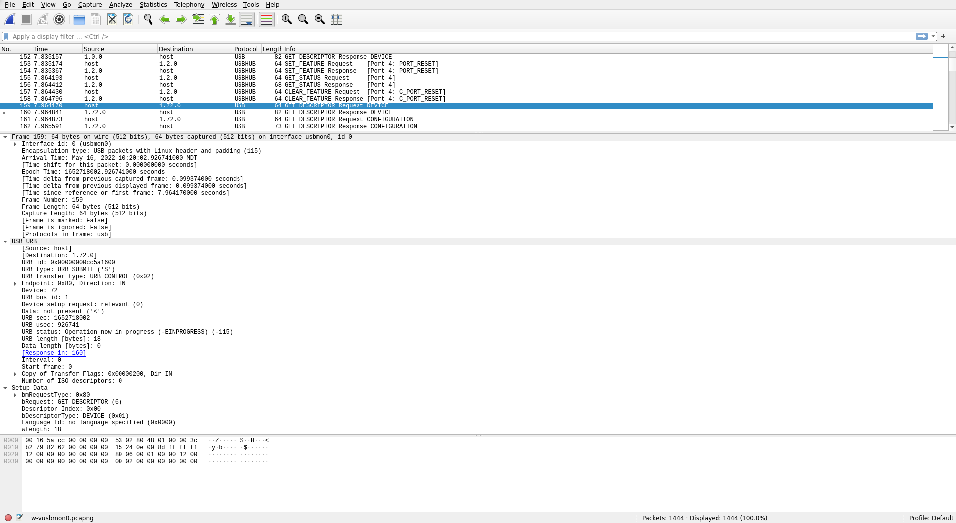
image 1

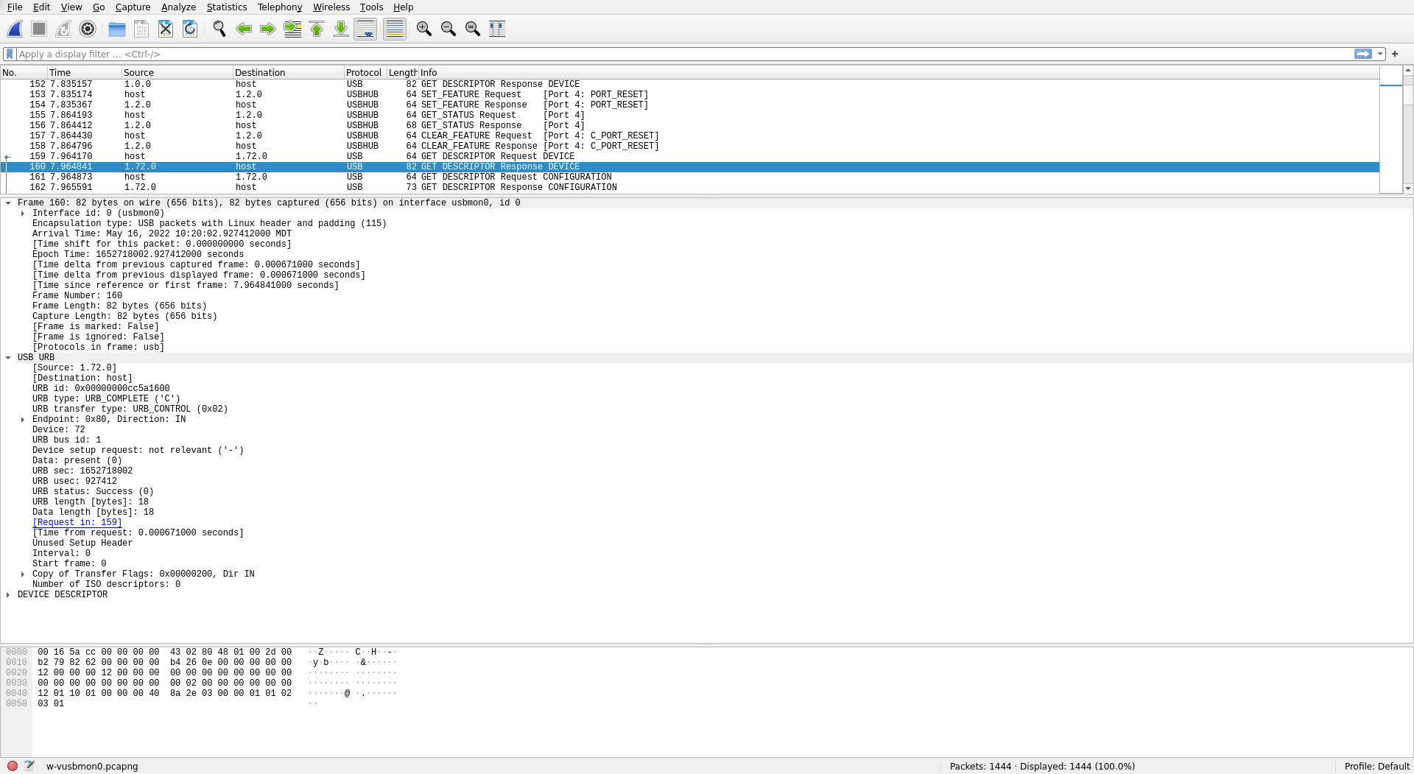
image 2

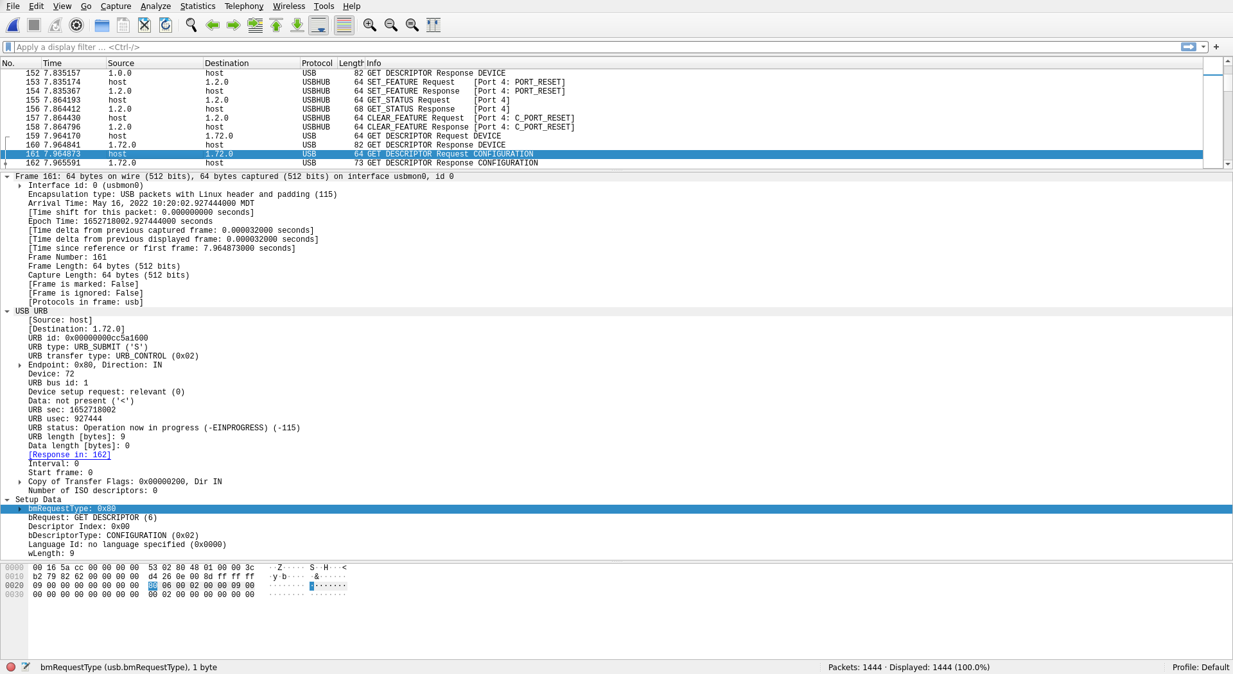
image 3

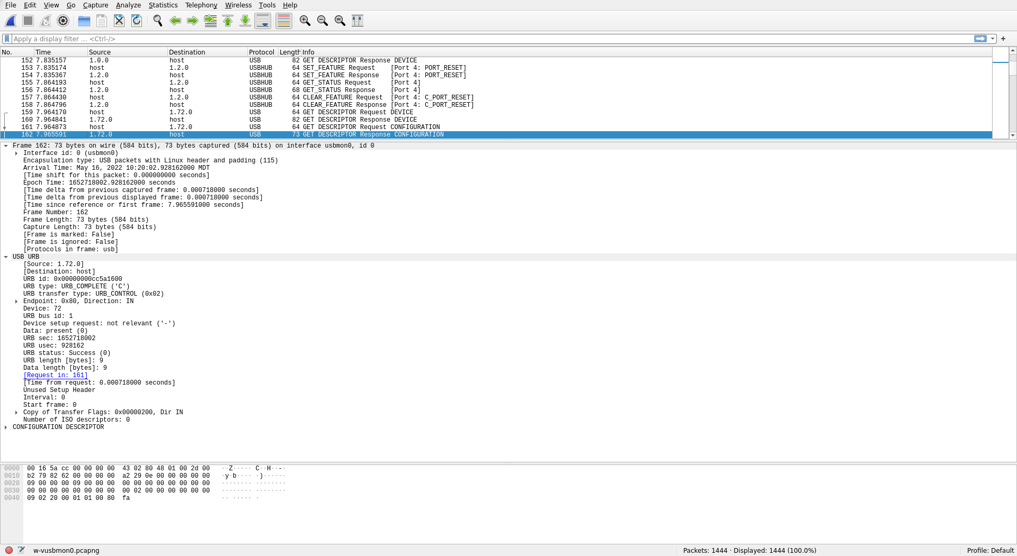
image 4

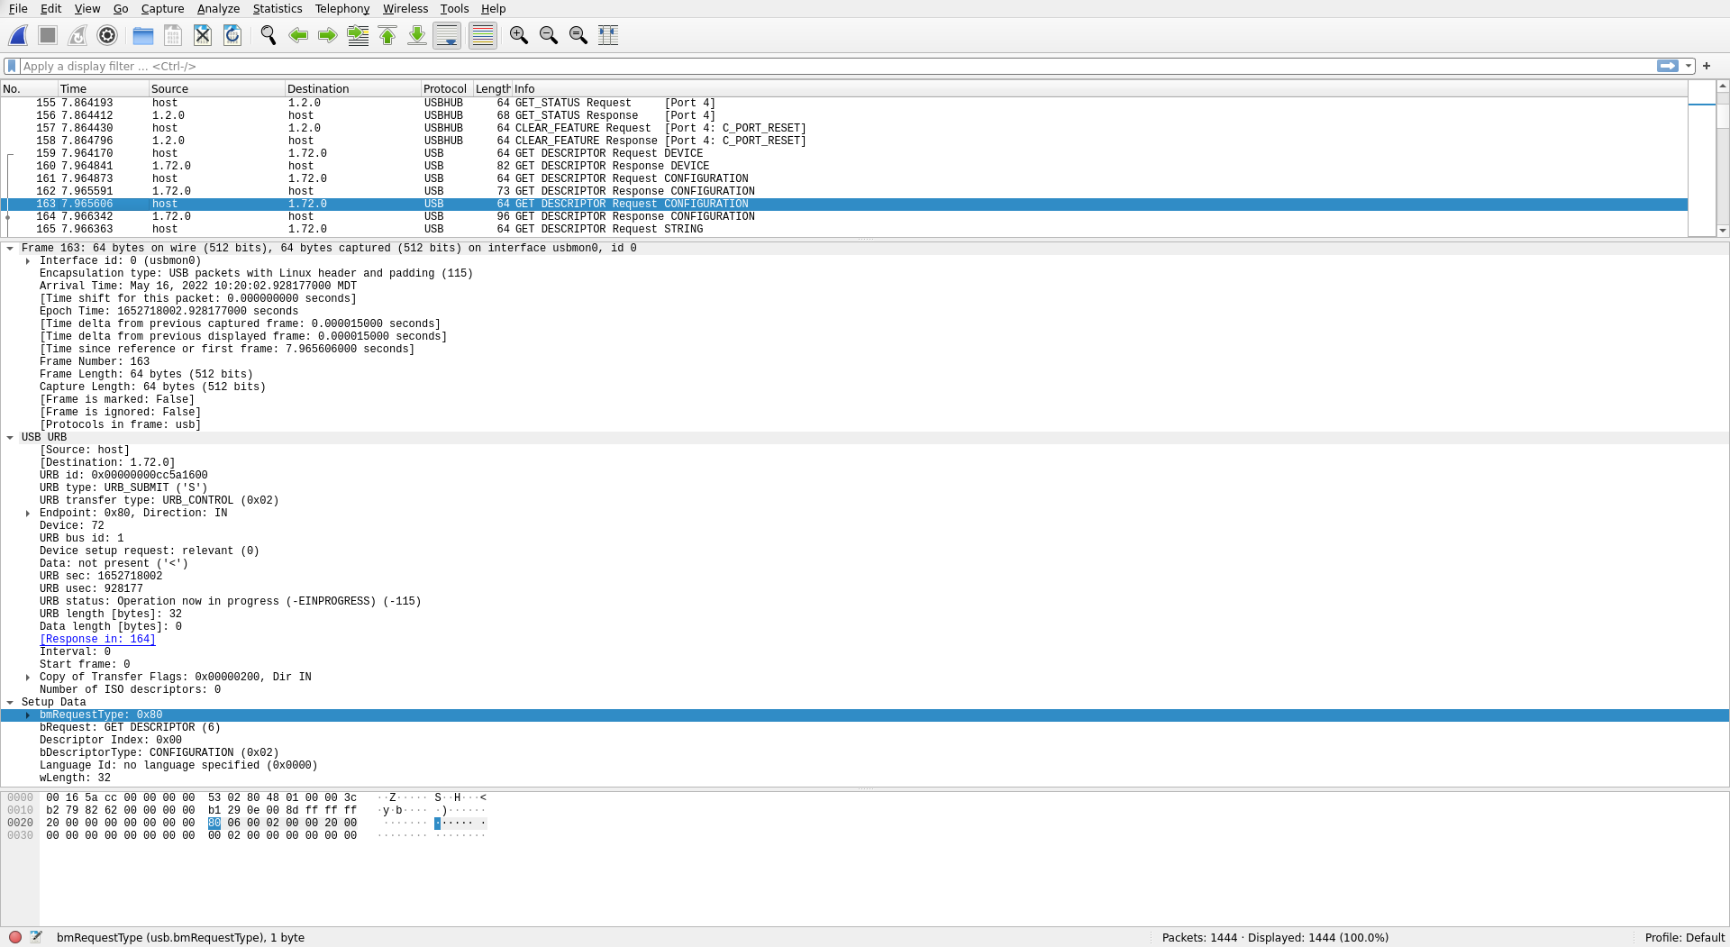
image 5

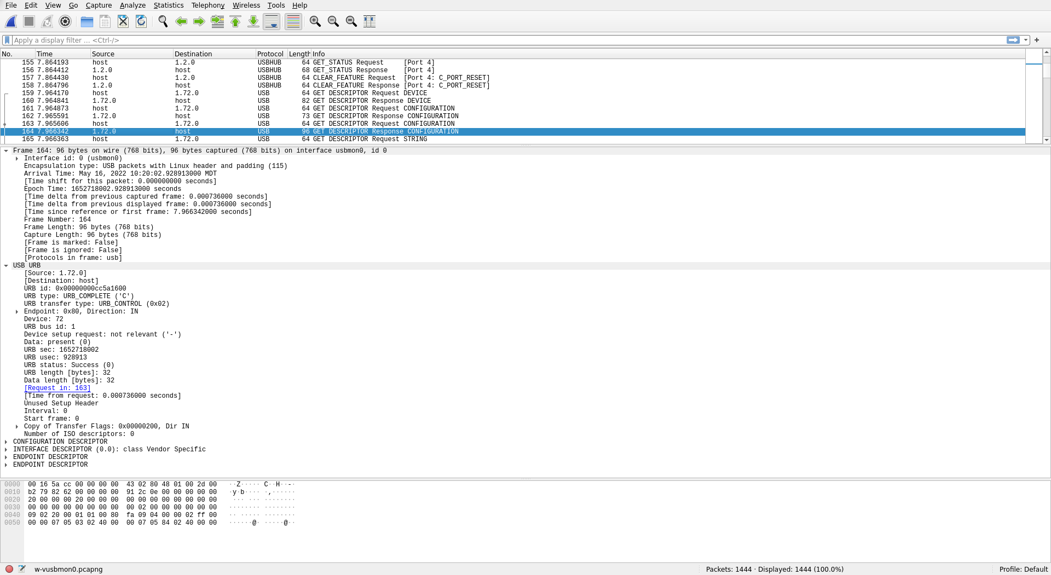
image 6

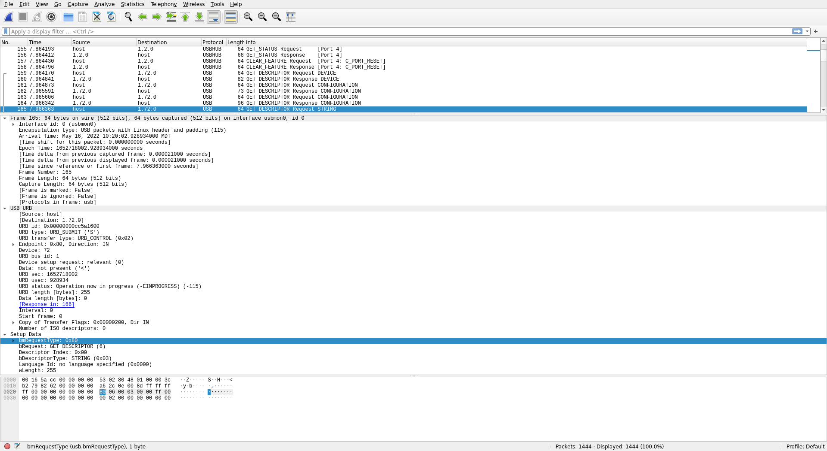
Appendix A.
sudo ./picotool help
PICOTOOL:
Tool for interacting with a RP2040 device in BOOTSEL mode, or with a RP2040
binary

SYNOPSYS:
picotool info [-b] [-p] [-d] [-l] [-a] [--bus <bus>] [--address <addr>] [-f]
[-F]
picotool info [-b] [-p] [-d] [-l] [-a] <filename> [-t <type>]
picotool load [-n] [-N] [-v] [-x] <filename> [-t <type>] [-o <offset>]
[--bus <bus>] [--address <addr>] [-f] [-F]
picotool save [-p] [--bus <bus>] [--address <addr>] [-f] [-F] <filename> [-t
<type>]
picotool save -a [--bus <bus>] [--address <addr>] [-f] [-F] <filename> [-t
<type>]
picotool save -r <from> <to> [--bus <bus>] [--address <addr>] [-f] [-F]
<filename> [-t <type>]
picotool verify [--bus <bus>] [--address <addr>] [-f] [-F] <filename> [-t
<type>] [-r <from> <to>] [-o <offset>]
picotool reboot [-a] [-u] [--bus <bus>] [--address <addr>] [-f] [-F]
picotool version [-s]
picotool help [<cmd>]

COMMANDS:
info Display information from the target device(s) or file.
Without any arguments, this will display basic information for all
connected RP2040 devices in BOOTSEL mode
load Load the program / memory range stored in a file onto the device.
save Save the program / memory stored in flash on the device to a file.
verify Check that the device contents match those in the file.
reboot Reboot the device
version Display picotool version
help Show general help or help for a specific command

Use "picotool help <cmd>" for more info

