***************Draft***************
Kanade-Lucas-Tomasi feature tracker
03/13/22
Raspberry Pico
***************Draft***************

Goals of klt-test:

Create a library for the pico with the C from

**********************************************************************
NOTICE:

This code is now in the public domain. The Stanford Office of
Technology Licensing has removed all licensing restrictions.

**********************************************************************

KLT
An implementation of the Kanade-Lucas-Tomasi feature tracker

Version 1.3.4

Authors: Stan Birchfield
stb@clemson.edu

Thorsten Thormaehlen
thormae@tnt.uni-hannover.de
(implemented affine code)

Thanks to many others for various bug fixes.

Date: August 30, A.D. 2007
May 10, A.D. 2007
March 28, A.D. 2006
November 21, A.D. 2005
August 17, A.D. 2005
June 16, A.D. 2004
October 7, A.D. 1998

The code can be obtained from http://www.ces.clemson.edu/~stb/klt
(alternatively http://www.vision.stanford.edu/~birch/klt),
where the official manuals reside. For your convenience, unofficial
manuals have been placed in the current subdirectory 'doc'.
Starting with 64 X 64 image


Finding The Principal component analysis (PCA)



Trying to add the following code to /rp2040-freertos-project this following the freertos libarary steps.

allocate.c error.c klt_util.c selectGoodFeatures.c
convolve.c klt.c pyramid.c

~/rp2040-freertos-project/build $ cmake ../

~/rp2040-freertos-project/build $ make

openocd -f interface/raspberrypi-swd.cfg -f target/rp2040.cfg -c "program klt-test/klt-test.elf verify reset exit"

sudo minicom -s
scroll down Serial port setup
Enter
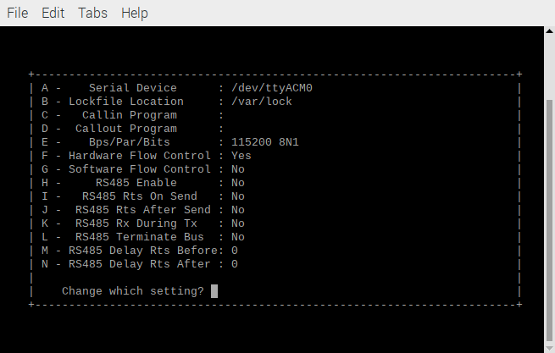
q
Need to change the baud rate to 1M

Depress E

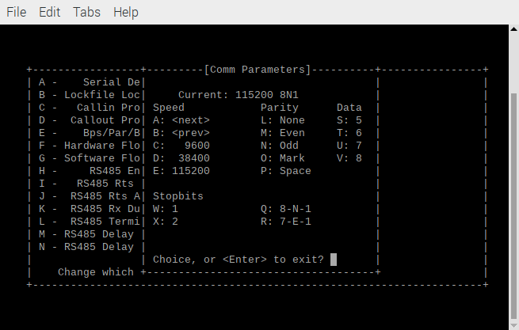
Depress A 6 times.

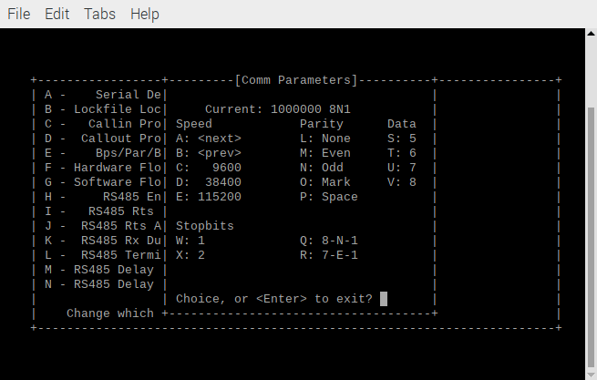
Depress Enter
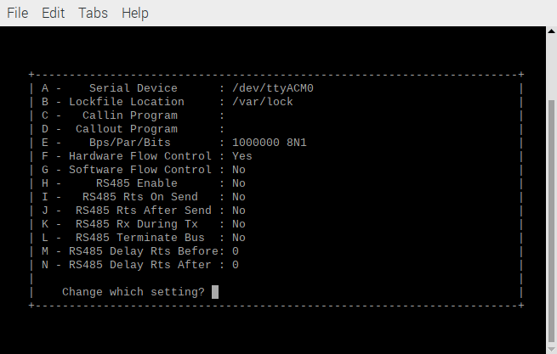

Depress Enter

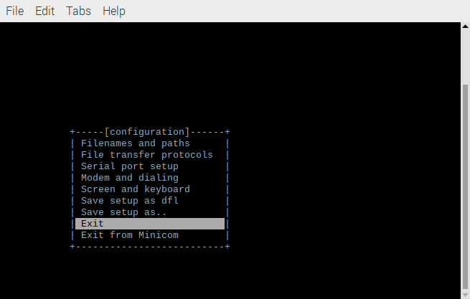

Scroll down to Exit Depress Enter

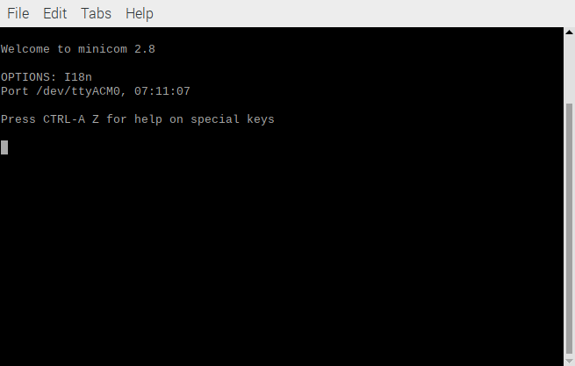
openocd -f interface/raspberrypi-swd.cfg -f target/rp2040.cfg -c "program klt-test/klt-test.elf verify reset exit"

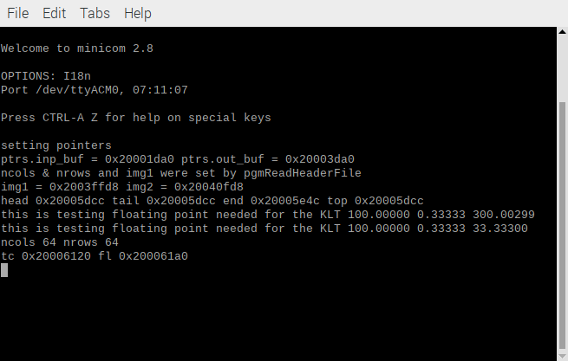

ctrl A S Scroll down to ascii

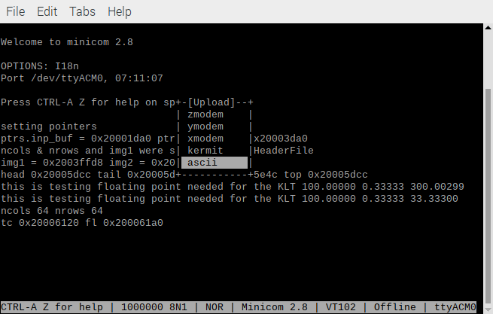
Depress Enter

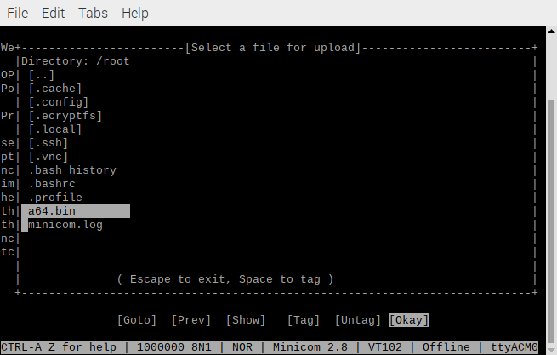
Scroll down to a64.bin Depress Enter

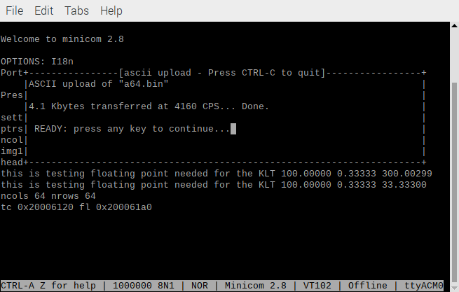
Depress Enter

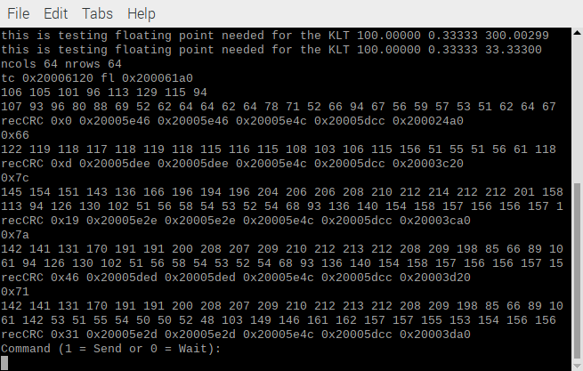
Depress 1

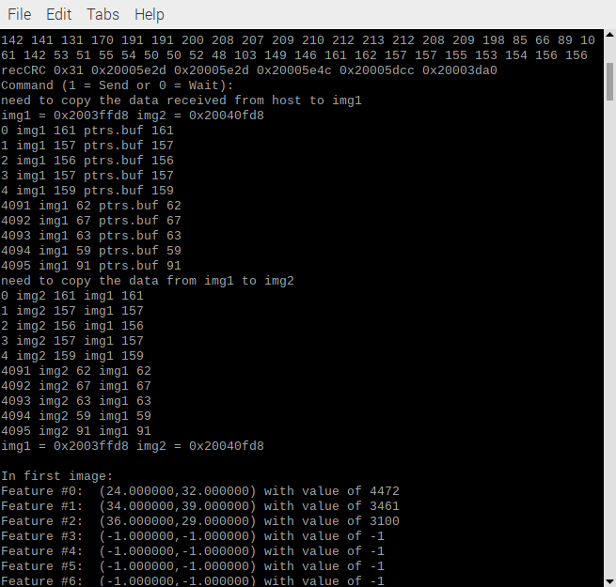

When img0.pgm and img1.pgm both have the 64 x 64 image lena_rgb_64.pgm from
/pico-lifting/testfiles/ and the program
./example1 is executed in klt-feature-detect/klt. The image feat2.ppm is created.
The Principal component analysis (PCA) are in feat1.txt
In first image:
Feature #0: (32.000000,24.000000) with value of 4472
Feature #1: (39.000000,34.000000) with value of 3461
Feature #2: (29.000000,36.000000) with value of 3100

