*************************Draft*************************
Converting a project kltdwt-ultibo/main.c to a freeRTOS project
pico-ultibo/main.c
Testing several freeRTOS features Tasks, Mutex, Semaphores, Events, and Streams
04/19/2022
*************************Draft*************************

openocd -f interface/raspberrypi-swd.cfg -f target/rp2040.cfg -c "program 2tasks/2tasks.elf verify reset exit"

openocd -f interface/raspberrypi-swd.cfg -f target/rp2040.cfg -c "program kltdwt-ultibo/kltdwt-ultibo.elf verify reset exit"

03/27/22
Merged Ultibo_Projects/picotransfer/RPi3/FileHandling.lpr with Ultibo_Projects/picoledonoff/RPI3/picoledonoff.lpr.
into Ultibo_Projects/picotransfer/RPi3/picokltdwtultibo.lpr. Now the hw version can read & parse one of
2 64 x 64 image found in a64.bin or bb.bin. Starting with rp2040-freertos-project/klt-test/main.c. Made modifications in rp2040-freertos-project/kltdwt-ultibo/main.c
which now sends Sync until a '4' is sent from the host. Then it sends Ready and expects 4160 characters of data
which make up a 64 x 64 image with a CRC added added to each row. The pico processes the image
and sends "Command (1 = Send or 0 = Wait):" When the '1' is received the pico sends the results of the
"klt-feature-detect" and then with the "dwt lifting step".

With a Semaphore

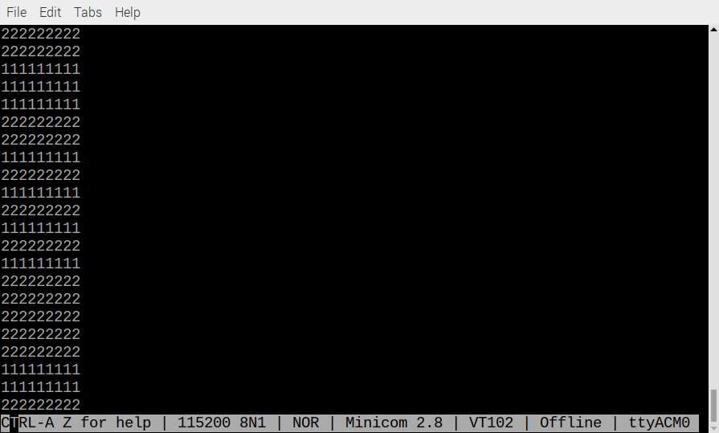
Without a Semaphore

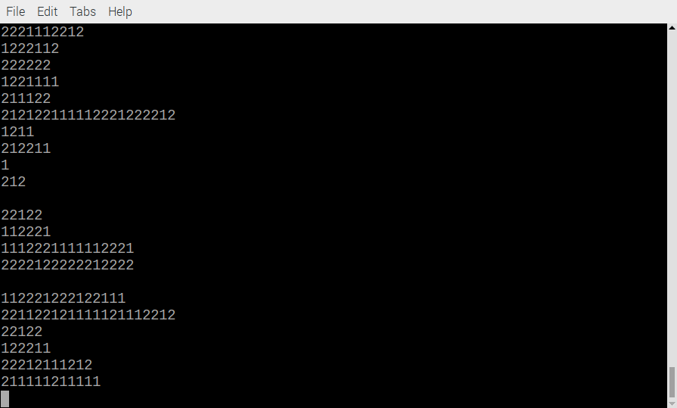

In the image below two tasks display either 1111111111 or 2222222222. If a Semaphore was not used
Xx
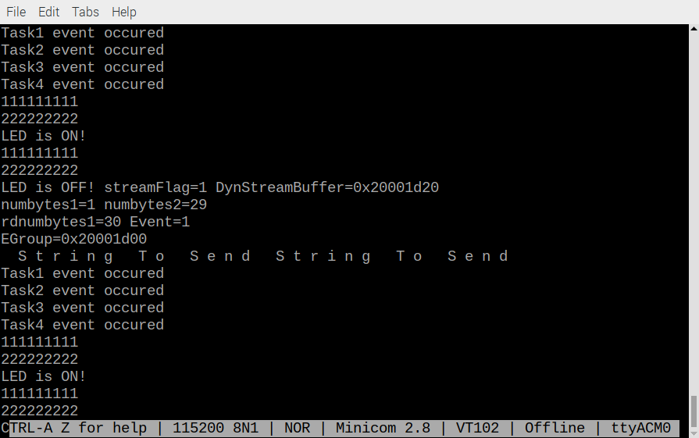

Xx

