***************************Default***************************
RPi4B+ Raspberry Pi O/S
with multiple Picos connected on USB
Programming the Pico with picotool
05/18/2022
***************************Default***************************

Testing 3 pico connected to RPi4B+ 8Gb
ttyACM0, ttyACM1, and ttyACM2
lsusb
Bus 002 Device 001: ID 1d6b:0003 Linux Foundation 3.0 root hub
Bus 001 Device 026: ID 2e8a:000a Raspberry Pi Pico
Bus 001 Device 027: ID 2e8a:000a Raspberry Pi Pico
Bus 001 Device 005: ID 046d:c534 Logitech, Inc. Unifying Receiver
Bus 001 Device 029: ID 2e8a:000a Raspberry Pi Pico
Bus 001 Device 003: ID 058f:6254 Alcor Micro Corp. USB Hub
Bus 001 Device 002: ID 2109:3431 VIA Labs, Inc. Hub
Bus 001 Device 001: ID 1d6b:0002 Linux Foundation 2.0 root hub

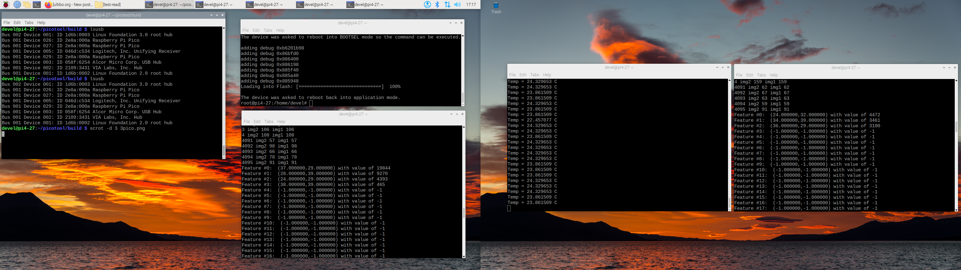
pico on lower left monitor used bb.bin test-read freeRTOS (klt-feature-detect & dwt lifting) step

3 img2 106 img1 106
4 img2 108 img1 108
4091 img2 57 img1 57
4092 img2 98 img1 98
4093 img2 66 img1 66
4094 img2 78 img1 78
4095 img2 91 img1 91
Feature #0: (37.000000,29.000000) with value of 19844
Feature #1: (28.000000,39.000000) with value of 9270
Feature #2: (24.000000,29.000000) with value of 4393
Feature #3: (38.000000,39.000000) with value of 465

pico on far right 2nd monitor used a64.bin test-read freeRTOS (klt-feature-detect & dwt lifting) step
4 img2 159 img1 159
4091 img2 62 img1 62
4092 img2 67 img1 67
4093 img2 63 img1 63
4094 img2 59 img1 59
4095 img2 91 img1 91
Feature #0: (24.000000,32.000000) with value of 4472
Feature #1: (34.000000,39.000000) with value of 3461
Feature #2: (36.000000,29.000000) with value of 3100
Feature #3: (-1.000000,-1.000000) with value of -1
Feature #4: (-1.000000,-1.000000) with value of -1

pico on left of 2nd monitor running multi-core Temperature

Re programmed 1 of the pico to rp2040-logic-analyzer.elf



