**************************Draft**************************
Testing the pshell project for addition to rp2040-freertos-project
The initial work consisted of 2 repos pshell & littlefs
which provides a flash file system & vi
05/26/22
**************************Draft**************************

picotool info --bus 1 --address 6 -f -a
The device was asked to reboot into BOOTSEL mode so the command can be executed.

Program Information
name: pshell
features: UART stdin / stdout
USB stdin / stdout
binary start: 0x10000000
binary end: 0x1001be8c

Fixed Pin Information
0: UART0 TX
1: UART0 RX

Build Information
sdk version: 1.3.0
pico_board: pico
boot2_name: boot2_w25q080
build date: May 22 2022
build attributes: Release

Device Information
flash size: 2048K
ROM version: 2

The device was asked to reboot back into application mode.

picotool info --bus 1 --address 8 -f -a
The device was asked to reboot into BOOTSEL mode so the command can be executed.

Program Information
name: test-read-crc16
features: USB stdin / stdout
binary start: 0x10000000
binary end: 0x10014834

Fixed Pin Information
none

Build Information
sdk version: 1.3.0
pico_board: pico
boot2_name: boot2_w25q080
build date: May 25 2022
build attributes: Release

Device Information
flash size: 2048K
ROM version: 2

The device was asked to reboot back into application mode.
Only required “Ultibo_Projects/rebuild-repo.sh” if the rp2040-freertos-project is not present or a fresh start is desired.
cd rp2040-freertos-project/build/
cmake ..
make
An 8 bit crc working in “rp2040-freertos-project”
These are the files from pshell that are now compiled in the libcrc16.a

9 20 158 crc16.h
130 475 4015 fs.h
6 21 134 vi.h
19 46 328 xcommon.h
10 23 202 xreceive.h
8 19 154 xtransmit.h
to libcrc16.a
arm-none-eabi-ar t crc16/libcrc16.a
crc16.c.obj
head-tail.c.obj
cvtutils.c.obj
lfs_util.c.obj
lfs.c.obj
fs.c.obj
xreceive.c.obj
xtransmit.c.obj
vi.c.obj
The pshell project has crc16. I created a library
https://github.com/develone/rp2040-freertos-project/tree/master/crc16
https://github.com/develone/rp2040-freertos-project/blob/master/crc16/CMakeLists.txt

This is still a WIP to add other files to library vi.c

set(PICO_SDK_CRC16_SOURCE CRC16-Files)

add_library(crc16
${PICO_SDK_CRC16_SOURCE}/crc16.c
${PICO_SDK_CRC16_SOURCE}/head-tail.c
${PICO_SDK_CRC16_SOURCE}/cvtutils.c
${PICO_SDK_CRC16_SOURCE}/lfs_util.c
${PICO_SDK_CRC16_SOURCE}/lfs.c
${PICO_SDK_CRC16_SOURCE}/fs.c
${PICO_SDK_CRC16_SOURCE}/xreceive.c
${PICO_SDK_CRC16_SOURCE}/xtransmit.c
${PICO_SDK_CRC16_SOURCE}/vi.c

)

target_include_directories(crc16 PUBLIC
.
${PICO_SDK_CRC16_SOURCE}/include
${PICO_SDK_CRC16_SOURCE}/hardware

${PICO_SDK_CRC16_SOURCE}/portable/GCC/ARM_CM0
)

https://github.com/develone/rp2040-freertos-project/blob/master/doc/libcrc16.dis

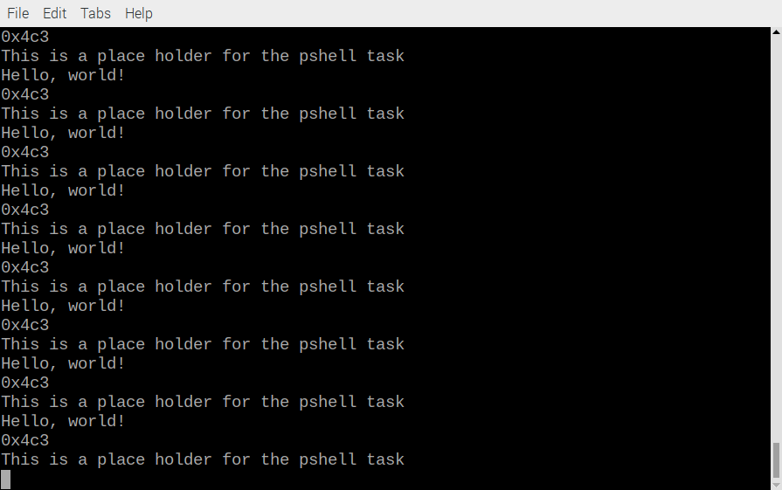
from repo pshell crc16.c crc16.h from repo littlefs lfs.c lfs_util.c lfs.h lfs_util.h
from libcrc.a repo rp2040-freertos-project cvtutils.c head-tail.c head-tail.h
These now are used to create libcrc16.a

from the repo pshell fs.h vi.c xcommon.h xreceive.h xtransmit.h fs.c vi.h xreceive.c xtransmit.c
fs.c has the following .h files which prevents from being included in libcrc16.a
#include "hardware/flash.h"
#include "hardware/regs/addressmap.h"
#include "hardware/sync.h"

xreceive.c & xtransmit.c have the following .h files which prevents from being included in libcrc16.a
#include "pico/stdlib.h"

vi.c has the following .h files which prevents from being included in libcrc16.a
#include "pico/stdlib.h"

The files from pshell & littlefs could not be include in libcrc16.a fs.h vi.h xreceive.c xtransmit.c fs.c vi.c xcommon.h xreceive.h xtransmit.h

Now in the libcrc16.a
crc16.h lfs.h lfs_util.h crc16.c lfs.c lfs_util.c

From previous libcrc.a head-tail.h head-tail.c cvtutils.c

The library also provides a circular buffer.
The library was tested on a pico with the following

https://github.com/develone/rp2040-freertos-project/blob/master/test-read-crc16/main.c

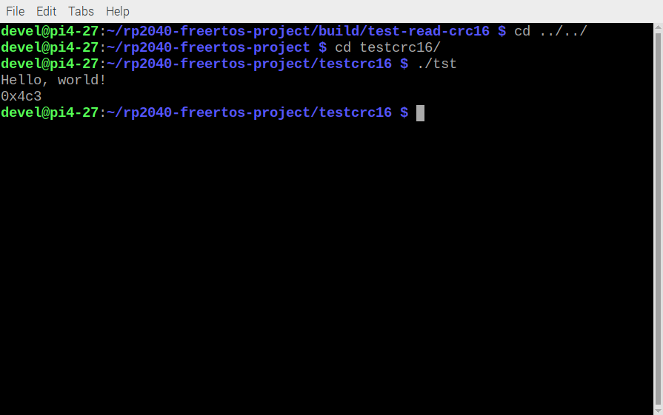

Testing in Linux RPi4B+ 8Gb Raspberry Pi O/S
rp2040-freertos-project/testcrc16-RPi

One of the Ultibo members post the folloing
https://ultibo.org/forum/viewtopic.php?f=9&t=1640&start=30

by Gavinmc42 »
This is interesting, talk about about adding Pascal to it.
https://forums.raspberrypi.com/viewtopic.php?t=323018
With a shell, editor and Pascal, OTA update of just the Pascal code should be smaller/quicker?
Hmm, should look at OTA of Micropython on Picos or has that been done?

Forked “https://github.com/lurk101/pshell”
“git clone git@github.com:develone/pshell.git”

“cd pshell”

“git submodule update –init”

mkdir build

cd build

cmake ..

make

The image below is running test-read-crc16.elf

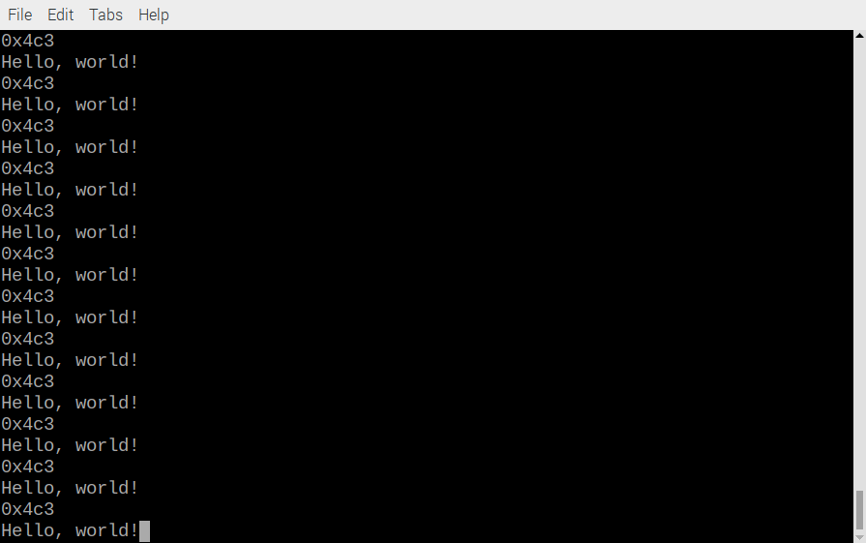
First needed format followed by mount

Created tt.txt using vi from the pshell

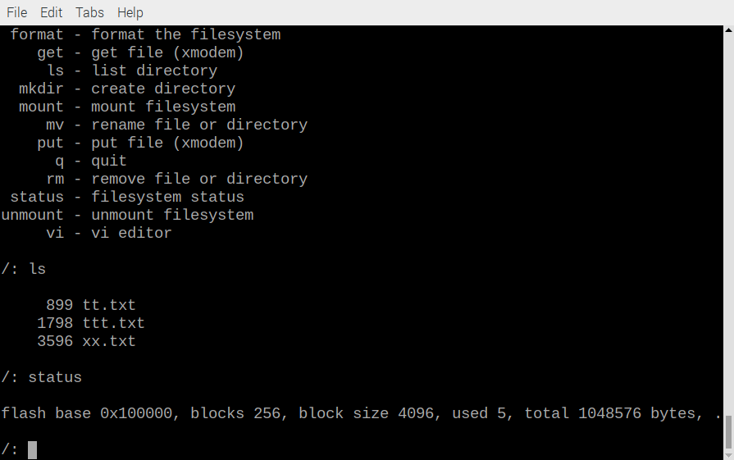
m

m
The image below is using the vi command

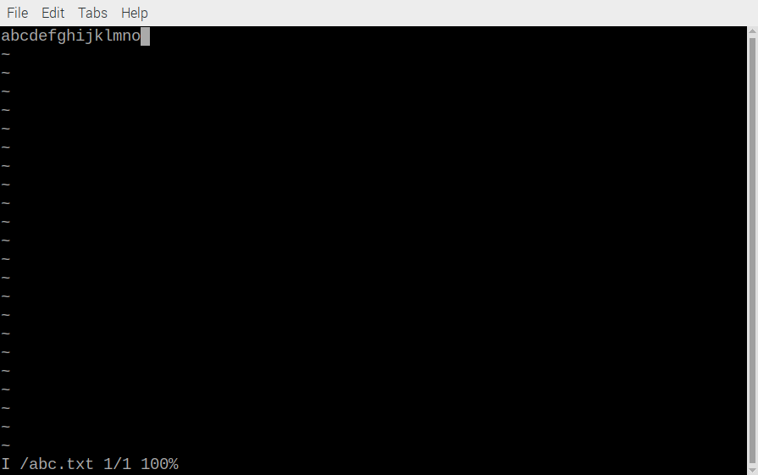
m

