************************Draft************************
Testing Pico running freertos an pshell
06/06/22
************************Draft************************

All of the code was developed on the Raspberry Pi 4 B with 8Gb

openocd050322-610f137 is used to download the execrable to the pico.

https://github.com/develone/pico-sdk

23 authors SDK 1.3.0 release
2062372

Raspberry Pi 4

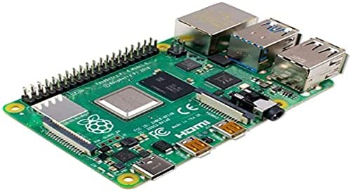

Raspberry Pico.

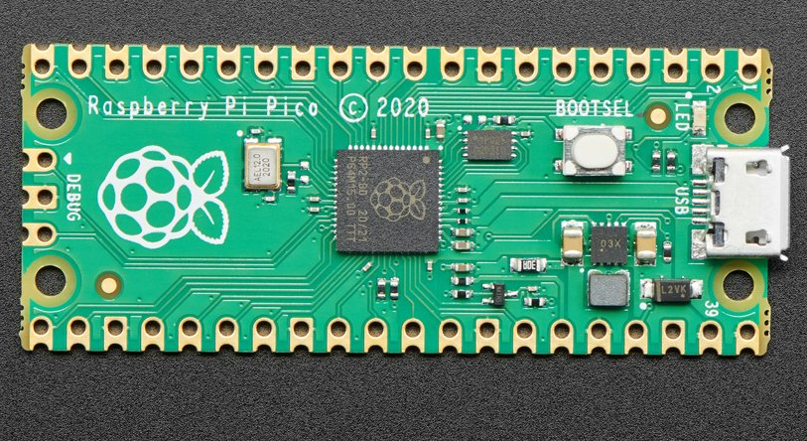

Back
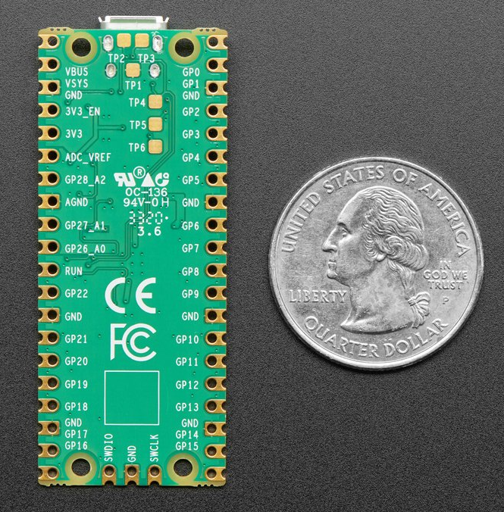

Raspberry Pi Pico RP2040
Product ID: 4864
$4.00

- 21 mm × 51 mm form factor
- RP2040 microcontroller chip designed by Raspberry Pi in the UK
- Dual-core Arm Cortex-M0+ processor, flexible clock running up to 133 MHz
- 264KB on-chip SRAM
- 2MB on-board QSPI Flash
- 26 multifunction GPIO pins, including 3 analogue inputs
- 2 × UART, 2 × SPI controllers, 2 × I2C controllers, 16 × PWM channels
- 1 × USB 1.1 controller and PHY, with host and device support
- 8 × Programmable I/O (PIO) state machines for custom peripheral support
- Supported input power 1.8–5.5V DC
- Operating temperature -20°C to +85°C
- Castellated module allows soldering direct to carrier boards
- Drag-and-drop programming using mass storage over USB
- Low-power sleep and dormant modes
- Accurate on-chip clock
- Temperature sensor
- Accelerated integer and floating-point libraries on-chip

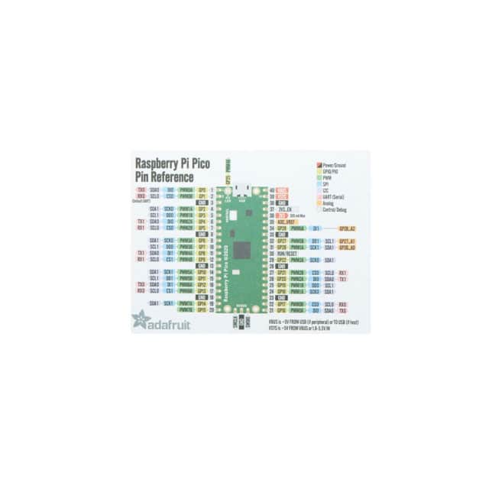

“git clone --recursive git@github.com:develone/rp2040-freertos-project -b dev”

“cd rp2040-freertos-project”

“mkdir build”

“cd build”

“cmake ..”

“make”

lsusb
Bus 002 Device 001: ID 1d6b:0003 Linux Foundation 3.0 root hub
Bus 001 Device 006: ID 046d:c534 Logitech, Inc. Unifying Receiver
Bus 001 Device 005: ID 0403:6001 Future Technology Devices International, Ltd FT232 Serial (UART) IC
Bus 001 Device 004: ID 058f:6254 Alcor Micro Corp. USB Hub
Bus 001 Device 003: ID 2e8a:000a Raspberry Pi Pico
Bus 001 Device 002: ID 2109:3431 VIA Labs, Inc. Hub
Bus 001 Device 001: ID 1d6b:0002 Linux Foundation 2.0 root hub

Note: The picotool command needs to be run with sudo or as root. Also
export PICOTOOL=/home/devel/picotool/build/ This can be setup with
“. Ultibo_Projects/picoultibo.sh”

picotool info --bus 1 --address 3 -f -a
The device was asked to reboot into BOOTSEL mode so the command can be executed.

Program Information
name: test-read-crc16
features: UART stdin / stdout
USB stdin / stdout
binary start: 0x10000000
binary end: 0x1002662c

Fixed Pin Information
0: UART0 TX
1: UART0 RX

Build Information
sdk version: 1.3.0
pico_board: pico
boot2_name: boot2_w25q080
build date: Jun 3 2022
build attributes: Release

Device Information
flash size: 2048K
ROM version: 2

The device was asked to reboot back into application mode.

Programmed the pico with the following command.
openocd -f interface/raspberrypi-swd.cfg -f target/rp2040.cfg -c "program test-read-crc16/test-read-crc16.elf verify reset exit"

In a shell running “minicom -s”

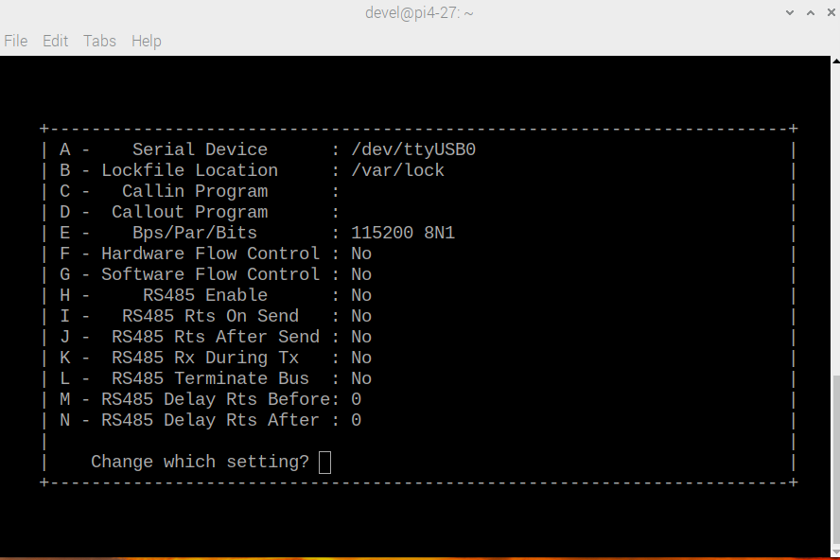
The help menu

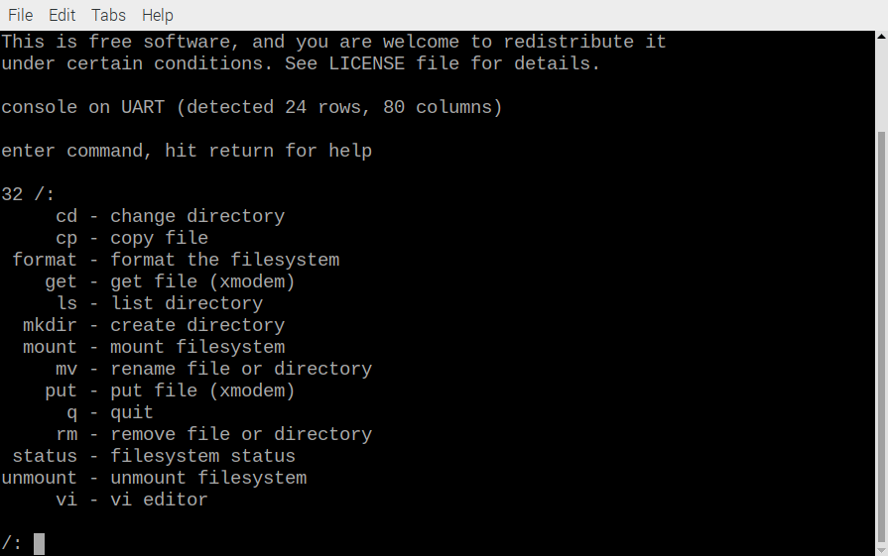
/: mount
6 mount mount filesystem
mounted
/:

vi f1.txt

Using mousepad on RPi4B 8Gb wrote 5 lines of text

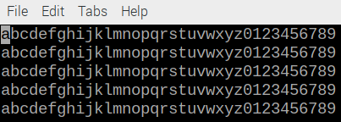
This was pasted in a vi f1.txt

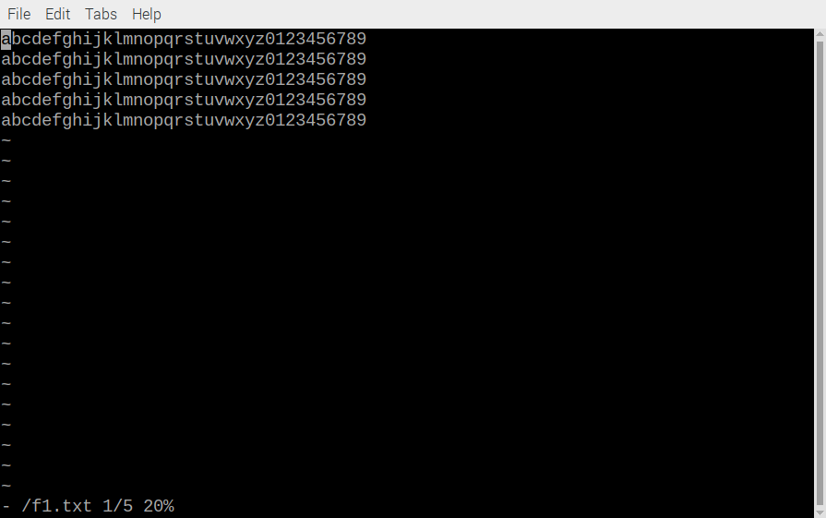
Esc :
w
Esc :
q
185 f1.txt

-rw-r--r-- 1 devel devel 184 Jun 4 07:29 o1.txt

The file was downloaded from pico to RPi4

get f1.txt

CtrlAS

The download loaded is padded after the 5 lines of text.

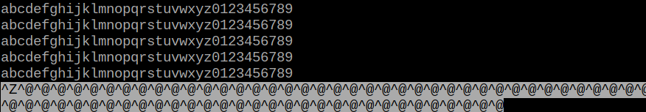

The file was downloaded from pico to RPi4

Using mousepad on RPi4B 8Gb wrote 10 lines of text
This was pasted in a vi f2.txt

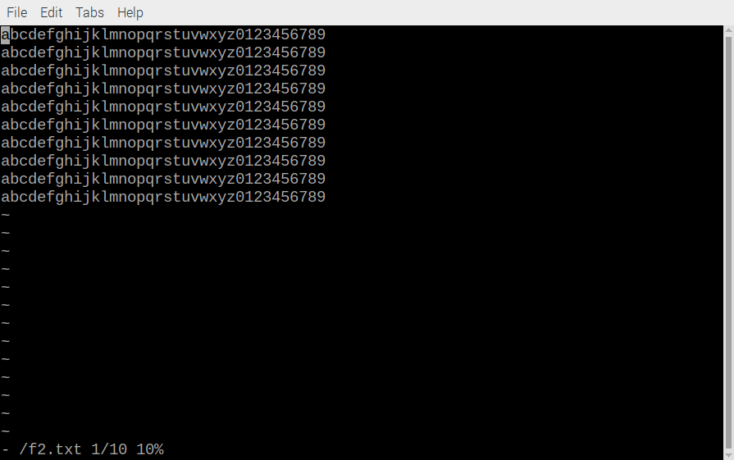
Esc :
w
Esc :
q

370 f2.txt

-rw-r--r-- 1 devel devel 369 Jun 4 07:29 /home/devel/o2.txt

get f2.txt

CtrlAS

The download loaded is padded after the 10 lines of text.

