***************************Default***************************
Pico Demo
02/28/24
***************************Default***************************

The program on the Raspberry Pico which has the power shell, littlefs, and processing dwt & klt.

git clone --recursive git@github.com:develone/rp2040-freertos-project.git -b dev

cd rp2040-freertos-project
The files used to create the uf2 & elf files

/rp2040-freertos-project/test-read-crc16 $ ls
CMakeLists.txt crc16.h main.c test-files xcommon.h
comprogs.h fs.c main.c.128 vi.c xreceive.h
comprogs.h.128 fs.h pshell.h vi.h xtransmit.h
compile.sh

This is the contents of the script compile.sh

#!/bin/bash
rm -rf build
mkdir build
cd build/
cmake -DPICO_BOARD=pico -DFREERTOS_KERNEL_PATH:PATH=../freertos/FreeRTOS-Kernel/ ..
make

CMakeLists.txt file

add_executable(test-read-crc16
main.c crc16.h xreceive.h xtransmit.h fs.c fs.h vi.c vi.h comprogs.h
)

target_link_libraries(test-read-crc16 pico_stdlib xmodem freertos lifting crc_crc16 cir-buf klt littlefs)

pico_enable_stdio_usb(test-read-crc16 1)
pico_enable_stdio_uart(test-read-crc16 1)

pico_add_extra_outputs(test-read-crc16)
This is the Pico and FTDI to USB hardware setup.

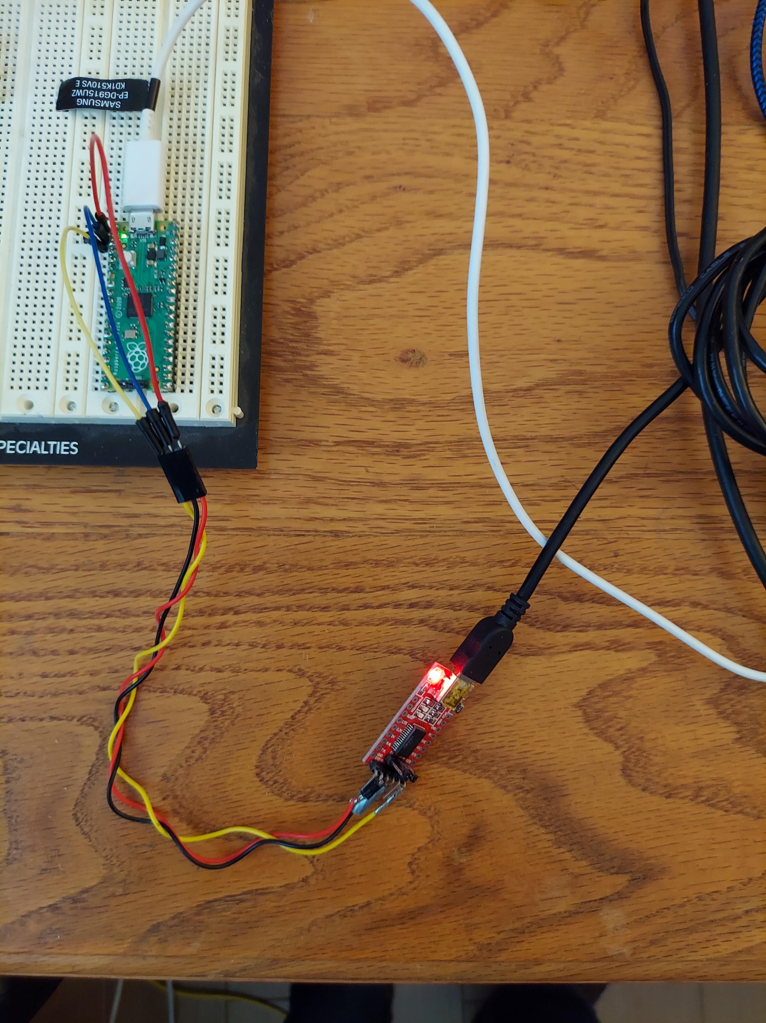
Minicom is used to communicate with the Pico.

After programming the Pico with /home/devel/rp2040-freertos-project/build/test-read-crc16/test-read-crc16.uf2

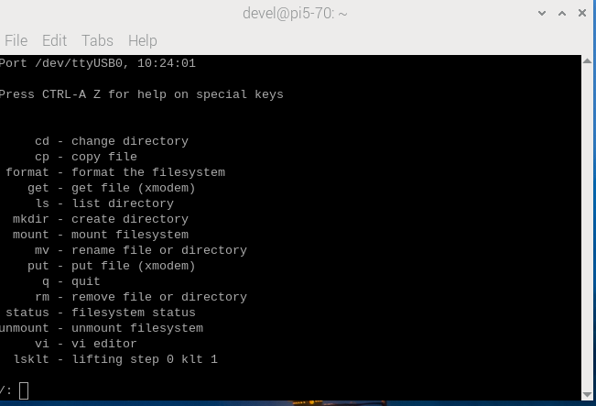
xx
The status command

/: status
11 status filesystem status

flash base 0x100000, blocks 256, block size 4096, used 2, total 1048576 bytes,.

/:
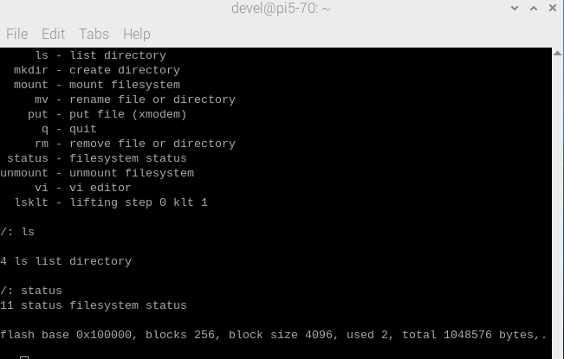
xx
The files were sent to the Pico using the put xx command which uses xmodem to send the file.

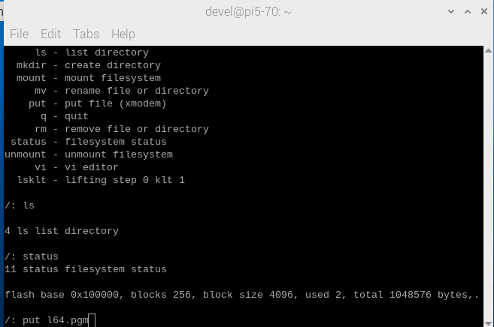

When the CR is depressed you need to depress ESC Ctrl A S

Select the Upload methon Xmodem.

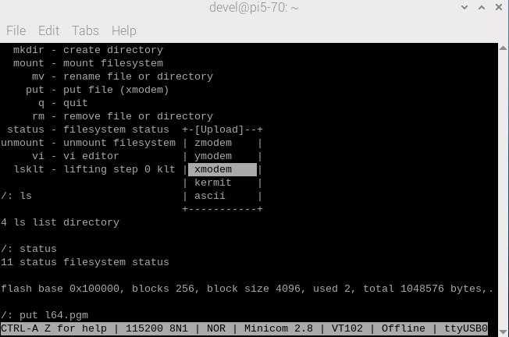

Select the file to be transferred.

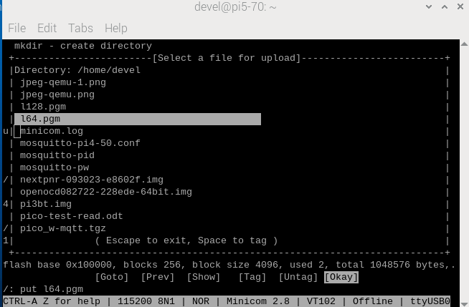

Now the ls command displays the recently transferred file.

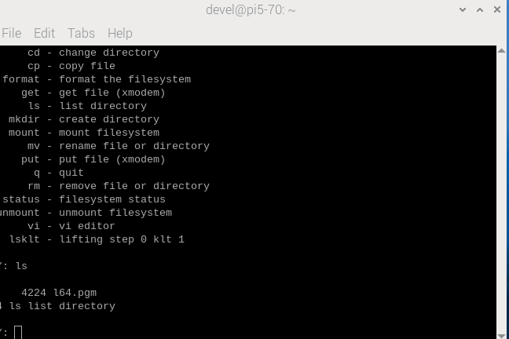

When files have been transferred from the Raspberry Pi to Pico the command ls shows the following.

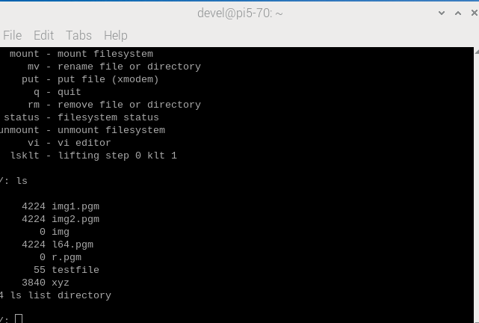
Xx
At this point the dwt or KLT can be done on the l64.pmg

lsklt l64.pgm r.pgm 0 or lsklt l64.pgm r.pgm 1

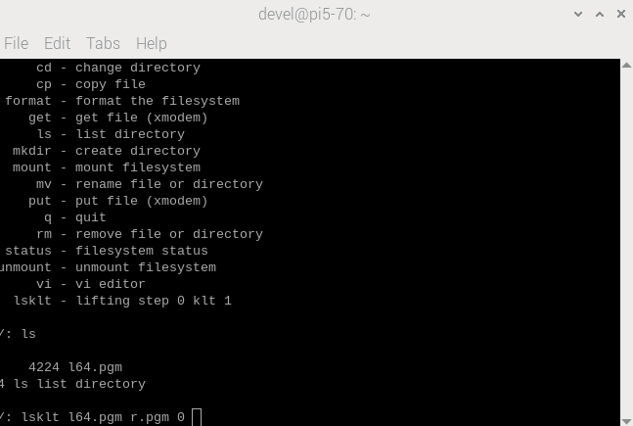

4 l64.pgm r.pgm 0
0
P5
# Created by GIMP version 2.10.8 PNM plug-in64 64
255
161 159 157 155 160 170 168 134 97 106 109 109 109 117 124 129 132 133 132 133
opening a file to write the results
need to copy the data received from host to img1
img1 = 0x200042f4 img2 = 0x200052f4
0 img1 161 ptrs.buf 161
1 img1 159 ptrs.buf 159
2 img1 157 ptrs.buf 157
3 img1 155 ptrs.buf 155
4 img1 160 ptrs.buf 160
4091 img1 123 ptrs.buf 123
4092 img1 94 ptrs.buf 94
4093 img1 58 ptrs.buf 58
4094 img1 61 ptrs.buf 61
4095 img1 91 ptrs.buf 91
need to copy the data from img1 to img2
0 img2 161 img1 161
1 img2 159 img1 159
2 img2 157 img1 157
3 img2 155 img1 155
4 img2 160 img1 160
4091 img2 123 img1 123
4092 img2 94 img1 94
4093 img2 58 img1 58
4094 img2 61 img1 61
4095 img2 91 img1 91
lifting step
64 0x200063b4 0x200083b4 01
2 0 -3 2 -1 0 0 0 1 -2 1 2 2 -1 0 0 1 0 -1 0 10 0 -2 0 0 18 -7 26 -1 1 2 -25 3
0 3 3 -4 0 3 0 -1 1 1 0 2 -1 1 0 2 0 1 2 0 1 1 -2 0 0 0 -1 -34 0 1 15 -30 0 0
0 0 0 0 0 2 1 -1 1 -1 1 1 0 0 -2 4 1 0 -1 2 1 -2 1 0 0 1 -15 28 11 12 -33 2 0
-4 7 -1 0 0 1 0 1 1 2 0 2 4 2 4 11 -9 13 0 1 0 2 0 -1 1 -1 7 10 -18 -32 5 0 4
2 -9 2 -1 -1 1 1 1 1 -7 -8 -1 -3 0 4 -2 -7 34 -29 1 -1 -1 -4 6 -1 2 1 -41 -36
19 6 0 -1 2 -1 0 -1 1 8 4 0 0 -1 0 8 -6 6 11 -46 -2 0 5 -5 -2 0 -6 17 11 -8 -3
-14 0 1 0 0 0 2 0 -10 1 -1 2 1 1 -10 14 -1 4 1 31 -37 0 2 1 10 -5 27 -3 -4 -3
4 -2 1 1 0 -1 2 5 20 0 -4 4 19 -6 -9 -9 0 0 -1 -2 47 17 0 30 -6 4 -70 -1 2 -29
-1 1 1 1 2 -1 1 -1 -6 -3 -3 14 21 -8 6 3 -1 0 9 0 -22 -23 -3 59 4 -6 23 0 16 3
0 2 0 2 0 0 1 -7 -2 4 6 12 -14 0 5 7 -3 2 3 -4 7 -2 -2 1 1 -3 -29 0 -16 -11 -1
0 -3 1 2 1 1 1 3 3 -1 17 -17 -4 -4 -1 -3 -6 -1 -1 -13 0 2 -2 -6 -8 -20 -2 2 12
-2 -1 -1 0 0 1 -1 1 3 -1 -16 -5 -3 -13 2 23 -15 12 17 3 -1 0 -5 14 -55 -17 -1
0 0 -2 0 2 1 0 -8 -6 -6 -4 0 8 -12 -9 -22 -24 18 3 0 -3 38 -18 -15 2 21 3 14 0
2 1 1 3 1 1 2 8 -6 5 4 17 -1 -15 -5 10 -10 -2 -3 -6 -1 5 9 -15 18 -1 -14 -3 -2
-1 -1 1 2 1 1 -2 2 -5 -8 24 1 7 -6 11 22 -6 4 -14 -1 0 4 -8 -5 0 6 14 4 -4 1 2
1 1 -1 1 1 1 0 1 8 11 -6 -8 -16 11 0 2 43 -7 9 -1 -9 27 -6 1 4 -6 -9 -1 2 2 -2
0 2 -1 -1 1 2 -3 -1 26 -23 1 34 34 -44 -8 41 -1 -40 16 -8 18 -21 8 3 0 -8 5 1
-1 0 0 0 2 13 -7 37 4 8 5 -4 14 20 45 13 -18 -28 -6 14 12 -29 2 -1 -2 6 0 -2 0
2 0 0 2 0 6 -2 -5 12 9 16 -16 -3 49 12 0 2 1 1 0 6 2 0 8 0 -5 -1 1 0 -13 13 -3
-1 0 1 0 -7 9 14 3 7 -8 -30 18 -10 -69 1 0 -1 0 -2 -1 -1 5 3 -1 -13 1 2 -1 7 1
2 2 -1 0 9 -9 2 -12 33 7 31 21 27 16 0 0 1 2 7 -10 4 0 -3 4 3 0 2 0 -4 -3 1 2
3 -1 -1 0 -3 -3 14 -3 -11 -12 4 9 18 -6 2 2 -7 1 -8 0 -11 -4 0 -1 3 1 0 1 1 -1
-3 -1 0 0 31 15 -14 8 30 23 -56 -44 6 5 3 1 4 -6 5 -7 0 -3 2 -11 -1 1 -1 2 1 -
0 11 -2 0 1 8 12 -5 -6 -32 -37 2 -1 5 -2 8 -1 2 8 8 -1 2 1 -3 -2 0 0 1 -6 2 -3
-8 -1 1 6 24 1 10 31 -16 11 -21 11 -1 -5 -5 -6 2 2 8 11 -24 14 1 -2 -13 2 3 1
20 -9 3 5 -5 -25 -15 -33 13 9 -23 -18 -1 2 -2 -1 -3 0 -1 -1 -7 28 36 1 3 1 0 1
-12 5 0 1 -10 7 -20 -16 19 4 24 17 1 6 9 -8 -3 -1 1 -1 2 -13 -13 0 0 -1 1 -18
-1 2 2 3 -10 -4 33 6 -1 19 2 -16 -7 -5 4 -3 0 1 -1 -2 0 2 10 -3 0 1 -3 16 3 -1
2 2 1 1 -2 -6 -8 -3 -2 9 25 5 7 -2 11 6 -2 0 1 0 -2 -1 -2 -8 1 1 -2 7 3 1 -12
-15 4 1 -2 -12 -15 0 4 -7 34 20 9 -5 0 -38 -4 -1 1 -1 -1 0 -1 1 -3 -4 -7 -3 1
0 -8 -2 3 15 -2 -4 7 8 -11 6 2 11 -33 19 1 0 1 1 2 3 -1 0 18 14 3 -11 19 20 22
1 1 -3 3 -2 -3 1 -16 -21 11 8 -5 5 -2 0 1 1 -2 0 1 -1 0 -1 -3 -6 4 8 23 17 -5
1 1 1 14 -22 3 -4 1 1 1 0 0 0 1 0 4 0 0 1 2 -13 8 0 -1 0 -19 39 -22 1 1 4 -1 1
-3 -2 5 15 -23 4 -3 3 1 0 1 0 4 -2 0 3 3 1 0 1 -10 8 1 1 1 1 13 -2 7 0 6 -10 -
-2 7 0 15 -24 3 -4 3 2 0 -1 2 3 0 5 -2 0 5 0 2 -6 6 2 0 1 0 -28 43 -44 10 -8 0
0 -12 14 15 -26 3 -2 3 2 0 -1 -7 -2 -2 2 3 9 -10 -6 1 -8 11 -1 4 0 0 3 -8 44 -
40 -42 18 13 -30 4 -2 3 1 5 -10 2 2 -2 1 4 -1 6 21 -8 -7 13 7 -9 -2 -2 -1 29 -
26 -15 14 14 -26 3 -1 2 0 -5 4 -2 3 1 -2 -4 5 1 0 -9 -16 14 14 -59 20 -2 12 -3
-3 -16 14 14 -26 3 -2 5 36 3 -2 4 4 -11 7 2 -2 2 1 6 -28 20 14 -19 1 4 5 2 -2
-3 -14 16 15 -28 5 -1 -17 14 3 3 3 -12 8 2 6 1 2 2 3 45 -9 14 -63 12 -2 -29 5
1 -11 10 17 -28 5 -2 -40 -20 -2 4 -4 5 0 -3 -3 1 4 -4 3 -3 11 4 14 -1 -4 -49 0
1 -11 14 17 -29 3 -1 -47 -12 -12 -1 4 4 -4 4 0 -3 -1 4 0 -2 0 -1 -1 10 8 -69 -
2 -10 13 16 -32 4 1 -25 -5 -14 2 4 -8 6 -3 15 4 8 3 3 6 1 0 10 -36 95 1 -37 6
4 -9 11 16 -32 3 1 -59 19 9 8 -2 10 6 -3 24 -1 -40 14 6 -1 12 14 -15 38 -34 0
4 -13 14 15 -34 4 -1 -7 49 -27 -4 5 -11 -23 -27 -11 -4 28 -4 -7 6 -41 -11 38 -
2 -13 16 16 -33 4 -4 10 33 -32 9 -8 -16 -4 37 -5 -11 12 5 4 -1 24 -23 -43 7 -6
3 -11 15 16 -32 4 -3 4 -6 -1 -10 -18 -1 -7 -23 13 -5 -10 1 5 -2 48 -76 -25 6 -
-1 -10 16 16 -32 6 -4 -6 6 21 -8 -11 9 -6 18 4 -10 0 5 0 18 -11 -49 24 2 -35 2
3 -13 19 17 -32 8 -27 42 -11 -6 47 4 3 -18 23 -2 4 75 -4 23 -50 35 -21 46 -8 1
9 -15 20 18 -32 2 21 -8 38 -16 18 -21 -29 37 -31 9 -5 0 -7 19 -8 -3 -23 78 -14
3 -16 22 17 -36 12 0 -20 -5 -5 -35 11 -1 8 21 -1 6 5 1 -8 -15 20 -13 95 -36 14
6 -20 25 15 -41 19 17 -9 7 -20 31 -41 55 -51 7 1 0 10 0 -29 -20 21 14 60 -39 8
2 -25 17 17 -32 34 10 -17 31 41 2 -15 -45 -22 5 1 -3 6 -11 3 -7 -39 19 29 2 3
-5 -22 17 16 -31 30 3 17 -10 -30 29 1 -7 -22 0 0 10 -1 -5 8 36 -8 16 -24 1 1 1
-4 -8 13 14 -44 -10 -20 38 -18 -8 25 -11 -1 -4 -12 2 3 -3 0 12 -37 -2 12 -54 -
0 3 8 16 -32 -22 5 49 14 9 -33 11 0 3 0 -11 4 0 7 34 -10 -8 10 -54 -13 0 4 4 3
28 -14 22 9 -13 -40 -7 7 5 7 35 2 -4 -4 -6 13 -2 3 -8 13 11 -30 19 -35 -10 1 0
-16 5 28 11 41 -7 -1 -13 -7 4 -13 -6 -1 4 27 17 3 0 2 2 -1 30 -51 -4 5 2 1 1 3
-101 50 31 11 3 9 2 -16 -4 -9 28 55 10 0 40 2 1 -1 -1 0 0 -2 69 22 3 1 0 14 14
-95 59 27 10 -7 -6 11 2 -5 -10 -9 -6 9 -24 36 12 4 -2 -1 -1 2 2 32 -29 0 3 -24
-75 63 11 12 6 4 2 0 -2 9 -14 -24 -2 8 -11 16 3 -2 0 -1 -1 2 1 -28 -1 2 6 -15
-37 62 -9 14 -3 -1 -4 10 0 12 22 3 -11 20 -14 0 0 1 -1 0 -2 2 2 31 12 -1 19 28
-33 47 -22 18 -30 3 -1 -17 -12 -10 7 -4 7 -1 5 2 0 3 0 -1 0 1 2 51 -16 -3 -2 -
-20 65 -44 21 -43 2 -11 -20 3 -11 17 -12 5 1 1 2 1 1 0 -2 -1 -2 2 14 -53 3 -6
0
14 lsklt lifting step 0 klt 1

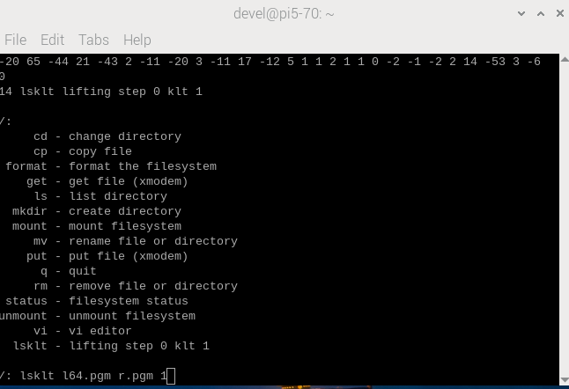
xxx

4 l64.pgm r.pgm 1
0
P5
# Created by GIMP version 2.10.8 PNM plug-in64 64
255
161 159 157 155 160 170 168 134 97 106 109 109 109 117 124 129 132 133 132 133
opening a file to write the results
need to copy the data received from host to img1
img1 = 0x200042f4 img2 = 0x200052f4
0 img1 161 ptrs.buf 161
1 img1 159 ptrs.buf 159
2 img1 157 ptrs.buf 157
3 img1 155 ptrs.buf 155
4 img1 160 ptrs.buf 160
4091 img1 123 ptrs.buf 123
4092 img1 94 ptrs.buf 94
4093 img1 58 ptrs.buf 58
4094 img1 61 ptrs.buf 61
4095 img1 91 ptrs.buf 91
need to copy the data from img1 to img2
0 img2 161 img1 161
1 img2 159 img1 159
2 img2 157 img1 157
3 img2 155 img1 155
4 img2 160 img1 160
4091 img2 123 img1 123
4092 img2 94 img1 94
4093 img2 58 img1 58
4094 img2 61 img1 61
4095 img2 91 img1 91
klt
(KLT) Selecting the 100 best features from a 64 by 64 image...
3 features found.
Feature #0: (32.000000,24.000000) with value of 4472
Feature #1: (39.000000,34.000000) with value of 3461
Feature #2: (29.000000,36.000000) with value of 3100
Feature #3: (-1.000000,-1.000000) with value of -1
Feature #4: (-1.000000,-1.000000) with value of -1
Feature #5: (-1.000000,-1.000000) with value of -1
Feature #6: (-1.000000,-1.000000) with value of -1
Feature #7: (-1.000000,-1.000000) with value of -1
Feature #8: (-1.000000,-1.000000) with value of -1
Feature #9: (-1.000000,-1.000000) with value of -1
Feature #10: (-1.000000,-1.000000) with value of -1
Feature #11: (-1.000000,-1.000000) with value of -1
Feature #12: (-1.000000,-1.000000) with value of -1
Feature #13: (-1.000000,-1.000000) with value of -1
Feature #14: (-1.000000,-1.000000) with value of -1
Feature #15: (-1.000000,-1.000000) with value of -1
Feature #16: (-1.000000,-1.000000) with value of -1
Feature #17: (-1.000000,-1.000000) with value of -1
Feature #18: (-1.000000,-1.000000) with value of -1
Feature #19: (-1.000000,-1.000000) with value of -1
Feature #20: (-1.000000,-1.000000) with value of -1
Feature #21: (-1.000000,-1.000000) with value of -1
Feature #22: (-1.000000,-1.000000) with value of -1
Feature #23: (-1.000000,-1.000000) with value of -1
Feature #24: (-1.000000,-1.000000) with value of -1
Feature #25: (-1.000000,-1.000000) with value of -1
Feature #26: (-1.000000,-1.000000) with value of -1
Feature #27: (-1.000000,-1.000000) with value of -1
Feature #28: (-1.000000,-1.000000) with value of -1
Feature #29: (-1.000000,-1.000000) with value of -1
Feature #30: (-1.000000,-1.000000) with value of -1
Feature #31: (-1.000000,-1.000000) with value of -1
Feature #32: (-1.000000,-1.000000) with value of -1
Feature #33: (-1.000000,-1.000000) with value of -1
Feature #34: (-1.000000,-1.000000) with value of -1
Feature #35: (-1.000000,-1.000000) with value of -1
Feature #36: (-1.000000,-1.000000) with value of -1
Feature #37: (-1.000000,-1.000000) with value of -1
Feature #38: (-1.000000,-1.000000) with value of -1
Feature #39: (-1.000000,-1.000000) with value of -1
Feature #40: (-1.000000,-1.000000) with value of -1
Feature #41: (-1.000000,-1.000000) with value of -1
Feature #42: (-1.000000,-1.000000) with value of -1
Feature #43: (-1.000000,-1.000000) with value of -1
Feature #44: (-1.000000,-1.000000) with value of -1
Feature #45: (-1.000000,-1.000000) with value of -1
Feature #46: (-1.000000,-1.000000) with value of -1
Feature #47: (-1.000000,-1.000000) with value of -1
Feature #48: (-1.000000,-1.000000) with value of -1
Feature #49: (-1.000000,-1.000000) with value of -1
Feature #50: (-1.000000,-1.000000) with value of -1
Feature #51: (-1.000000,-1.000000) with value of -1
Feature #52: (-1.000000,-1.000000) with value of -1
Feature #53: (-1.000000,-1.000000) with value of -1
Feature #54: (-1.000000,-1.000000) with value of -1
Feature #55: (-1.000000,-1.000000) with value of -1
Feature #56: (-1.000000,-1.000000) with value of -1
Feature #57: (-1.000000,-1.000000) with value of -1
Feature #58: (-1.000000,-1.000000) with value of -1
Feature #59: (-1.000000,-1.000000) with value of -1
Feature #60: (-1.000000,-1.000000) with value of -1
Feature #61: (-1.000000,-1.000000) with value of -1
Feature #62: (-1.000000,-1.000000) with value of -1
Feature #63: (-1.000000,-1.000000) with value of -1
Feature #64: (-1.000000,-1.000000) with value of -1
Feature #65: (-1.000000,-1.000000) with value of -1
Feature #66: (-1.000000,-1.000000) with value of -1
Feature #67: (-1.000000,-1.000000) with value of -1
Feature #68: (-1.000000,-1.000000) with value of -1
Feature #69: (-1.000000,-1.000000) with value of -1
Feature #70: (-1.000000,-1.000000) with value of -1
Feature #71: (-1.000000,-1.000000) with value of -1
Feature #72: (-1.000000,-1.000000) with value of -1
Feature #73: (-1.000000,-1.000000) with value of -1
Feature #74: (-1.000000,-1.000000) with value of -1
Feature #75: (-1.000000,-1.000000) with value of -1
Feature #76: (-1.000000,-1.000000) with value of -1
Feature #77: (-1.000000,-1.000000) with value of -1
Feature #78: (-1.000000,-1.000000) with value of -1
Feature #79: (-1.000000,-1.000000) with value of -1
Feature #80: (-1.000000,-1.000000) with value of -1
Feature #81: (-1.000000,-1.000000) with value of -1
Feature #82: (-1.000000,-1.000000) with value of -1
Feature #83: (-1.000000,-1.000000) with value of -1
Feature #84: (-1.000000,-1.000000) with value of -1
Feature #85: (-1.000000,-1.000000) with value of -1
Feature #86: (-1.000000,-1.000000) with value of -1
Feature #87: (-1.000000,-1.000000) with value of -1
Feature #88: (-1.000000,-1.000000) with value of -1
Feature #89: (-1.000000,-1.000000) with value of -1
Feature #90: (-1.000000,-1.000000) with value of -1
Feature #91: (-1.000000,-1.000000) with value of -1
Feature #92: (-1.000000,-1.000000) with value of -1
Feature #93: (-1.000000,-1.000000) with value of -1
Feature #94: (-1.000000,-1.000000) with value of -1
Feature #95: (-1.000000,-1.000000) with value of -1
Feature #96: (-1.000000,-1.000000) with value of -1
Feature #97: (-1.000000,-1.000000) with value of -1
Feature #98: (-1.000000,-1.000000) with value of -1
Feature #99: (-1.000000,-1.000000) with value of -1
this is the string 0 Ð0
14 lsklt lifting step 0 klt 1
xxx

