************************Default************************
JPEG2000 Pico & Pico2 Openjpeg
01/19/25
************************Default************************

git clone https://github.com/develone/Ultibo_Projects.git
cd ~/Ultibo_Projects/jpeg2000/src
./compile_ultibo.sh
cd ../QEMU
./libbuild.sh
Using Lazarus-Ultibo-Edition

./startqemu.sh
git clone https://github.com/develone/openjpeg.git -b ultibo t_ultibo
cd t_ultibo
mkdir build
cd build
cmake ..
make
cd bin
./opj_compress -i ~/Ultibo_Projects/jpeg2000/QEMU/lena_rgb_256.bmp -r 75 -o test-75.j2k
./opj_decompress -i test-75.j2k -o test-75.bmp
./opj_compress -i ~/Ultibo_Projects/jpeg2000/QEMU/lena_rgb_256.bmp -r 150 -o test-150.j2k
./opj_decompress -i test-150.j2k -o test-150.bmp
./opj_compress -i ~/Ultibo_Projects/jpeg2000/QEMU/lena_rgb_256.bmp -r 200 -o test-200.j2k
./opj_decompress -i test-200.j2k -o test-200.bmp
./opj_compress -i ~/Ultibo_Projects/jpeg2000/QEMU/lena_rgb_256.bmp -r 250 -o test-250.j2k
./opj_decompress -i test-250.j2k -o test-250.bmp

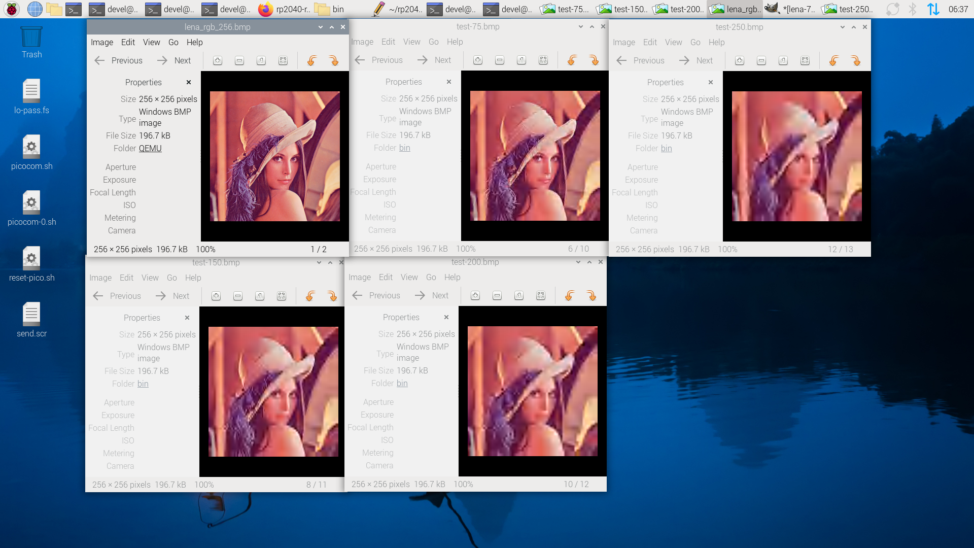
Lazarus Ultibo Edition.

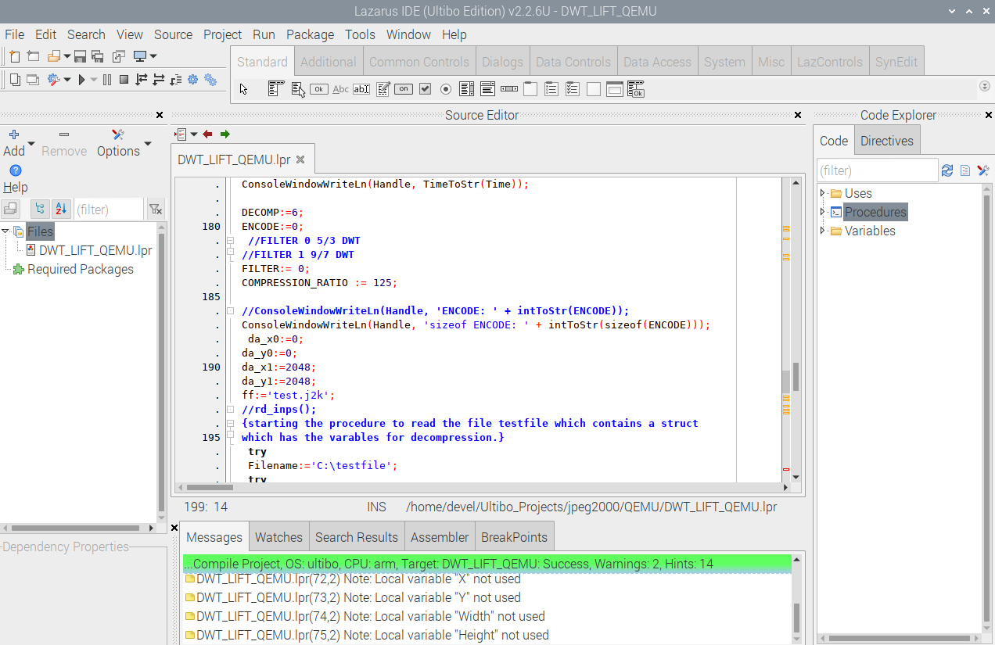
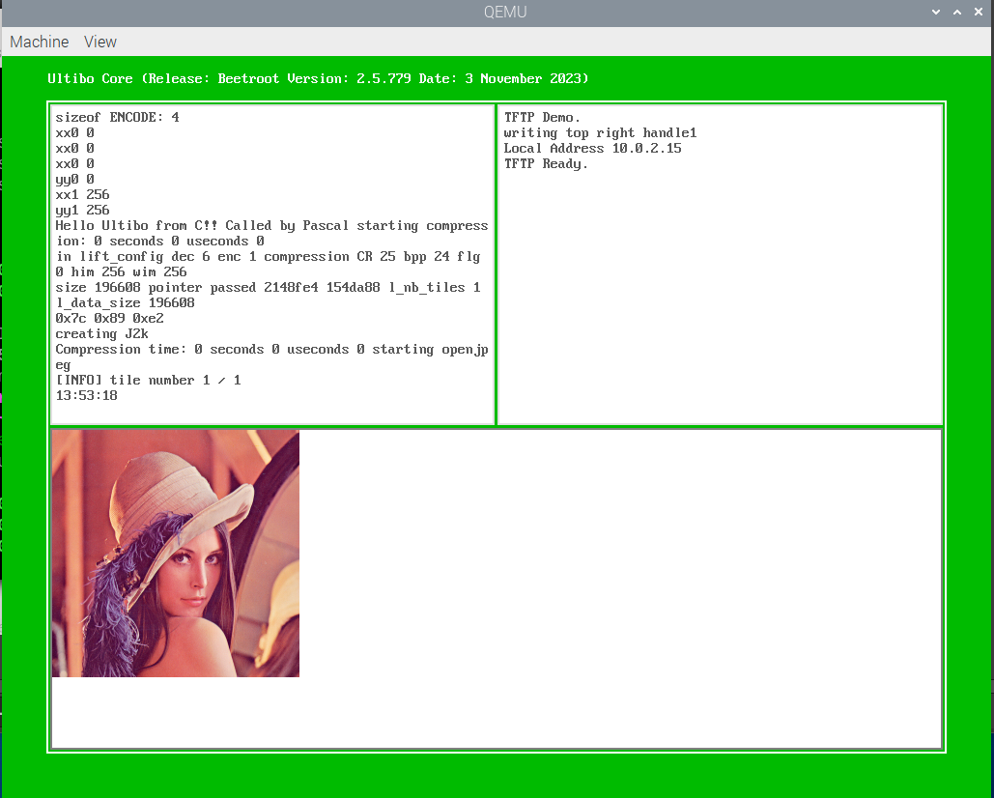
The Bullseye vs Bookworm. Bullseye currently the is working while Bookworm is having issues.
