*************DEFAULT*************
Initial steps to convert ppio to tlv
10/10/20
*************DEFAULT*************

“java -jar /home/devel/SandPiper_1.9-2018_02_11-beta_distro/target/sandpiper.jar --verbose --dhtml --stats --viz --svg --graphTrans -i top.m4 -o top.sv”

INFORM(0) (PROD_INFO):
SandPiper(TM) 1.9-2018/02/11-beta from Redwood EDA
Run as: "java -jar /home/devel/SandPiper_1.9-2018_02_11-beta_distro/target/sandpiper.jar --verbose --dhtml --stats --viz --svg --graphTrans -i top.m4 -o top.sv
For help, including product info, run with -h.

INFORM(0) (LICENSE):
Licensed to "Edward Vidal Jr." as: Full Edition.

INFORM(0) (FILES):
From directory: /home/devel/sandpiper_test/test2b/TLVerilog
Reading "top.m4" to produce:
Translated HDL File: "top.sv"
Generated HDL File: "top_gen.sv"
HTML TLX File: "top.html"
Transaction Flow Graph (Dot) File: "top_trans.dot"
Navigation Environment: "top_graph.svg"
Simulation Visualization File: "top_viz.json"
Statistics Directory: "top_stats"

Exiting due to DEFERRED_ERROR(s).

Note: Can not use –dhtml with –svg

“java -jar /home/devel/SandPiper_1.9-2018_02_11-beta_distro/target/sandpiper.jar --verbose --stats --viz --svg --graphTrans -i top.m4 -o top.sv”
INFORM(0) (PROD_INFO):
SandPiper(TM) 1.9-2018/02/11-beta from Redwood EDA
Run as: "java -jar /home/devel/SandPiper_1.9-2018_02_11-beta_distro/target/sandpiper.jar --verbose --stats --viz --svg --graphTrans -i top.m4 -o top.sv
For help, including product info, run with -h.

INFORM(0) (LICENSE):
Licensed to "Edward Vidal Jr." as: Full Edition.

INFORM(0) (FILES):
From directory: /home/devel/sandpiper_test/test2b/TLVerilog
Reading "top.m4" to produce:
Translated HDL File: "top.sv"
Generated HDL File: "top_gen.sv"
Transaction Flow Graph (Dot) File: "top_trans.dot"
Navigation Environment: "top_graph.svg"
Simulation Visualization File: "top_viz.json"
Statistics Directory: "top_stats"

WARNING(1) (UNUSED-SIG): File 'top.tlv' Line 25 (char 4)
Preprocessed as 'top.m4':25(ch4):
+---vvvvvvv-------------------------------
> $in_dir = *in_dir
+---^^^^^^^-------------------------------
Signal $in_dir is assigned but never used.
To silence this message use "`BOGUS_USE($in_dir)".

INFORM(0) (FILE): File 'top.tlv'
Writing file "top.sv".

INFORM(0) (FILE):
Writing file "top_gen.sv".

INFORM(0) (FILE):
Writing file "top_trans.dot".

INFORM(0) (FILE):
Writing file "top_stats/tlx.css".

INFORM(0) (FILE):
Writing file "top_stats/tlx.css".

INFORM(0) (FILE):
Writing file "top_stats/tlx.css".

INFORM(0) (FILE):
Writing file "top_stats/tlx.css".

INFORM(0) (FILE):
Writing file "top_stats/index.html".

INFORM(0) (FILE):
Writing file "top_stats/tlx.css".

INFORM(0) (FILE):
Writing file "top_stats/stats.csv".

INFORM(0) (STATS):
SandPiper generated 16% of your HDL code.
This includes: 1 signal declarations, 0 flops/latches, and 0 conditional clock signals.
View "top_stats" for more details.

INFORM(0) (FILE):
Writing file "top_viz.json".

INFORM(0) (FILE): File 'top.tlv'
Writing file "top_graph.svg".
Used Inkscape to view top_graph.svg.

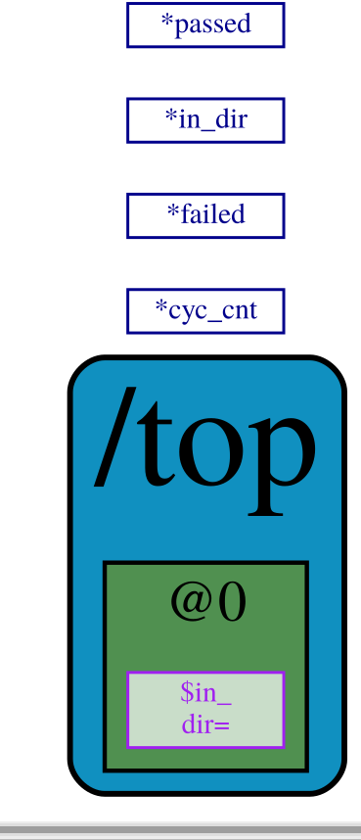

xdot top_trans.dot

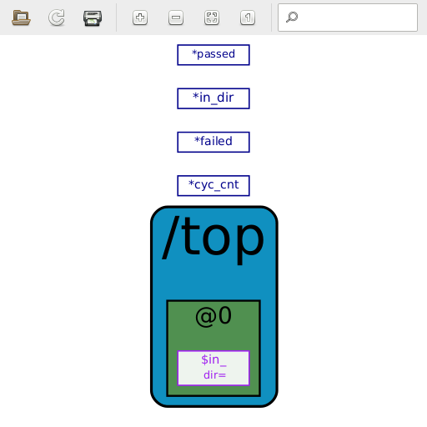
removing –svg and adding –dhtml now provides top.html

java -jar /home/devel/SandPiper_1.9-2018_02_11-beta_distro/target/sandpiper.jar --verbose --stats --viz --dhtml --graphTrans -i top.m4 -o top.sv

