*************DRAFT*************
UART No Flow Ctrl
10/26/20
iverlog Simulation
and
RPi with Catboard
running minicom

*************DRAFT*************

The files used to create the module uart are found at Appendix A. File tb_txuart.v & Appendix B File txuart.v

iverilog -o uart tb_txuart.v txuart.v

To create the dump.vcd "vvp uart" and run the simulation.

gtkwave “dump.vcd”

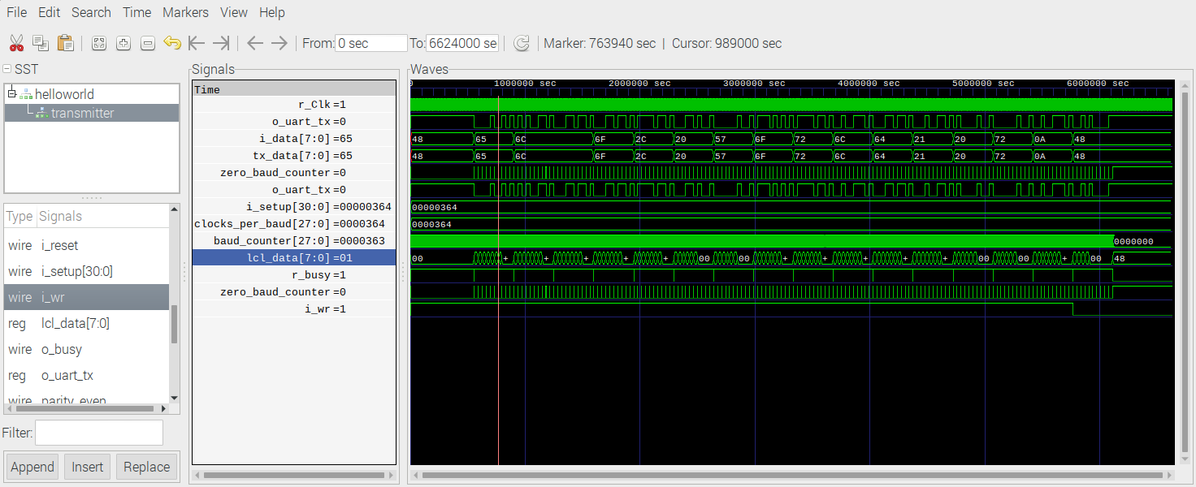
48.png

4 8
0 1 0 0 1 0 0 0
0 1 2 3 4 5 6 7
0 0 0 0 1 0 0 1 0 1
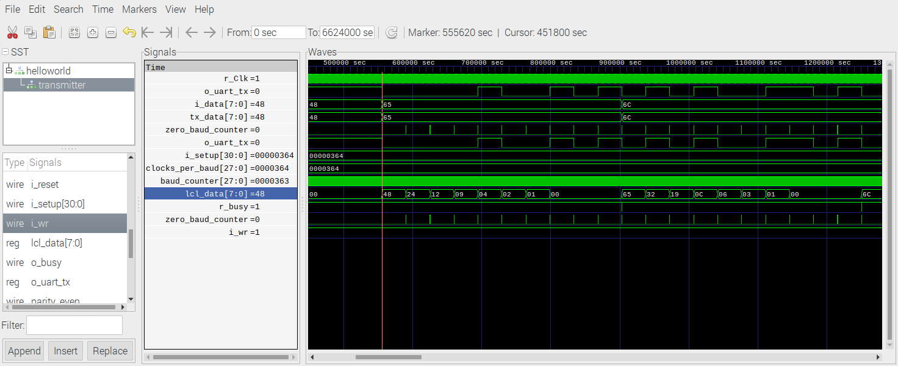
65.png

6 5
0 1 1 0 0 1 0 1
0 1 2 3 4 5 6 7
0 1 0 1 0 0 1 1 0 1

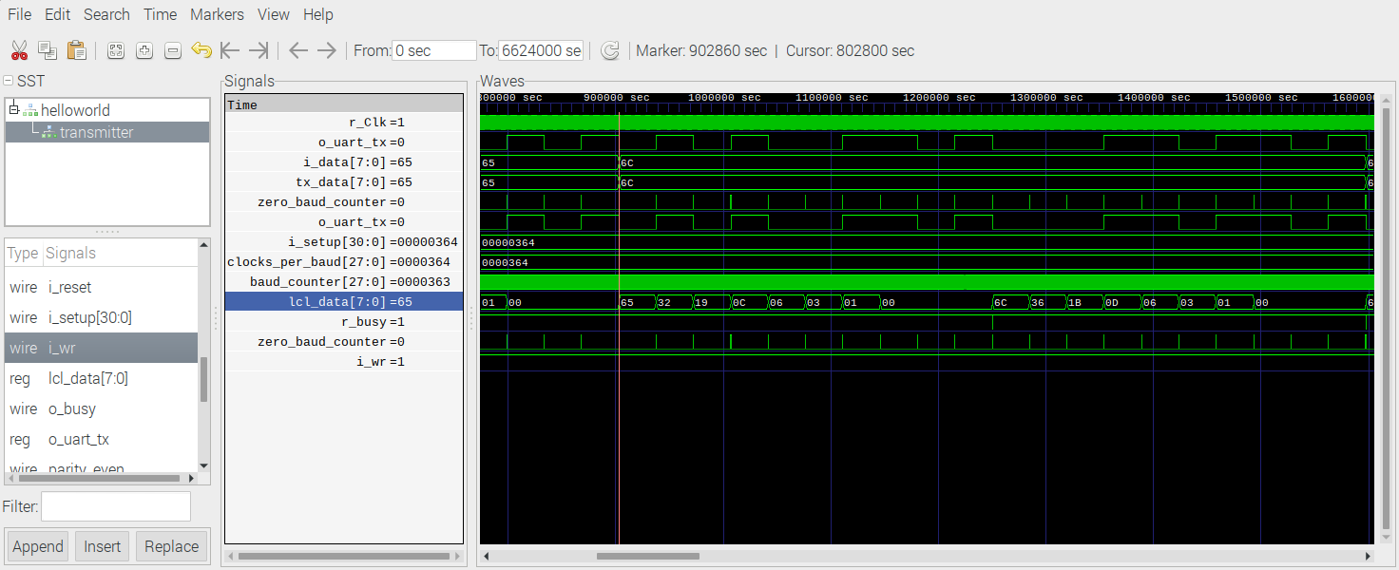
6C.png

6 C
0 1 1 0 1 1 0 0
0 1 2 3 4 5 6 7
0 0 0 0 1 1 0 1 1 1

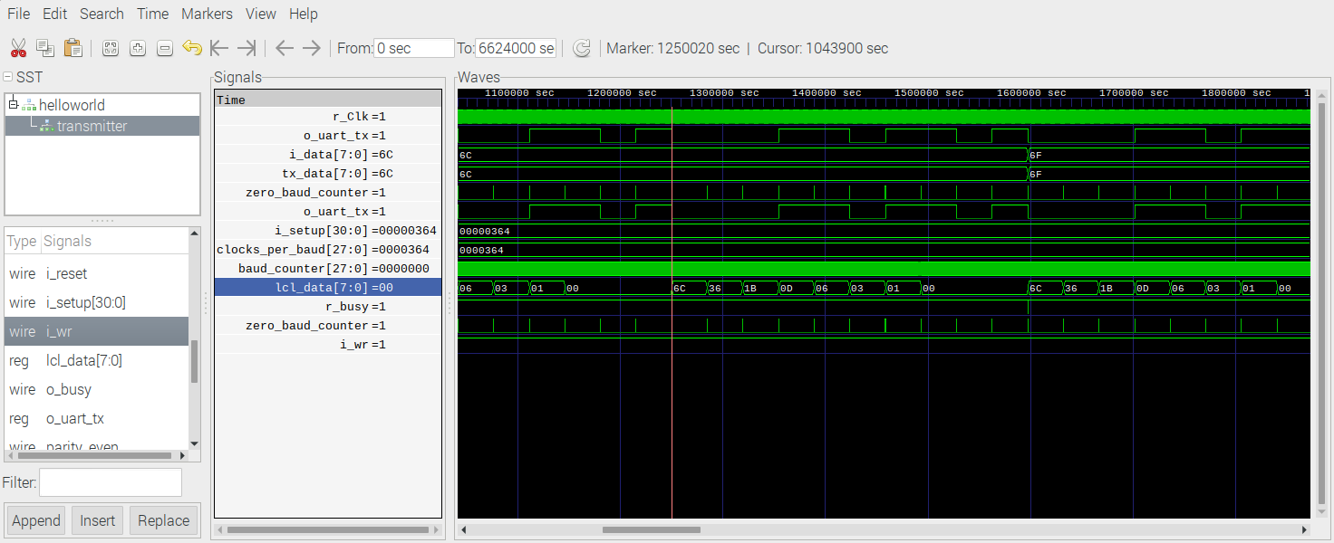
RPi

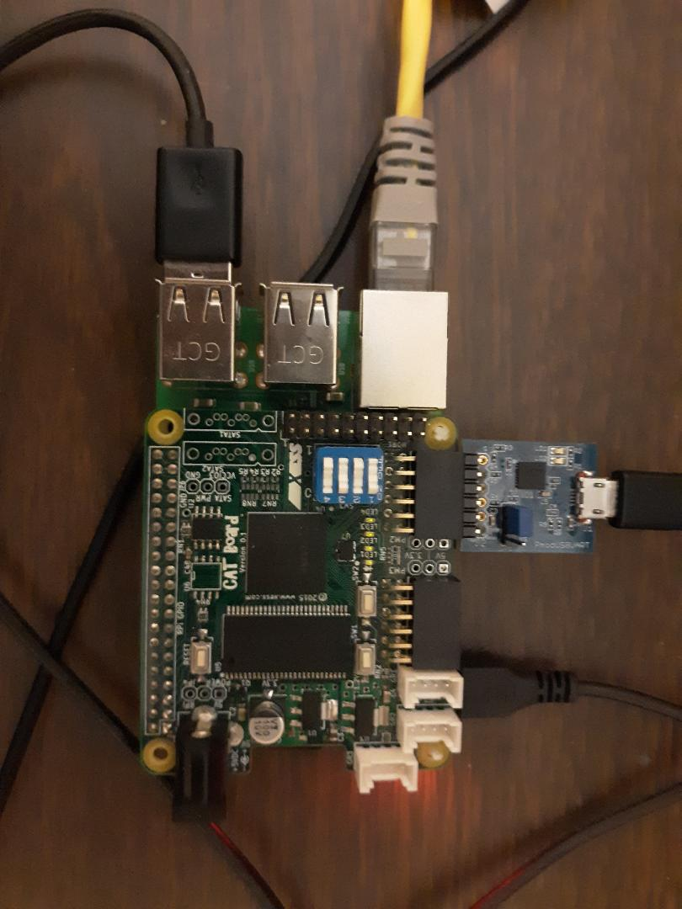
devel@mypi3-21:~/home/devl/uart/noflowcntl/
“sudo minicom -s”

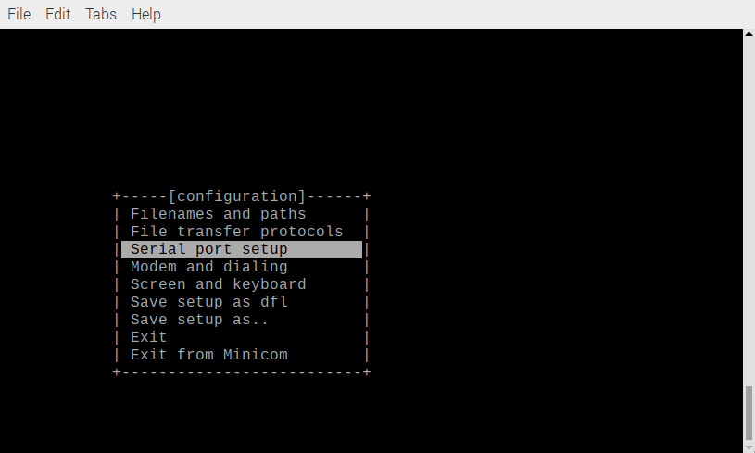
Scroll down to “Serial port setup” “Depress enter”

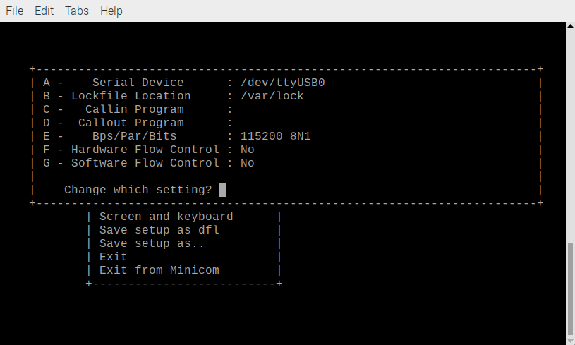

“Depress enter”

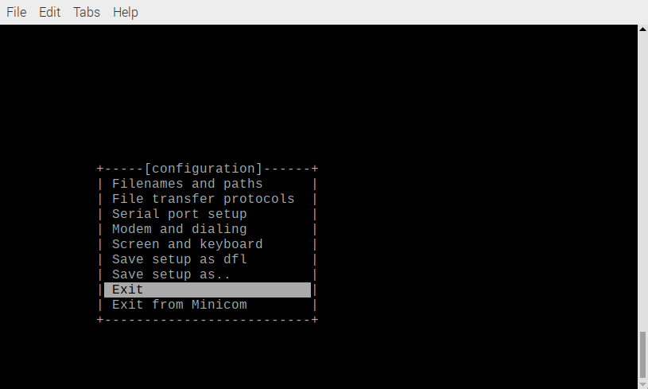
Scroll Down “Exit” “Depress enter”

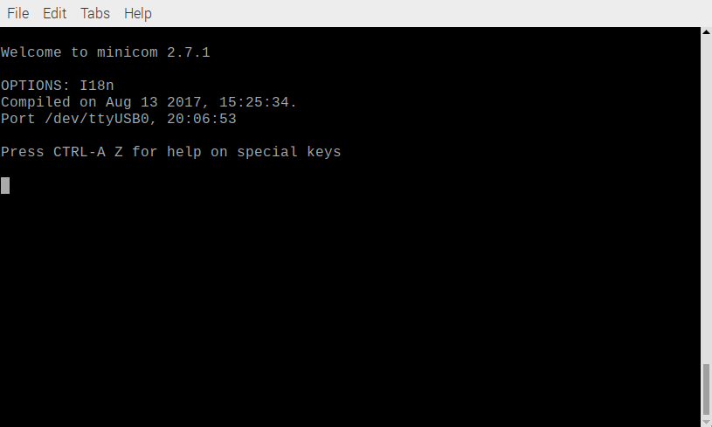
Program the Catboard FPGA to send “Hello, World!”

devel@mypi3-21:~/home/devl/uart/noflowcntl/
“sudo ~/catboard_yosys/config_cat helloworld.bin”

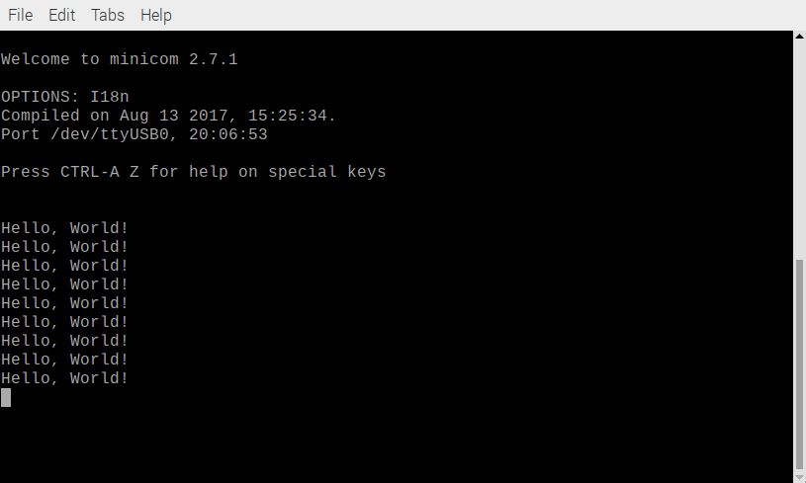
Program the Catboard FPGA to send “speech.hex”

devel@mypi3-21:~/home/devl/uart/noflowcntl/
“sudo ~/catboard_yosys/config_cat speechfifo.bin”

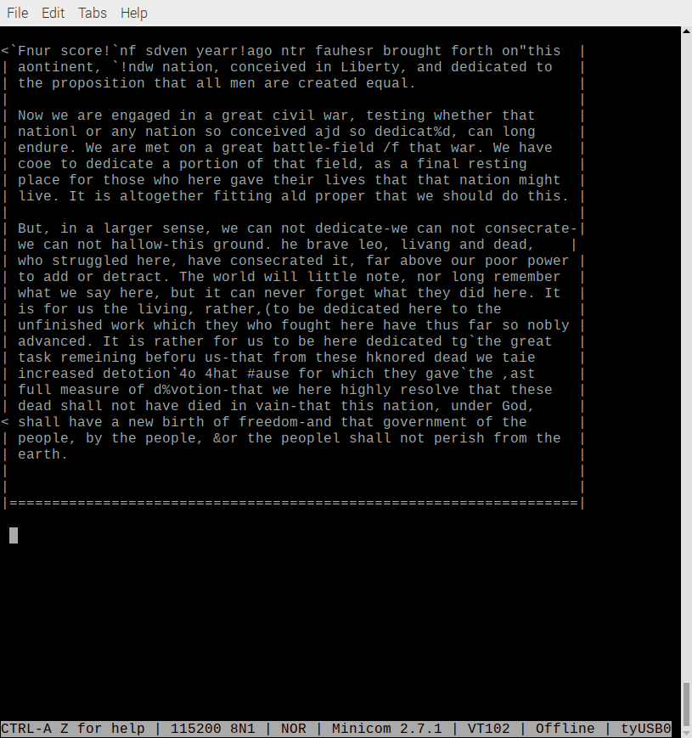
Appendix A. File tb_txuart.v

////////////////////////////////////////////////////////////////////////////////
//
// Filename: helloworld.v
//
// Project: wbuart32, a full featured UART with simulator
//
// Purpose: To create a *very* simple UART test program, which can be used
// as the top level design file of any FPGA program.
//
// With some modifications (discussed below), this RTL should be able to
// run as a top-level testing file, requiring only the UART and clock pin
// to work.
//
// Creator: Dan Gisselquist, Ph.D.
// Gisselquist Technology, LLC
//
////////////////////////////////////////////////////////////////////////////////
//
// Copyright (C) 2015-2016, Gisselquist Technology, LLC
//
// This program is free software (firmware): you can redistribute it and/or
// modify it under the terms of the GNU General Public License as published
// by the Free Software Foundation, either version 3 of the License, or (at
// your option) any later version.
//
// This program is distributed in the hope that it will be useful, but WITHOUT
// ANY WARRANTY; without even the implied warranty of MERCHANTIBILITY or
// FITNESS FOR A PARTICULAR PURPOSE. See the GNU General Public License
// for more details.
//
// You should have received a copy of the GNU General Public License along
// with this program. (It's in the $(ROOT)/doc directory, run make with no
// target there if the PDF file isn't present.) If not, see
// <http://www.gnu.org/licenses/> for a copy.
//
// License: GPL, v3, as defined and found on www.gnu.org,
// http://www.gnu.org/licenses/gpl.html
//
//
////////////////////////////////////////////////////////////////////////////////
//
//
// One issue with the design is how to set the values of the setup register.
// (*This is a comment, not a verilator attribute ... ) Verilator needs to
// know/set those values in order to work. However, this design can also be
// used as a stand-alone top level configuration file. In this latter case,
// the setup register needs to be set internal to the file. Here, we use
// OPT_STANDALONE to distinguish between the two. If set, the file runs under
// (* Another comment still ...) Verilator and we need to get i_setup from the
// external environment. If not, it must be set internally.
//
`ifndef VERILATOR
`define OPT_STANDALONE
`endif
//
//
// Two versions of the UART can be found in the rtl directory: a full featured
// UART, and a LITE UART that only handles 8N1 -- no break sending, break
// detection, parity error detection, etc. If we set USE_LITE_UART here, those
// simplified UART modules will be used.
//
// `define USE_LITE_UART
//
//
module helloworld(i_clk,
`ifndef OPT_STANDALONE
i_setup,
`endif
o_uart_tx);
input i_clk;
output wire o_uart_tx;

// Here we set i_setup to something appropriate to create a 115200 Baud
// UART system from a 100MHz clock. This also sets us to an 8-bit data
// word, 1-stop bit, and no parity. This will be overwritten by
// i_setup, but at least it gives us something to start with/from.
//parameter INITIAL_UART_SETUP = 31'd50;
parameter INITIAL_UART_SETUP = 31'd868;

// The i_setup wires are input when run under Verilator, but need to
// be set internally if this is going to run as a standalone top level
// test configuration.
`ifdef OPT_STANDALONE
wire [30:0] i_setup;
assign i_setup = INITIAL_UART_SETUP;
`else
input [30:0] i_setup;
`endif
reg r_Clk = 1'b0;

always #20 r_Clk <= ~r_Clk;
reg pwr_reset;
initial pwr_reset = 1'b1;
always @(posedge r_Clk)
pwr_reset <= 1'b0;

reg [7:0] message [0:15];

reg [27:0] counter;
initial counter = 28'hffffff0;
always @(posedge r_Clk)
counter <= counter + 1'b1;

wire tx_break, tx_busy;
reg tx_stb;
reg [3:0] tx_index;
reg [7:0] tx_data;

assign tx_break = 1'b0;

initial tx_index = 4'h0;
always @(posedge r_Clk)
if ((tx_stb)&&(!tx_busy))
tx_index <= tx_index + 1'b1;
always @(posedge r_Clk)
tx_data <= message[tx_index];

initial tx_stb = 1'b0;
always @(posedge r_Clk)
if (&counter)
tx_stb <= 1'b1;
else if ((tx_stb)&&(!tx_busy)&&(tx_index==4'hf))
tx_stb <= 1'b0;

// Bypass any hardware flow control
wire cts_n;
assign cts_n = 1'b0;

`ifdef USE_LITE_UART
txuartlite
#(24'd868)
transmitter(r_Clk, tx_stb, tx_data, o_uart_tx, tx_busy);
`else
txuart transmitter(r_Clk, pwr_reset, i_setup, tx_break,
tx_stb, tx_data, cts_n, o_uart_tx, tx_busy);
`endif
initial
begin
message[ 0] = "H";
message[ 1] = "e";
message[ 2] = "l";
message[ 3] = "l";
message[ 4] = "o";
message[ 5] = ",";
message[ 6] = " ";
message[ 7] = "W";
message[ 8] = "o";
message[ 9] = "r";
message[10] = "l";
message[11] = "d";
message[12] = "!";
message[13] = " ";
message[14] = "\r";
message[15] = "\n";

#6624000;
$finish();
end

initial
begin
$dumpfile("dump.vcd");
$dumpvars(0);
end
endmodule

Appendix B File txuart.v

////////////////////////////////////////////////////////////////////////////////
//
// Filename: txuart.v
//
// Project: wbuart32, a full featured UART with simulator
//
// Purpose: Transmit outputs over a single UART line.
//
// To interface with this module, connect it to your system clock,
// pass it the 32 bit setup register (defined below) and the byte
// of data you wish to transmit. Strobe the i_wr line high for one
// clock cycle, and your data will be off. Wait until the 'o_busy'
// line is low before strobing the i_wr line again--this implementation
// has NO BUFFER, so strobing i_wr while the core is busy will just
// cause your data to be lost. The output will be placed on the o_txuart
// output line. If you wish to set/send a break condition, assert the
// i_break line otherwise leave it low.
//
// There is a synchronous reset line, logic high.
//
// Now for the setup register. The register is 32 bits, so that this
// UART may be set up over a 32-bit bus.
//
// i_setup[30] Set this to zero to use hardware flow control, and to
// one to ignore hardware flow control. Only works if the hardware
// flow control has been properly wired.
//
// If you don't want hardware flow control, fix the i_rts bit to
// 1'b1, and let the synthesys tools optimize out the logic.
//
// i_setup[29:28] Indicates the number of data bits per word. This will
// either be 2'b00 for an 8-bit word, 2'b01 for a 7-bit word, 2'b10
// for a six bit word, or 2'b11 for a five bit word.
//
// i_setup[27] Indicates whether or not to use one or two stop bits.
// Set this to one to expect two stop bits, zero for one.
//
// i_setup[26] Indicates whether or not a parity bit exists. Set this
// to 1'b1 to include parity.
//
// i_setup[25] Indicates whether or not the parity bit is fixed. Set
// to 1'b1 to include a fixed bit of parity, 1'b0 to allow the
// parity to be set based upon data. (Both assume the parity
// enable value is set.)
//
// i_setup[24] This bit is ignored if parity is not used. Otherwise,
// in the case of a fixed parity bit, this bit indicates whether
// mark (1'b1) or space (1'b0) parity is used. Likewise if the
// parity is not fixed, a 1'b1 selects even parity, and 1'b0
// selects odd.
//
// i_setup[23:0] Indicates the speed of the UART in terms of clocks.
// So, for example, if you have a 200 MHz clock and wish to
// run your UART at 9600 baud, you would take 200 MHz and divide
// by 9600 to set this value to 24'd20834. Likewise if you wished
// to run this serial port at 115200 baud from a 200 MHz clock,
// you would set the value to 24'd1736
//
// Thus, to set the UART for the common setting of an 8-bit word,
// one stop bit, no parity, and 115200 baud over a 200 MHz clock, you
// would want to set the setup value to:
//
// 32'h0006c8 // For 115,200 baud, 8 bit, no parity
// 32'h005161 // For 9600 baud, 8 bit, no parity
//
//
// Creator: Dan Gisselquist, Ph.D.
// Gisselquist Technology, LLC
//
////////////////////////////////////////////////////////////////////////////////
//
// Copyright (C) 2015-2017, Gisselquist Technology, LLC
//
// This program is free software (firmware): you can redistribute it and/or
// modify it under the terms of the GNU General Public License as published
// by the Free Software Foundation, either version 3 of the License, or (at
// your option) any later version.
//
// This program is distributed in the hope that it will be useful, but WITHOUT
// ANY WARRANTY; without even the implied warranty of MERCHANTIBILITY or
// FITNESS FOR A PARTICULAR PURPOSE. See the GNU General Public License
// for more details.
//
// You should have received a copy of the GNU General Public License along
// with this program. (It's in the $(ROOT)/doc directory. Run make with no
// target there if the PDF file isn't present.) If not, see
// <http://www.gnu.org/licenses/> for a copy.
//
// License: GPL, v3, as defined and found on www.gnu.org,
// http://www.gnu.org/licenses/gpl.html
//
//
////////////////////////////////////////////////////////////////////////////////
//
//
`default_nettype none
//
`define TXU_BIT_ZERO 4'h0
`define TXU_BIT_ONE 4'h1
`define TXU_BIT_TWO 4'h2
`define TXU_BIT_THREE 4'h3
`define TXU_BIT_FOUR 4'h4
`define TXU_BIT_FIVE 4'h5
`define TXU_BIT_SIX 4'h6
`define TXU_BIT_SEVEN 4'h7
`define TXU_PARITY 4'h8 // Constant 1
`define TXU_STOP 4'h9 // Constant 1
`define TXU_SECOND_STOP 4'ha
// 4'hb // Unused
// 4'hc // Unused
// `define TXU_START 4'hd // An unused state
`define TXU_BREAK 4'he
`define TXU_IDLE 4'hf
//
//
module txuart(i_clk, i_reset, i_setup, i_break, i_wr, i_data,
i_cts_n, o_uart_tx, o_busy);
parameter [30:0] INITIAL_SETUP = 31'd868;
input wire i_clk, i_reset;
input wire [30:0] i_setup;
input wire i_break;
input wire i_wr;
input wire [7:0] i_data;
// Hardware flow control Ready-To-Send bit. Set this to one to use
// the core without flow control. (A more appropriate name would be
// the Ready-To-Receive bit ...)
input wire i_cts_n;
// And the UART input line itself
output reg o_uart_tx;
// A line to tell others when we are ready to accept data. If
// (i_wr)&&(!o_busy) is ever true, then the core has accepted a byte
// for transmission.
output wire o_busy;

wire [27:0] clocks_per_baud, break_condition;
wire [1:0] data_bits;
wire use_parity, parity_even, dblstop, fixd_parity,
fixdp_value, hw_flow_control;
reg [30:0] r_setup;
assign clocks_per_baud = { 4'h0, r_setup[23:0] };
assign break_condition = { r_setup[23:0], 4'h0 };
assign hw_flow_control = !r_setup[30];
assign data_bits = r_setup[29:28];
assign dblstop = r_setup[27];
assign use_parity = r_setup[26];
assign fixd_parity = r_setup[25];
assign parity_even = r_setup[24];
assign fixdp_value = r_setup[24];

reg [27:0] baud_counter;
reg [3:0] state;
reg [7:0] lcl_data;
reg calc_parity, r_busy, zero_baud_counter;

// First step ... handle any hardware flow control, if so enabled.
//
// Clock in the flow control data, two clocks to avoid metastability
// Default to using hardware flow control (uart_setup[30]==0 to use it).
// Set this high order bit off if you do not wish to use it.
reg q_cts_n, qq_cts_n, ck_cts;
// While we might wish to give initial values to q_rts and ck_cts,
// 1) it's not required since the transmitter starts in a long wait
// state, and 2) doing so will prevent the synthesizer from optimizing
// this pin in the case it is hard set to 1'b1 external to this
// peripheral.
//
// initial q_cts_n = 1'b1;
// initial qq_cts_n = 1'b1;
// initial ck_cts = 1'b0;
always @(posedge i_clk)
q_cts_n <= i_cts_n;
always @(posedge i_clk)
qq_cts_n <= q_cts_n;
always @(posedge i_clk)
ck_cts <= (!qq_cts_n)||(!hw_flow_control);

initial o_uart_tx = 1'b1;
initial r_busy = 1'b1;
initial state = `TXU_IDLE;
initial lcl_data= 8'h0;
initial calc_parity = 1'b0;
// initial baud_counter = clocks_per_baud;//ILLEGAL--not constant
always @(posedge i_clk)
begin
if (i_reset)
begin
r_busy <= 1'b1;
state <= `TXU_IDLE;
end else if (i_break)
begin
state <= `TXU_BREAK;
r_busy <= 1'b1;
end else if (!zero_baud_counter)
begin // r_busy needs to be set coming into here
r_busy <= 1'b1;
end else if (state == `TXU_BREAK)
begin
state <= `TXU_IDLE;
r_busy <= 1'b1;
end else if (state == `TXU_IDLE) // STATE_IDLE
begin
if ((i_wr)&&(!r_busy))
begin // Immediately start us off with a start bit
r_busy <= 1'b1;
case(data_bits)
2'b00: state <= `TXU_BIT_ZERO;
2'b01: state <= `TXU_BIT_ONE;
2'b10: state <= `TXU_BIT_TWO;
2'b11: state <= `TXU_BIT_THREE;
endcase
end else begin // Stay in idle
r_busy <= !ck_cts;
end
end else begin
// One clock tick in each of these states ...
// baud_counter <= clocks_per_baud - 28'h01;
r_busy <= 1'b1;
if (state[3] == 0) // First 8 bits
begin
if (state == `TXU_BIT_SEVEN)
state <= (use_parity)?`TXU_PARITY:`TXU_STOP;
else
state <= state + 1;
end else if (state == `TXU_PARITY)
begin
state <= `TXU_STOP;
end else if (state == `TXU_STOP)
begin // two stop bit(s)
if (dblstop)
state <= `TXU_SECOND_STOP;
else
state <= `TXU_IDLE;
end else // `TXU_SECOND_STOP and default:
begin
state <= `TXU_IDLE; // Go back to idle
// Still r_busy, since we need to wait
// for the baud clock to finish counting
// out this last bit.
end
end
end

// o_busy
//
// This is a wire, designed to be true is we are ever busy above.
// originally, this was going to be true if we were ever not in the
// idle state. The logic has since become more complex, hence we have
// a register dedicated to this and just copy out that registers value.
assign o_busy = (r_busy);

// r_setup
//
// Our setup register. Accept changes between any pair of transmitted
// words. The register itself has many fields to it. These are
// broken out up top, and indicate what 1) our baud rate is, 2) our
// number of stop bits, 3) what type of parity we are using, and 4)
// the size of our data word.
initial r_setup = INITIAL_SETUP;
always @(posedge i_clk)
if (state == `TXU_IDLE)
r_setup <= i_setup;

// lcl_data
//
// This is our working copy of the i_data register which we use
// when transmitting. It is only of interest during transmit, and is
// allowed to be whatever at any other time. Hence, if r_busy isn't
// true, we can always set it. On the one clock where r_busy isn't
// true and i_wr is, we set it and r_busy is true thereafter.
// Then, on any zero_baud_counter (i.e. change between baud intervals)
// we simple logically shift the register right to grab the next bit.
always @(posedge i_clk)
if (!r_busy)
lcl_data <= i_data;
else if (zero_baud_counter)
lcl_data <= { 1'b0, lcl_data[7:1] };

// o_uart_tx
//
// This is the final result/output desired of this core. It's all
// centered about o_uart_tx. This is what finally needs to follow
// the UART protocol.
//
// Ok, that said, our rules are:
// 1'b0 on any break condition
// 1'b0 on a start bit (IDLE, write, and not busy)
// lcl_data[0] during any data transfer, but only at the baud
// change
// PARITY -- During the parity bit. This depends upon whether or
// not the parity bit is fixed, then what it's fixed to,
// or changing, and hence what it's calculated value is.
// 1'b1 at all other times (stop bits, idle, etc)
always @(posedge i_clk)
if (i_reset)
o_uart_tx <= 1'b1;
else if ((i_break)||((i_wr)&&(!r_busy)))
o_uart_tx <= 1'b0;
else if (zero_baud_counter)
casez(state)
4'b0???: o_uart_tx <= lcl_data[0];
`TXU_PARITY: o_uart_tx <= calc_parity;
default: o_uart_tx <= 1'b1;
endcase

// calc_parity
//
// Calculate the parity to be placed into the parity bit. If the
// parity is fixed, then the parity bit is given by the fixed parity
// value (r_setup[24]). Otherwise the parity is given by the GF2
// sum of all the data bits (plus one for even parity).
always @(posedge i_clk)
if (fixd_parity)
calc_parity <= fixdp_value;
else if (zero_baud_counter)
begin
if (state[3] == 0) // First 8 bits of msg
calc_parity <= calc_parity ^ lcl_data[0];
else
calc_parity <= parity_even;
end else if (!r_busy)
calc_parity <= parity_even;

// All of the above logic is driven by the baud counter. Bits must last
// clocks_per_baud in length, and this baud counter is what we use to
// make certain of that.
//
// The basic logic is this: at the beginning of a bit interval, start
// the baud counter and set it to count clocks_per_baud. When it gets
// to zero, restart it.
//
// However, comparing a 28'bit number to zero can be rather complex--
// especially if we wish to do anything else on that same clock. For
// that reason, we create "zero_baud_counter". zero_baud_counter is
// nothing more than a flag that is true anytime baud_counter is zero.
// It's true when the logic (above) needs to step to the next bit.
// Simple enough?
//
// I wish we could stop there, but there are some other (ugly)
// conditions to deal with that offer exceptions to this basic logic.
//
// 1. When the user has commanded a BREAK across the line, we need to
// wait several baud intervals following the break before we start
// transmitting, to give any receiver a chance to recognize that we are
// out of the break condition, and to know that the next bit will be
// a stop bit.
//
// 2. A reset is similar to a break condition--on both we wait several
// baud intervals before allowing a start bit.
//
// 3. In the idle state, we stop our counter--so that upon a request
// to transmit when idle we can start transmitting immediately, rather
// than waiting for the end of the next (fictitious and arbitrary) baud
// interval.
//
// When (i_wr)&&(!r_busy)&&(state == `TXU_IDLE) then we're not only in
// the idle state, but we also just accepted a command to start writing
// the next word. At this point, the baud counter needs to be reset
// to the number of clocks per baud, and zero_baud_counter set to zero.
//
// The logic is a bit twisted here, in that it will only check for the
// above condition when zero_baud_counter is false--so as to make
// certain the STOP bit is complete.
initial zero_baud_counter = 1'b0;
initial baud_counter = 28'h05;
always @(posedge i_clk)
begin
zero_baud_counter <= (baud_counter == 28'h01);
if ((i_reset)||(i_break))
begin
// Give ourselves 16 bauds before being ready
baud_counter <= break_condition;
zero_baud_counter <= 1'b0;
end else if (!zero_baud_counter)
baud_counter <= baud_counter - 28'h01;
else if (state == `TXU_BREAK)
// Give us four idle baud intervals before becoming
// available
baud_counter <= clocks_per_baud<<2;
else if (state == `TXU_IDLE)
begin
baud_counter <= 28'h0;
zero_baud_counter <= 1'b1;
if ((i_wr)&&(!r_busy))
begin
baud_counter <= clocks_per_baud - 28'h01;
zero_baud_counter <= 1'b0;
end
end else
baud_counter <= clocks_per_baud - 28'h01;
end
endmodule

