=============================================
Time-Division Multiplexer and De-multiplexing
10/29/20
=============================================

Started in Makerchip.com

Downloaded top.tlv, top.m4.pre, and top.m4.

java -jar /home/devel/SandPiper_1.9-2018_02_11-beta_distro/target/sandpiper.jar --debugSigs --viz --dhtml --stats --compiler verilator --graphTrans -i top.m4 -o top.sv

dot -Tpdf top_trans.dot -o top_trans.pdf

qpdfview top_trans.pdf &

cp ../extra_files/* .

https://raw.githubusercontent.com/stevehoover/tlv_flow_lib/master/makerchip_files/verilog/sandhost/sqrt32.v

cp ~/warp-v/formal/verilog/clk_gate.v

//`include "sp_verilog.vh" in clk_gate.v
verilator --trace --debug --debugi 0 -gdbbt --no-dump-tree --cc makerchip.sv --exe --build sim_main.cpp

A wide vector, at a 1/4 "frequency" (1 valid cycle, followed by 3 invalid ones)
is time-division multiplexed (TDM) into a narrow vector, carrying one of n pieces per cycle,
(1st, least-significant flit in stage 0, 2nd in stage 2, etc.)
and this is de-multiplexed into a stream similar to the original in the same pipeline.
This is a useful design pattern for reducing wire routing.

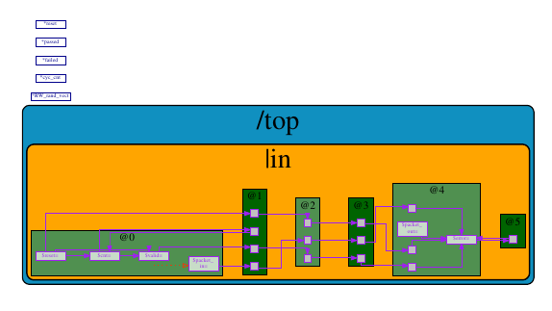

diff output.txt ../output.txt
2,11c2,9
< a128 became a128
< 1636 became 1636
< 62ea became 62ea
< 2b9c became 2b9c
< bb9b became bb9b
< bc8c became bc8c
< c94a became c94a
< 9159 became 9159
< 1590 became 1590
< Simulation PASSED!!!
---
> a128 became 0
> 1636 became 0
> 62ea became 0
> 2b9c became 0
> bb9b became 0
> bc8c became 0
> c94a became 0
> Simulation FAILED!!!

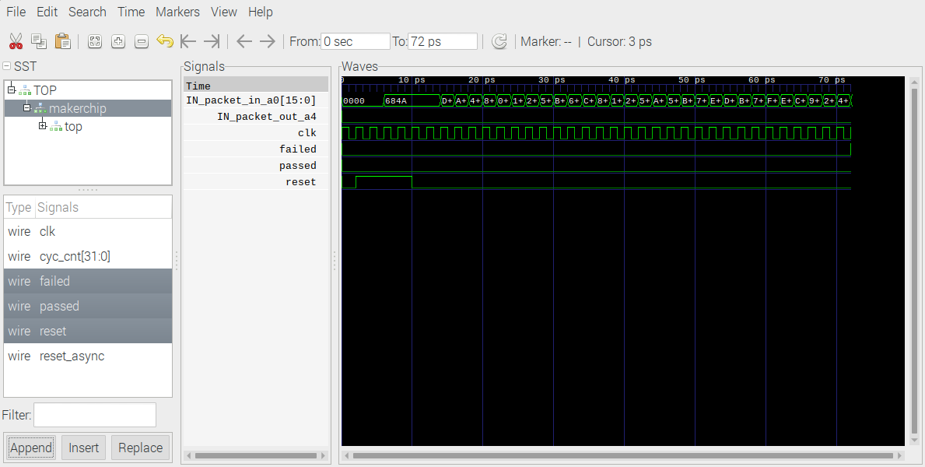

diff top.m4 ../top.m4
31,34c31,35
< $flit[3:0] = >>0$valid ? >>0$packet_in[3:0] :
< >>1$valid ? >>1$packet_in[7:4] :
< >>2$valid ? >>2$packet_in[11:8] :
< >>3$packet_in[15:12];
---
>
> // LAB PART 1
> // FILL IN THIS LINE:
> // $flit[3:0] = ...; // HINT: Use ? : ? : ...
>
39c40,43
< $packet_out[15:0] = {<<3$flit, <<2$flit, <<1$flit, <>0$flit};
---
>
> // LAB PART 2
> // FILL IN THIS LINE:
> // $packet_out[15:0] = ...; // HINT: Use { , , …}

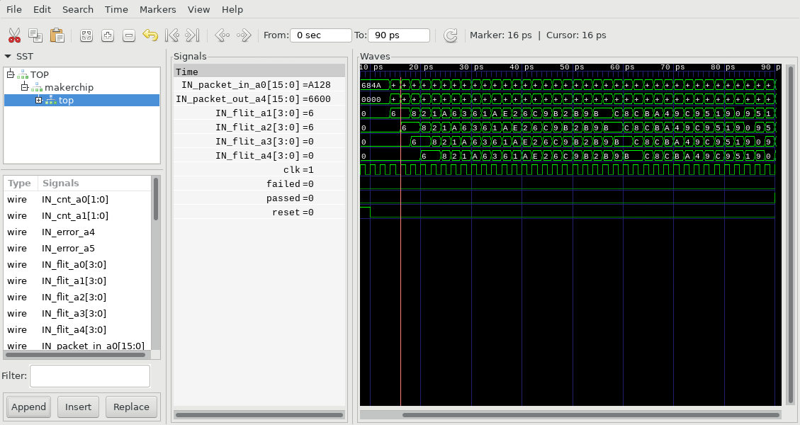
packet_1_in

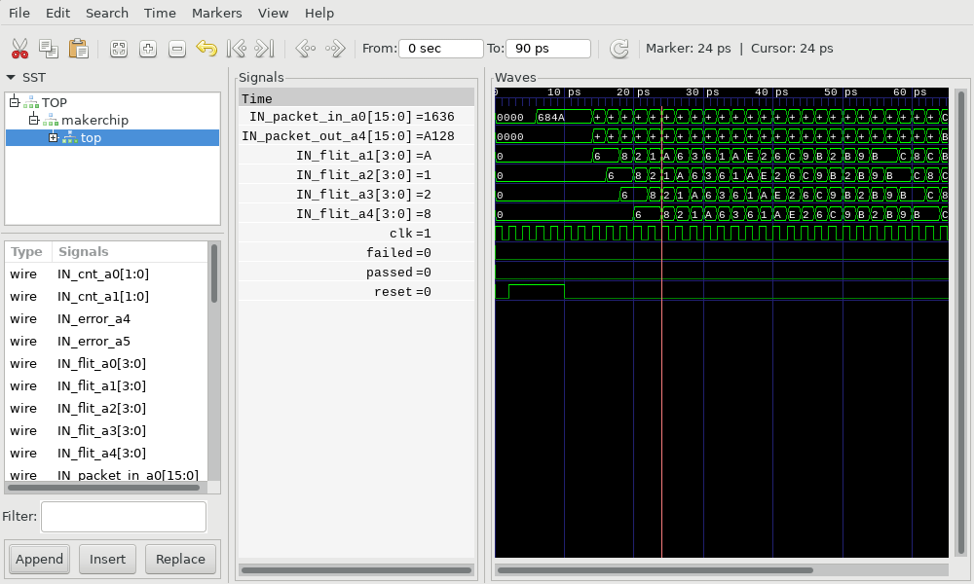
packet_1_out

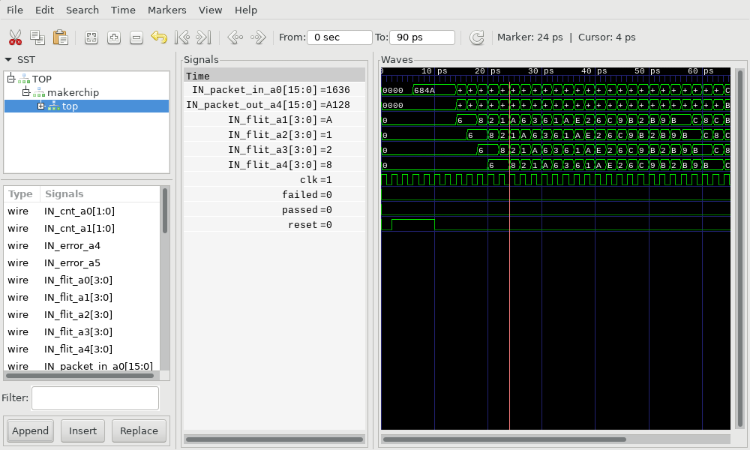

packet_2_in

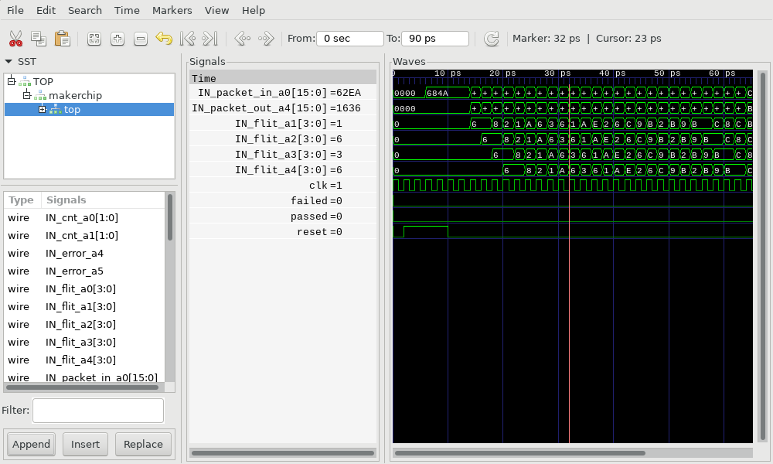
packet_2_out

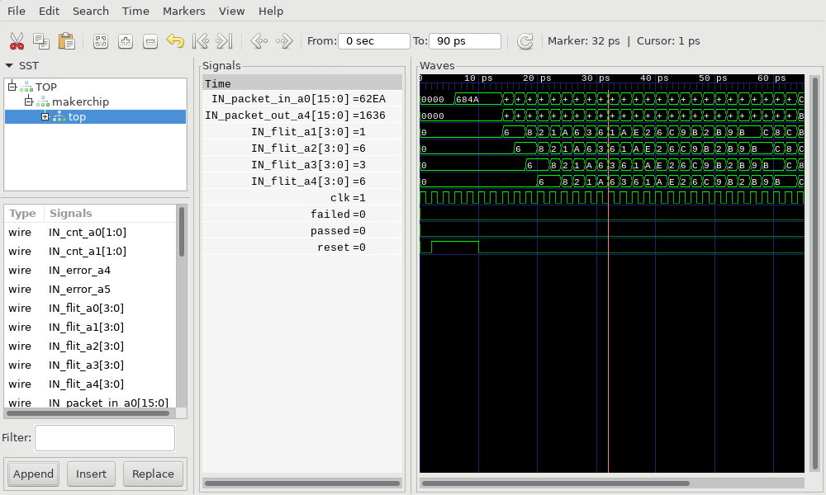

packet_3_in

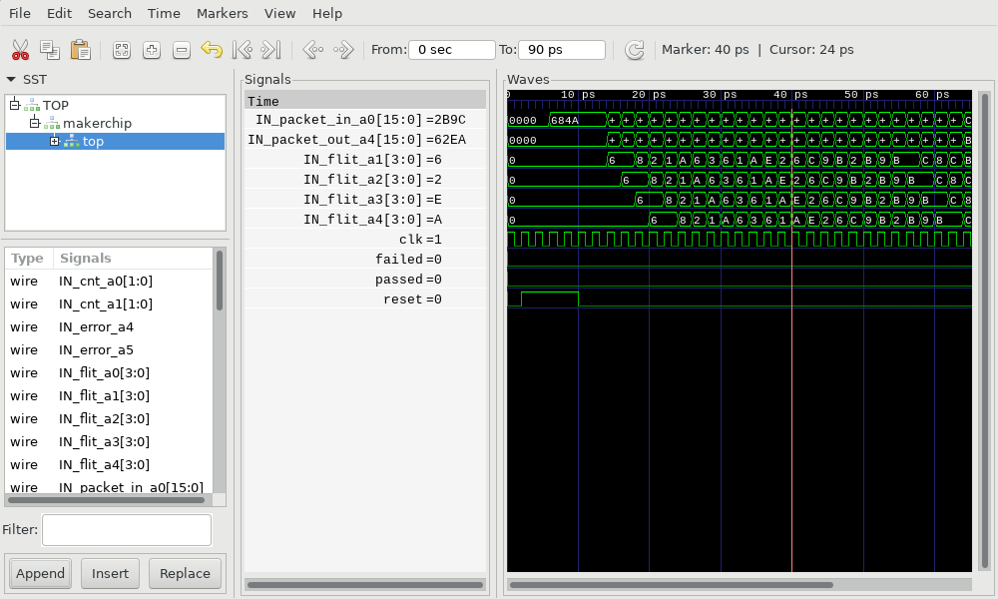

packet_3_out

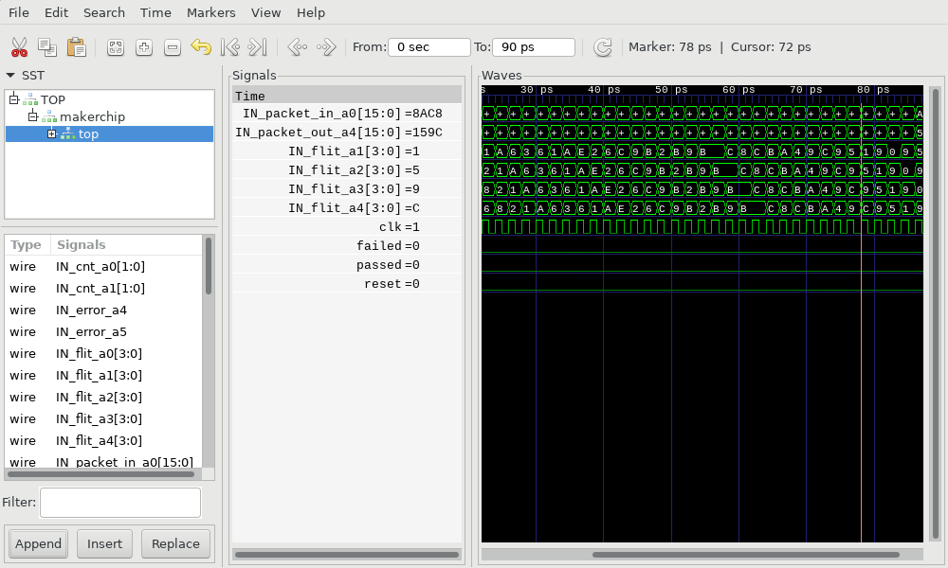

packet_6_in

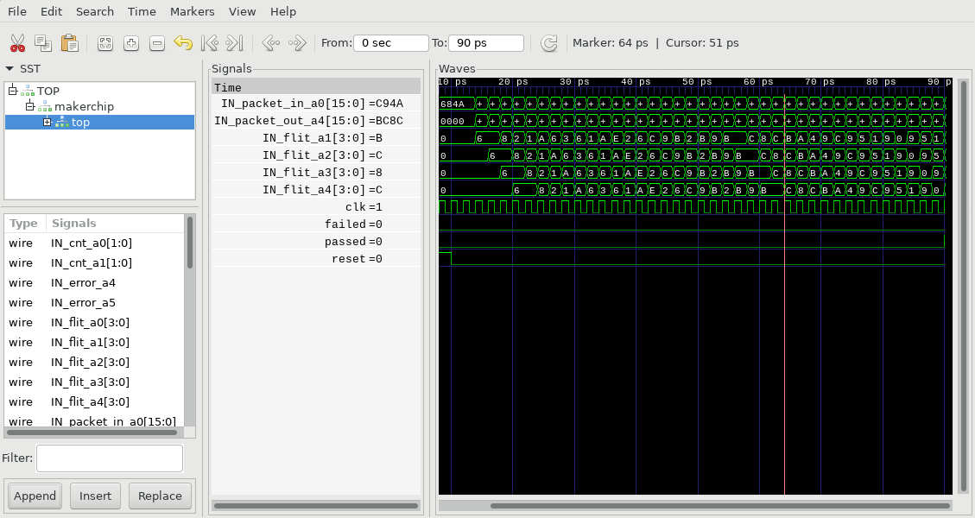
packet_6_out

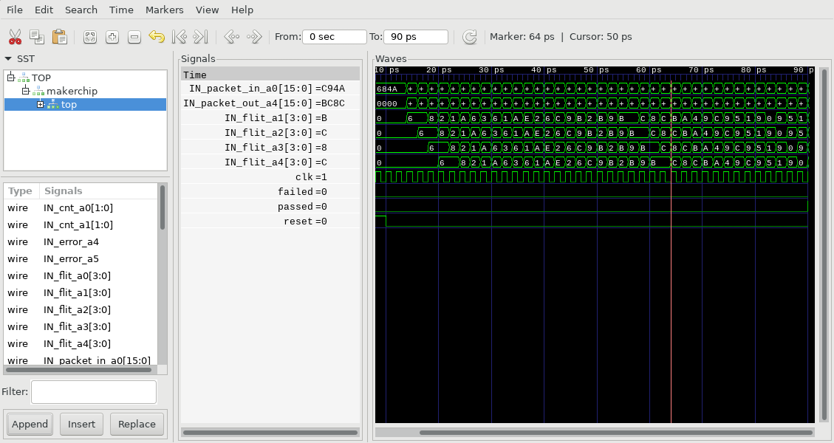

packet_7_in

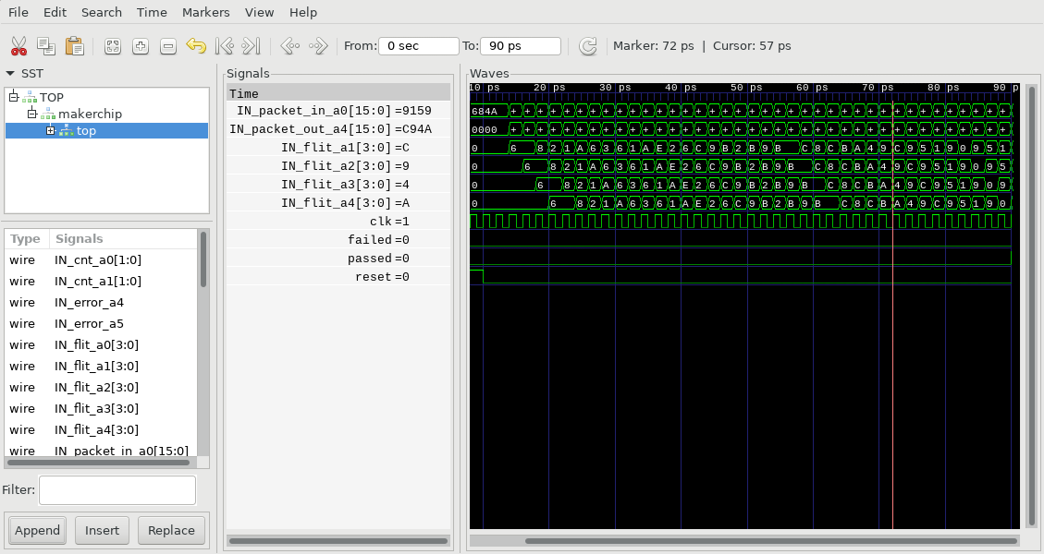

packet_7_out

