***************************Draft***************************
Testing paho.mqtt.c wih Ultibo with Raspberry Pi O/S and Ultibo
09/21/23

***************************Draft***************************

Steps to install paho MQTT client
09/17/23
https://bytesofgigabytes.com/raspberrypi/mqtt-c-client-raspberry-pi/

devel@pi4-50:~ $ git clone https://github.com/develone/paho.mqtt.c.git
Cloning into 'paho.mqtt.c'...
remote: Enumerating objects: 12427, done.
remote: Counting objects: 100% (2392/2392), done.
remote: Compressing objects: 100% (634/634), done.
remote: Total 12427 (delta 1816), reused 2213 (delta 1701), pack-reused 10035
Receiving objects: 100% (12427/12427), 9.66 MiB | 10.55 MiB/s, done.
Resolving deltas: 100% (8929/8929), done.
devel@pi4-50:~ $ cd paho.mqtt.c/
devel@pi4-50:~/paho.mqtt.c $ make
mkdir -p build/output/samples
mkdir -p build/output/test
echo OSTYPE is Linux
OSTYPE is Linux
mkdir -p build
sed -e "s/@CLIENT_VERSION@/1.3.12/g" -e "s/@BUILD_TIMESTAMP@/Sun 17 Sep 2023 06:50:42 AM MDT/g" src/VersionInfo.h.in > build/VersionInfo.h
cc -g -fPIC -D_GNU_SOURCE -Os -Wall -fvisibility=hidden -Ibuild -DPAHO_MQTT_EXPORTS=1 -o build/output/libpaho-mqtt3c.so.1.3 src/Base64.c src/Clients.c src/Heap.c src/LinkedList.c src/Log.c src/Messages.c src/MQTTClient.c src/MQTTPacket.c src/MQTTPacketOut.c src/MQTTPersistence.c src/MQTTPersistenceDefault.c src/MQTTProperties.c src/MQTTProtocolClient.c src/MQTTProtocolOut.c src/MQTTReasonCodes.c src/MQTTTime.c src/OsWrapper.c src/Proxy.c src/SHA1.c src/SocketBuffer.c src/Socket.c src/StackTrace.c src/Thread.c src/Tree.c src/utf-8.c src/WebSocket.c -shared -Wl,-init,MQTTClient_init -Wl,--start-group -pthread -lanl -Wl,--end-group -Wl,-soname,libpaho-mqtt3c.so.1
ln -s libpaho-mqtt3c.so.1.3 build/output/libpaho-mqtt3c.so.1
ln -s libpaho-mqtt3c.so.1 build/output/libpaho-mqtt3c.so
cc -g -fPIC -D_GNU_SOURCE -Os -Wall -fvisibility=hidden -Ibuild -DPAHO_MQTT_EXPORTS=1 -o build/output/libpaho-mqtt3cs.so.1.3 src/Base64.c src/Clients.c src/Heap.c src/LinkedList.c src/Log.c src/Messages.c src/MQTTClient.c src/MQTTPacket.c src/MQTTPacketOut.c src/MQTTPersistence.c src/MQTTPersistenceDefault.c src/MQTTProperties.c src/MQTTProtocolClient.c src/MQTTProtocolOut.c src/MQTTReasonCodes.c src/MQTTTime.c src/OsWrapper.c src/Proxy.c src/SHA1.c src/SocketBuffer.c src/Socket.c src/SSLSocket.c src/StackTrace.c src/Thread.c src/Tree.c src/utf-8.c src/WebSocket.c -DOPENSSL -shared -Wl,--start-group -pthread -lanl -ldl -lssl -lcrypto -Wl,--end-group -Wl,-init,MQTTClient_init -Wl,-soname,libpaho-mqtt3cs.so.1 -Wl,-no-whole-archive
ln -s libpaho-mqtt3cs.so.1.3 build/output/libpaho-mqtt3cs.so.1
ln -s libpaho-mqtt3cs.so.1 build/output/libpaho-mqtt3cs.so
cc -g -fPIC -D_GNU_SOURCE -Os -Wall -fvisibility=hidden -Ibuild -DPAHO_MQTT_EXPORTS=1 -o build/output/libpaho-mqtt3a.so.1.3 src/Base64.c src/Clients.c src/Heap.c src/LinkedList.c src/Log.c src/Messages.c src/MQTTAsync.c src/MQTTAsyncUtils.c src/MQTTPacket.c src/MQTTPacketOut.c src/MQTTPersistence.c src/MQTTPersistenceDefault.c src/MQTTProperties.c src/MQTTProtocolClient.c src/MQTTProtocolOut.c src/MQTTReasonCodes.c src/MQTTTime.c src/OsWrapper.c src/Proxy.c src/SHA1.c src/SocketBuffer.c src/Socket.c src/StackTrace.c src/Thread.c src/Tree.c src/utf-8.c src/WebSocket.c -shared -Wl,-init,MQTTAsync_init -Wl,--start-group -pthread -lanl -Wl,--end-group -Wl,-soname,libpaho-mqtt3a.so.1
ln -s libpaho-mqtt3a.so.1.3 build/output/libpaho-mqtt3a.so.1
ln -s libpaho-mqtt3a.so.1 build/output/libpaho-mqtt3a.so
cc -g -fPIC -D_GNU_SOURCE -Os -Wall -fvisibility=hidden -Ibuild -DPAHO_MQTT_EXPORTS=1 -o build/output/libpaho-mqtt3as.so.1.3 src/Base64.c src/Clients.c src/Heap.c src/LinkedList.c src/Log.c src/Messages.c src/MQTTAsync.c src/MQTTAsyncUtils.c src/MQTTPacket.c src/MQTTPacketOut.c src/MQTTPersistence.c src/MQTTPersistenceDefault.c src/MQTTProperties.c src/MQTTProtocolClient.c src/MQTTProtocolOut.c src/MQTTReasonCodes.c src/MQTTTime.c src/OsWrapper.c src/Proxy.c src/SHA1.c src/SocketBuffer.c src/Socket.c src/SSLSocket.c src/StackTrace.c src/Thread.c src/Tree.c src/utf-8.c src/WebSocket.c -DOPENSSL -shared -Wl,--start-group -pthread -lanl -ldl -lssl -lcrypto -Wl,--end-group -Wl,-init,MQTTAsync_init -Wl,-soname,libpaho-mqtt3as.so.1 -Wl,-no-whole-archive
ln -s libpaho-mqtt3as.so.1.3 build/output/libpaho-mqtt3as.so.1
ln -s libpaho-mqtt3as.so.1 build/output/libpaho-mqtt3as.so
cc -I src -Wl,--start-group -pthread -lanl -Wl,--end-group -L build/output -o build/output/paho_c_version -lpaho-mqtt3a src/MQTTVersion.c -ldl
cc -o build/output/samples/MQTTClient_publish src/samples/MQTTClient_publish.c -lpaho-mqtt3cs -I src -Wl,--start-group -pthread -lanl -lssl -lcrypto -Wl,--end-group -L build/output
cc -o build/output/samples/MQTTClient_publish_async src/samples/MQTTClient_publish_async.c -lpaho-mqtt3cs -I src -Wl,--start-group -pthread -lanl -lssl -lcrypto -Wl,--end-group -L build/output
cc -o build/output/samples/MQTTClient_subscribe src/samples/MQTTClient_subscribe.c -lpaho-mqtt3cs -I src -Wl,--start-group -pthread -lanl -lssl -lcrypto -Wl,--end-group -L build/output
cc -o build/output/samples/paho_cs_pub src/samples/paho_cs_pub.c -lpaho-mqtt3cs -I src -Wl,--start-group -pthread -lanl -lssl -lcrypto -Wl,--end-group -L build/output src/samples/pubsub_opts.c
cc -o build/output/samples/paho_cs_sub src/samples/paho_cs_sub.c -lpaho-mqtt3cs -I src -Wl,--start-group -pthread -lanl -lssl -lcrypto -Wl,--end-group -L build/output src/samples/pubsub_opts.c
cc -o build/output/samples/MQTTAsync_subscribe src/samples/MQTTAsync_subscribe.c -lpaho-mqtt3as -I src -Wl,--start-group -pthread -lanl -lssl -lcrypto -Wl,--end-group -L build/output
cc -o build/output/samples/MQTTAsync_publish src/samples/MQTTAsync_publish.c -lpaho-mqtt3as -I src -Wl,--start-group -pthread -lanl -lssl -lcrypto -Wl,--end-group -L build/output
cc -o build/output/samples/paho_c_pub src/samples/paho_c_pub.c -lpaho-mqtt3as -I src -Wl,--start-group -pthread -lanl -lssl -lcrypto -Wl,--end-group -L build/output src/samples/pubsub_opts.c
cc -o build/output/samples/paho_c_sub src/samples/paho_c_sub.c -lpaho-mqtt3as -I src -Wl,--start-group -pthread -lanl -lssl -lcrypto -Wl,--end-group -L build/output src/samples/pubsub_opts.c
cc -DNOSTACKTRACE -DNOLOG_MESSAGES src/Thread.c -g -o build/output/test/test1 src/../test/test1.c -lpaho-mqtt3c -I src -Wl,--start-group -pthread -lanl -Wl,--end-group -L build/output
cc -DNOSTACKTRACE -DNOLOG_MESSAGES src/Thread.c -g -o build/output/test/test15 src/../test/test15.c -lpaho-mqtt3c -I src -Wl,--start-group -pthread -lanl -Wl,--end-group -L build/output
cc -DNOSTACKTRACE -DNOLOG_MESSAGES src/Thread.c -g -o build/output/test/test2 src/../test/test2.c -lpaho-mqtt3c -I src -Wl,--start-group -pthread -lanl -Wl,--end-group -L build/output
cc -DNOSTACKTRACE -DNOLOG_MESSAGES src/Thread.c -g -o build/output/test/sync_client_test src/../test/sync_client_test.c -lpaho-mqtt3c -I src -Wl,--start-group -pthread -lanl -Wl,--end-group -L build/output
cc -DNOSTACKTRACE -DNOLOG_MESSAGES src/Thread.c -g -o build/output/test/test_mqtt4sync src/../test/test_mqtt4sync.c -lpaho-mqtt3c -I src -Wl,--start-group -pthread -lanl -Wl,--end-group -L build/output
cc -DNOSTACKTRACE -DNOLOG_MESSAGES src/Thread.c -g -o build/output/test/test10 src/../test/test10.c -lpaho-mqtt3c -I src -Wl,--start-group -pthread -lanl -Wl,--end-group -L build/output
cc -g -o build/output/test/test3 src/../test/test3.c -lpaho-mqtt3cs -I src -Wl,--start-group -pthread -lanl -lssl -lcrypto -Wl,--end-group -L build/output
cc -g -o build/output/test/test4 src/../test/test4.c -lpaho-mqtt3a -I src -Wl,--start-group -pthread -lanl -Wl,--end-group -L build/output
cc -g -o build/output/test/test45 src/../test/test45.c -lpaho-mqtt3a -I src -Wl,--start-group -pthread -lanl -Wl,--end-group -L build/output
cc -g -o build/output/test/test6 src/../test/test6.c -lpaho-mqtt3a -I src -Wl,--start-group -pthread -lanl -Wl,--end-group -L build/output
cc -g -o build/output/test/test9 src/../test/test9.c -lpaho-mqtt3a -I src -Wl,--start-group -pthread -lanl -Wl,--end-group -L build/output
cc -g -o build/output/test/test95 src/../test/test95.c -lpaho-mqtt3a -I src -Wl,--start-group -pthread -lanl -Wl,--end-group -L build/output
cc -g -o build/output/test/test_mqtt4async src/../test/test_mqtt4async.c -lpaho-mqtt3a -I src -Wl,--start-group -pthread -lanl -Wl,--end-group -L build/output
cc -g -o build/output/test/test11 src/../test/test11.c -lpaho-mqtt3a -I src -Wl,--start-group -pthread -lanl -Wl,--end-group -L build/output
cc -g -o build/output/test/test5 src/../test/test5.c -lpaho-mqtt3as -I src -Wl,--start-group -pthread -lanl -lssl -lcrypto -Wl,--end-group -L build/output

devel@pi4-50:~/paho.mqtt.c $ sudo make install
mkdir -p build/output/samples
mkdir -p build/output/test
echo OSTYPE is Linux
OSTYPE is Linux
mkdir -p /usr/local/include
install -m 644 build/output/libpaho-mqtt3c.so.1.3 /usr/local/lib
install -m 644 build/output/libpaho-mqtt3cs.so.1.3 /usr/local/lib
install -m 644 build/output/libpaho-mqtt3a.so.1.3 /usr/local/lib
install -m 644 build/output/libpaho-mqtt3as.so.1.3 /usr/local/lib
install build/output/paho_c_version /usr/local/bin
install build/output/samples/paho_c_pub /usr/local/bin
install build/output/samples/paho_c_sub /usr/local/bin
install build/output/samples/paho_cs_pub /usr/local/bin
install build/output/samples/paho_cs_sub /usr/local/bin
/sbin/ldconfig /usr/local/lib
ln -s libpaho-mqtt3c.so.1 /usr/local/lib/libpaho-mqtt3c.so
ln -s libpaho-mqtt3cs.so.1 /usr/local/lib/libpaho-mqtt3cs.so
ln -s libpaho-mqtt3a.so.1 /usr/local/lib/libpaho-mqtt3a.so
ln -s libpaho-mqtt3as.so.1 /usr/local/lib/libpaho-mqtt3as.so
install -m 644 src/MQTTAsync.h /usr/local/include
install -m 644 src/MQTTClient.h /usr/local/include
install -m 644 src/MQTTClientPersistence.h /usr/local/include
install -m 644 src/MQTTProperties.h /usr/local/include
install -m 644 src/MQTTReasonCodes.h /usr/local/include
install -m 644 src/MQTTSubscribeOpts.h /usr/local/include
install -m 644 src/MQTTExportDeclarations.h /usr/local/include
install -m 644 doc/man/man1/paho_c_pub.1 /usr/local/share/man/man1
install -m 644 doc/man/man1/paho_c_sub.1 /usr/local/share/man/man1
install -m 644 doc/man/man1/paho_cs_pub.1 /usr/local/share/man/man1
install -m 644 doc/man/man1/paho_cs_sub.1 /usr/local/share/man/man1

devel@pi4-50:~/paho.mqtt.c $ ls /usr/local/bin/
geek-timer.sh paho_c_pub paho_cs_pub paho_cs_sub paho_c_sub paho_c_version

devel@pi4-50:~ $ paho_c_sub -t 'pico/status' -u 'testuser' -P 'password123' -h 'pi4-37'
T = 31.82 C 0x26c batt = 0.50 remote5
T = 29.01 C 0x050 batt = 0.06 remote3
T = 31.82 C 0x26c batt = 0.50 remote5
T = 29.01 C 0x04f batt = 0.06 remote3
T = 31.82 C 0x26c batt = 0.50 remote5
T = 29.01 C 0x04f batt = 0.06 remote3
T = 31.82 C 0x26c batt = 0.50 remote5
T = 29.01 C 0x04f batt = 0.06 remote3

These 2 cmds required a modification to /etc/mosquitto/mosquitto.conf

needed to edit /etc/mosquitto/mosquitto.conf

line 522

allow_anonymous false -> allow_anonymous true

cc MQTTClient_subscribe.c -o MQTTSUB -lpaho-mqtt3c

cc MQTTClient_publish.c -o MQTTPUB -lpaho-mqtt3c

devel@pi4-30:~/paho.mqtt.c/src/samples $ paho_c_pub -t "MQTT Examples" -u 'testuser' -P 'password123' -m 'hello-world' -h 'pi4-37'
devel@pi4-30:~/paho.mqtt.c/src/samples $ paho_c_pub -t "MQTT Examples" -u 'testuser' -P 'password123' -m 'hello-world temp pi4-30' -h 'pi4-37'
devel@pi4-30:~/paho.mqtt.c/src/samples $ paho_c_sub -t "MQTT Examples" -u 'testuser' -P 'password123' -h 'pi4-37'
hello-world
hello-world
hello-world
hello-world this is a test

Make the following change to
devel@pi4-20:~/Ultibo_Projects/Pauls-ultibo-mqtt/QEMU $ git diff
diff --git a/Pauls-ultibo-mqtt/QEMU/MQTTServerTest.lpr b/Pauls-ultibo-mqtt/QEMU/MQTTServerTest.lpr
index 5ec5275..7eccace 100644
--- a/Pauls-ultibo-mqtt/QEMU/MQTTServerTest.lpr
+++ b/Pauls-ultibo-mqtt/QEMU/MQTTServerTest.lpr
@@ -209,7 +209,7 @@ begin
'7' :
begin

- MQC.Host := '192.168.1.212';
+ MQC.Host := '192.168.42.116';
MQC.Username := 'testuser';
MQC.Password := 'password123';
MQC.LocalBounce := false;

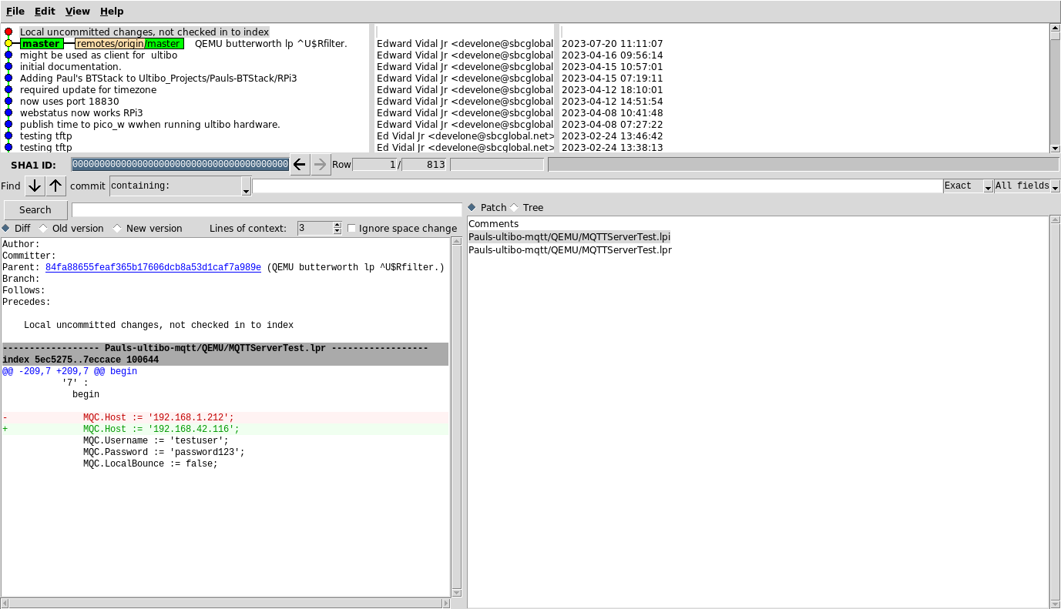
xx
Compile the using Lazarus IDE (Ultibo Edition)

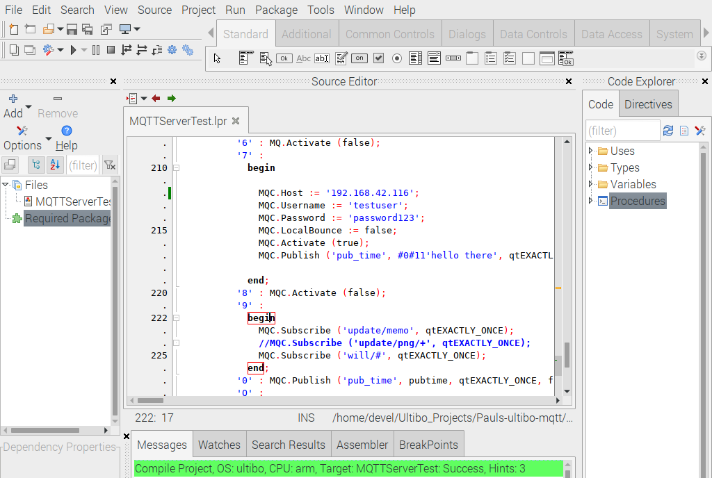

#!/bin/bash
qemu-system-arm -machine versatilepb -cpu cortex-a8 -kernel kernel.bin \
-net user,hostfwd=tcp::5080-:80,hostfwd=tcp::5023-:23,hostfwd=tcp::18830-:18830,hostfwd=udp::5069-:69,hostfwd=tcp::6050-:5050 -net nic \
-drive file=disk.img,if=sd,format=raw

devel@pi4-20:~/Ultibo_Projects/Pauls-ultibo-mqtt/QEMU $ ./startqemu.sh

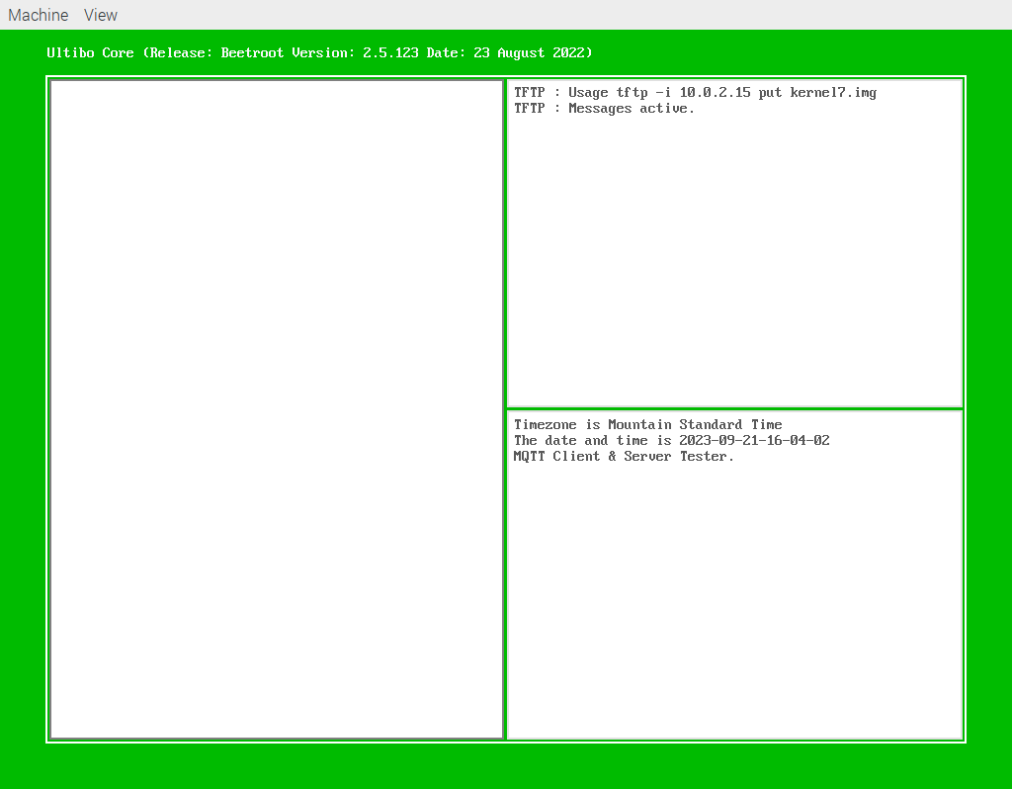
Depress 7

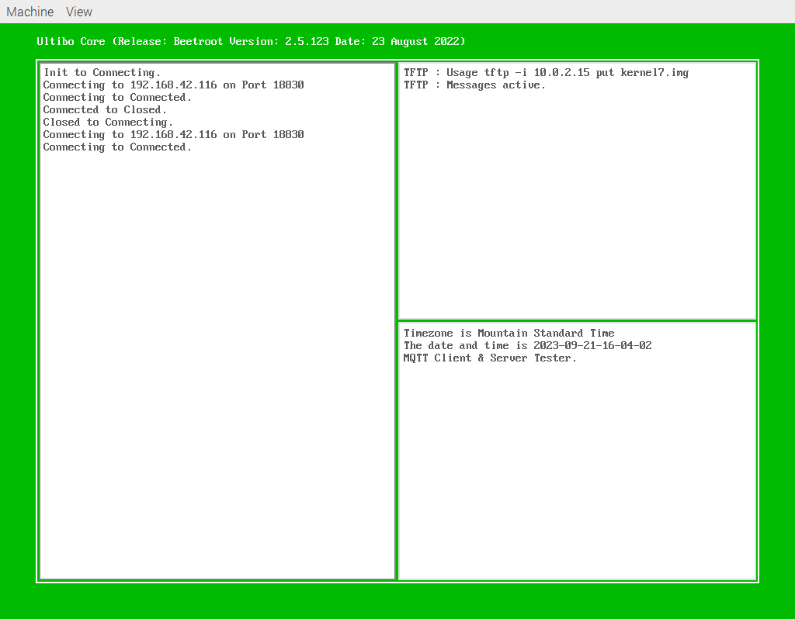
Depress 5
Depress 7
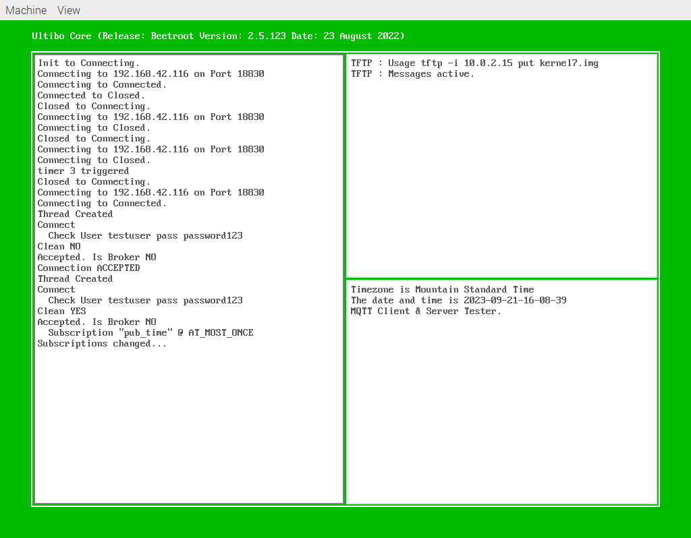

devel@pi4-20:~ $ paho_c_sub -t 'pub_time' -u 'testuser' -P 'password123' -h '192.168.42.116' -p '18830
Depress 0
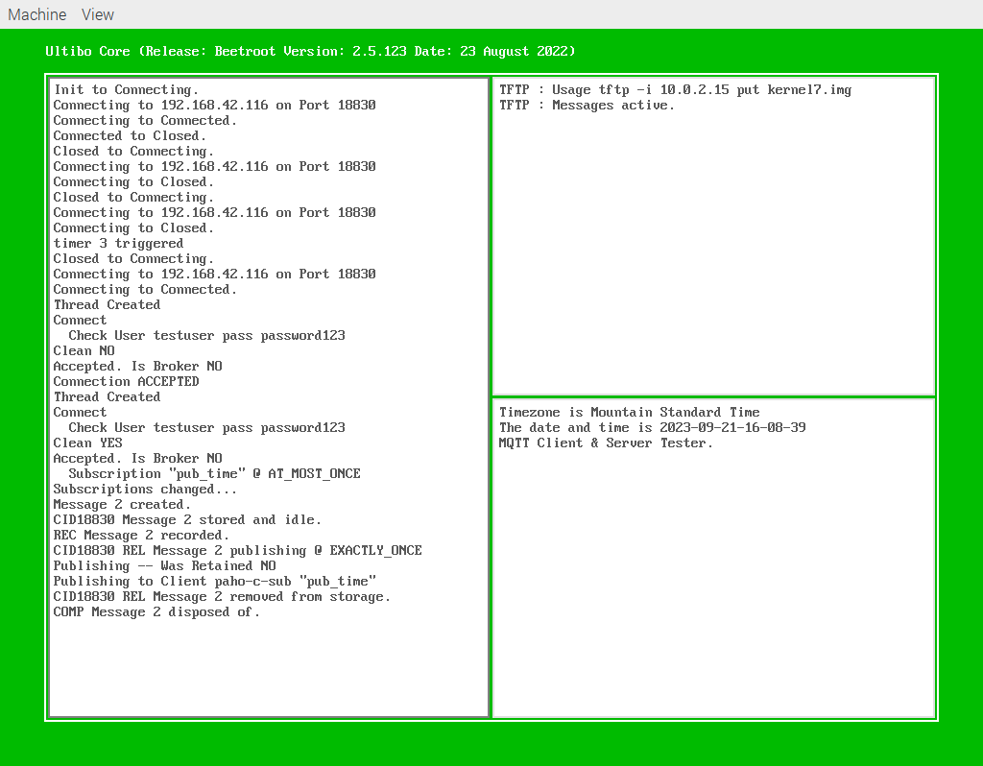

devel@pi4-20:~ $ paho_c_sub -t 'pub_time' -u 'testuser' -P 'password123' -h '192.168.42.116' -p '18830'
2023-09-21-16-08-39

