The Chrome is very import for running pico_w-mqtt.
You need to run linux.
After logging in go to bottom of display and depress with mouse the date
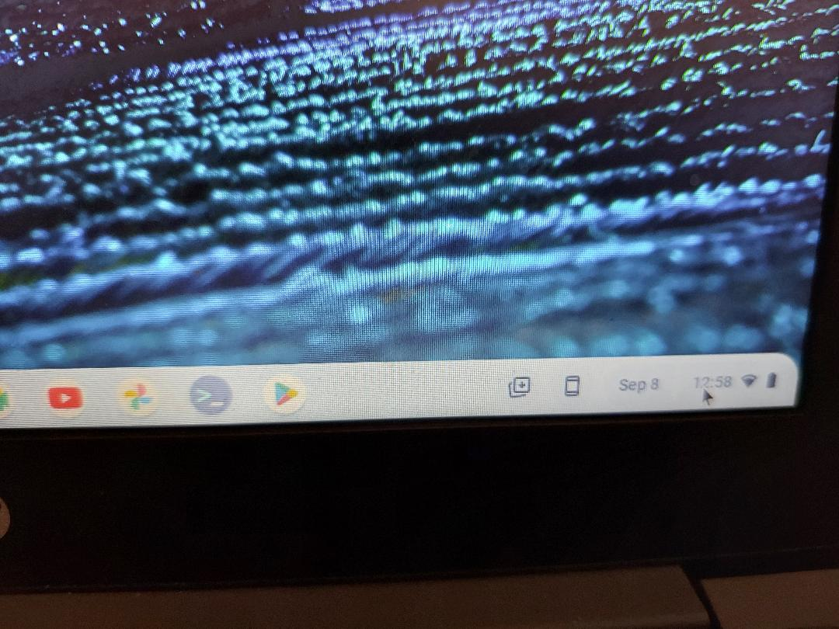
Depress the Date.

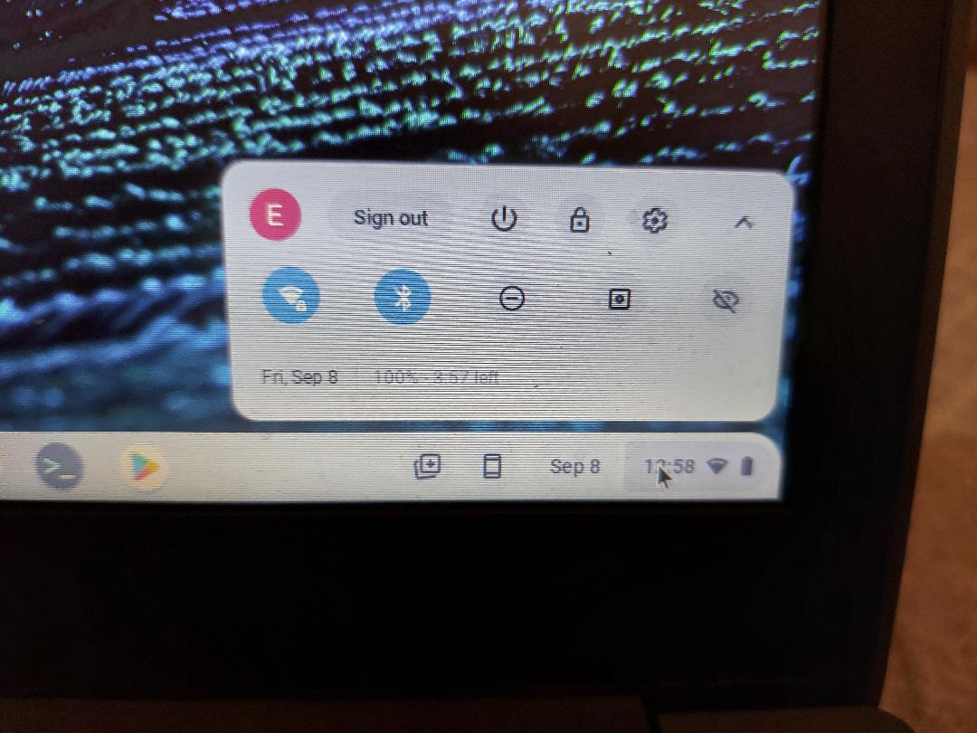

Depress Advance.
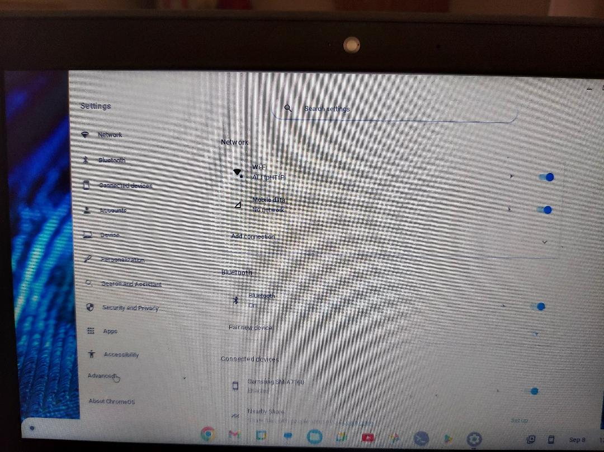
Then scroll to Developers and select Linux

