Mp3 compression and transmission of infrasonic sensor array signals and task-specific metrics for distortion evaluation.
Smitha Paramanandan¹, Sergio D. Cabrera^{1,*}, Edward Vidal, Jr. ²,
¹ Dept. of Electrical and Comp. Eng., Univ. of Texas at El Paso, El Paso, TX 79968
² U. S. Army Research Laboratory, WSMR, NM, 88002-5501
abstract
Infrasonic sensor arrays are very useful for detecting and tracking hostile military vehicles or aircrafts. This paper describes part of an ongoing project for compressing and transmitting a set of infrasonic signals that need to be delivered to a remote location for decompression and processing. The project also deals with the evaluation of the effect of the compression distortion on the signals by the use of application specific distortion metrics. The overall system consists of 8 sensors (4 microphones, 3 geophones and 1 temperature sensor) from which target events can be detected by computing coherence, beamforming and phase velocity. The distortion caused by the compression needs to be quantified in terms of its effect on the processing. We evaluate the effectiveness of the scheme using one hour worth of signals from the 4 microphones sampled at 100.16 samples/sec, having a resolution of 24 bits/sample for a total of 4 Mbytes of data.
The approach described here is to combine the 4 microphone signals/channels using a transmultiplexer and to use an off-the-shelf audio compression standard, namely the popular Mp3 method which is based on subband coding with uniform bandwidths. The codec used in this project is the readily available LAME software package. Before the compress/decompress operations the combined signal is converted to 16 bits per sample. LAME allow the user to control some of the parameters involved in the compression, most importantly the desired bit rate. For the purposes of finding low-frequency events, these 4 signals are considered to be oversampled by a factor of 4, however, they are merged using a 5-channel Cosine-Modulated filterbank transmultiplexer in order to maintain a small degree of oversampling. The results presented indicate a linear relationship between the bit rate and the SNR in dB at compression ratios between 6:1 and 32:1. In the application considered, the microphone signals are used to compute time-dependent quantities including the average between-channel coherence, a beampattern, and a phase velocity estimate. These same quantities are used as task-specific metrics that reveal the distortion caused by the application of the mp3 compressor so that the user can evaluate the tolerable distortion.
Keywords: Infrasonic signals, MP3 Compression, LAME, Transmultiplexer, Coherence, Beamforming, Task-Specific Metrics.

- INTRODUCTION AND SUMMARY
Figure 1 shows the whole process stage by stage. We start with the four signals from the microphones available at a sampling frequency of 100.16 Hz. Since all events of interest occur at very low frequencies, we next decimate the signals by a factor of 4 using a powerful anti-aliasing filter and the resulting signals are now sampled at 25.04 Hz. Then the four signals/channels are combined as one using a modern transmultiplexer based on near-perfect-reconstruction multirate filterbanks [Mitra]. In order to avoid using a highpass filter that will produce a full-band transmultiplexer output signal with energy all the way up to half of the sampling frequency, we choose to design the transmultiplexer with 5 channels, one more than the minimal number for our 4 signals/channels. The synthesis filterbank processing involves first upsampling each of the four signals by 5 and then filtering channel 1 with a lowpass filter and channels 2, 3 & 4 with bandpass filters. Then we use an adder to combine the four signals into one. This combined signal is passed through the mp3 encoder. We can specify the desired compression ratio at this stage. This compressed signal is now ready for transmission. All the filters in the transmultiplexer are obtained by cosine-modulating a prototype filter as explained later in the paper.
At the receiver side, the received binary data is passed through the mp3 decoder. The received signal is decompressed using the same bit rate (compression ratio) specified at the transmitter and then it is fed to the analysis filterbank so that the channels can be separated again. This involves filtering the same decompressed signal with a lowpass filter and three bandpass filters. This operation separates the combined signal into four narrowband signals with most of their energy occupying 1/5 of the total bandwidth. Each of these four signals are then downsampled by 5 to get back to the sampling rate that we started with. This completes the process. Now, the signals are available for analysing the distortion caused by the tansmultiplexer and the compress-decompress operations.
5
5

5

5

LPF
BPF
BPF
BPF

Ch1
Ch2
Ch3
Ch4

LPF
Decimate Signals
by 4

5

5
5

5

5

5

5
5
5
BPF
Channel
5
LAME
Encoder

LAME
Decoder

BPF
5
BPF
5

Transmitter Side
Receiver Side

Figure 1; Overall view of the multiplexing-compression approach evaluated in this paper

- AN INFRASONIC SIGNAL ARRAY
Infrasonic Signals are acoustic signals that have very low frequencies and so are inaudible. U.S Army Research Laboratory (ARL) [JNoble] developed a project which uses an array of infrasonic sensors to detect man-made and natural signals. Their interests began with detection of signals like missiles. Detections have ranged from space shuttle launches to local power station noise. With this setup, other notable detections analyzed by the ARL include explosives tests from Dahlgren and Quantico in Virginia and from Stump Neck in Maryland. Concorde flights leaving from Kennedy International Airport and accelerating over the Atlantic Ocean have also been detected. The setup involves an array of microphones collocated with meteorological sensors, 24-bit analog-to-digital converters (ADCs), a simple PC running a UNIX like QNX OS, a Windows based PC using Matlab for signal processing and an additional Linux machine for file management. The three PCs are netted together for file sharing and archiving. Up to 72 hours of data is available at any given time in the server.

2.1 Overview of Sensors and Signals
The array of sensors consists of four microphones, three geophones and one temperature sensor. Out of the 8 sensors this paper considers the signals from the four microphones for compression. The Chaparral Physics Model 2 microphones are used. To avoid the low frequency noise caused by turbulent wind, each microphone is attached to six 20 feet porous hoses arranged radially [JNoble].
The four signals are sampled at a sampling frequency of 100.16 Hz. Clearly, the four signals will not be the same since the four microphones are separated by 20 meters and are arranged in the form of a “Y” letter. However, all the four signals are very highly correlated, and have very similar amplitudes and DC levels.

2.2 Data Acquisition/Computer System and Signal Processing
The ADC is based on a Sigma-Delta analog-to-digital converter and requires four times oversampling. That is why we sample the data at 100.16 Hz to achieve a 25.04 Hz sample rate for analysis purposes. For this purpose, the data is lowpass filtered by an equiripple lowpass FIR filter and then downsampled by a factor of 4 using Matlab. In order to remove the DC offset and to get rid of very low frequencies the signals are also highpass filtered with a 1 Hz cutoff using an 8-pole Butterworth filter. So, over the course of one hour, the original signals consist of 360485 samples each before the decimation and 90122 samples after decimation.
2.3 Problem Statement
There are 11.54 Mb of data collected per hour from the sensors. In order to economize on computer resources and optimize CPU processing rates, we need to incorporate off-the-shelf compression techniques suitable for real-time implementation using a low-cost processor. This can be achieved by using modern compression techniques such as the mp3 standard by treating the infrasonic signals as audio signals. Furthermore, the four signals can be combined into one so that a single codec can be used in the implementation. Recall that lossless compression techniques such as “gzip” give compression ratios on the order 1.5:1. Using the mp3 approach, we can obtain compression ratios on the order of 8:1 and higher.
[TO BE CONTINUED HERE]
- Mp3 CODEC and LAME

Mp3 has emerged to be known as one of the best audio compression tools. MPEG-1 Layer-3 performs as a perceptual audio coding system and gives high quality compression in the sense the compressed file is as small as possible and the decompressed audio sounds as close as possible to the original audio. It is a lossy compression algorithm. It is lossless in the perceptual sense, as mp3 uses the psychoacoustic modeling which exploits the perceptual limitations of the human auditory system.
A basic perceptual audio coder consists of the following blocks.
Analysis Filterbank
Quantization and Coding
Encoding of bitstream
Perceptual Model
Audio
in
Decoding of Bitstream
Inverse Quantization
Synthesis Filterbank
Bitstream

in
Audio

out
Bitstream

out

Figure 2

The filterbank is used to decompose the incoming audio signal into subband spectral components. Using the concept of psychoacoustic modeling and the input audio signal a decision about the masking threshold is made. The signal is then quantized and coded with the quantization noise being kept below the masking threshold. Now as the last step bits are allocated to the quantized and coded spectral coefficients in the Encoding of bitstream block.
The LAME project is an open-source mp3 encoding application. LAME is a recursive acronym for LAME Ain’t an Mp3 Encoder. The reason we use LAME and not the ISO Mp3 code is that the ISO Mp3 coder is not optimized for execution on a general-purpose processor and LAME is. [LAME]

Some of the features of LAME are
- Capable of encoding mpeg 1, 2 and 2.5 layer 3.
- Improved quality and speed over the ISO reference software.
- Allows constant bitrate and two types of variable bitrate.
- Powerful and easy to use presets.
- Encodes faster than real-time on a P II 266 at highest quality mode.
- They have a GUI and command line version. GUI is called the Razor Lame.
- The command line can be used to control a lot of parameters while compressing
like the bitrate and destination of the output file etc.,.
- merging approach: transmultiplexers
M
M
M
x₀(n)
x₁(n)
x_{M-1}(n)
f₀(n)
f₁(n)
f_{M-1}(n)
h₀(z)
h₁(z)
h_{M-1}(z)
M
M
M
y₀(n)
y₁(n)
y_{M-1}(n)

Figure 3

Here we use the theory and design of an M-channel cosine modulated filter bank for the implementation of the transmultiplexer [Kaiser] [Mitra]. The analysis and synthesis filters in the filterbank are cosine modulated versions of a prototype filter. The whole design of the filterbank and thus of the transmultiplexer reduces to the design of the prototype filter.
[ ADD MORE ABOUT THE ANALYSIS OF THE TRANSMULTIPLEXER, BRIEF BUT A FEW KEY EQUATIONS FOR THE GENERAL CASE]
In the cosine-modulated system of filters, all the M analysis and synthesis filters are derived from a prototype filter P(n) by cosine modulation. The advantages of this system are that the cost of the analysis and synthesis filter banks is equal to the cost of one filter plus modulation overhead. The modulation can be performed using fast techniques like discrete cosine transform (DCT). Also, another advantage is that when it comes to optimization of parameters there are very few as only the prototype filter parameters are to be optimized.
Once the prototype filter is known, the analysis h_{k}[n]and synthesis f_{k}[n] filters can be obtained by cosine modulating the prototype filter as follows
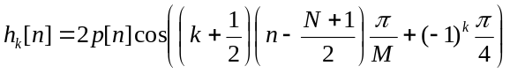
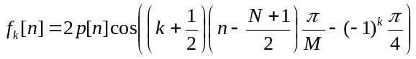
Where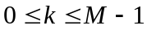, where M is the number of bands in the filterbank and N is the prototype filter order.
We use Kaiser Window approach to design the prototype filter. This gives us an approximate reconstruction cosine modulated filterbank (aliasing is canceled approximately) and the distortion is only a delay. Following are the steps involved in the Kaiser Window approach.
The order of the window N can be estimated given the desired stopband attenuation A_{S} and the transition bandwidth ∆ω as:
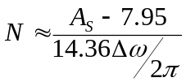
Once we have the order of the window, the window is given by
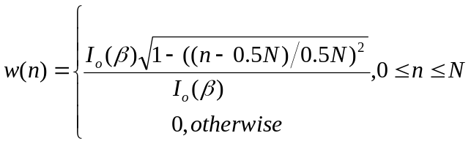
Where I_{o}(⋅) is the zeroth-order modified Bessel Function which can be computed using
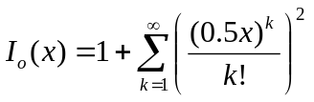
The impulse response of the ideal filter with cutoff frequency ω_{C} is given by
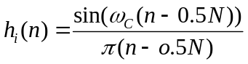
A filter p(n) of length N+1 designed using Kaiser Window is of the form
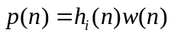
Now, the Kaiser Window is completely determined and the cutoff frequency ω_{C} is the only parameter left in the design. ω_{C} is optimized such that an objective function is minimized. Define a filter 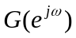 given by 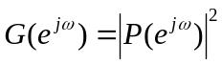. is approximately a Nyquist (2M) filter. That is, g(2Mn) is approximately (1/2M)δ(n), where δ(n) is given by,
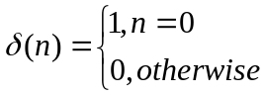
Using this, the objective function to be minimized is
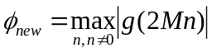
ω_{C} is chosen to find the best p(n) that yields the smallest φ_{new}.

The filters that are used in this paper for the processing of infrasonic signals were designed using the above approach. Choosing parameters A_{S} and ∆ω as 60 dB and 0.45 respectively, we obtain a prototype filter of order 40 for a 5-channel system which is guaranteed to give a filterbank delay of 8 [5] since the order is an integer factor of 5. The output of the analysis filters have to be scaled by a factor of 5 as the analysis filters scale the signals by a factor of 1/5.

In addition,

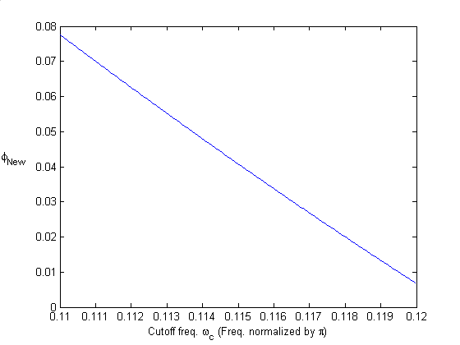
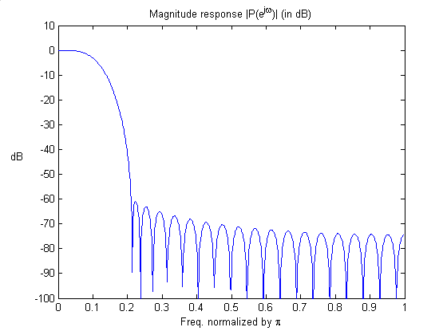
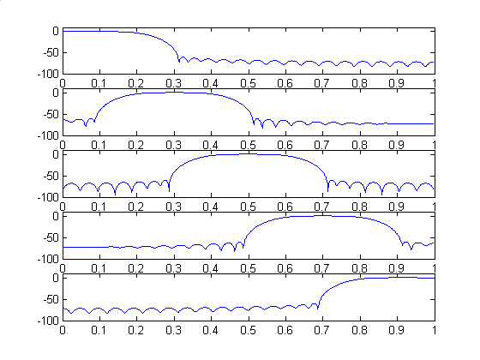
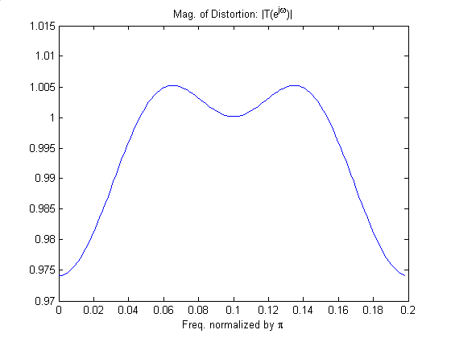
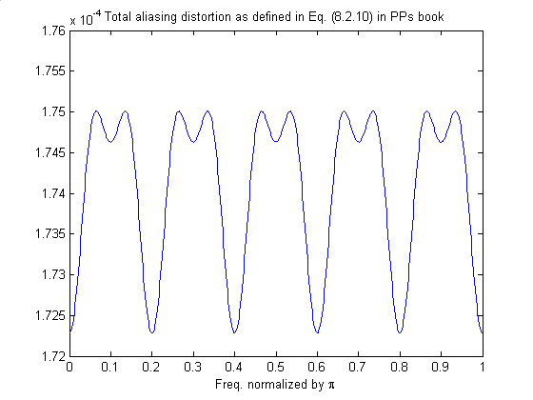

- COMPRESSION RESULTS using traditional metrics

Bitrate(kbps) | SNR(dB) | MSE | Coherence SNR | Coherence MSE | CR  (*4)
8 | 8.08573145 | 0.00002024 | 14.80332119 | 0.02225098 | 31.8841:1 (128:1)
16 | 14.05924533 | 0.00000511 | 16.14572047 | 0.01633463 | 15.9420:1 (64:1)
24 | 17.48122435 | 0.00000233 | 17.63716726 | 0.01158683 | 10.6280:1 (40:1)
32 | 20.58404136 | 0.00000114 | 19.75474167 | 0.00711553 | 8:1  (32:1)
40 | 23.22306770 | 0.00000062 | 21.75872300 | 0.00448548 | 6.3913:1 (24:1)

Table 1

The table above shows results for 5 different cases of bitrate. We can see that SNR increases as the amount of compression decreases. And MSE decreases as SNR increases. We see that due to the use of transmultiplexer we gain a factor of four on the compression ratios and SNRs. So, even at a low compression rate of 32 kbps we achieve a compression ratio of 32:1 with an SNR of 20.58 dB.
Originally the signal has 25.04 Hz. After going through the synthesis filters the sampling frequency becomes five times the original i.e., 125.20 Hz. When we do the processing in matlab using the “wavewrite” command we artificially write the signal in to a “.wav” file using 16 KHz. This is done as LAME performs well with higher sampling frequencies.
- compression distortion BASED ON TASK-SPECIFIC METRICS

We use Coherence, beamforming and phase velocity as task-specific metrics.
6.1 Coherence
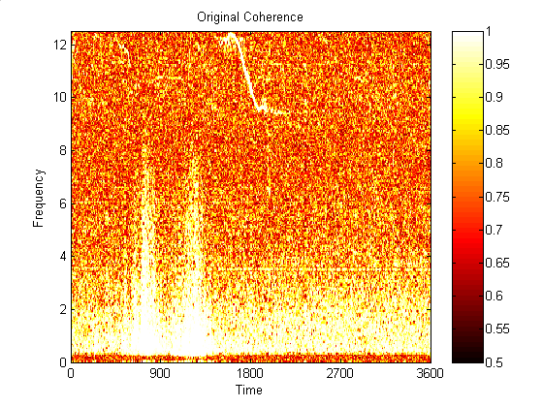
Coherence gives how similar in phase the signals are at the same time along with frequency. Coherence is normalized cross-spectrum given by
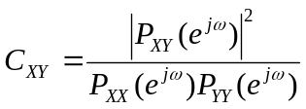

Here P_{XY} is the cross-spectral density of any two signals X and Y. And P_{XX} and P_{YY} are the power spectral densities of X and Y respectively. Coherence is a function of frequency with values between 0 and 1 that indicate how well the signal X corresponds to the signal Y at each frequency. X and Y are divided into overlapping sections, each of which is detrended, then windowed by a hanning window of length NFFT. We are using NFFT=512 point DFTs in our case. The magnitude squared of the length NFFT DFTs of the sections of X and the sections of Y are averaged to form P_{XX} and P_{YY}. The products of the length NFFT DFTs of the sections of X and Y are averaged to form P_{XY}.
C_{XY} has length NFFT/2+1 for NFFT even, (NFFT+1)/2 for NFFT odd or NFFT if X or Y is complex. Sampling frequency Fs is does not affect the cross spectrum estimate but is used for scaling of plots. We plot the coherence as time-frequency plots.

8 kbps
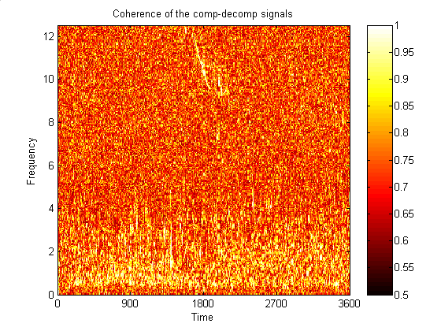
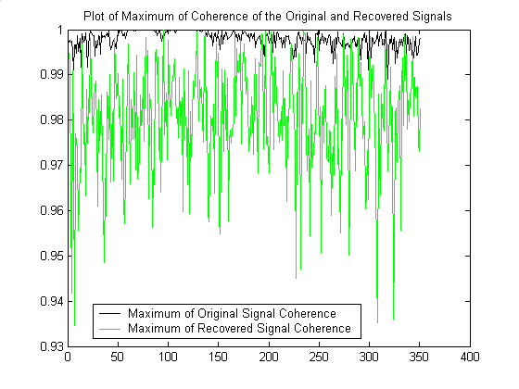

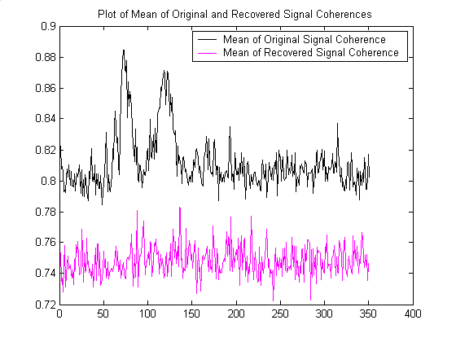

16kbps
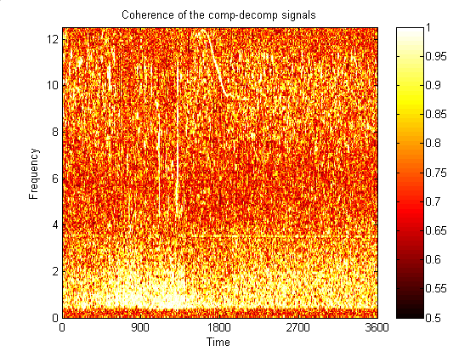
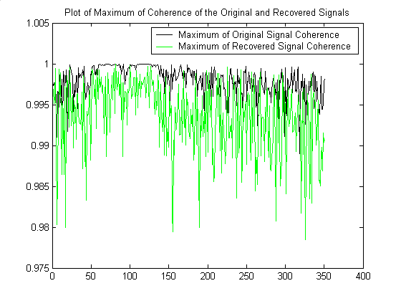
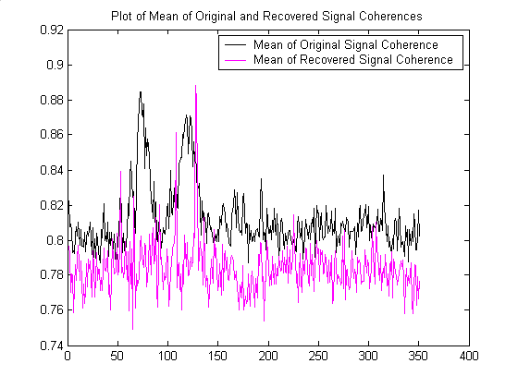

24 kbps
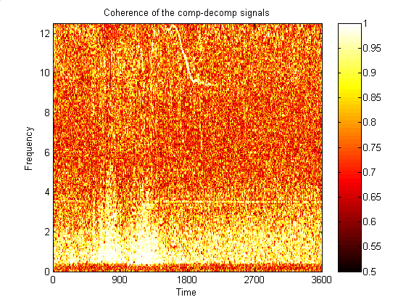
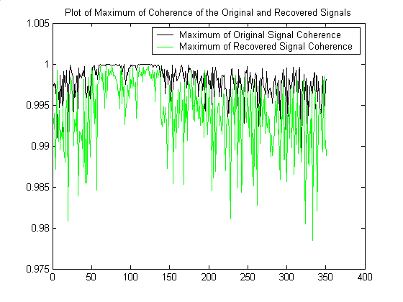
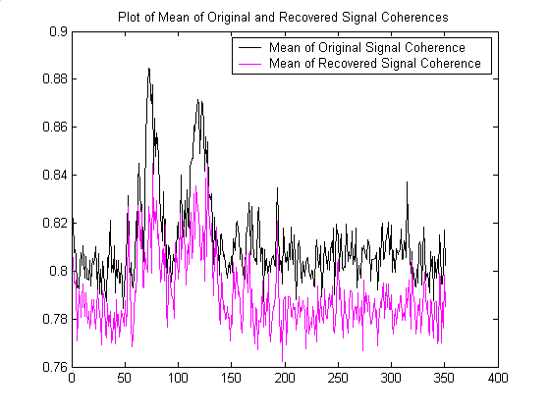

32 kbps
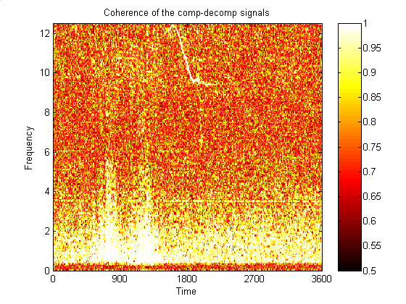
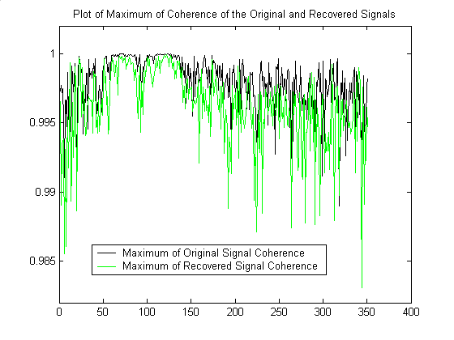
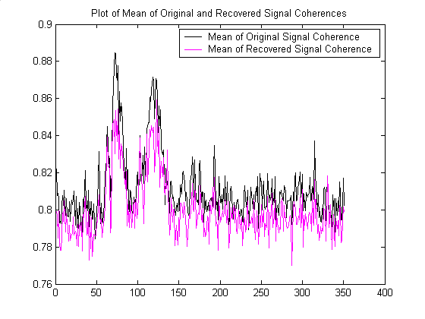

40 kbps
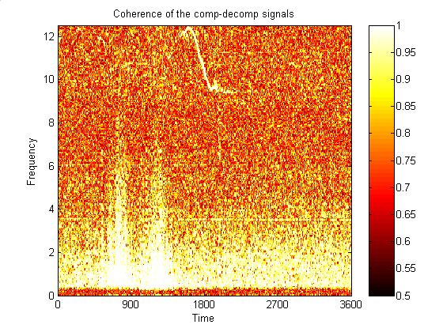
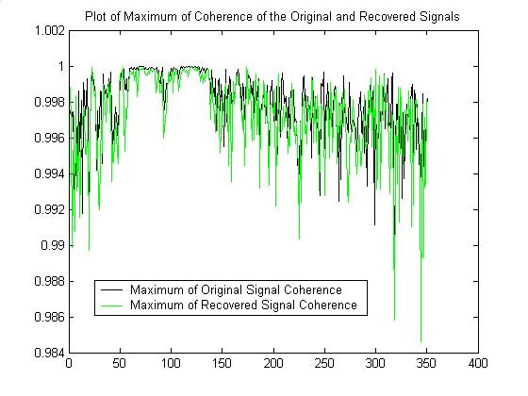
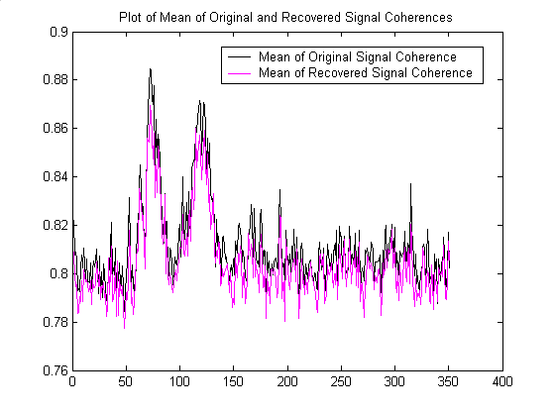

6.2 Beamforming
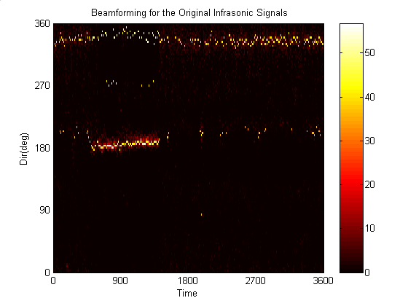
Beamforming helps us see if the direction of arrival of the signal is restored after all the processing. In this section we discuss the beamforming equations and explicitly define the frequency domain estimation process used to generate the cross-power matrix in the beamforming equations. If we have an array of M sensors, each sensor is a spatial wavefield point which records over time. Each of the sensors has a vector location R_{m} in the x-y plane as
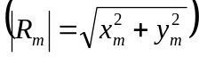
A collection of sensor data like this is called a signal vector. If a single source is sampled at locations 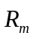then the wavefield is given by a single vector with components
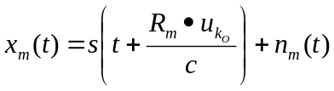
Where
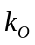is a wave number 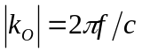
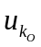is the unit vector direction of the source
nm is the background noise field
and c is the scalar wave propagation velocity.

In the frequency domain the above equation becomes
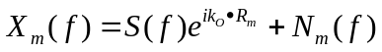
Where S(f) is the ideal Fourier transform of the signal without noise. In the matrix notation the signal vector is,
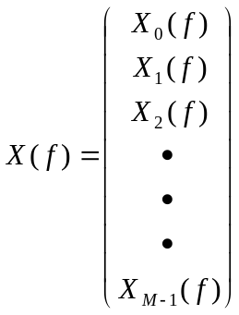
Given M spatial samples of the wave field, a beam response function [(Y (f,)] is formed by summing over each component of the signal vector and applying a phase shift that is dependent upon an observation wave number 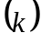:
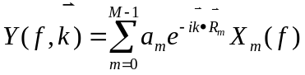
In the frequency domain,
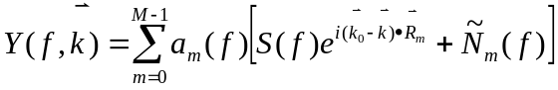
Where the a_{m}(f) constants are spatial filter weights to be defined through the application of a specific beamforming strategy, and 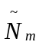is the noise field modified by a phase shift of 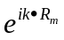. In the matrix notation the beam response is
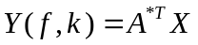
Where *T means complex conjugate transpose, and
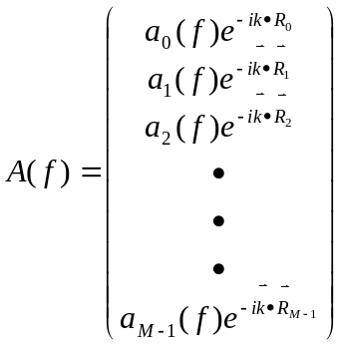
A(f) is referred to as steering vector. The beam power at the given frequency and observation wave number is
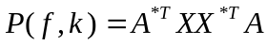
Or
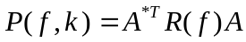
Where R(f) is an M × M matrix composed of the product of the signal vector and its complex conjugate transpose. The matrix R is commonly referred to as the spatial correlation matrix. A wideband beam power function can be produced by integrating over a band of frequencies:
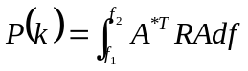
Two beamformers have been used to spatially filter array signals. The first is the conventional Bartlett ( BT) beamformer given by 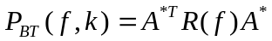. The second is the Minimum Variance Distortionless Response (MVDR) beamformer given by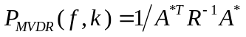. In this paper all beamforming results were computed using the MVDR beamformer.
Beamformed results are not evaluated for the presence of signals above noise, but all of the microphones in the array are used in the calculation. Once the coherence indicates that there is signal the beamformer creates 120 beams. The direction of arrival is selected by determining the maximum amplitude reaching the array. The direction of maximum beam power is thus determined to be the direction signal propagation. For MVDR Beamforming the correlation matrix must be nonsingular for R⁻¹ to exist. Many a times the correlation matrix is singular which cannot be inverted. To alleviate this problem a small amount of white noise (λ) is added to the spatial correlation matrix. Capon[CaponJ] has suggested the following
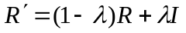
We have chosen λ=0.004. The maximum beam power versus slowness is then determined to demonstrate if the signal has emanated from a source high above the ground level or at ground level.

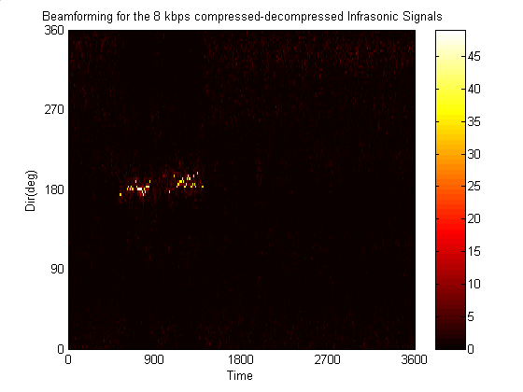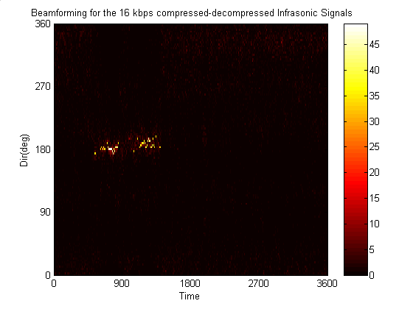

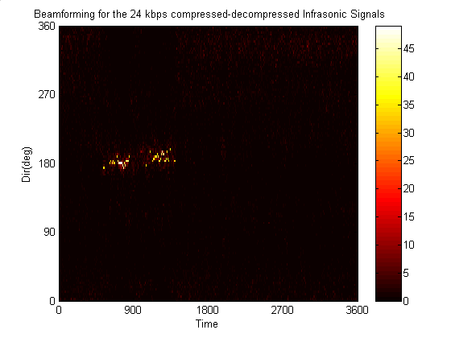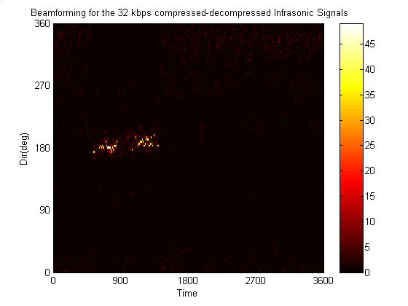
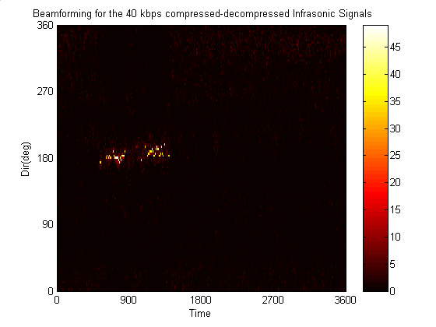

6.3 Phase Velocity
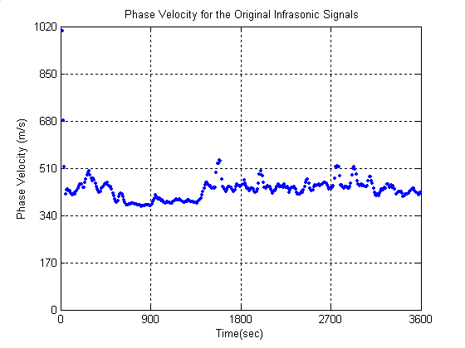
Signals that arrive from directly above the array appear to have infinite apparent propagation speed. Surface wave signals move at sound speed. Slowness is very useful in suggesting what type of target/signal source we have detected and tracked. By converting slowness to phase velocity or apparent propagation velocity we can illustrate source altitude with respect to the array.
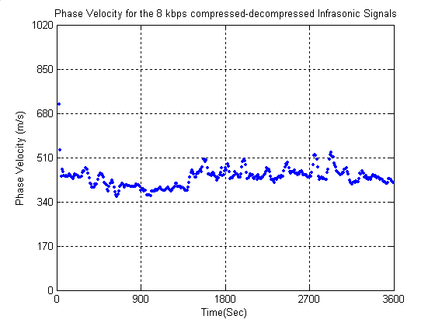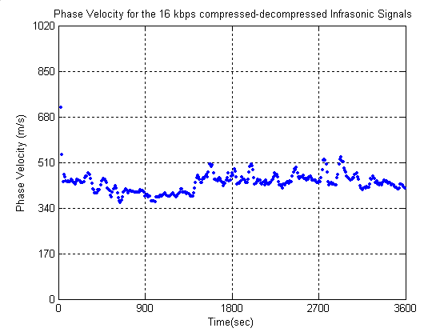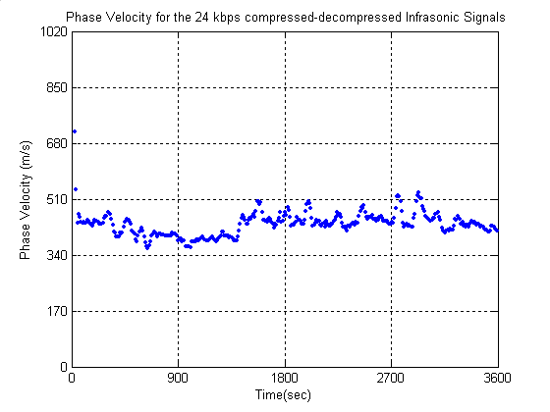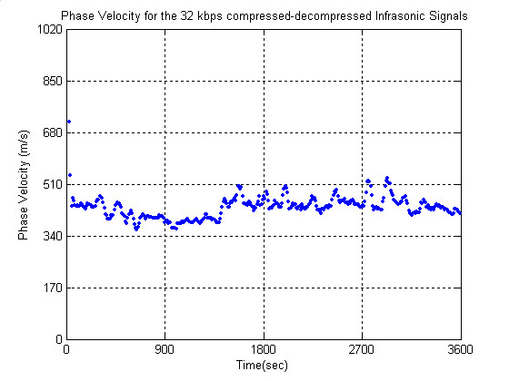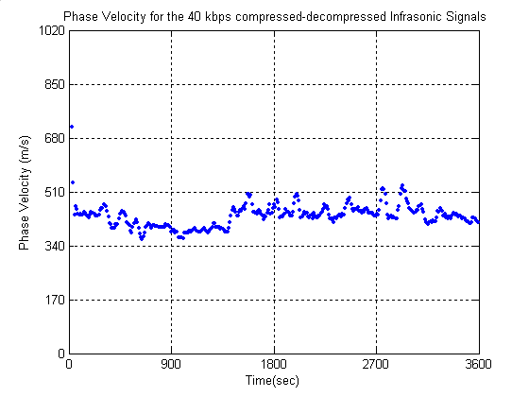
- APPLICATION TO METEOROLOGICAL SENSOR SIGNALS

Time permitting include this.

- Conclusions and future work

Real-Time implementation is one of the goals for the future. Since we are able to combine all the signals as one, only one processor can be used to do the processing no matter how many signals are to be compressed for transmission. We will need one processor at the transmitter and another one at the receiver. Increasing the number of signals only increases the size of the filterbank.
- Acknowledgements

Partial support for this work was provided by a graduate stipend made possible by a grant from the Texas Instruments Foundation.

- References
- [1-JNoble] John M. Noble and Stephen M. Tenney “Implementing an Infrasonic Array for detecting Man- Made and Natural Events”. U.S. Army Research Lab, September 2000.
- [2-Kaiser] Yuan-Pei Lin and P.P. Vaidyanathan “A Kaiser Window Approach for the Design of Prototype Filters of Cosine Modulated Filterbanks”. IEEE Signal Processing Letters, Vol. 5, No. 6, June 1998
- [3-Transmult] Ari Viholainen, Tapio Saramäki and Markku Renfors “Nearly Perfect-Reconstruction Cosine Modulated Filter Bank Design for VDSL Modems”. Telecommunications Laboratory, Tampere University of Technology.
- [4-LAME] Michael Lance Karm “Memory Access and Computational Behavior of Mp3 Encoding”. University of Texas at Austin, December 2003.
- [5-Mitra] Sanjit K. Mitra Digital Signal Processing-A Computer based approach. 2nd Ed, McGraw-Hill, 2001.
- [6-He] Xinzhao Li “1-D Infrasonic Signal Compression in Acoustic Array Processing”. Masters thesis, Dept. of Electrical and Computer Eng., University of Texas at El Paso, El Paso, August 2002
- [CaponJ]Capon, J., “High-resolution frequency-wavenumber spectrum analysis, Proceedings of the IEEE, 57: 1408-1418, 1969.

