*****************************Draft*****************************
SPI-Master Written in SystemVerilog & SPI-Master with Single CS

10/14/23
*****************************Draft*****************************

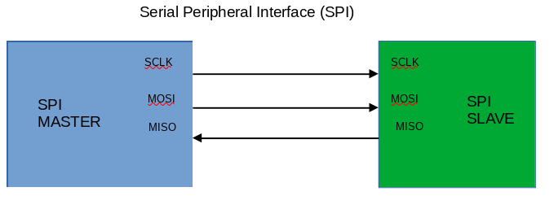

https://youtu.be/ba0SQwjTQfw? Youtube video

Forked https://github.com/nandland/spi-master

Iverilog required -g2005-sv and the file SPI_Master.v to obtain the dsn

devel@pi4-20:git clone https://github.com/develone/spi-master.git -b dev
devel@pi4-20:~/spi-master/Verilog/sim $ iverilog -g2005-sv -o dsn SPI_Master_TB.sv SPI_Master.v

devel@pi4-20:~/spi-master/Verilog/sim $ vvp dsn
VCD info: dumpfile dump.vcd opened for output.
VCD warning: $dumpvars: Unsupported argument type (vpiPackage)
Sent out 0xC1, Received 0xc1
Sent out 0xBE, Received 0xbe
Sent out 0xEF, Received 0xef

devel@pi4-20:~/spi-master/Verilog/sim $ gtkwave dump.vcd

GTKWave Analyzer v3.3.104 (w)1999-2020 BSI

[0] start time.
[922] end time.

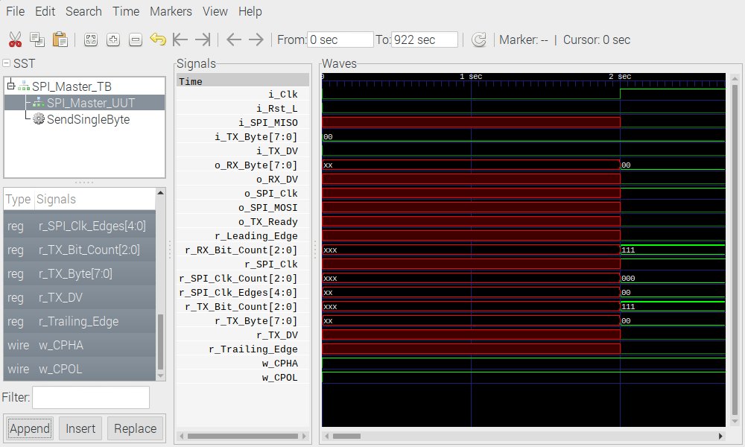

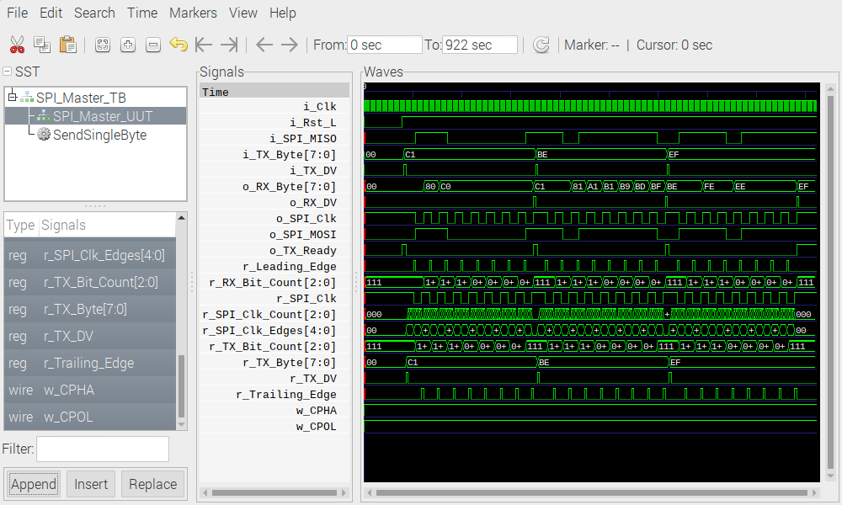

devel@pi4-20:~/spi-master/Verilog/sim $ iverilog -o dsn1 -g2005-sv SPI_Master_With_Single_CS_TB.sv ../source/SPI_Master_With_Single_CS.v
devel@pi4-20:~/spi-master/Verilog/sim $ vvp dsn1
VCD info: dumpfile dump.vcd opened for output.
VCD warning: $dumpvars: Unsupported argument type (vpiPackage)
Sent out 0xC1, Received 0xc1
Sent out 0xC2, Received 0xc2
xx

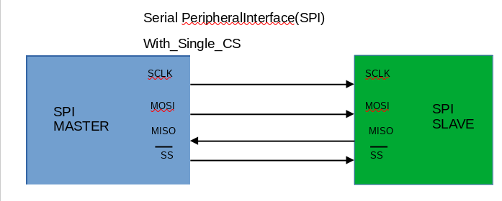

xx
xx
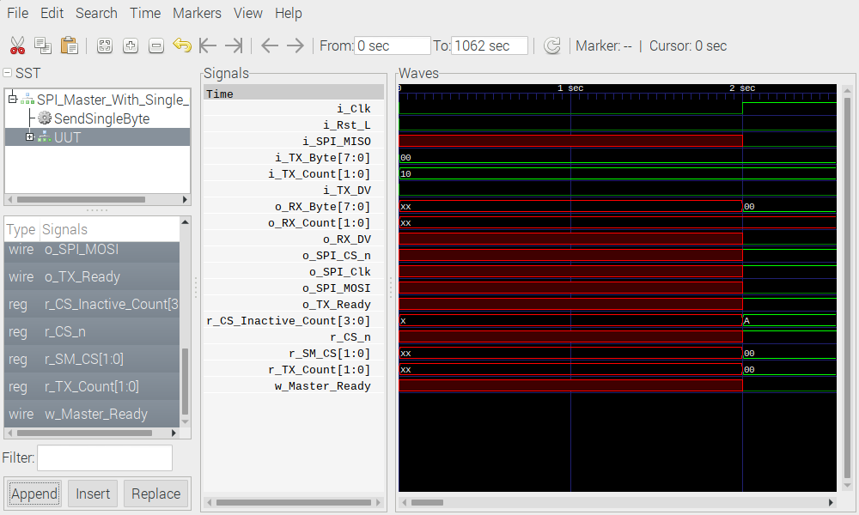

xx

Note: In the center of the image below the signal o_SPI_CS_n.

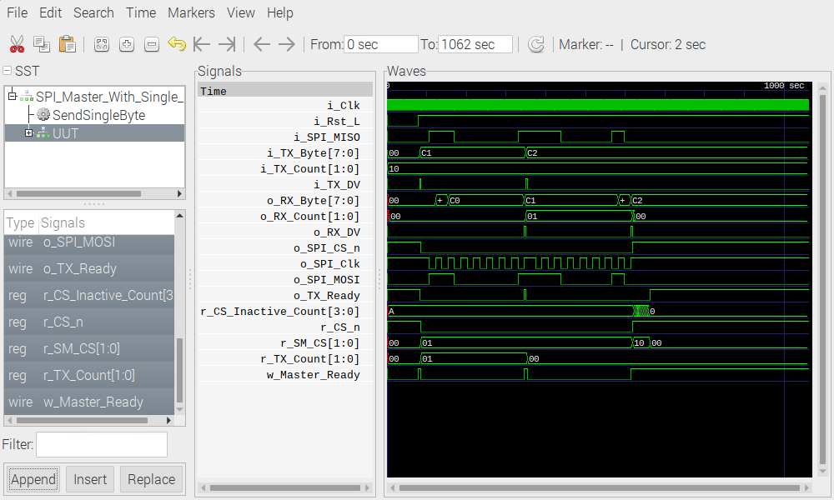
xx

