***************default***************
ben-marshall Uart
links found nanoV
07/11/25

***************default***************

devel@pi5-90:~ $ git clone https://github.com/develone/uart.git -b dev-test

devel@pi5-90:~ $ cd uart

devel@pi5-90:~/uart $ make rx tx

verilog -o work/sim-rx.bin rtl/uart_rx.v test/tb_rx.v
test/tb_rx.v:37: vvp.tgt sorry: procedural continuous assignments are not yet fully supported. The RHS of this assignment will only be evaluated once, at the time the assignment statement is executed.
vvp -l work/sim.log work/sim-rx.bin
VCD info: dumpfile ./work/waves-rx.vcd opened for output.
1/ 0/ 1 [PASS] Expected 00100100 and got 00100100
2/ 0/ 2 [PASS] Expected 10000001 and got 10000001
3/ 0/ 3 [PASS] Expected 00001001 and got 00001001
4/ 0/ 4 [PASS] Expected 01100011 and got 01100011
5/ 0/ 5 [PASS] Expected 00001101 and got 00001101
6/ 0/ 6 [PASS] Expected 10001101 and got 10001101
7/ 0/ 7 [PASS] Expected 01100101 and got 01100101
8/ 0/ 8 [PASS] Expected 00010010 and got 00010010
9/ 0/ 9 [PASS] Expected 00000001 and got 00000001
10/ 0/ 10 [PASS] Expected 00001101 and got 00001101
BIT RATE : 115200b/s
CLK PERIOD : 20ns
CYCLES/BIT : 434
SAMPLE PERIOD : 8680
BIT PERIOD : 8680ns
Test Results:
PASSES: 10
FAILS : 0
Finish simulation at time 879040
iverilog -o work/sim-tx.bin rtl/uart_tx.v test/tb_tx.v
vvp -l work/sim.log work/sim-tx.bin
VCD info: dumpfile ./work/waves-tx.vcd opened for output.
Send data 00100100 at time 40
Send data 10000001 at time 1041870
Send data 00001001 at time 2083690
Send data 01100011 at time 3125510
Send data 00001101 at time 4167330
Send data 10001101 at time 5209150
Send data 01100101 at time 6250970
Send data 00010010 at time 7292790
Send data 00000001 at time 8334610
Send data 00001101 at time 9376430
Send data 01110110 at time 10418250
Send data 00111101 at time 11460070
Send data 11101101 at time 12501890
Send data 10001100 at time 13543710
Send data 11111001 at time 14585530
Send data 11000110 at time 15627350
Send data 11000101 at time 16669170
Send data 10101010 at time 17710990
Send data 11100101 at time 18752810
Send data 01110111 at time 19794630
BIT RATE : 9600b/s
BIT PERIOD: 104166ns
CLK PERIOD: 20ns
CYCLES/BIT: 5208
Finish simulation at time 20836450

devel@pi5-90:~/nanoV/uart $ cd ~/uart/work/
devel@pi5-90:~/uart/work $ ls
sim.log sim-rx.bin sim-tx.bin waves-rx.vcd waves-tx.vcd

devel@pi5-90:~/uart/work $ gtkwave waves-tx.vcd

GTKWave Analyzer v3.3.118 (w)1999-2023 BSI

[40] start time.
[20836450] end time.

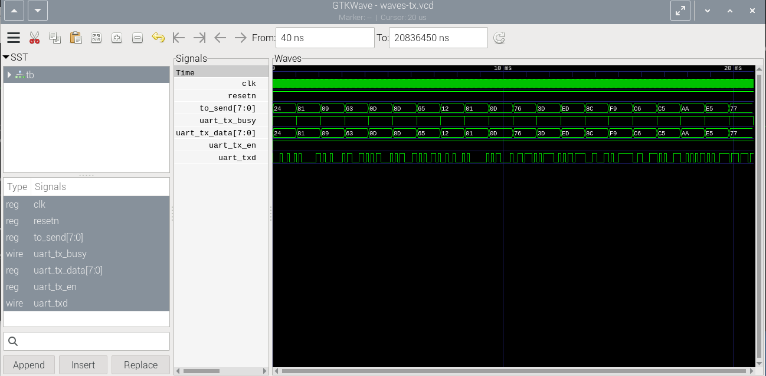
waves-tx-vcd

devel@pi5-90:~/uart/work $ gtkwave waves-rx.vcd

GTKWave Analyzer v3.3.118 (w)1999-2023 BSI

[40] start time.
[879040] end time.

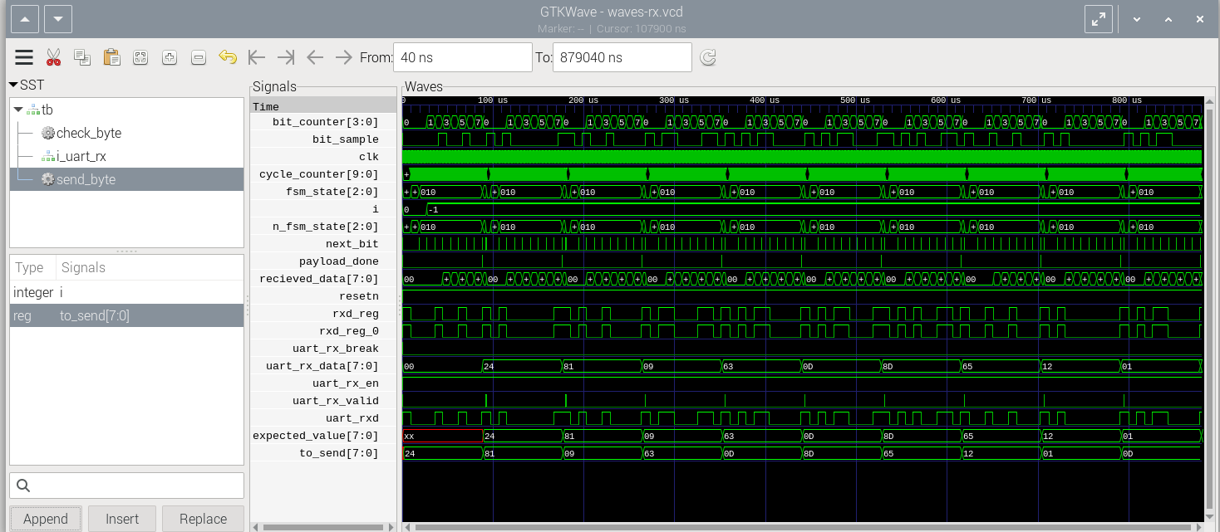

waves-rx-vcd

