********DRAFT********
Testing MyHDL created uart_tx.v & uart_rx.v
for the CATBOARD

based UART_RX.v & UART_TX.v
On a RPi2B
05/01/18
********DRAFT********

1.0)
“cd uart_txrx/catboard”
2.0)
“./build-Prog-cat.sh 3”
This ivokes serveral scripts. The first creates the “catboard.blif”. The 2nd creates the “catboard.txt”. The 3rd creates the “catboard.bin”. If thes files wre created the last script programs the FPGA,

“catboard.sh”
“catboard_pnr.sh”
“catboard_bin.sh”
“sudo ~/catboard_yosys/config_cat catboard.bin”
3.0)
“sudo minicom -s”

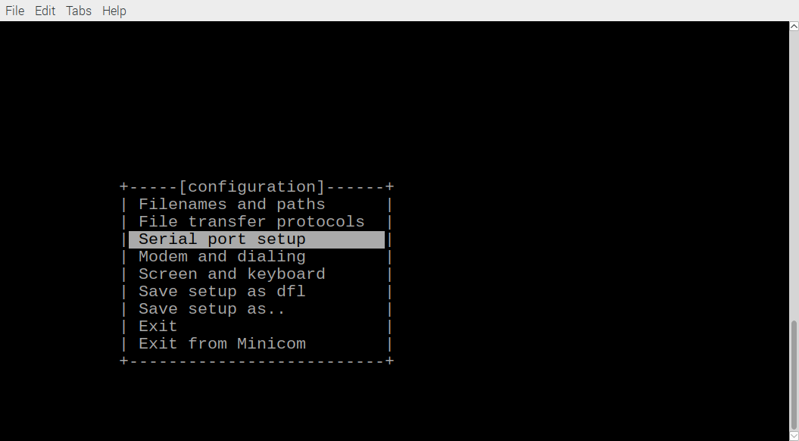

Depressing “Enter” bringup a new screen

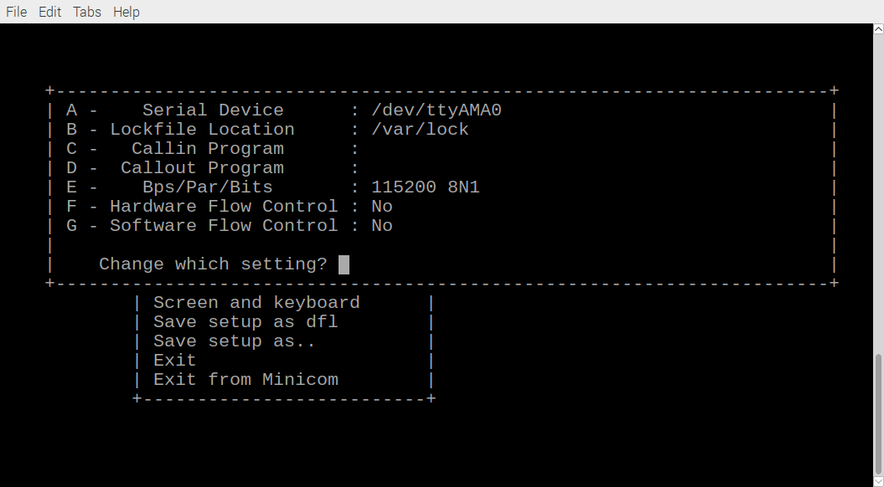

If the onbard Rpi is used /dev/ttyAMA0 is used as above.
If the pmodusbuart is connected to pm2-A /dev/ttyUSB0 is used as below.

This requires that catboard.pcf be modified
catboard.pcf.rpi catboard.pcf.pm2-A
set_io i_UART_RX T15 set_io i_UART_RX B5
set_io o_UART_TX T14 et_io o_UART_TX B3

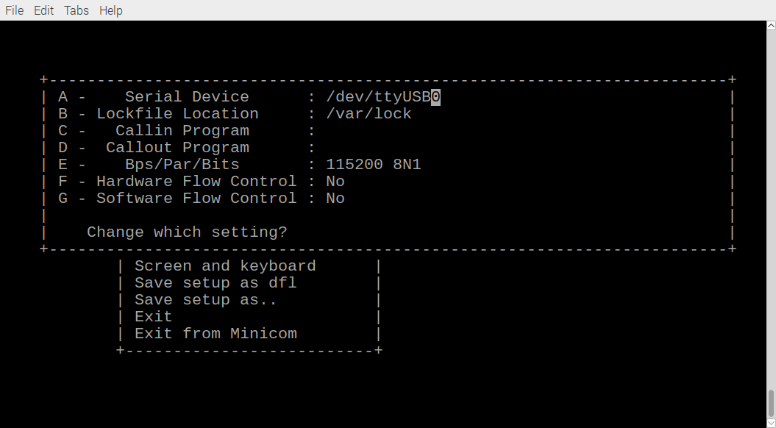

Depressing “Enter” and scrolling down to “Exit”.

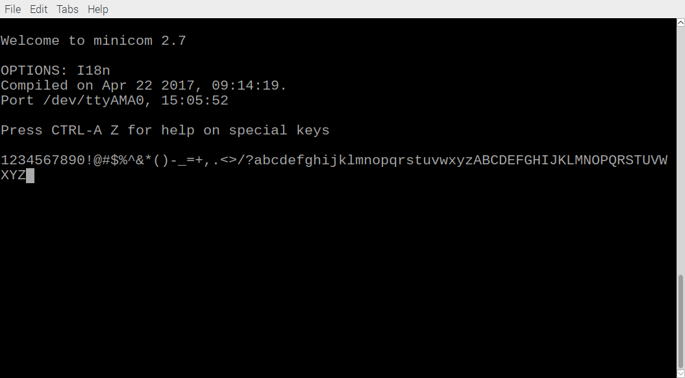
Typing characters get echoed. The programmed FPGA is transmitting the received characters correctly

Thu Apr 19 2018

Initial code was download from
https://www.edaplayground.com/x/Pgf
http://www.nandland.com
Command to create testuart from UART_TB.v UART_RX.v UART_TB/v includes UART_TX.v

iverilog -o testuart UART_TB.v UART_RX.v

vvp testuart
VCD info: dumpfile dump.vcd opened for output.
Test Passed - Correct Byte Received

This code was created

// Testbench uses a 25 MHz clock
// Want to interface to 115200 baud UART
// 25000000 / 115200 = 217 Clocks Per Bit.
parameter c_CLOCK_PERIOD_NS = 40;
At 100MHz the parameter c_CLKS_PER_BIT = 868; is required.

Note: This does not fit in 8 bits which required a change in both UART_TX.v and UART_RX.v
reg [7:0] r_Clock_Count = 0; → reg [11:0] r_Clock_Count = 0;

In UART_TB.v parameter c_CLKS_PER_BIT = 217 → parameter c_CLKS_PER_BIT = 868;

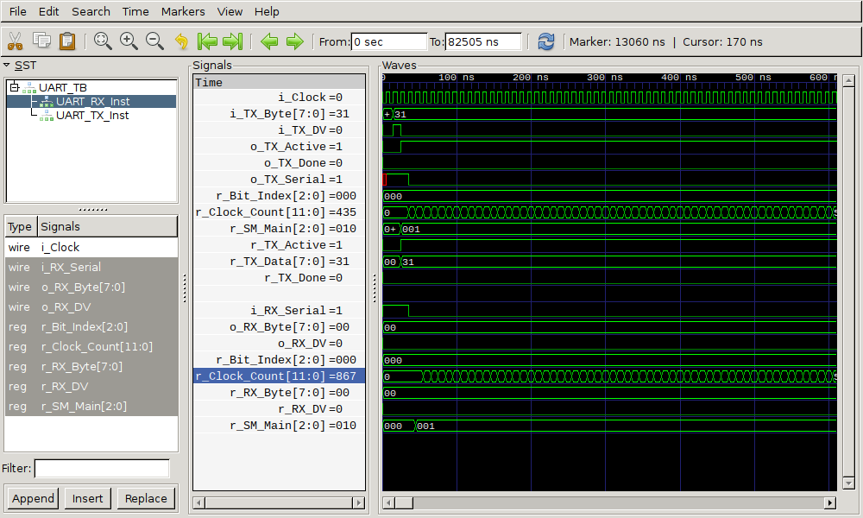

Checking that r_Clock_Count does not overflow with 868.

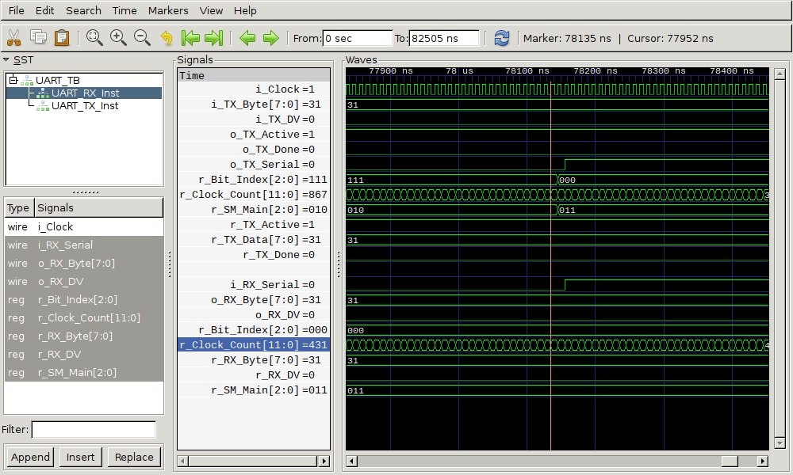
Simulation of 00110001 being transmitted and recived.

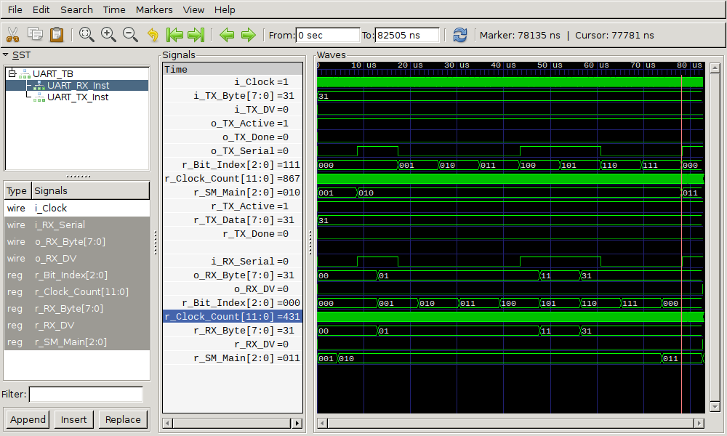

Simulation of 00110101 being transmitted and recived.

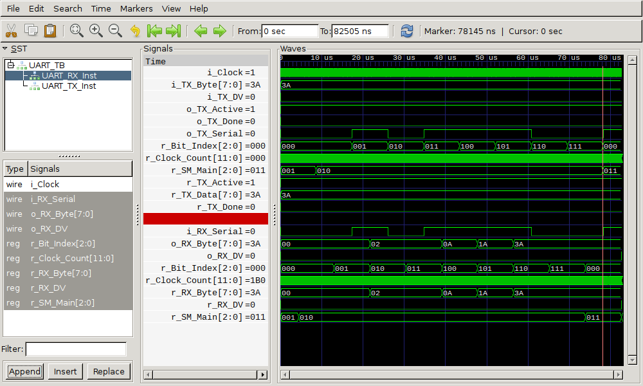

Both the UART_TX and UART_RX are a case statement
IDLE, TX_START_BIT, TX_DATA_BITS, TX_STOP_BIT, and C:EANUP.
IDLE, RX_START_BIT, RX_DATA_BITS, RX_STOP_BIT, and C:EANUP.
In MyHDL the case statement was written for uart_tx.
if(r_SM_Main==IDLE):
.
.
elif (r_SM_Main==TX_START_BIT):
.
.
elif (r_SM_Main==TX_DATA_BITS):
.
.
elif (r_SM_Main==TX_STOP_BIT):
.
.
else:
.
.
and the uart_rx was similar
if(r_SM_Main==IDLE):
.
.
elif (r_SM_Main==RX_START_BIT):
.
.
elif (r_SM_Main==RX_DATA_BITS):
.
.
elif (r_SM_Main==RX_STOP_BIT):
.
.
else:
.
.

In the simulation the r_TX_BYTE is set to byte to be transmitted and a 1 clock wide r_TX_DV.
r_TX_DV <= 1'b1;
r_TX_Byte <= 8'h3A;
@(posedge r_Clock);
r_TX_DV <= 1'b0;

Testing at 100 MHz appears okay
Using MyHDL to create uart_rx.v with uart_rx.py
& uart_tx.v with uart_tx.py

iverilog -o testuart tb_dut_uart_txrx.v uart_rx.v

vvp testuart
VCD info: dumpfile dump.vcd opened for output.
Test Passed - Correct Byte Received

Serveral simulation were tested 0x3F, 0x32, 0x38, 0x3A, 0x41.
3F transmitted & recived

00111111
32 transmitted & recived
00110010

38 transmitted & recived

00111000
3A transmitted & recived

00111010
41 transmitted & recived

0100001

uart_txrx.sh catboard.sh

uart_txrx_pnr.sh catboard_pnr.sh
uart_loopback.pcf catboard.pcf

uart_txrx_bin.sh catboard_bin.sh

/home/pi/uart_rxtx/MyHDL
sudo ~/catboard_yosys/config_cat uart_loopback.bin

/home/pi/uart_rxtx/catboard
sudo ~/catboard_yosys/config_cat catboard.bin

.

