Speechpp
05/15/18

In the speechpp.pcf set_io i_clk R9. Pin R9 on the icoboard ICE_CLK is connected to IOB_81_GBIN5 on the right side of the image below.

Trying to chg set_io i_clk R9 # 100 MHz clock
To C8 USER_CLK was causing the following error
fatal error: bad constraint on 'i_clk': no PLL at pin C8

Post on #yosys
Pin C8 is my USER_CLK comes from a 100MHz osc. It is connected to IOT_197_GBIN1 on HX8K. When I try using it for as an input to PLL I get the fatal error: bad constraint on `i_clk': no PLL at pin C8.
Can only certain pins be used as inputs to PLL?
daveshah
develonepi3: use the SB_PLL40_CORE instead of SB_PLL40_PAD variant (and REFERENCECLK in instead of PACKAGEPIN)
on the left side of the image below.

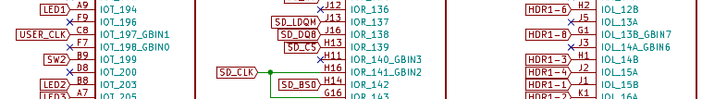

ICOBOARD RPI

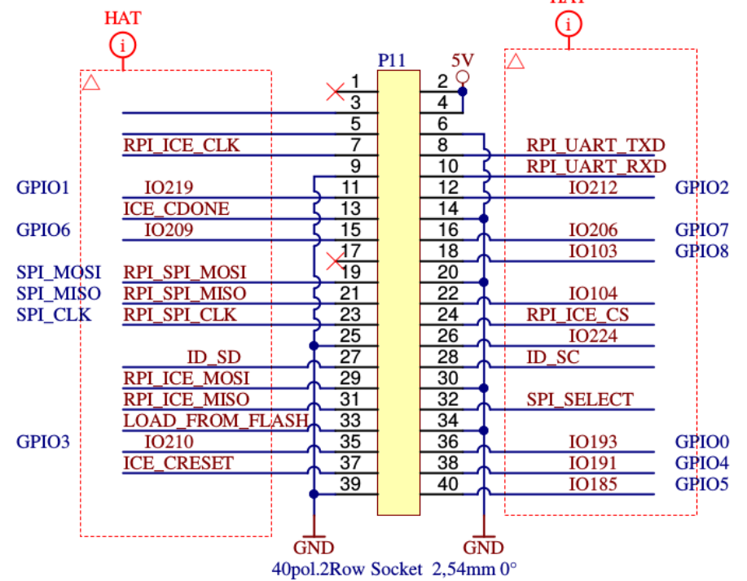
CATBOARD RPI

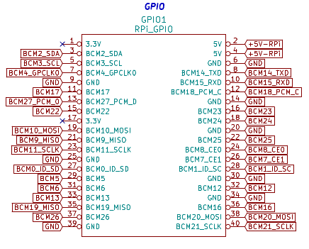

make speechpp
write_txt speechpp.asc...
icetime -d hx8k -c 75 speechpp.asc
// Reading input .asc file..
// Reading 8k chipdb file..
// Creating timing netlist..
// Timing estimate: 10.21 ns (97.91 MHz)
// Checking 13.33 ns (75.00 MHz) clock constraint: PASSED.
icepack speechpp.asc speechpp.bin
rm speechpp.asc

verilator -Wall -I../pport/ --cc speechpp.v
cd obj_dir/
make -f Vspeechpp.mk

R9 on the icoboard ICE_CLK IOB_81_GBIN5 which RPI_ICE_CLK pin 7 GPIO 4 on RPi.
On the catboard BCM4_GPCLK0 IOB_81_GBIN5
netpport.cpp

// RPi GPIO #, connector pin #, schematic name, fpga pin #
//
# define RASPI_D8 0 // PIN 11, GPIO.0, IO219, D5
# define RASPI_D7 1 // PIN 12, GPIO.1, IO212, D6
# define RASPI_D6 3 // PIN 15, GPIO.3, IO209, C6
# define RASPI_D5 4 // PIN 16, GPIO.4, IO206, C7
# define RASPI_D4 12 // PIN 19, MOSI, RPI_SPI_MOSI,A6
# define RASPI_D3 13 // PIN 21, MISO, RPI_SPI_MISO,A7
# define RASPI_D2 11 // PIN 26, CE1, IO224, D4
# define RASPI_D1 24 // PIN 35, GPIO.24, IO210, D7
# define RASPI_D0 27 // PIN 36, GPIO.27, IO193, D9
# define RASPI_DIR 28 // PIN 38, GPIO.28, IO191, C9
# define RASPI_CLK 29 // PIN 40, GPIO.29, IO185, C10
set_io io_pp_data[0] D9 36 R4
set_io io_pp_data[1] D7 35 T3
set_io io_pp_data[2] D4 26 T7
set_io io_pp_data[3] A7 21 P12
set_io io_pp_data[4] A6 19 P11
set_io io_pp_data[5] C7 16 P9
set_io io_pp_data[6] C6 15 N11
set_io io_pp_data[7] D6 12 T11
set_io i_pp_clk C10 40 T1
WiringPi 0 is 17
schematic name connector pin # fpga pin #
# GPIO0/BCM17 PIN 11 M10/T13 CDONE pg6 CAT_schematic.pdf
# GPIO1/BCM18 PIN 12 T11
# GPIO2/BCM22 PIN 15 N11 C_RESET_B
# GPIO3/BCM23 PIN 16 P9
# GPIO10/BCM10 MOSI PIN 19 P11
# GPIO9/BCM9 MISO PIN 21 P12
# GPIO7/BCM7 PIN 26 T7
# GPIO19/BCM19 PIN 35 T3
# GPIO16/BCM16 PCM_0 PIN 36 R4
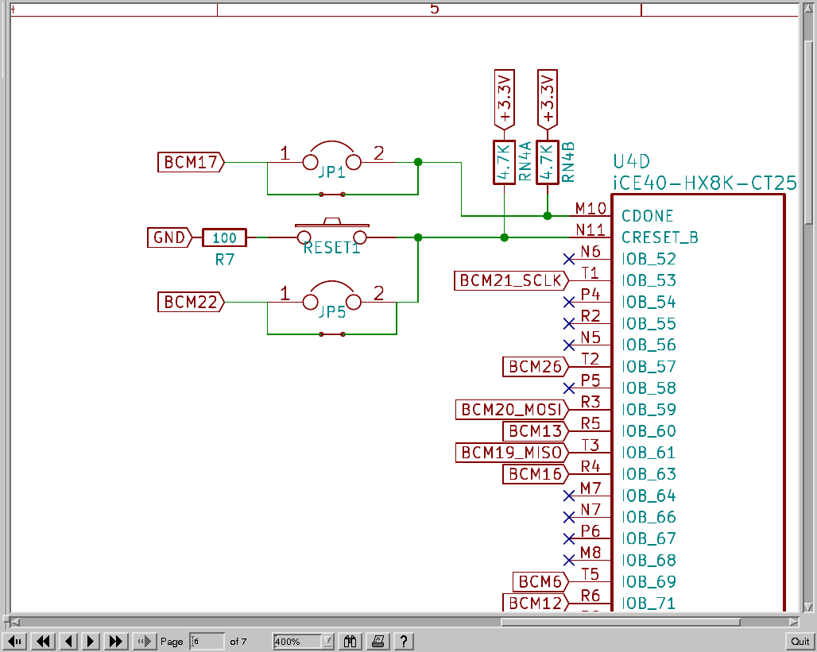
# /BCM20 MOSI PIN 38 R3
# /BCM21 PIN 40 T1

On the catboard, FPGA pin N11 BCM 22 pin 15, is connected to CRESET_B. On the icoboard io_pp_data[6] C6 15



FPGA pin C6 DIPSW1 io_pp_data[6] needs a pin on Rpi BCM24 T9 pin

added to clktest.v input wire io_pp_data;
from speechpp.v inout wire [7:0] io_pp_data;
modified assign o_ledr = 1'b0;--> assign o_ledr = (io_pp_data) ? 1'b1 : 1'b0;

diff clktest.v clktest_d0.v
42c42
< module clktest(i_clk, o_ledg, o_ledr);
---
> module clktest(i_clk, o_ledg, o_ledr,io_pp_data);
46c46
<
---
> input wire io_pp_data;
107c107,110
< assign o_ledr = 1'b0;
---
> //assign o_ledr = 1'b0;
> assign o_ledr = (io_pp_data) ? 1'b1 : 1'b0;
>
>

Testing 1 pin at time
testing d0-d8 then i_pp_dir & i_pp_clk

make clktest_d0
sudo ~/catboard_yosys/config_cat clktest_d0.bin
gcc -Wall -o blink blink.c -lwiringPi
sudo ./blink

~/uart_rxtx/wbuart32/basic/clktest_d0.pcf
set_io i_clk C8 # 25MHz clock ?
set_io o_ledg[0] A9 #C8
set_io o_ledg[1] B8 #F7
set_io o_ledr B7 #K9
#testing d0-d8
#set_io io_pp_data R4 #icoboard D9 mapped to Catboard used make speechpp to test
#set_io io_pp_data T3 #icoboard D9 mapped to Catboard used make speechpp to test
#set_io io_pp_data T13 #icoboard D4 mapped to Catboard used make speechpp to test
#set_io io_pp_data T6 #icoboard A7 mapped to Catboard used make speechpp to test
#set_io io_pp_data T5 #icoboard A6 mapped to Catboard used make speechpp to test
#set_io io_pp_data P9 #icoboard C7 mapped to Catboard used make speechpp to test
#set_io io_pp_data T9 #icoboard C6 mapped to Catboard used make speechpp to test
#set_io io_pp_data T11 #icoboard D6 mapped to Catboard used make speechpp to test
#set_io io_pp_data T7 #icoboard D5 # set_io io_pp_data[8] D5 mapped to Catboard used make speechpp to test

#testing i_pp_dir & i_pp_clk
#set_io i_pp_dir R3 #icoboard C9 mapped to Catboard used make speechpp to test
#set_io i_pp_clk T8 #icoboard C10 mapped to Catboard used make speechpp to test
#set_io io_pp_data R3 #icoboard C9 mapped to Catboard used make speechpp to test
set_io io_pp_data T8 #icoboard C10 mapped to Catboard used make speechpp to test

#include <wiringPi.h>
//gcc -Wall -o blink blink.c -lwiringPi
//sudo ./blink
~/uart_rxtx/wbuart32/basic/blink.c
# define RASPI_DIR 28 //BCM20 PIN 38, GPIO.28 IOB_59 R3
# define RASPI_CLK 10 //BCM8 PIN 24, GPIO.10, IOB_75 T8

# define RASPI_D0 27 //BCM16 PIN 36, GPIO.27, IOB_63 R4
# define RASPI_D1 24 //BCM19 PIN 35, GPIO.24, IOB_61 T3
# define RASPI_D2 0 //BCM17 PIN 11, GPIO.0 ,IOB_94 T13

# define RASPI_D3 21 //BCM5 PIN 29,GPIO.21 ,IOB_73 T6

# define RASPI_D4 22 //BCM6 PIN 31,GPIO.22 ,IOB_69 T5
# define RASPI_D5 4 //BCM23 PIN 16,GPIO.4, IOB_83 P9

# define RASPI_D6 5 //BCM24 PIN 18, GPIO.5, IOB_79 T9
# define RASPI_D7 1 //BCM18 pin 12, GPIO.1, IOB_89 T11
# define RASPI_D8 11 //BCM7 PIN 26, GPIO.11, IOB_75 T7
int main (void)
{
wiringPiSetup () ;
pinMode (RASPI_CLK, OUTPUT) ;
for (;;)
{
digitalWrite (RASPI_CLK, HIGH) ; delay (500) ;
digitalWrite (RASPI_CLK, LOW) ; delay (500) ;
}
return 0 ;
}
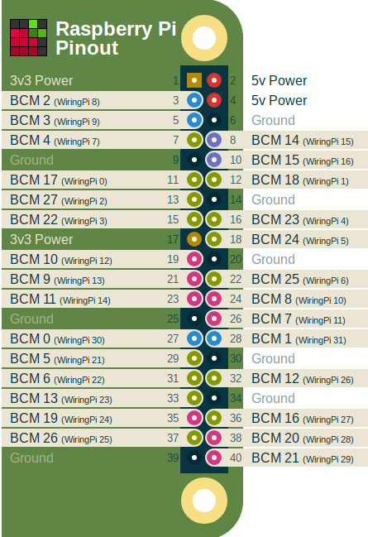

icepll -i 100 -o 66 -f pll_para.v

F_PLLIN: 100.000 MHz (given)
F_PLLOUT: 66.000 MHz (requested)
F_PLLOUT: 65.972 MHz (achieved)

FEEDBACK: SIMPLE
F_PFD: 11.111 MHz
F_VCO: 1055.556 MHz

DIVR: 8 (4'b1000)
DIVF: 94 (7'b1011110)
DIVQ: 4 (3'b100)

FILTER_RANGE: 1 (3'b001)

PLL configuration written to: pll_para.v

sb_pll40_pad.v
module top(
input PACKAGEPIN,
output PLLOUTCORE,
output PLLOUTGLOBAL,
input EXTFEEDBACK,
input [7:0] DYNAMICDELAY,
output LOCK,
input BYPASS,
input RESETB,
input LATCHINPUTVALUE,

//Test Pins
output SDO,
input SDI,
input SCLK
);
SB_PLL40_PAD #(
.FEEDBACK_PATH("DELAY"),
// .FEEDBACK_PATH("SIMPLE"),
// .FEEDBACK_PATH("PHASE_AND_DELAY"),
// .FEEDBACK_PATH("EXTERNAL"),

.DELAY_ADJUSTMENT_MODE_FEEDBACK("FIXED"),
// .DELAY_ADJUSTMENT_MODE_FEEDBACK("DYNAMIC"),

.DELAY_ADJUSTMENT_MODE_RELATIVE("FIXED"),
// .DELAY_ADJUSTMENT_MODE_RELATIVE("DYNAMIC"),

.PLLOUT_SELECT("GENCLK"),
// .PLLOUT_SELECT("GENCLK_HALF"),
// .PLLOUT_SELECT("SHIFTREG_90deg"),
// .PLLOUT_SELECT("SHIFTREG_0deg"),

.SHIFTREG_DIV_MODE(1'b0),
.FDA_FEEDBACK(4'b1111),
.FDA_RELATIVE(4'b1111),
.DIVR(4'b0000),
.DIVF(7'b0000000),
.DIVQ(3'b001),
.FILTER_RANGE(3'b000),
.ENABLE_ICEGATE(1'b0),
.TEST_MODE(1'b0)
) uut (
.PACKAGEPIN (PACKAGEPIN ),
.PLLOUTCORE (PLLOUTCORE ),
.PLLOUTGLOBALaa7cfd685ce7 (PLLOUTGLOBAL ),
.EXTFEEDBACK (EXTFEEDBACK ),
.DYNAMICDELAY (DYNAMICDELAY ),
.LOCK (LOCK ),
.BYPASS (BYPASS ),
.RESETB (RESETB ),
.LATCHINPUTVALUE(LATCHINPUTVALUE),
.SDO (SDO ),
.SDI (SDI ),
.SCLK (SCLK )
);
endmodule

BCM4 GPCLk0 PIN 16 R9

Trying to chg set_io io_pp_data[6] C6
fatal error: unknown pin `N11' on package `ct256'
diff --git a/wbuart32/pptest/speechpp.pcf b/wbuart32/pptest/speechpp.pcf
index 985962a..9333a95 100644
--- a/wbuart32/pptest/speechpp.pcf
+++ b/wbuart32/pptest/speechpp.pcf
@@ -1,16 +1,16 @@
set_io i_clk R9 # 100 MHz clock
-set_io o_ledg[0] C8
-set_io o_ledg[1] F7
-set_io o_ledr K9
+set_io o_ledg[0] A9 #icoboard C8 mapped to Catboard used make speechpp to test
+set_io o_ledg[1] B8 #icoboard F7 mapped to Catboard used make speechpp to test
+set_io o_ledr B7 #icoboard K9 mapped to Catboard used make speechpp to test

-set_io i_pp_dir C9 IOT_191
-set_io i_pp_clk C10 IOT_185 Check out i_pp_clk inside pport.v, 'cause that's the other end of that signal.
-set_io io_pp_data[0] D9
-set_io io_pp_data[1] D7
-set_io io_pp_data[2] D4
-set_io io_pp_data[3] A7
-set_io io_pp_data[4] A6
-set_io io_pp_data[5] C7

+set_io i_pp_dir R3 #icoboard C9 mapped to Catboard used make speechpp to test
+set_io i_pp_clk T1 #icoboard C10 mapped to Catboard used make speechpp to test
+set_io io_pp_data[0] R4 #icoboard D9 mapped to Catboard used make speechpp to test
+set_io io_pp_data[1] T3 #icoboard D7 mapped to Catboard used make speechpp to test
+set_io io_pp_data[2] T7 #icoboard D4 mapped to Catboard used make speechpp to test
+set_io io_pp_data[3] P12 #icoboard A7 mapped to Catboard used make speechpp to test
+set_io io_pp_data[4] P11 #icoboard A6 mapped to Catboard used make speechpp to test
+set_io io_pp_data[5] P9 #icoboard C7 mapped to Catboard used make speechpp to test
set_io io_pp_data[6] C6
-set_io io_pp_data[7] D6
-set_io o_pp_clkfb D5 # set_io io_pp_data[8] D5
+set_io io_pp_data[7] T11 #icoboard D6 mapped to Catboard used make speechpp to test
+set_io o_pp_clkfb T13 #icoboard D5 # set_io io_pp_data[8] D5 mapped to Catboard used make speechpp to test

cd uart_rxtx/wbuart32/pptest/
sudo ~/catboard_yosys/config_cat ../basic/clktest.bin
sudo ~/catboard_yosys/config_cat speechpp.bin

cd icozip/sw/host/
./arm-wbregs -n localhost -p 8363 VERISON
Connect Failed Err: Connection refused

./arm-netpport
Listening on port 8363
Listening on port 8364

cd icozip/sw/host/
./arm-wbregs -n localhost -p 8363 VERISON
Unknown register: VERISON

cd icozip/sw/host/
on pi3-2
./arm-wbregs -n pi2-2 -p 8363 VERISON
Unknown register: VERISON

