****************************Default****************************
zipcpu-dwt-lifting
pgm input
07/06/26
****************************Default****************************

devel@pi4-50:~/zipcpu-dwt-lifting/src $ git clone -b bgr https://github.com/develone/zipcpu-dwt-lifting.git

devel@pi4-50:~/zipcpu-dwt-lifting/src $ make clean ; make all ; make pi_jpeg

devel@pi4-50:~/zipcpu-dwt-lifting/host $ ./pi_jpeg 64 64 lena_rgb_64.pgm 1
ptrs.w 64 ptrs.h 64 malloc of ptrs.inpbuf 8192
fname lena_rgb_64.pgm
ptrs.inpbuf = 0xb84ce4b0
reading
fwd_inv = 0xb84cb890
fwd lifting step only 0x1 *fwd_inv -1202931568
starting transfer between buf1 and ptrs.inpbuf
i 0 0x0 0xa0 i 1 0x0 0x9f i 2 0x0 0x9c i 3 0x0 0x9b i 4 0x0 0xa0 i 5 0x0 0xaa i 6 0x0 0xa7 i 7 0x0 0x86 i 8 0x0 0x62 i 9 0x0 0x69 i 10 0x0 0x6c i 11 0x0 0x6d i 12 0x0 0x6d i 13 0x0 0x74 i 14 0x0 0x7c i 15 0x0 0x81 i 16 0x0 0x84 i 17 0x0 0x85 i 18 0x0 0x84 i 19 0x0 0x85 i 20 0x0 0x87 i 21 0x0 0x87 i 22 0x0 0x87 i 23 0x0 0x86 i 24 0x0 0x87 i 25 0x0 0x87 i 26 0x0 0x85 i 27 0x0 0x84 i 28 0x0 0x85 i 29 0x0 0x85 i 30 0x0 0x87 i 31 0x0 0x85 i 32 0x0 0x86 i 33 0x0 0x84 i 34 0x0 0x83 I
.
.
.
4050 0x0 0x41 i 4051 0x0 0x43 i 4052 0x0 0x56 i 4053 0x0 0x4c i 4054 0x0 0x4f i 4055 0x0 0x68 i 4056 0x0 0x77 i 4057 0x0 0x7d i 4058 0x0 0x82 i 4059 0x0 0x83 i 4060 0x0 0x85 i 4061 0x0 0x87 i 4062 0x0 0x8a i 4063 0x0 0x8b i 4064 0x0 0x8d i 4065 0x0 0x8f i 4066 0x0 0x92 i 4067 0x0 0x93 i 4068 0x0 0x94 i 4069 0x0 0x96 i 4070 0x0 0x96 i 4071 0x0 0x97 i 4072 0x0 0x9c i 4073 0x0 0xa2 i 4074 0x0 0xa8 i 4075 0x0 0xb2 i 4076 0x0 0xbe i 4077 0x0 0xc7 i 4078 0x0 0xce i 4079 0x0 0xb8 i 4080 0x0 0x5f i 4081 0x0 0x63 i 4082 0x0 0x73 i 4083 0x0 0x7f i 4084 0x0 0x7a i 4085 0x0 0x81 i 4086 0x0 0x72 i 4087 0x0 0x5c i 4088 0x0 0x55 i 4089 0x0 0x54 i 4090 0x0 0x60 i 4091 0x0 0x79 i 4092 0x0 0x60 i 4093 0x0 0x3d i 4094 0x0 0x3d i 4095 0x0 0x5a
&ptrs.inpbuf[0] = 0x861800c0
wptr = 0x861800c0
ptrs.inpbuf = 0xb84ce4b0
ptrs.alt = 0x861840c0
starting dwt
ip = 0x861800c0 tp = 0x861840c0
in lifting
ip = 0x861800c0 op = 0x861840c0 opb = 0x861860c0
ap = 160 b = 159 cp = 156 d = 155
ip = 0x861801c0 op = 0x861840c4 opb = 0x861860c4
ap = 157 b = 157 cp = 156 d = 155
ip = 0x861802c0 op = 0x861840c8 opb = 0x861860c8
ap = 156 b = 158 cp = 157 d = 158
ip = 0x861803c0 op = 0x861840cc opb = 0x861860cc
ap = 157 b = 159 cp = 159 d = 164
ip = 0x861804c0 op = 0x861840d0 opb = 0x861860d0
ap = 159 b = 161 cp = 165 d = 167
ip = 0x861805c0 op = 0x861840d4 opb = 0x861860d4
.
.
.

ip = 0x86186640 op = 0x86182154 opb = 0x86183154
ap = 1 b = 1 cp = 0 d = 2
ip = 0x86186740 op = 0x86182158 opb = 0x86183158
ap = 0 b = 0 cp = -4 d = -4
ip = 0x86186840 op = 0x8618215c opb = 0x8618315c
ap = 1 b = -4 cp = 7 d = 3
ip = 0x86186940 op = 0x86182160 opb = 0x86183160
ap = 1 b = 0 cp = -6 d = 15
ip = 0x86186a40 op = 0x86182164 opb = 0x86183164
ap = 11 b = 7 cp = 4 d = 8
ip = 0x86186b40 op = 0x86182168 opb = 0x86183168
ap = 5 b = -16 cp = -13 d = -9
ip = 0x86186c40 op = 0x8618216c opb = 0x8618316c
ap = 2 b = 1 cp = 3 d = 4
ip = 0x86186d40 op = 0x86182170 opb = 0x86183170
ap = -34 b = -1 cp = 6 d = 1
ip = 0x86186e40 op = 0x86182174 opb = 0x86183174
ap = -15 b = 94 cp = 34 d = -53
ip = 0x86186f40 op = 0x86182178 opb = 0x86183178
ap = 2 b = 2 cp = -6 d = -83
ip = 0x86187040 op = 0x8618217c opb = 0x8618317c
ap = 30 b = -37 cp = 4 d = 4
ip = 0x86187140 op = 0x86182180 opb = 0x86183180
ap = 164 b = 169 cp = 168 d = 151
ip = 0x86187240 op = 0x86182184 opb = 0x86183184
ap = 133 b = 129 cp = 129 d = 134
ip = 0x86187340 op = 0x86182188 opb = 0x86183188
ap = 103 b = 102 cp = 103 d = 100
ip = 0x86187440 op = 0x8618218c opb = 0x8618318c
ap = 129 b = 128 cp = 126 d = 126
ip = 0x86187540 op = 0x86182190 opb = 0x86183190
ap = 134 b = 132 cp = 131 d = 133
ip = 0x86187640 op = 0x86182194 opb = 0x86183194
ap = 135 b = 134 cp = 132 d = 130
ip = 0x86187740 op = 0x86182198 opb = 0x86183198
ap = 133 b = 127 cp = 142 d = 164
ip = 0x86187840 op = 0x8618219c opb = 0x8618319c
ap = 135 b = 133 cp = 130 d = 197
ip = 0x86187940 op = 0x861821a0 opb = 0x861831a0
ap = 132 b = 131 cp = 131 d = 123
ip = 0x86187a40 op = 0x861821a4 opb = 0x861831a4
ap = 116 b = 116 cp = 117 d = 114
ip = 0x86187b40 op = 0x861821a8 opb = 0x861831a8
ap = 161 b = 159 cp = 149 d = 147
ip = 0x86187c40 op = 0x861821ac opb = 0x861831ac
ap = 147 b = 157 cp = 158 d = 150
ip = 0x86187d40 op = 0x861821b0 opb = 0x861831b0
ap = 199 b = 177 cp = 150 d = 129
ip = 0x86187e40 op = 0x861821b4 opb = 0x861831b4
ap = 112 b = 136 cp = 193 d = 211
ip = 0x86187f40 op = 0x861821b8 opb = 0x861831b8
ap = 135 b = 125 cp = 55 d = 33
ip = 0x86188040 op = 0x861821bc opb = 0x861831bc
ap = 81 b = 47 cp = 50 d = 45
back from singlelift
finished dwt
i 0 0x1
i 1 0xffffffff
i 2 0xfffffffe
i 3 0x2
i 4 0xffffffff
i 5 0xffffffff
i 6 0x1
i 7 0x1
i 8 0x1
i 9 0xfffffffe
i 10 0x1
i 11 0x2
i 12 0x1
.
.
.

i 4091 0xa7
i 4092 0x75
i 4093 0x56
i 4094 0x68
i 4095 0x4e
devel@pi4-50:~/zipcpu-dwt-lifting/host $ ./pi_jpeg 64 64 lena_rgb_64.pgm 1

input lena_rgb_64.pmg


1 lvl

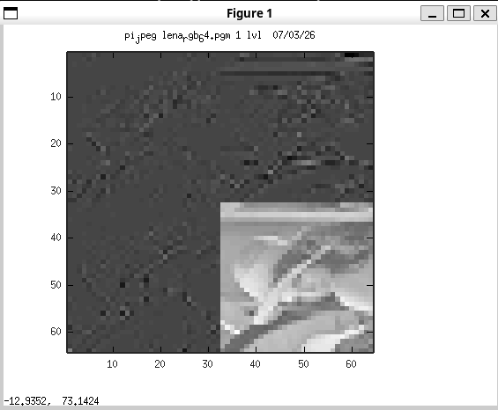
2 lvls
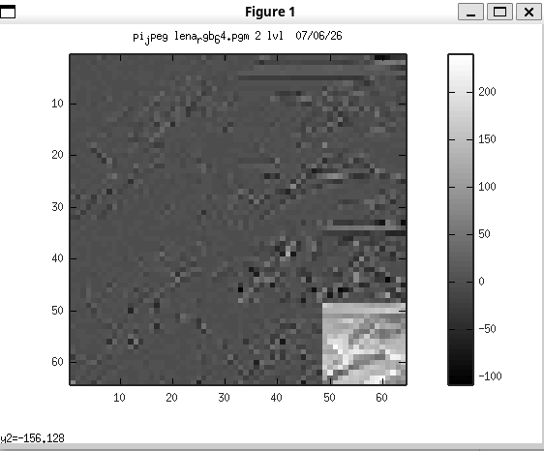
end

