*****************Default*****************
06/24/26
*****************Default*****************

./Encoder lena_rgb_64rot1.bmp

.

/Decoder 64 64 test.j2k

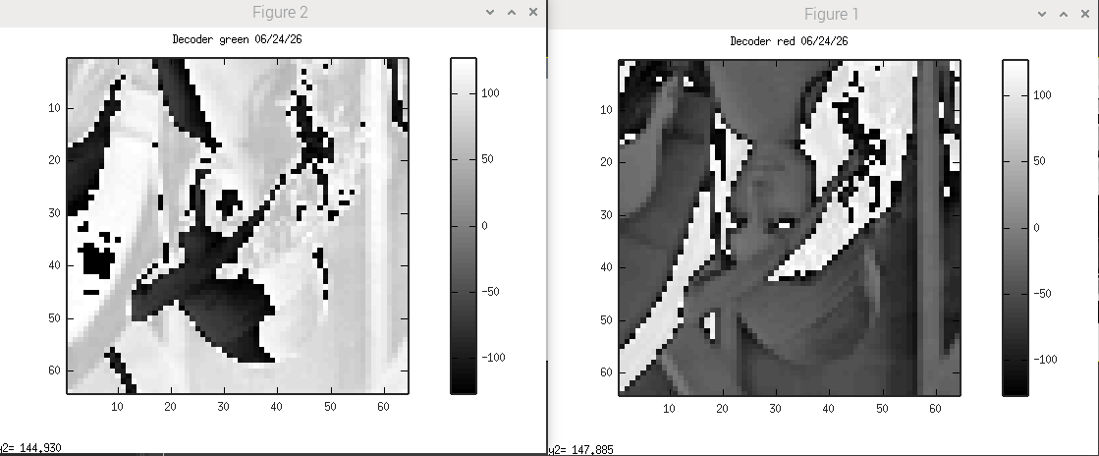
xx

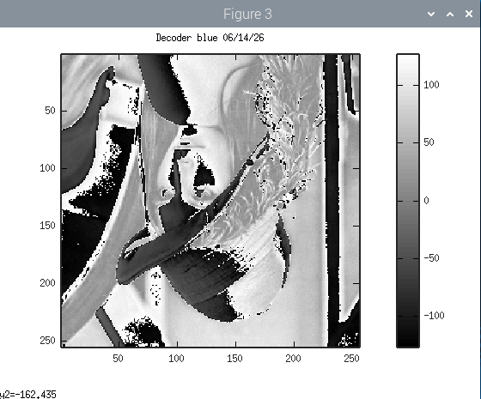
xx
Testing using rgb packed to single images.

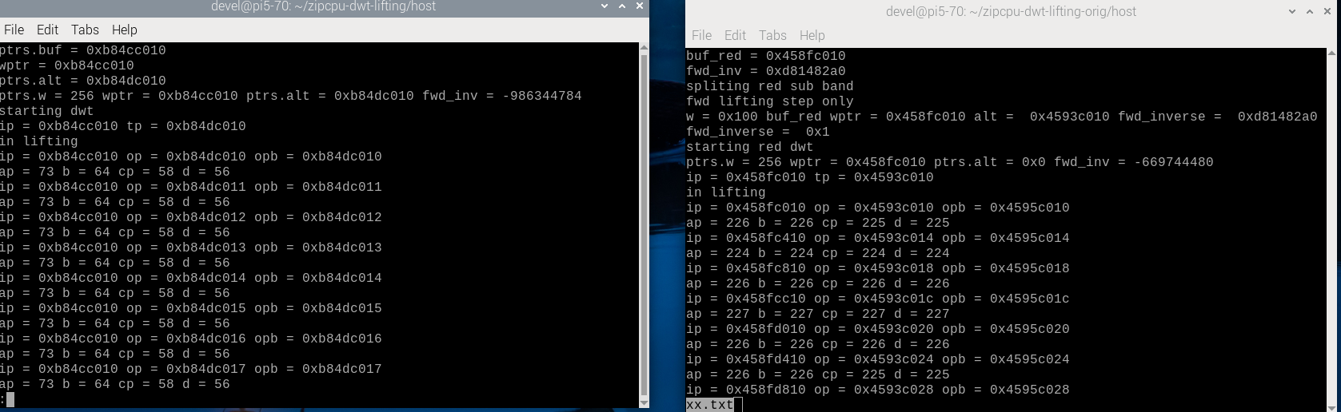

pi_jpeg-orig
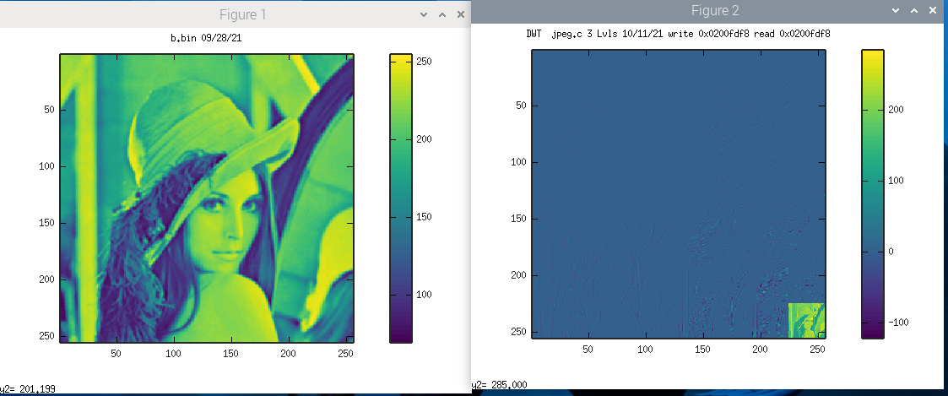
xx

