AWS Global Accelerator

AWS Global Accelerator is a networking service that helps you improve the availability and performance of the applications that you offer to your global users. AWS Global Accelerator is easy to set up, configure, and manage. It provides static IP addresses that provide a fixed entry point to your applications and eliminate the complexity of managing specific IP addresses for different AWS Regions and Availability Zones. AWS Global Accelerator always routes user traffic to the optimal endpoint based on performance, reacting instantly to changes in application health, your user’s location, and policies that you configure.

AWS Global Accelerator is a service in which you create *accelerators* to improve the performance of your applications for local and global users.

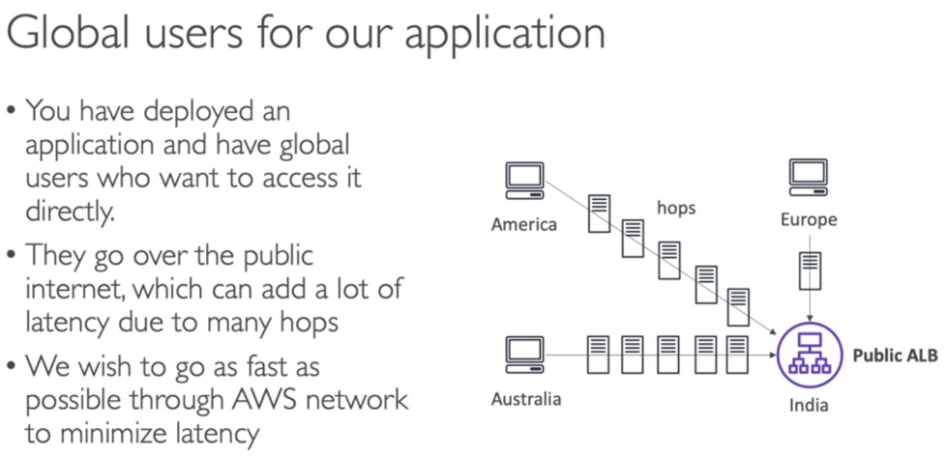

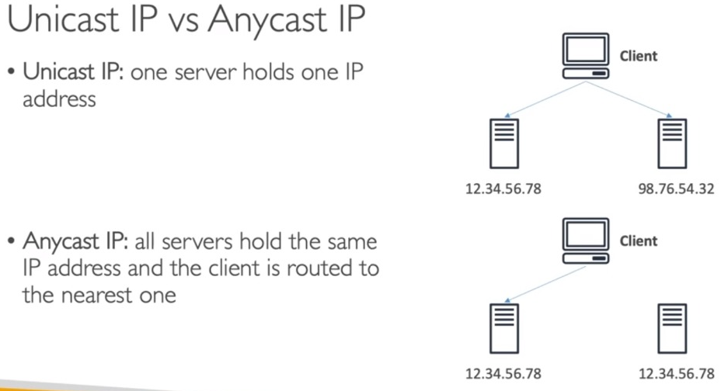

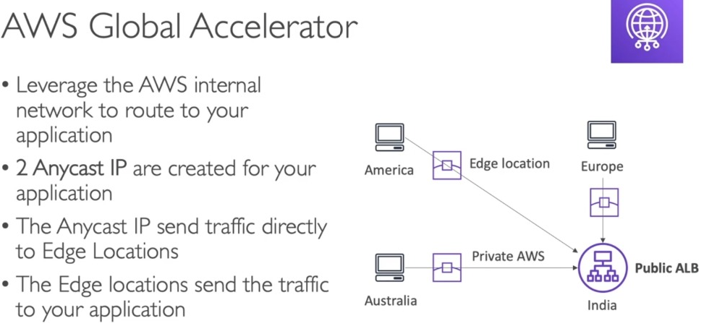 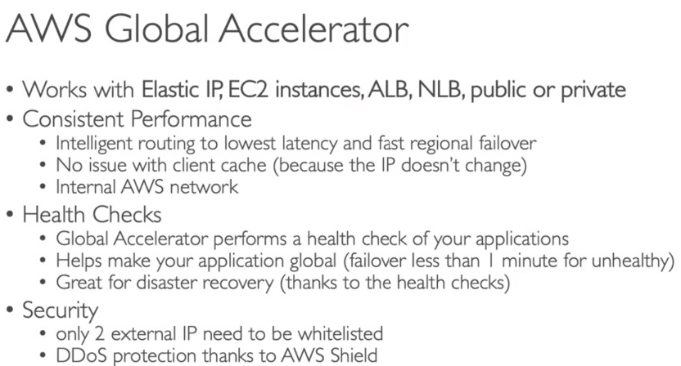

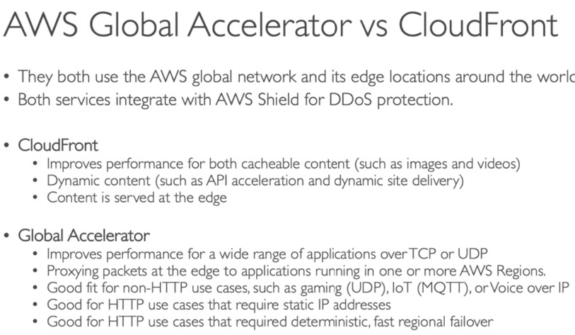

The differences between CloudFront and Global Accelerator are:

* CloudFront uses multiple sets of dynamically changing IP addresses while Global Accelerator will provide you a set of static IP addresses as a fixed entry point to your applications.
* CloudFront pricing is mainly based on data transfer out and HTTP requests while Global Accelerator charges a fixed hourly fee and an incremental charge over your standard Data Transfer rates, also called a Data Transfer-Premium fee (DT-Premium).
* CloudFront uses Edge Locations to cache content while Global Accelerator uses Edge Locations to find an optimal pathway to the nearest regional endpoint.
* CloudFront is designed to handle HTTP protocol meanwhile Global Accelerator is best used for both HTTP and non-HTTP protocols such as TCP and UDP.