**Amazon Elastic Container Registry (ECR)**

Amazon Elastic Container Registry (ECR) is a fully-managed [Docker](https://www.amazonaws.cn/en/docker/) container registry that makes it easy for developers to store, manage, and deploy Docker container images. Amazon ECR is integrated with [Amazon Elastic Container Service (ECS)](https://www.amazonaws.cn/en/ecs/), simplifying your development to production workflow. Amazon ECR eliminates the need to operate your own container repositories or worry about scaling the underlying infrastructure. Amazon ECR hosts your images in a highly available and scalable architecture, allowing you to reliably deploy containers for your applications. Integration with Amazon Identity and Access Management (IAM) provides resource-level control of each repository. With Amazon ECR, there are no upfront fees or commitments. You pay only for the amount of data you store in your repositories and data transferred to the Internet.

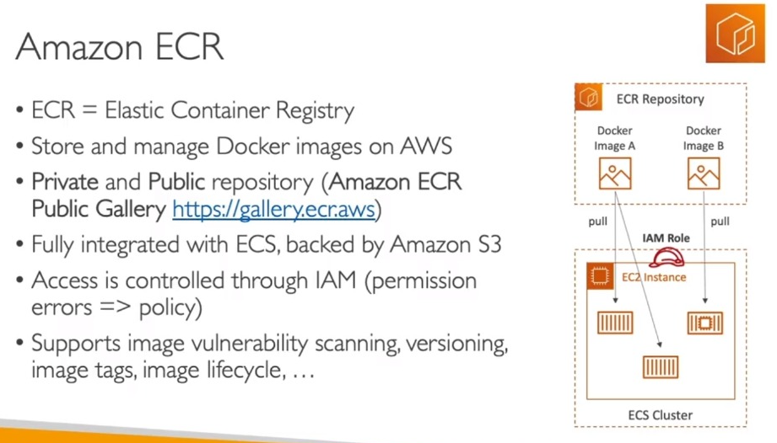

Amazon ECR is a fully managed container registry offering high-performance hosting, so you can reliably deploy application images and artifacts anywhere.

Amazon ECR eliminates the need to operate and scale the infrastructure required to power your container registry. There is no software to install and manage or infrastructure to scale. Just push your container images to Amazon ECR and pull the images when you need to deploy.

Amazon Elastic Container Registry (ECR) is a managed AWS Docker registry service. Amazon ECR is a secure and reliable AWS service. Just like any other cloud computing service, we can scale it up or scale it down based on our requirements. Amazon ECR uses AWS Identity and Access Management (IAM) to enable resource-based permissions for private Docker repositories. Through the Docker command line interface (CLI) we can push, pull, and manage images.

**Components of Amazon ECR:**

Amazon ECR has the following components:

**Registry:**  
Each AWS account has an access to Amazon ECR registry. In registry, we can create image repositories and we can also store its image.

**Authorization Token:**  
Before pushing and pulling of images, your Docker client must authenticate to Amazon ECR registries as an AWS user. The Amazon web services command line interface (CLI) has a command called get-login which provides the user with an authentication credential to be passed to docker.

**Repository:**  
The docker image is contained inside the Amazon ECR image repository.

**Repository Policy:**  
The repository policies enables the users to have control on the access to their repository and the image within it.

**Image:**  
The user can very easily push or pull the docker images to their repository. The user can use the image of the repository on their local system or it could be used in Amazon ECS task definitions.