**Amazon Elastic Container Service (Amazon ECS)**

Amazon ECS is a fully managed container orchestration service that makes it easy for you to deploy, manage, and scale containerized applications.

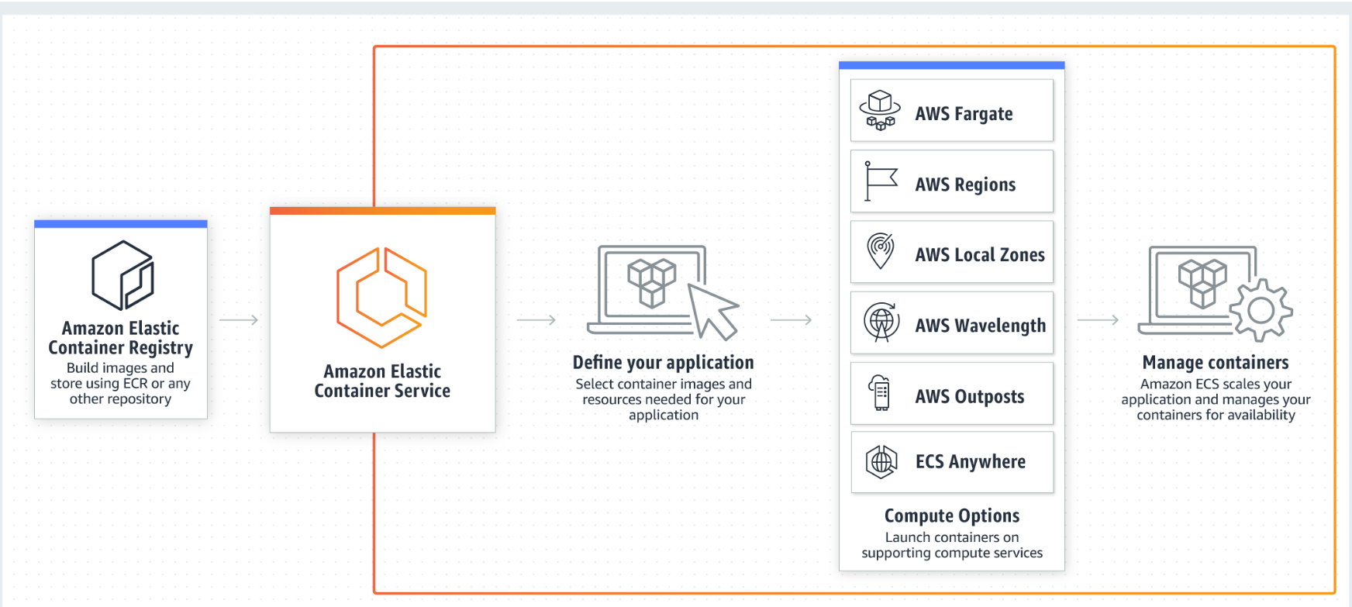

Amazon Elastic Container Service (Amazon ECS) is a fully managed container orchestration service that helps you easily deploy, manage, and scale containerized applications. As a fully managed service, Amazon ECS comes with AWS configuration and operational best practices built-in. This also means that you don't need to manage control plane, nodes, or add-ons. It's integrated with both AWS and third-party tools, such as Amazon Elastic Container Registry and Docker. This integration makes it easier for teams to focus on building the applications, not the environment. You can run and scale your container workloads across AWS Regions in the cloud, and on-premises, without the complexity of managing a control plane or nodes.

