**Amazon S3 Bucket**

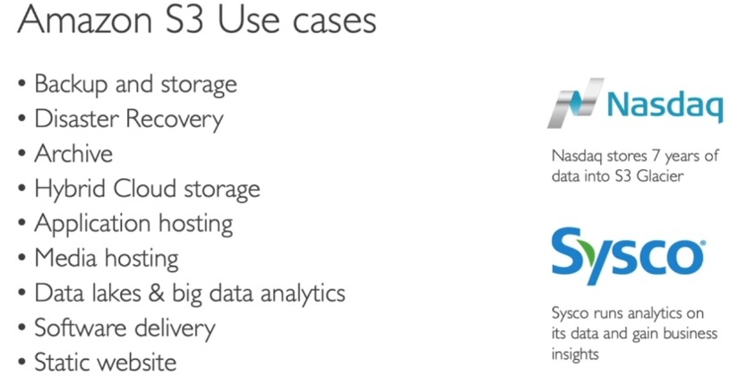

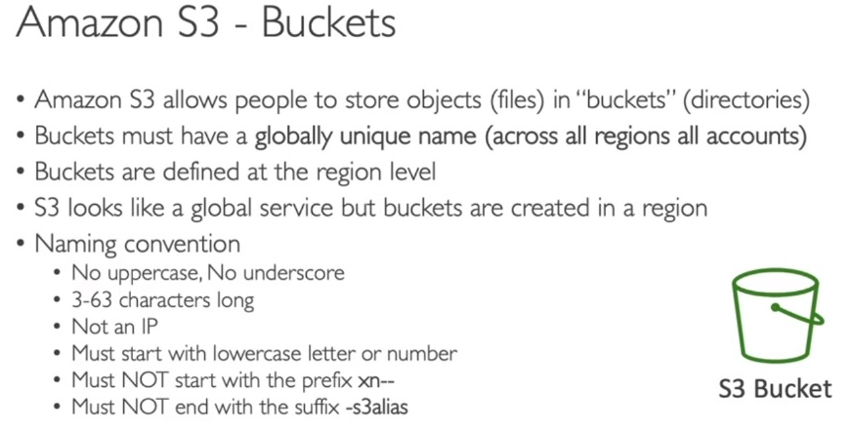

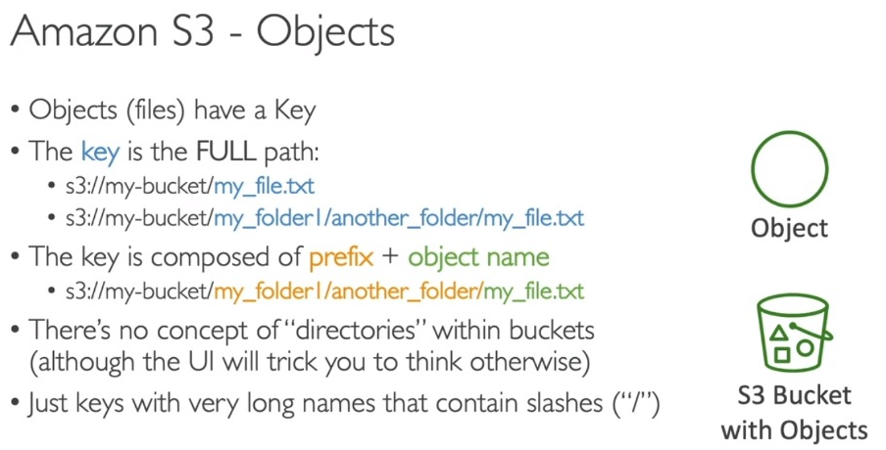

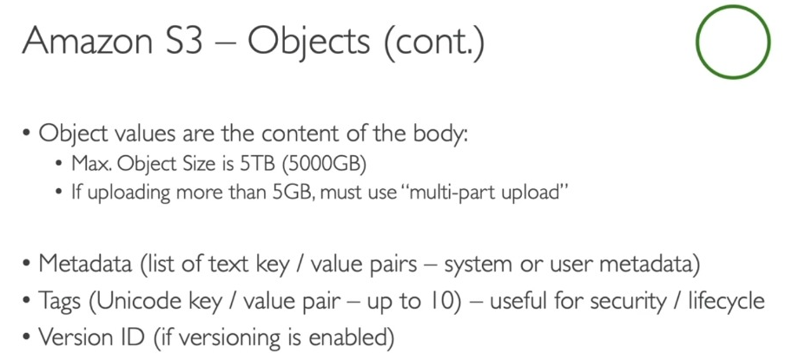

**S3 Security: Bucket Policy**

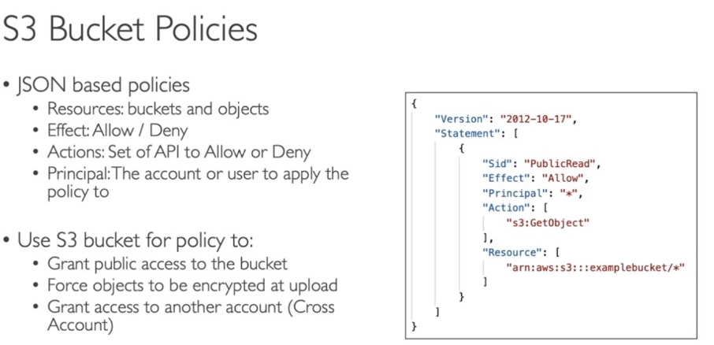

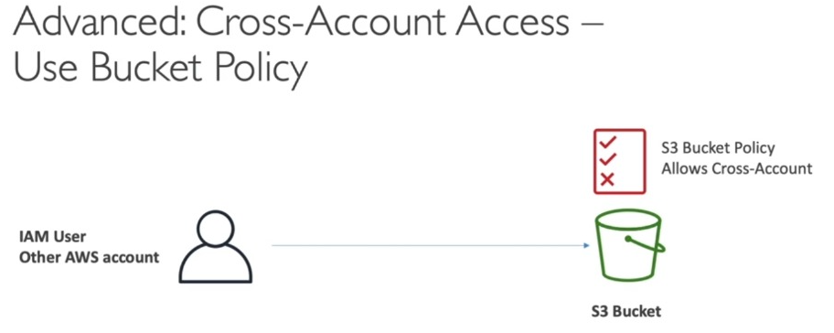

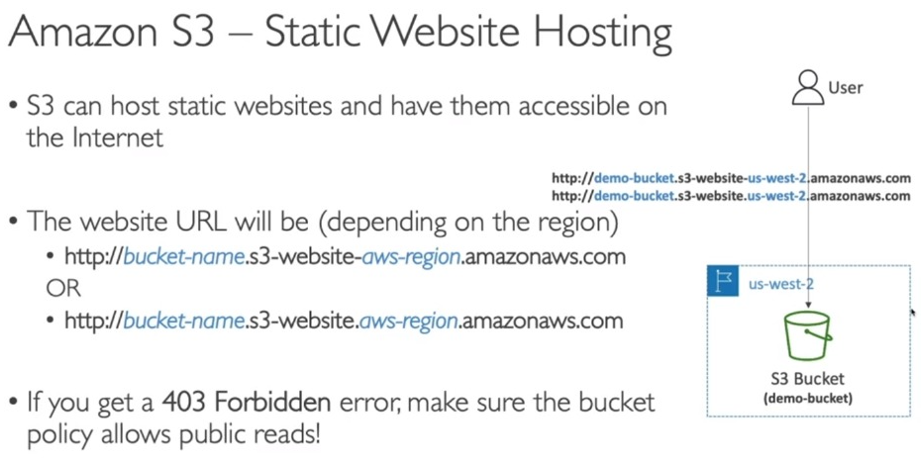

**Amazon S3 Versioning**

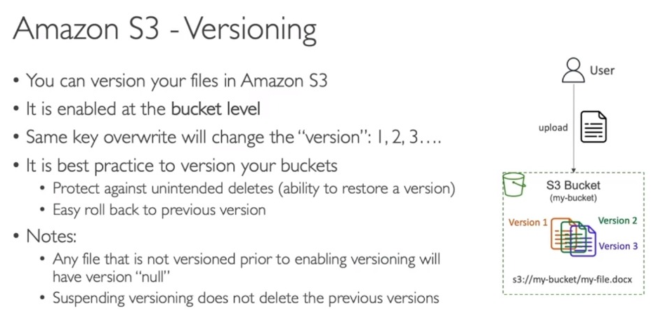

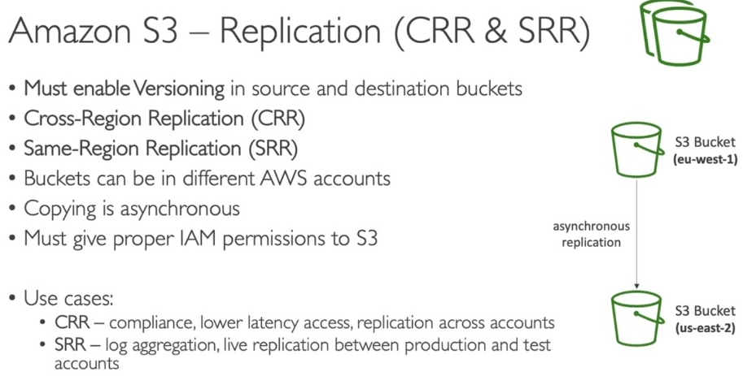

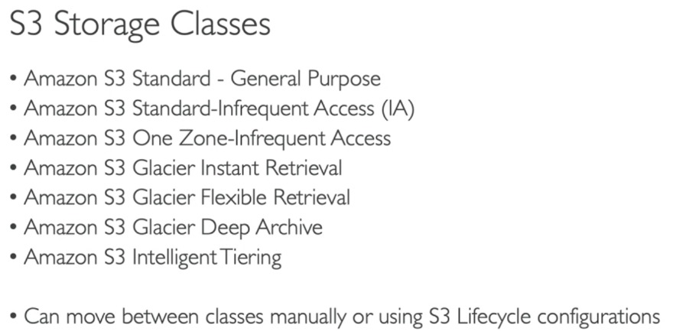

**AWS S3 Lifecycle Management**

Lifecycle Management is used so that objects are stored cost-effectively throughout their lifecycle. A lifecycle configuration is a set of rules that define the actions applied by S3 to a group of objects.

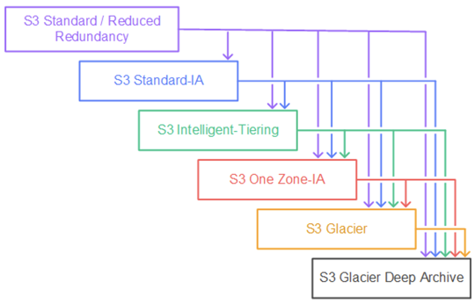

**The lifecycle defines two types of actions:**

**Transition actions:** When you define the transition to another storage class. For example, you choose to transit the objects to the Standard IA storage class 30 days after you have created them or archive the objects to the Glacier storage class 60 days after you have created them.

**Expiration actions:** You need to define when objects expire, the Amazon S3 deletes the expired object on your behalf.

Suppose a business generates a lot of data in the form of test files, images, audio, or videos and the data is relevant for 30 days only. After that, you might want to transition from standard to standard IA as storage cost is lower. After 60 days, you might want to transit to Glacier storage class for the longtime archival. Perhaps you want to expire the object after 60 days completely, so Amazon has a service known as Lifecycle Management, and this service exist within the S3 bucket.

**Lifecycle policies:**

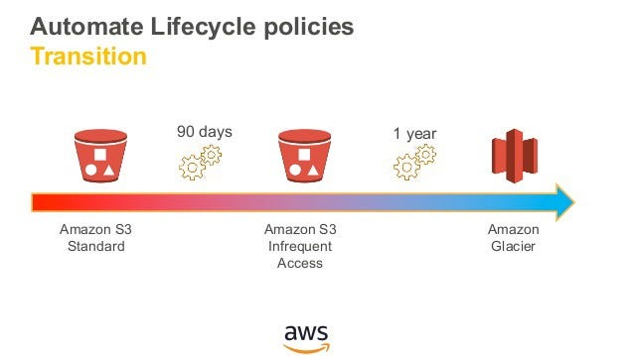

**Use Lifecycle rules to manage your object:** You can manage the Lifecycle of an object by using a Lifecycle rule that defines how Amazon S3 manages objects during their lifetime.

**Automate transition to tiered storage:** Lifecycle allows you to transition objects to the Standard IA storage class automatically and then to the Glacier storage class.

**Expire your objects:** Using the Lifecycle rule, you can automatically expire your objects.

**Amazon S3 Encryption**

