**Q: What is AWS Snowmobile?**

AWS Snowmobile is the first exabyte-scale data migration service that allows you to move very large datasets from on-premises to AWS. Each Snowmobile is a secured data truck with up to 100PB storage capacity that can be dispatched to your site and connected directly to your network backbone to perform high-speed data migration. You can quickly migrate an exabyte of data with ten Snowmobiles in parallel from a single location or multiple data centers. Snowmobile is offered by AWS as a managed service.

**Q: How does Snowmobile work?**

After you have placed your inquiry for a Snowmobile, AWS personnel will contact you to determine requirements for deploying a Snowmobile and schedule the job, and will drive the required Snowmobile equipment to your site. Once on site, they will connect it to your local network so that you can use your high-speed local connection to quickly transfer data from your local storage appliances or servers to the Snowmobile. After the data transfer is complete, the Snowmobile will be returned to your designated AWS region where your data will be uploaded into the AWS storage services you have selected, such as S3 or Glacier. Finally, AWS will work with you to validate that your data has been successfully uploaded.

**Q: What are the specifications of a Snowmobile?**

Each Snowmobile comes with up to 100PB of storage capacity housed in a 45-foot long High Cube shipping container that measures 8 foot wide, 9.6 foot tall and has a curb weight of approximately 68,000 pounds. The ruggedized shipping container is tamper-resistant, water-resistant, temperature controlled, and GPS-tracked.

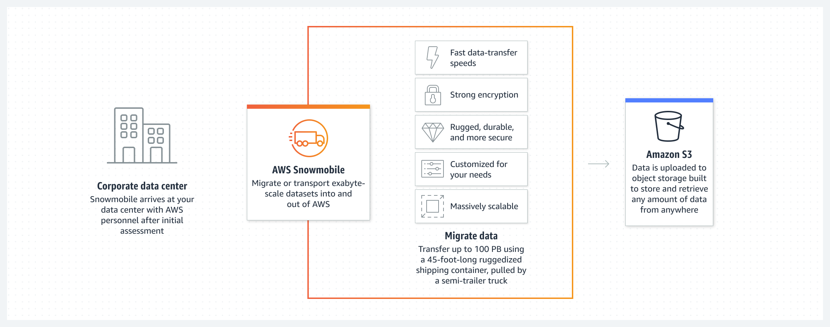

**Q: What is AWS Snowball?**

**Description**: Snowball is a petabyte-scale data transport solution that uses secure appliances to transfer large amounts of data into and out of the AWS cloud. Using Snowball addresses common challenges with large-scale data transfers including high network costs, long transfer times, and security concerns.

The AWS Snowball service uses physical storage devices to transfer large amounts of data between Amazon Simple Storage Service (Amazon S3) and your onsite data storage location at faster-than-internet speeds. By working with AWS Snowball, you can save time and money. Snowball provides powerful interfaces that you can use to create jobs, track data, and track the status of your jobs through to completion.

Snowball devices are physically rugged devices that are protected by the AWS Key Management Service (AWS KMS). They secure and protect your data in transit. Regional shipping carriers transport Snowballs between Amazon S3 and your onsite data storage location. For a list of AWS Regions where the Snowball device is available, see [AWS Snowball](https://docs.aws.amazon.com/general/latest/gr/rande.html#snowball_region) in the AWS General Reference.

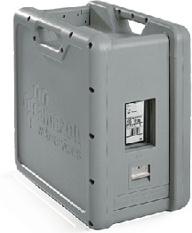

**Snowball Features**

AWS Snowball with the Snowball device has the following features:

* 80 TB and 50 TB models are available in US Regions; 50 TB model available in all other AWS Regions.
* Enforced encryption protects your data at rest and in physical transit.
* There's no need to buy or maintain your own hardware devices.
* You can manage your jobs through the AWS Snow Family Management Console or programmatically with the job management API.
* You can perform local data transfers between your on-premises data center and a Snowball. You can do these transfers through the Snowball client, a standalone downloadable client. Or you can transfer programmatically using Amazon S3 REST API calls with the downloadable Amazon S3 Adapter for Snowball. For more information, see [Transferring Data with a Snowball](https://docs.aws.amazon.com/snowball/latest/ug/using-device.html#snowball-data-transfer).
* The Snowball is its own shipping container, and its E Ink display changes to show your shipping label when the Snowball is ready to ship. For more information, see [Shipping Considerations for AWS Snowball](https://docs.aws.amazon.com/snowball/latest/ug/shipping.html).