**GPG(GNU Privacy Guard)**

**Encryption**

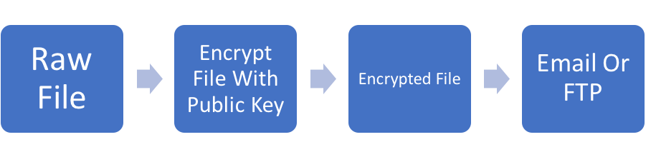

**Generating secret key**

gpg --gen-key

name_email= **'thehacker@in.imshealth.com'**,  
expire_date= **'2019-12-31'**,  
key_type=**'RSA'**,  
key_length= 4096,  
key_usage= **''**,  
subkey_type= **'RSA'**,  
subkey_length= 4096,  
subkey_usage=**'encrypt,sign,auth'**,  
passphrase=**'th#pyth0n'**

**Create encrypting file**

gpg --encrypt --recipient ‘<Key_Name>-pub-sub.asc/test@in.mail.com’ data_file.txt

**Decryption**

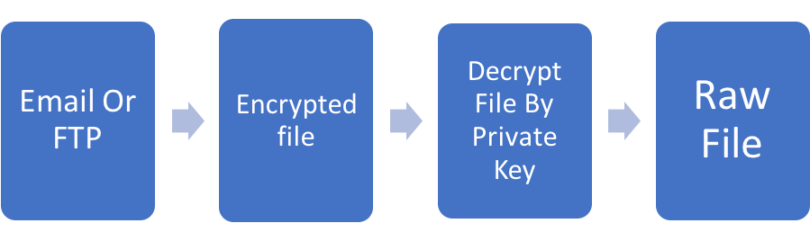

**gpg --decrypt a.txt.gpg passphase=’password’ output=secret.txt**

GPG

Mostly country using GPG for decryption like Italy

For US OPUS we are encrypting

PGP using for decryption

UK PMR

US ENDO

**encrypt**

/Users/achand/Documents/Project/BU/cryptographyAlgo/com/rxcorp/cryptographyAlgo/resource/input/fileName encrypt

**decrypt**

/Users/achand/Documents/Project/BU/cryptographyAlgo/com/rxcorp/cryptographyAlgo/resource/encrypt/fileName.enc decrypt

<https://jiraims.rm.imshealth.com/wiki/display/DBP/PFlow+Replacement+-+Italy>