You're Not "Managing" Anything. You're Just Living — In Bestiee.
Incontinence doesn't check your ID. It shows up after a marathon, after a baby, after a surgery, after sixty birthdays, or after none of the above — it just shows up. And for far too long, the products meant to help have talked to people like they've already given up on looking good, feeling good, or living fully.
Bestiee Pull-Up Pants were made to end that. Whether you're 25 and training for your next 10K, 45 and running a business in tailored trousers, or 85 and finally free to enjoy your grandkids without a second thought — Bestiee fits into your life, not the other way around. This isn't a medical device you tolerate. It's underwear you forget you're wearing.
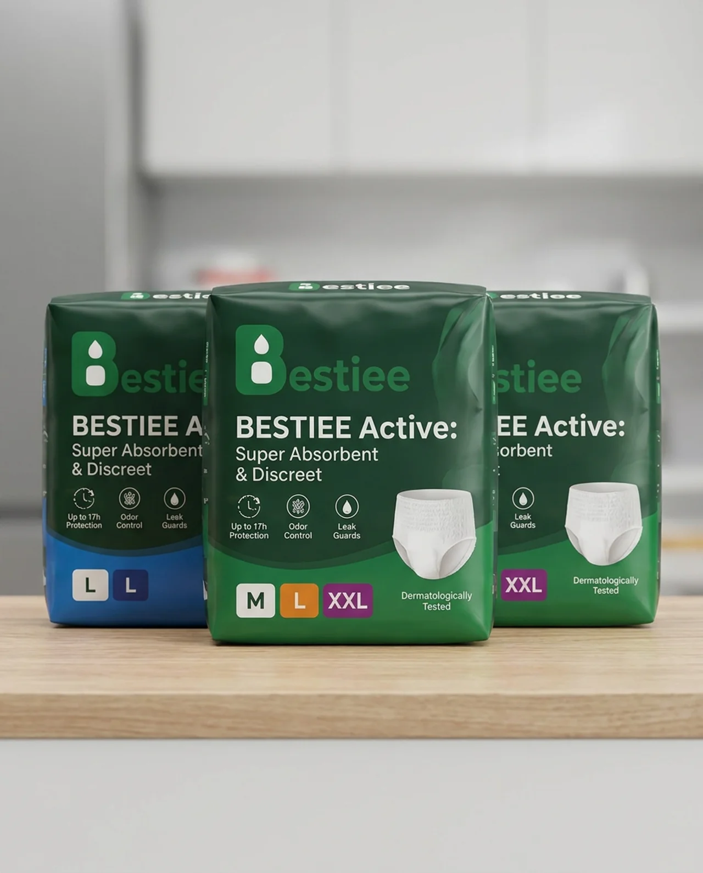
Bestiee Active: Super Absorbent & Discreet — Up to 17h Protection, Odor Control, Leak Guards, in sizes M, L, and XXL.

Beautiful, Handsome, Confident — At Every Age
Confidence doesn't have an age limit, and neither should the products that support it. Bestiee is built for:
- The young professional who refuses to let anything show under a fitted dress or slim-cut suit
- The athlete who needs total reliability through a workout, a long shift, or a full night's sleep
- The parent adjusting to a body that's changed and just wants to feel like themselves again
- The elder who has earned nothing less than comfort, dignity, and freedom
One product. Every stage of life. Zero compromise on how you look or feel.

Slim, Stretchy, and Practically Invisible
- Underwear-like fit with a soft, stretchable waistband that moves with your body
- Slim, low-profile design invisible under leggings, fitted jeans, dresses, or suits
- Flexible sides that hug your shape instead of bunching or sagging

Locked-In Protection, Day or Night
- High-capacity absorbent core that locks moisture away from skin
- Up to 17 hours of protection for active days and restful nights
- Leak guards for extra security during movement

Soft on Skin, Fresh All Day
- Breathable materials that keep skin cool, not damp
- Odor-control technology for all-day freshness
- Dermatologically tested, gentle on sensitive skin

Made for Real Life
- Easy pull-up design, on and off like regular underwear
- Tear-away sides for fast, discreet changes
- Built for the office, the airport, and everywhere in between

Your Life Doesn't Wait — Neither Should You
Incontinence is common. Feeling less-than about it shouldn't be. Whether you're 25 or 85, Bestiee lets you move, work, sleep, and show up exactly as confident as you already are.
Try Bestiee today — because comfort, dignity, and style were never meant to be mutually exclusive, at any age.

