Gender-Neutral, Age-Neutral: The New Standard for Active Adults
Incontinence in your 20s and 30s doesn't care whether you're a man or a woman, and it definitely doesn't care that you've got a workout, a work trip, or a weekend of plans. What matters is having something that keeps up with you — regardless of gender — without making you feel like you've traded in your regular underwear for something clinical.
Bestiee's unisex pull-up pants were built exactly for that: one fit, engineered for any active adult, whatever your gender.
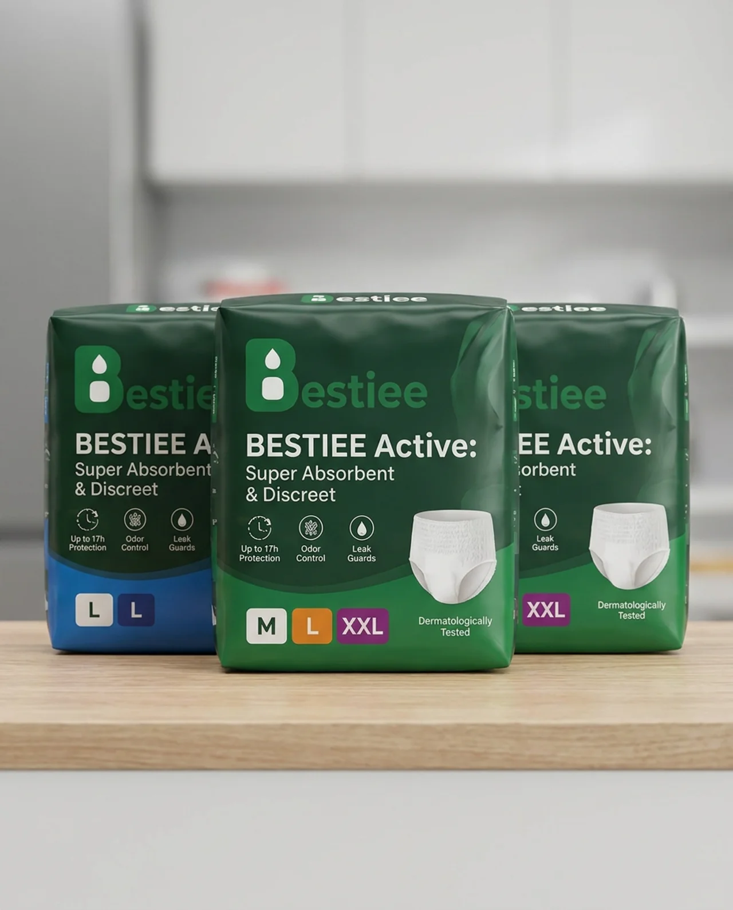
Bestiee Active: Super Absorbent & Discreet — Up to 17h Protection, Odor Control, Leak Guards, in sizes M, L, and XXL. One fit, made for everyone.

Built to Move, Whoever's Wearing It
- A slim, underwear-like profile invisible under gym clothes, jeans, or activewear — for any body
- A stretchable waistband that flexes through workouts, sprints, or long days on your feet
- A unisex design that doesn't force you into a fit meant for someone else

Reliable, No Matter Your Schedule
- Absorbency built for workouts, travel days, and everything in between
- Up to 17 hours of protection so one pair covers your whole day
- Leak guards that hold up through constant movement

Fresh After Any Activity
- Breathable materials that stay cool post-workout
- Odor control built in, regardless of activity level
- Dermatologically tested for active, sensitive skin

Fast Changes, No Awkwardness
- Pull up and go — no complicated steps for any body type
- Tear-away sides for quick changes between meetings or between sets

One Standard, For Everyone
An occasional leak doesn't care about your gender, and neither does Bestiee. Just reliable protection, built for whoever needs it.
Try Bestiee — one great fit, for every active adult.

