Aging Well, Together: Why One Product Fits Every Body After 65
Growing older happens to everyone — men and women alike — and so, often, does some degree of incontinence. Yet for years, the products available seemed to assume only one gender needed to age with dignity. Bestiee was built differently: one pull-up pant, engineered to fit and flatter any body, at any stage of later life.
Because comfort, independence, and confidence after 65 shouldn't come with a gender asterisk.
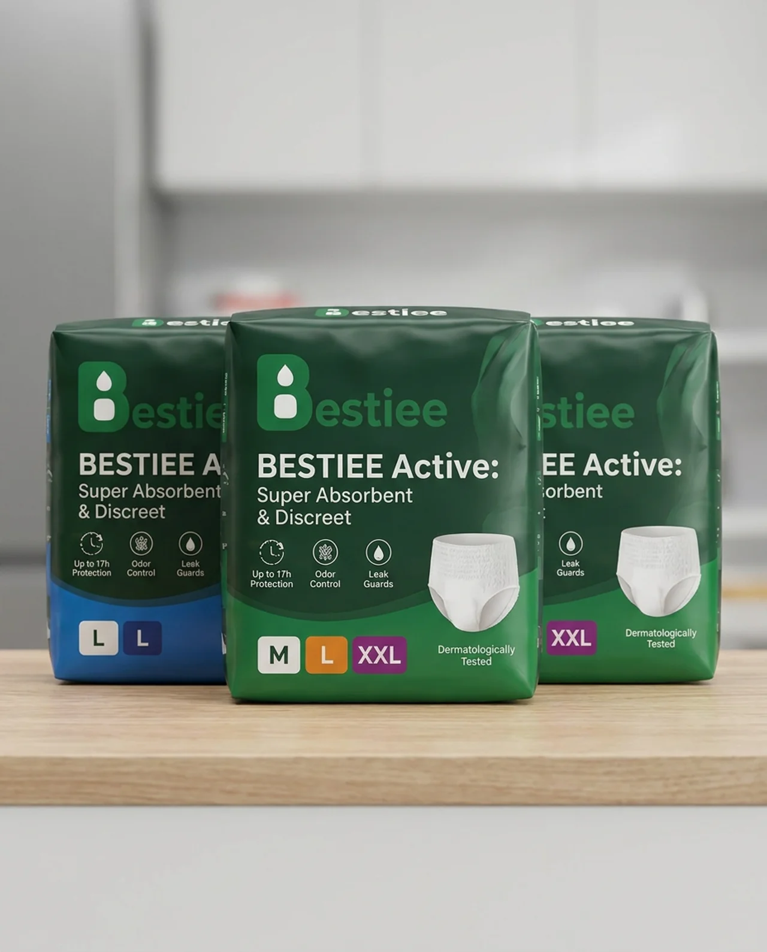
Bestiee Active: Super Absorbent & Discreet — Up to 17h Protection, Odor Control, Leak Guards, in sizes M, L, and XXL. One fit, made for everyone.

One Considered Fit, For Any Body
- A soft, stretchable waistband comfortable for a wide range of body types
- A slim, discreet profile that stays invisible under everyday clothing, for men and women alike
- Designed to move naturally, whether you're gardening, golfing, or heading out to dinner

Protection You Can Depend On
- A high-capacity absorbent core that locks moisture away from skin
- Up to 17 hours of protection for long days and undisturbed nights
- Leak guards for extra peace of mind during any activity

Gentle on Skin That Deserves Extra Care
- Breathable materials that reduce irritation on more delicate, mature skin — of any gender
- Built-in odor control for all-day freshness
- Dermatologically tested for sensitive skin

Independence, Made Simple
- An easy pull-up design that supports independence for most people, regardless of gender
- Tear-away sides that make changes fast and simple, whenever needed

Dignity Shouldn't Have a Gender Requirement
You've earned comfort and independence in later life — no matter who you are. With Bestiee, that standard applies equally, to everyone.
Try Bestiee — comfort and dignity, for every body, at every age.

