Bladder Leaks Before 40? You're in Way Better Company Than You Think
Runners after a hard sprint. New moms six months postpartum. Twenty-somethings with overactive bladders. CrossFit regulars mid-box-jump. If you've ever had a leak and quietly assumed you were the only person your age dealing with it — you're not. Light and moderate incontinence is one of the most common, least-talked-about things happening to people in their 20s, 30s, and 40s.
The problem was never your body. It was that every product on the shelf looked like it was designed for someone else's grandparent. Bestiee Pull-Up Pants change that — built to disappear under your actual clothes and keep up with your actual life.
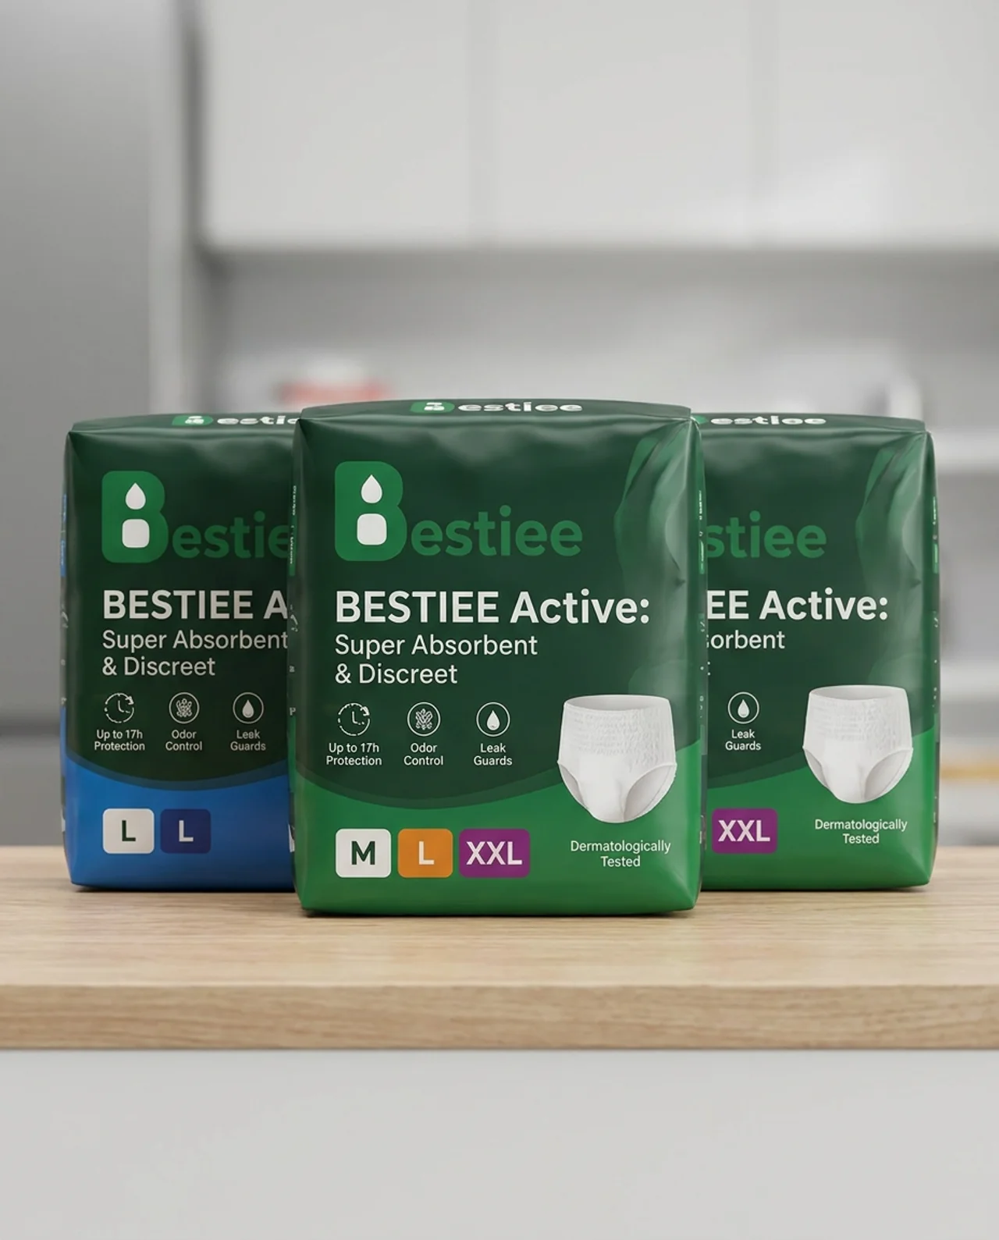
Bestiee Active: Super Absorbent & Discreet — Up to 17h Protection, Odor Control, Leak Guards, in sizes M, L, and XXL.

Made to Move With You
- Slim, underwear-like profile that stays invisible under leggings, gym shorts, or your favorite jeans
- Stretchable waistband that flexes through squats, sprints, and long days on your feet
- A fit that feels like your regular underwear, not like wearing a diagnosis

Built for Your Actual Schedule
- Absorbency that holds up through workouts, workdays, and long commutes
- Up to 17 hours of leak protection, so one pair covers your whole day
- Leak guards that keep you covered even when you're constantly in motion

Skin That Stays as Fresh as You Feel
- Breathable materials that won't leave you damp or irritated after a workout
- Odor control built in, so freshness isn't something you have to think about
- Dermatologically tested for sensitive, active skin

Quick Changes, Zero Drama
- Pull up and go — no awkward fumbling in a gym bathroom or airplane lavatory
- Tear-away sides for a fast change between meetings or between sets

You Don't Have to Slow Down
An occasional leak doesn't make you fragile — it makes you human. Bestiee just makes sure it never has to make you stop.
Try Bestiee — and keep training, working, and living exactly like you were before.

