The Thing Nobody Tells New Parents About — And the Fix That Actually Works
Somewhere between the birth plan and the 3 a.m. feedings, nobody mentions this part: for a lot of new parents, bladder control takes months — sometimes longer — to fully bounce back. It's common, it's temporary for most people, and it is absolutely nothing to be embarrassed about. But you still want something that keeps up with your day, not something that makes you feel like you're wearing a hospital gown.
That's exactly the gap Bestiee Pull-Up Pants were built to fill: real protection, without sacrificing how you look or feel while you're already juggling everything else.
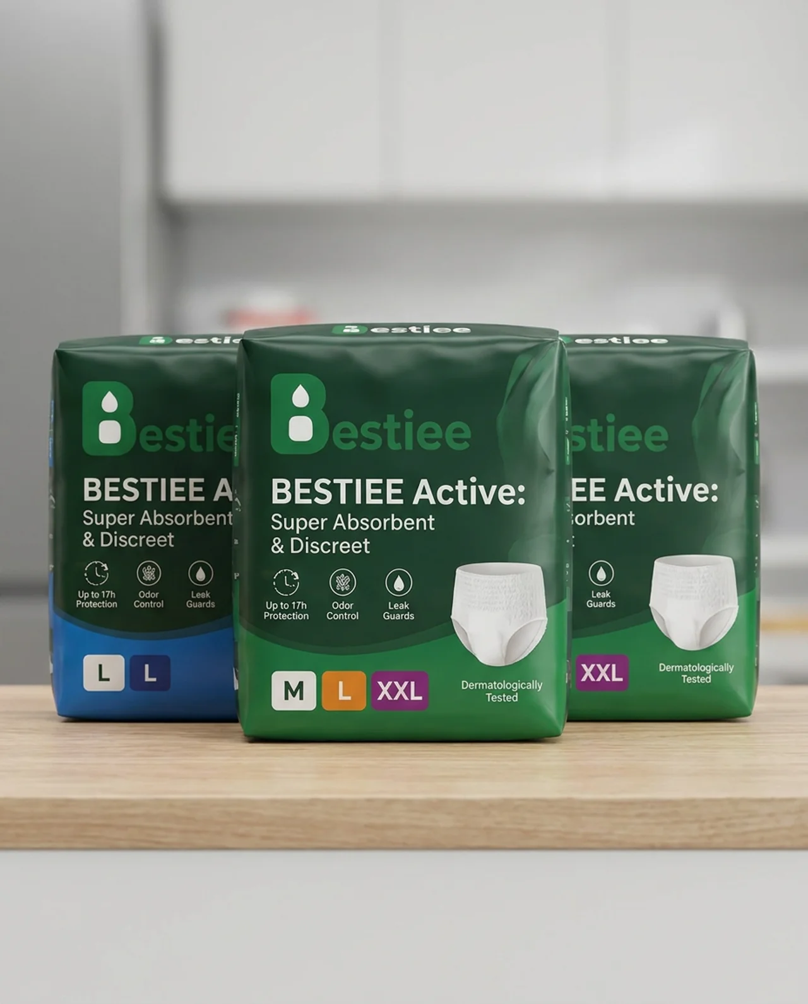
Bestiee Active: Super Absorbent & Discreet — Up to 17h Protection, Odor Control, Leak Guards, in sizes M, L, and XXL.

Discreet Enough for Actual Life
- Slim, form-fitting design that stays hidden under leggings, joggers, or your pre-pregnancy jeans
- A soft, stretchable waistband that's gentle on a still-recovering body
- A fit that feels like underwear, not a medical garment

Absorbency for the Unpredictable Days
- A high-capacity core built for both daytime unpredictability and overnight recovery
- Up to 17 hours of protection — because sleep is precious and you shouldn't lose more of it to changing
- Leak guards for the moments you're lifting, bending, or chasing a toddler

Gentle on Sensitive, Healing Skin
- Breathable materials that reduce heat and moisture against sensitive postpartum skin
- Odor control so you feel fresh and put-together, even on the hardest days
- Dermatologically tested for extra-sensitive skin

Fast Changes When You Have One Hand Free
- Easy pull-up, pull-down design — no clips or tapes to fight with one-handed
- Tear-away sides for quick changes between feedings

You're Doing Great
Your body just did something enormous. Bestiee is here to make the recovery part a little easier, so you can focus on everything — and everyone — else.
Try Bestiee — comfort and confidence for the recovery no one warns you about.

