Dignity Has a New Look: Meet the Pull-Up Pants Redefining Comfort at Any Age
There's a version of aging that gets sold to us in old commercials — muted colors, clinical language, quiet resignation. That's not the only way to do this. More people than ever are staying active, stylish, and social well into their 80s and 90s, and the products they wear should reflect that — not undercut it.
Bestiee Pull-Up Pants were designed with exactly that in mind: real, reliable protection that still lets you feel like yourself — sharp, comfortable, and completely in control of your day.
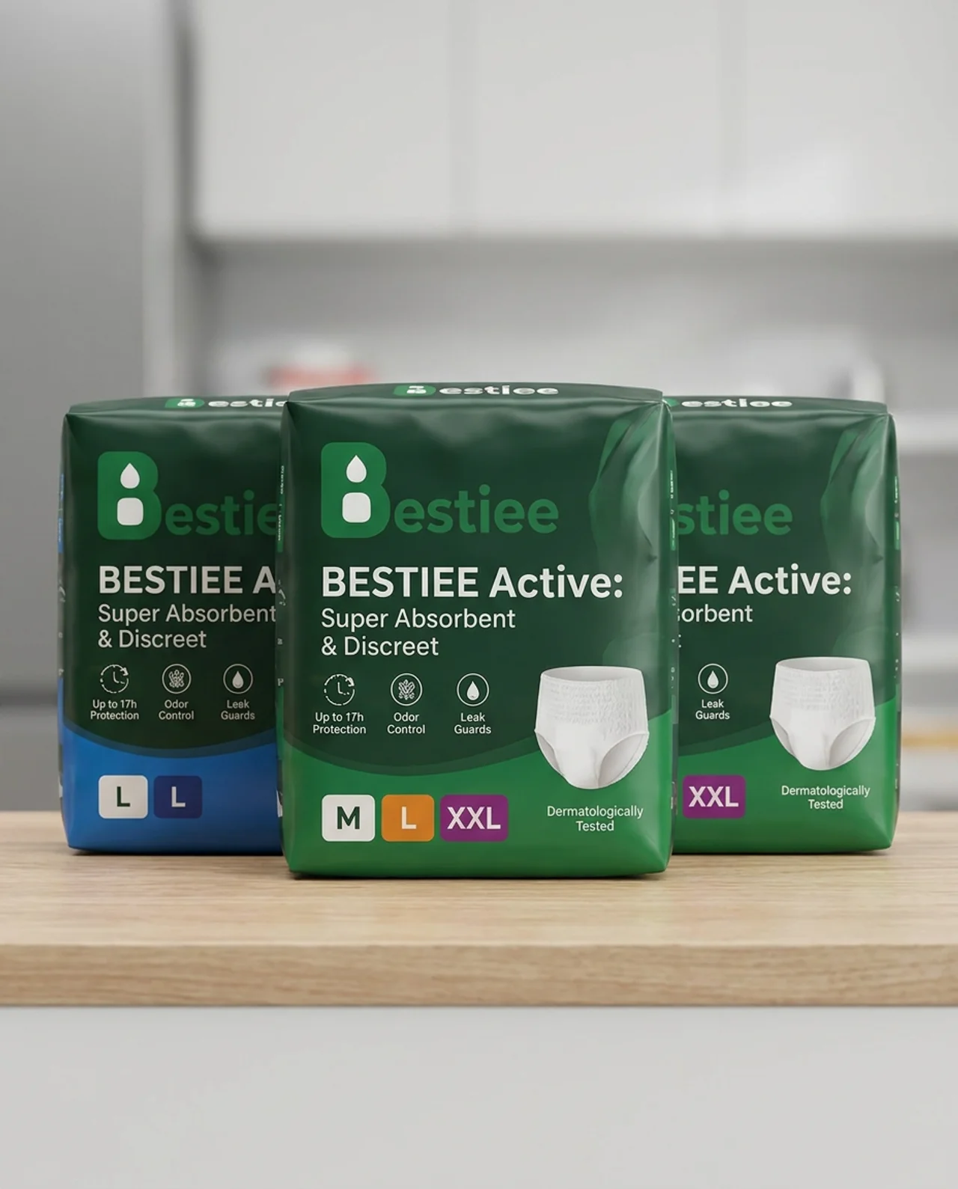
Bestiee Active: Super Absorbent & Discreet — Up to 17h Protection, Odor Control, Leak Guards, in sizes M, L, and XXL.

Comfort That Doesn't Look Like a Compromise
- An underwear-like fit with a soft, stretchable waistband that's gentle on skin
- A slim profile that stays discreet under everyday clothing — no bulk, no crinkle
- Designed to move naturally with you, whether you're gardening, golfing, or out to dinner

Protection You Can Actually Rely On
- A high-capacity absorbent core that locks moisture away from skin
- Up to 17 hours of protection for long days and undisturbed nights
- Leak guards for extra peace of mind during any activity

Kind to Skin That Deserves Extra Care
- Breathable materials that reduce irritation on more delicate, mature skin
- Built-in odor control for all-day freshness and confidence
- Dermatologically tested for sensitive skin

Simple, Independent, Dignified
- An easy pull-up design that supports independence — no assistance required for most people
- Tear-away sides that make changes fast and simple, whenever they're needed

You've Earned Comfort. Not Compromise.
Getting older was never supposed to mean giving up how you look or feel. With Bestiee, it doesn't have to.
Try Bestiee — comfort, independence, and dignity, exactly as they should be.

