Confidence On the Go: How Bestiee Keeps You Ready for Anything, Anywhere
Long-haul flights. Back-to-back meetings. A full day on your feet at a conference, a wedding, or a theme park with the grandkids. Real life doesn't pause for a bathroom break every hour — and the right pair of Bestiee Pull-Up Pants means you don't have to plan your whole day around finding one.
This is protection built for people who are still out there living — not staying home to avoid a worst-case scenario.
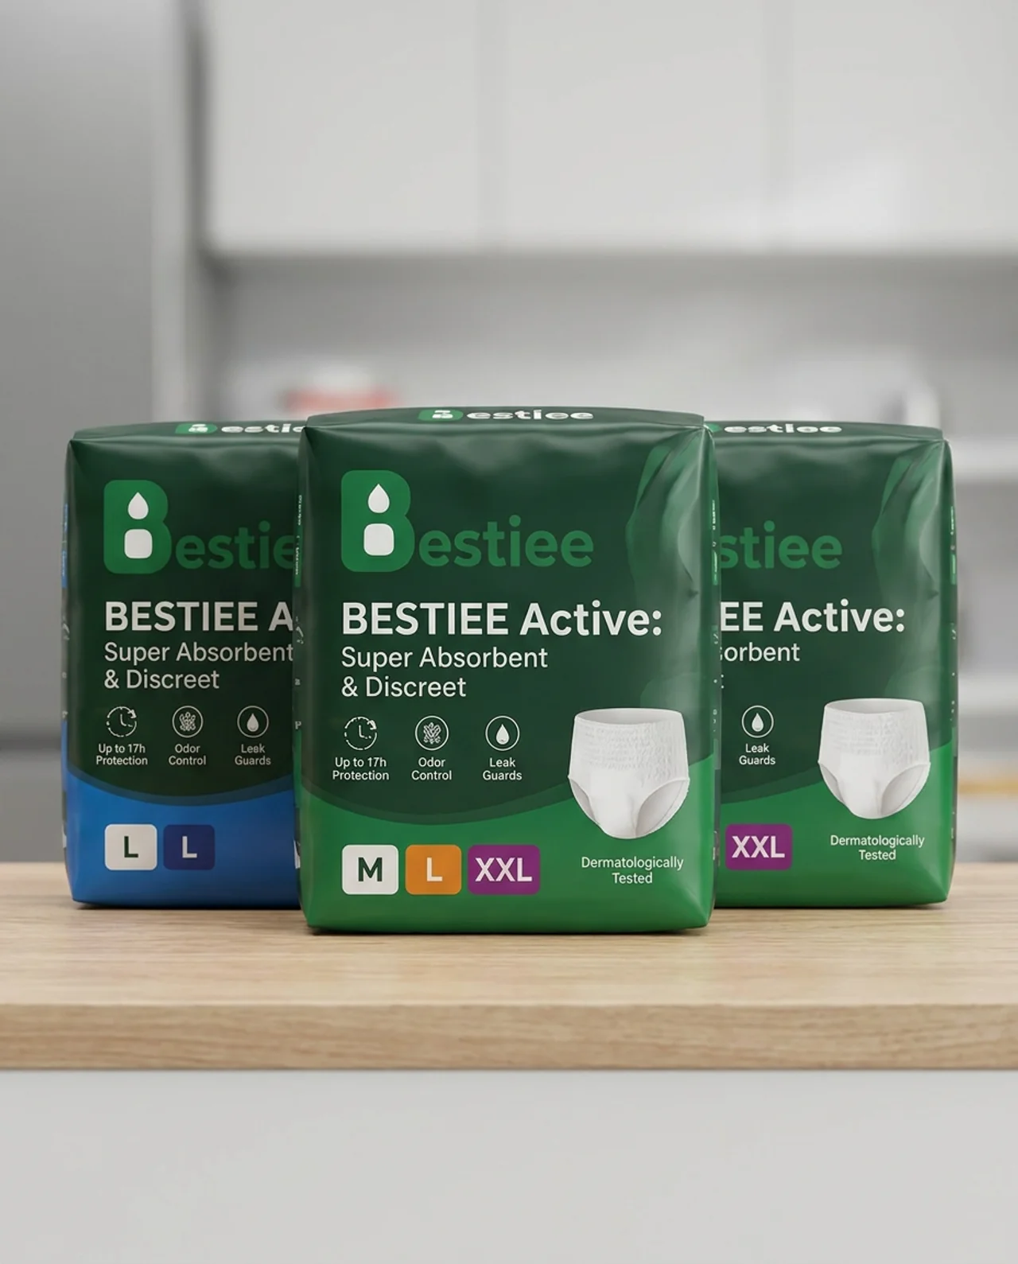
Bestiee Active: Super Absorbent & Discreet — Up to 17h Protection, Odor Control, Leak Guards, in sizes M, L, and XXL.

Invisible Under Whatever You're Wearing
- A slim, underwear-like fit that disappears under suits, dresses, and travel clothes alike
- A stretchable waistband comfortable enough for a full day of sitting, standing, and walking terminals

Protection That Lasts as Long as Your Day Does
- Up to 17 hours of reliable protection — built for long flights and even longer meetings
- A high-capacity core that locks away moisture so you stay dry through it all
- Leak guards for extra confidence when you're constantly on the move

Fresh, No Matter the Time Zone
- Breathable materials that keep you comfortable through hours of travel
- Odor control that keeps you feeling fresh from takeoff to touchdown
- Dermatologically tested, even for sensitive skin on long trips

Changes That Fit Into a Layover, Not a Detour
- Simple pull-up design for quick, easy changes in any restroom
- Tear-away sides so a change takes minutes, not a production

Go Anywhere. Do Anything.
The best trips, meetings, and milestones don't wait for perfect conditions. With Bestiee, neither do you.
Try Bestiee — protection built to travel as far as you do.

