The Health Topic Men Never Bring Up — And the Product That Was Built for Them Too
Men talk about a lot of things over beers, at the gym, in the group chat. This usually isn't one of them. But bladder leaks after prostate procedures, injuries, or simply getting older happen to a huge number of men — quietly, and mostly alone, because almost nothing on the shelf was ever designed with them in mind.
Bestiee's Pull-Up Pants were. Not a repackaged women's product with a different label — an actual unisex fit engineered to work as well for men as for anyone else.
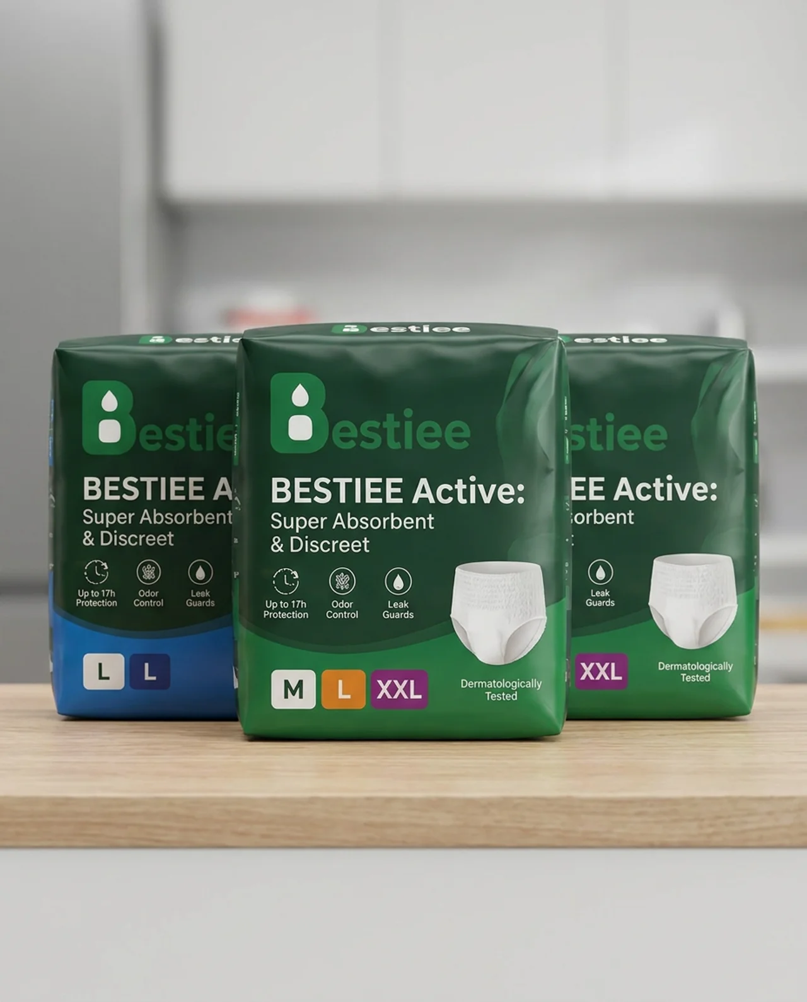
Bestiee Active: Super Absorbent & Discreet — Up to 17h Protection, Odor Control, Leak Guards, in sizes M, L, and XXL. One fit, made for everyone.

A Fit That Actually Works for a Man's Body
- An anatomically considerate design that sits comfortably and discreetly, without the awkward fit of products designed for someone else
- A stretchable waistband built to move with an athletic build or a broader frame
- A slim profile that stays invisible under jeans, suit trousers, or gym shorts

Protection That Keeps Up With You
- A high-capacity core that locks moisture away from skin
- Up to 17 hours of protection for full workdays, workouts, and undisturbed sleep
- Leak guards for extra security, whether you're at your desk or on the course

Fresh, Breathable, No Fuss
- Breathable materials that stay cool during activity
- Built-in odor control, so freshness is never something you have to think about
- Dermatologically tested and gentle on skin

Quick, Simple, Private
- Pull up, pull down — no complicated steps, no drawing attention
- Tear-away sides for a fast change wherever you are

You Don't Have to Go Through This Quietly
This isn't rare, and it isn't something to be embarrassed about. Bestiee was built so you can handle it the same way you handle everything else — quickly, confidently, and on your own terms.
Try Bestiee — real protection, built for men too.

