Made Just as Much for Her: Why a Unisex Fit Doesn't Mean a Compromise
"Unisex" can sound like a warning label — like something got averaged out and nobody got quite what they needed. That's not how Bestiee works. The same pull-up pants that fit men comfortably were engineered with just as much care for women's bodies, from postpartum recovery to menopause to simply getting older.
One design, fully considered for both — not a men's product that women are expected to tolerate.
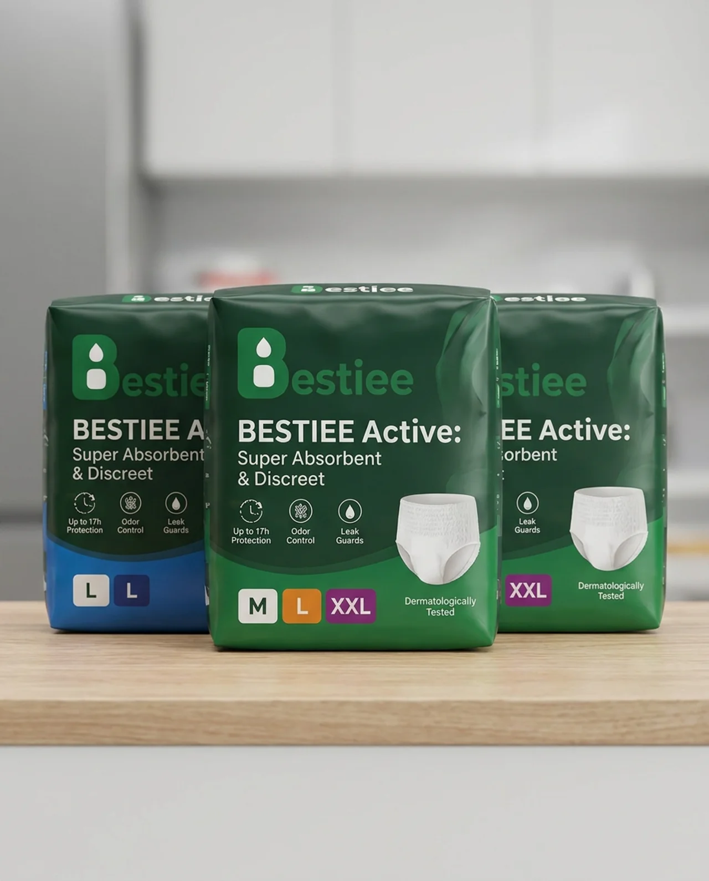
Bestiee Active: Super Absorbent & Discreet — Up to 17h Protection, Odor Control, Leak Guards, in sizes M, L, and XXL. One fit, made for everyone.

A Fit Engineered With Her in Mind, Too
- A soft, stretchable waistband that's gentle on a changing or recovering body
- A slim, discreet profile that disappears under leggings, dresses, and everyday clothes
- A shape considerate of women's anatomy, not just adapted from a men's pattern

Reliable, Whatever Life Stage You're In
- A high-capacity absorbent core built for postpartum recovery, menopause-related changes, or any other reason
- Up to 17 hours of protection for long days and uninterrupted sleep
- Leak guards for extra confidence during any activity

Gentle on Skin That Deserves Care
- Breathable materials that reduce irritation on sensitive or healing skin
- Odor control that keeps you feeling fresh and confident all day
- Dermatologically tested for extra-sensitive skin

Effortless, Any Time You Need It
- A simple pull-up design, easy to manage one-handed with a baby on your hip
- Tear-away sides for a quick, discreet change anywhere

You Don't Get the Leftover Version
Bestiee wasn't designed for one gender and adapted for the other. It was designed for both — so you get full comfort, full protection, and full confidence, exactly as you should.
Try Bestiee — designed with her, not just for her.

