One Pack, Every Family Member Covered: The Case for a True Unisex Diaper
Maybe it's your dad after his surgery. Maybe it's your mom who's noticed some changes since menopause. Maybe it's you, dealing with something after a tough delivery or a long training block. In a lot of households, incontinence isn't a one-person issue — it just shows up for different people at different times, for completely different reasons.
That's exactly why Bestiee designed one great product instead of a men's version and a women's version: so any adult in your household can reach for the same reliable pack and get the same great fit.
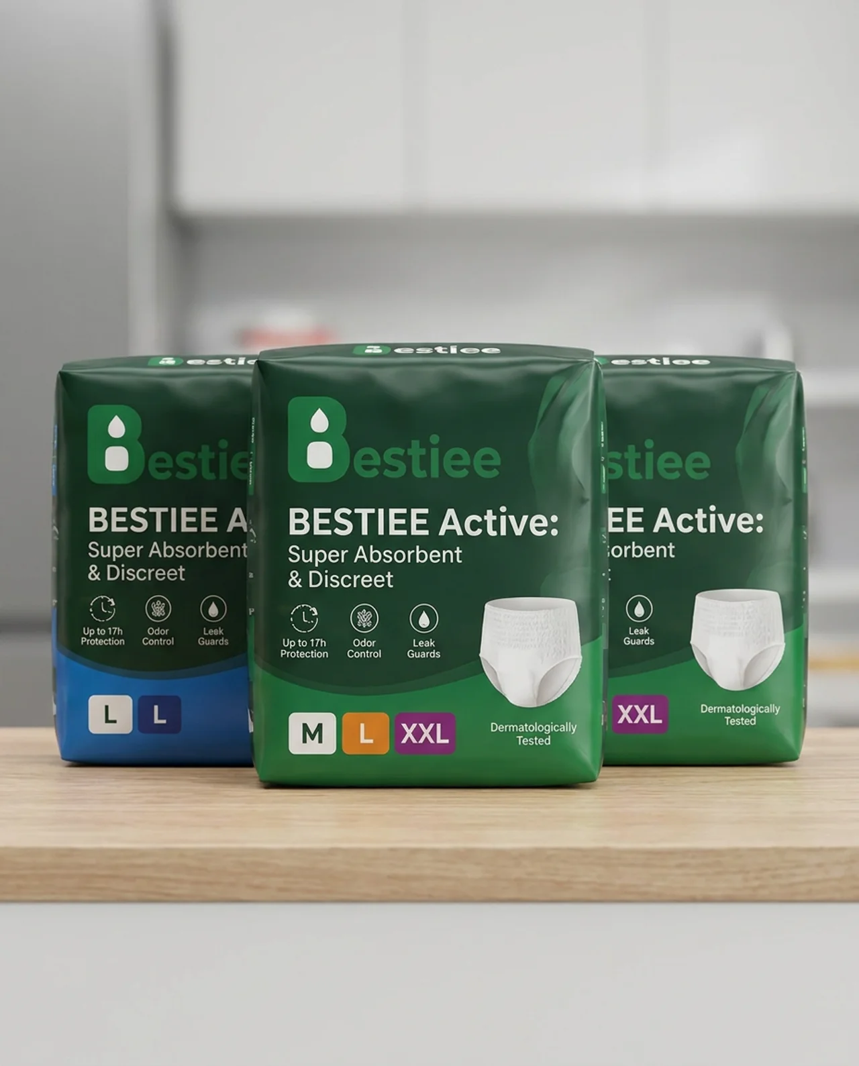
Bestiee Active: Super Absorbent & Discreet — Up to 17h Protection, Odor Control, Leak Guards, in sizes M, L, and XXL. One fit, made for everyone.

One Product, Every Body
- A unisex design engineered to fit comfortably and discreetly regardless of gender
- A stretchable waistband that adapts to a wide range of body types
- The same slim, invisible-under-clothing profile for whoever's wearing it

Consistent Protection for Everyone in the House
- A high-capacity core that locks away moisture, for any adult who needs it
- Up to 17 hours of protection, whether it's for daytime activity or a full night's sleep
- Leak guards that hold up through everyday movement

Comfortable and Gentle, No Matter the Skin
- Breathable materials suited to a range of skin types and sensitivities
- Odor control that works the same way for everyone
- Dermatologically tested for extra peace of mind

Simple Enough for the Whole Family to Use
- An easy pull-up design that doesn't require different instructions for different people
- Tear-away sides that make changes fast, whoever's doing them

Less to Stock, More Peace of Mind
You shouldn't need two different products in the cabinet for two different people. With Bestiee, one great pack covers everyone in your home who needs it — with zero drop-off in fit, comfort, or confidence.
Try Bestiee — one pack, the whole family covered.

