Adiuvaret AI Classroom Generator
What it is, why it's useful, and how it works — a two-page overview

What Is Adiuvaret AI Classroom?
Adiuvaret AI Classroom is a web app that turns a short form into a classroom-ready teaching resource in seconds. Pick a class (PG through Class 12), a subject, and a topic, and an AI model (Google's Gemini) writes a complete worksheet, lesson plan, quiz, activity set, or exam paper for you to review and use — no blank page, no starting from scratch.

Why It's Useful
- Saves hours of prep time. What normally takes an evening of planning becomes a two-minute form.
- Covers the full teaching toolkit. Worksheets, lesson plans, quizzes, activities, and exam papers, all in one place.
- Tailored by class and subject. Every class from PG to Class 12 has its own relevant subject list, so results fit the age group.
- Nothing gets lost. Every generation is logged automatically, and anything worth keeping can be bookmarked into a personal library.
- No installation, no setup for the teacher. It's a website — open it in a browser and start creating.

How It Works — and How It Flows Through the Site
Every visit follows the same simple path, shown below: sign in, land on a home screen that links to every tool, pick a tool and fill in a short form, and let the AI do the writing.
- Log in from the opening screen (or sign up in a few seconds if you're new).
- Land on the Dashboard — a home screen with a shortcut to every generator.
- Pick a tool: Worksheet, Lesson Plan, Quiz, Activity, or Exam Paper.
- Fill in a short form — class, subject, topic, and a couple of preferences.
- Click Generate. The app turns your answers into instructions, sends them to Gemini AI, and displays the finished resource seconds later.
- Review it on screen, regenerate if needed, and save the ones worth keeping — everything is also logged automatically in History either way.
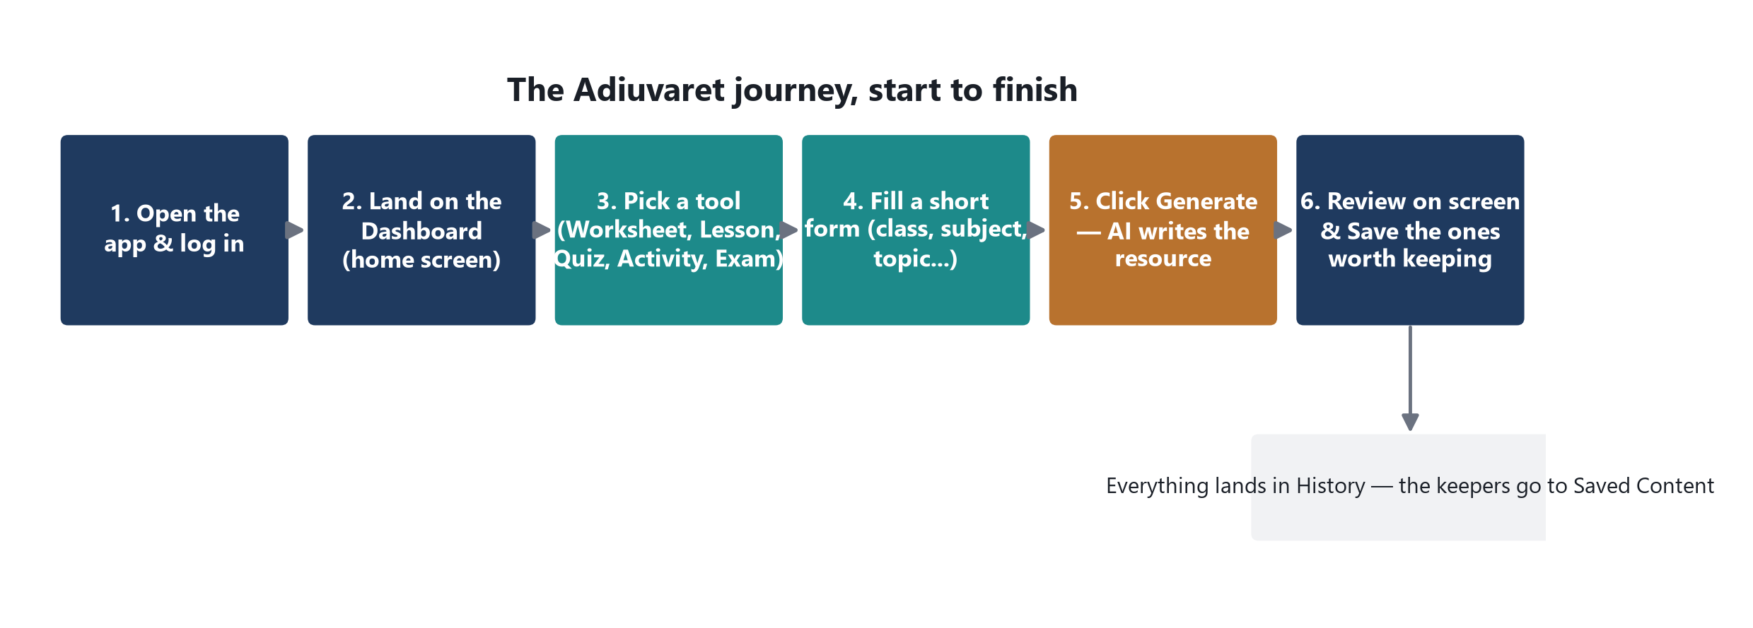
Figure 1. The Adiuvaret journey, start to finish.
A side menu is always on screen once you're logged in, so every tool — plus History, Saved Content, Profile, and Settings — is one click away from wherever you are, without retracing your steps.
Good to know: Adiuvaret runs entirely in your browser — there's no company server storing your data — and every “Generate” click needs an internet connection to reach Gemini AI.

